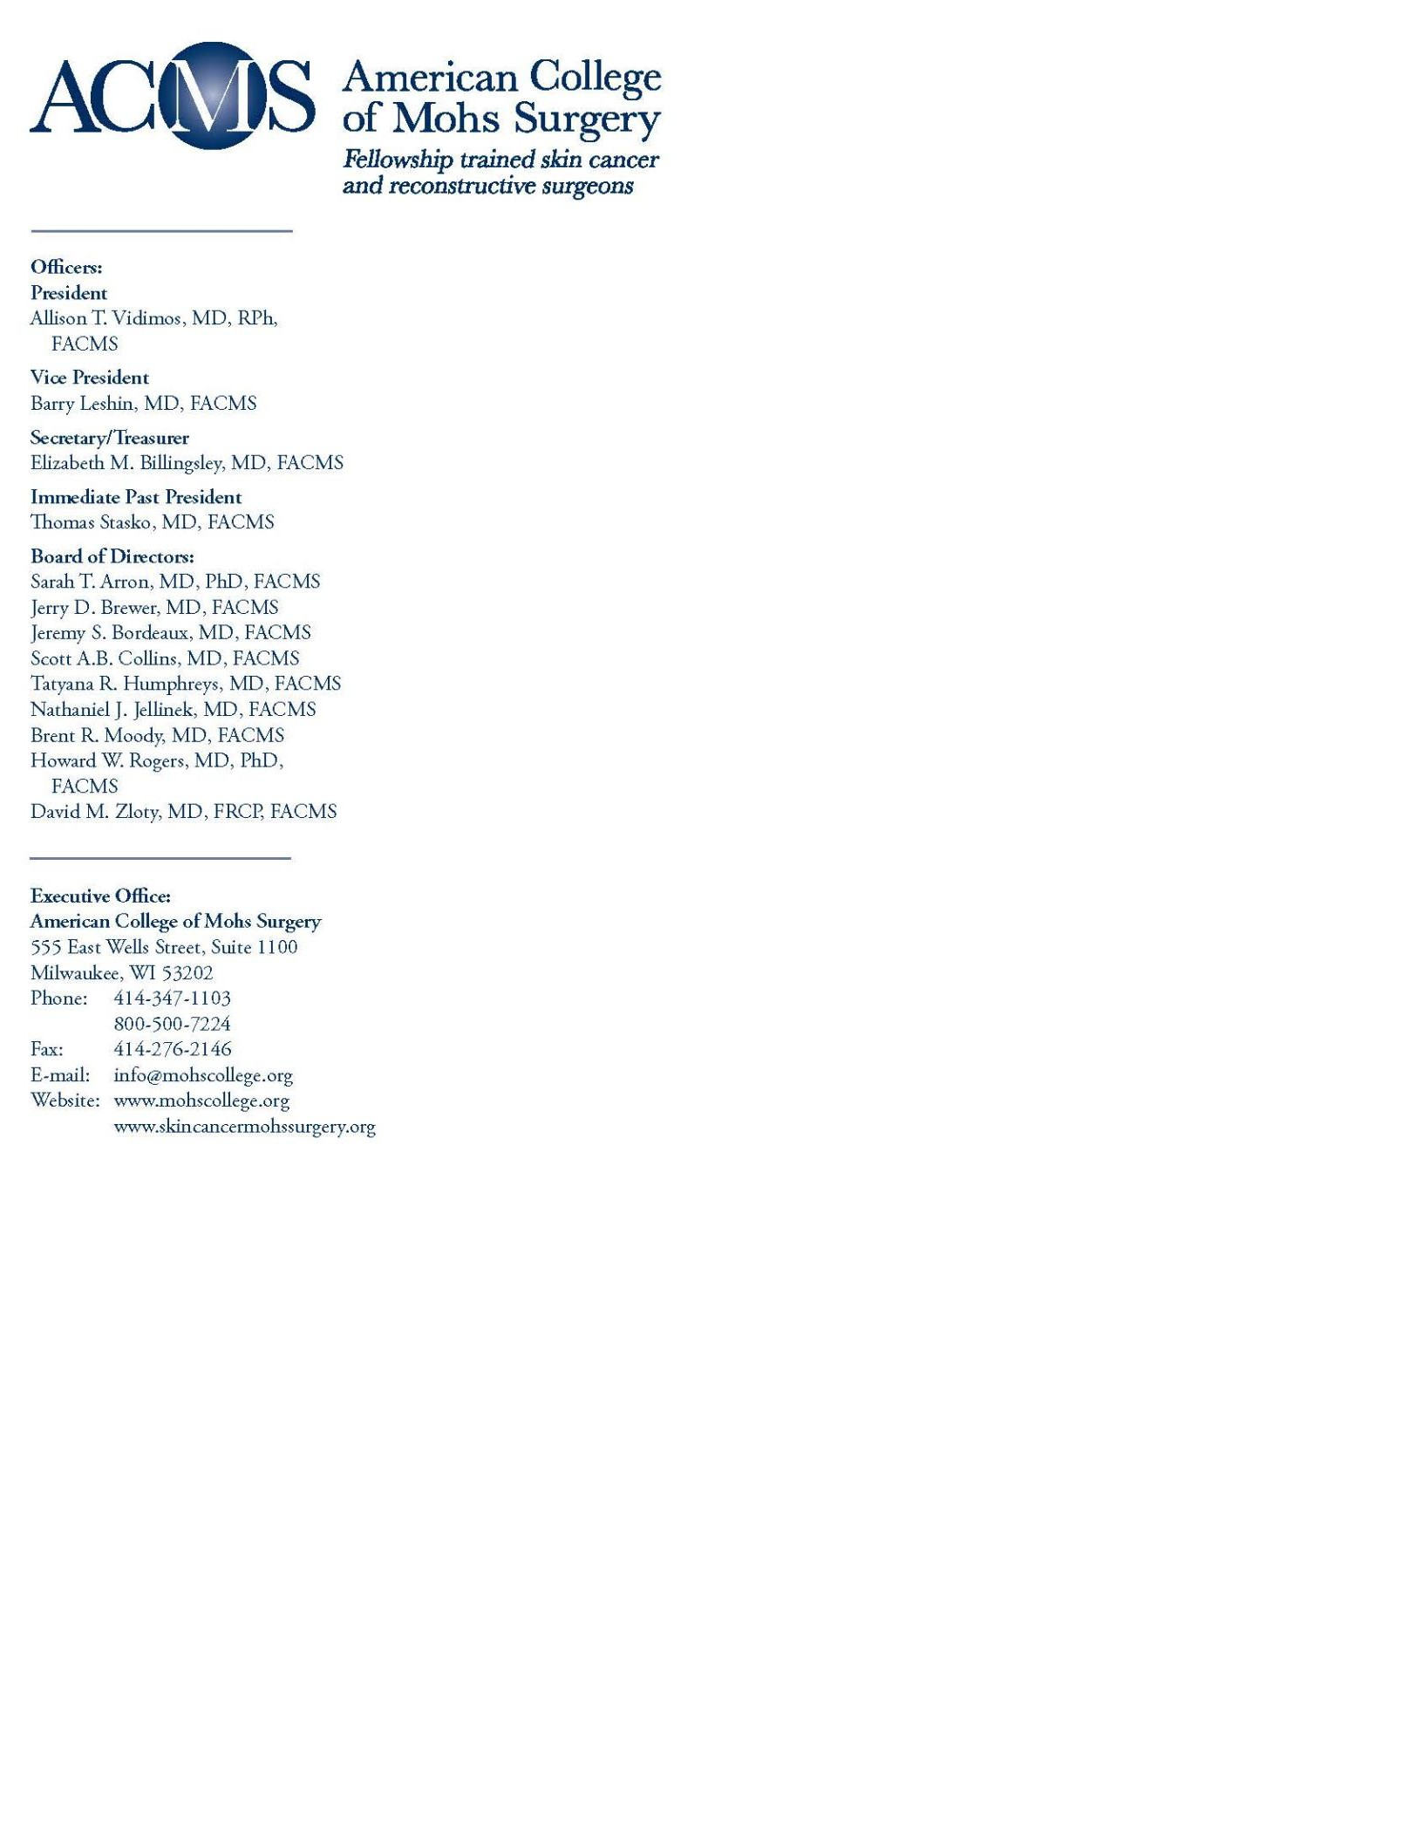

January 16, 2018

Ms. Seema Verma, Administrator

Centers for Medicare & Medicaid Services Department of Health and Human Services Room 445-G, Hubert H. Humphrey Building 200 Independence Avenue, SW Washington, DC 20201

Submitted electronically via Regulations.gov

Re: Medicare Program; Contract Year 2019 Policy and Technical Changes to the Medicare Advantage, Medicare Cost Plan, Medicare Fee-for-Service, the Medicare Prescription Drug Benefit Program, and the PACE Program

Dear Administrator Verma,

The American College of Mohs Surgery (ACMS) represents more than 1,400 Mohs micrographic surgeons who have successfully completed extensive fellowship-training in Mohs micrographic surgery following their dermatology residency training. Mohs Micrographic Surgery is the most effective and efficient treatment for advanced or difficult to treat skin cancers. In line with its mission, the Mohs College sets and promotes the highest standards of patient care relating to Mohs micrographic surgery.

We appreciate the opportunity to provide comments on proposals outlined for Medicare Advantage Organizations (MAOs) in 2019 as they impact enrollees access to skin cancer care and treatment.

Medicare Advantage and Part D Prescription Drug Plan Quality Rating System Fellowship-trained Mohs surgeons are working to address a growing epidemic of skin cancer. According to the Centers for Disease Control and Prevention (CDC), more than one in five Americans will develop skin cancer in their lifetime. Despite this and other concerning skin cancer statistics, MA plans continue to limit enrollee access to the integrated, coordinated, high-quality and cost-•‐effective skin cancer care and treatment options we provide by eliminating Mohs surgeons from their provider networks. This “narrow network” approach creates significant access-to-care challenges for enrollees with skin cancer. In fact, some MA plans that fell short of a 5- star rating in prior years eliminated every Mohs surgeons from their network because the plan perceived them as “expensive” compared to general dermatologists in the area. Mohs surgeons that have been

excluded from MA provider networks tell us they are seldom offered a sensible explanation regarding the circumstances for their termination, nor are they afforded a reasonable opportunity to dispute or challenge the decision.

ACMS has long advocated for changes in MA plan requirements that would improve enrollee access to skin cancer care and treatment and address “narrow networks,” to include modifications in the Quality Rating System and implementation of new stars measures. For this reason, we appreciate that CMS is soliciting feedback on the Quality Rating System and stars measures, and has expressed particular interest in key areas that may help address the challenges Mohs surgeons and MA enrollees face. We outline our recommendations below.

*We urge CMS to include a stars measure that would award points to MA plans that maintain an adequate network of specialty and subspecialty physicians, including Mohs surgeons.* MA plans that do not provide enrollees with access to a full range of specialists are ill-equipped to provide high- quality, cost-effective care. Enrollees may not realize they need certain specialists, services or therapies until after they have enrolled in a plan. This is especially true when it comes to skin cancers where a mole or skin lesion that seemed innocuous during enrollment suddenly requires the expertise of a fellowship-trained Mohs surgeon. *The weight for this measure should be at least 3.0.*

To accomplish this, *CMS must require MA plans to accurately identify physician specialties and subspecialties when calculating network adequacy.* The current MA network adequacy criteria guidance only requires plans to consider 27 provider specialty types. The list does not reflect the full range of physician specialty and subspecialty types that will be needed by enrollees as their health needs change over time, particularly in the Medicare population. As a result, most MA provider panels remain grossly inadequate. *We urge CMS to revise these criteria and require MA plans to use the Healthcare Provider Taxonomy code set*, which was developed by the National Uniform Claims Committee (NUCC) to distinguish between specialty and subspecialty physicians. These codes are already employed by physicians when applying for a National Provider Identifier (NPI) through the National Plan and Provider Enumeration System (NPPES). For example, Mohs surgeons identify themselves as follows:

* Level I, Provider Type: Allopathic & Osteopathic Physician (Medicare Provider Type 20)
* Level II, Classification: Dermatology (207N00000X) (Medicare Specialty Code 07)
* Level III, Area of Specialization: MOHS Micrographic Surgery (207ND0101X)

*We urge CMS to establish a stars measure that would award points to MA plans that maintain an adequate network of physicians who participate in CMS quality improvement programs, such as the Merit-based Incentive Payment System (MIPS) and Alternative Payment Models (APMs).* Mohs surgeons engaged in these programs are supporting broad efforts to improve quality and reduce resource use, which has tremendous benefits for MA plans and their enrollees. A stars measure that recognizes MA plans for maintaining high-quality, cost-efficient physicians on their provider panels may encourage MA plans to retain Mohs surgeons “in-network” and ensure enrollees have access to expert skin cancer care and treatment. *The weight for this measure should be at least 1.5.*

*We urge CMS to develop a survey of physician’s experiences with MA plans and establish a stars measure that would award points to MA plans based on survey responses.* The survey of physicians should focus on a broad number of issues that physicians face in their engagements with MA plans, but most importantly, network adequacy. As noted above, Mohs surgeons have been excluded from MA plans at unprecedented rates, are seldom offered a sensible explanation regarding the circumstances for their termination, nor are they afforded a reasonable opportunity to dispute or challenge the decision. This is unacceptable. We believe the survey should delve into these issues in great detail, providing specialists the opportunity to share important information with CMS about their experiences in learning about their terminations and in attempting to appeal. ACMS would be pleased to work closely with the agency to develop questions. *The weight for this measure should be at least 3.0.*

We would also be happy to share our members specific experiences, as well as how we’ve worked with Optum on improving data analytics for skin cancer measures that MA plans could use to compare Mohs surgeons based on quality and cost. Unfortunately, while these efforts have been helpful, because MA plans are not required to maintain an adequate network of subspecialists, there is no incentive to adopt updated algorithms to equitably evaluate the efficiency and cost of Mohs surgeons.

\*\*\*\*\*

We appreciate the opportunity to provide feedback on this important issue. If you have any questions about our comments, please contact Emily L. Graham, RHIA, CCS-P, Consultant to the American College of Mohs Surgery at 703-975-6395 or [egraham@hhs.com](mailto:egraham@hhs.com).

Sincerely,



Allison Vidimos, RPh, MD President, ACMS

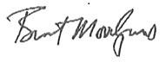

Brent Moody, MD

Chair, ACMS Public Policy Committee

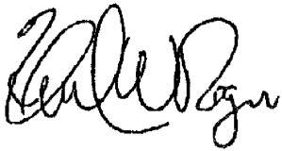

Howard Rogers, MD

Chair, ACMS Private Sector Advocacy Task Force