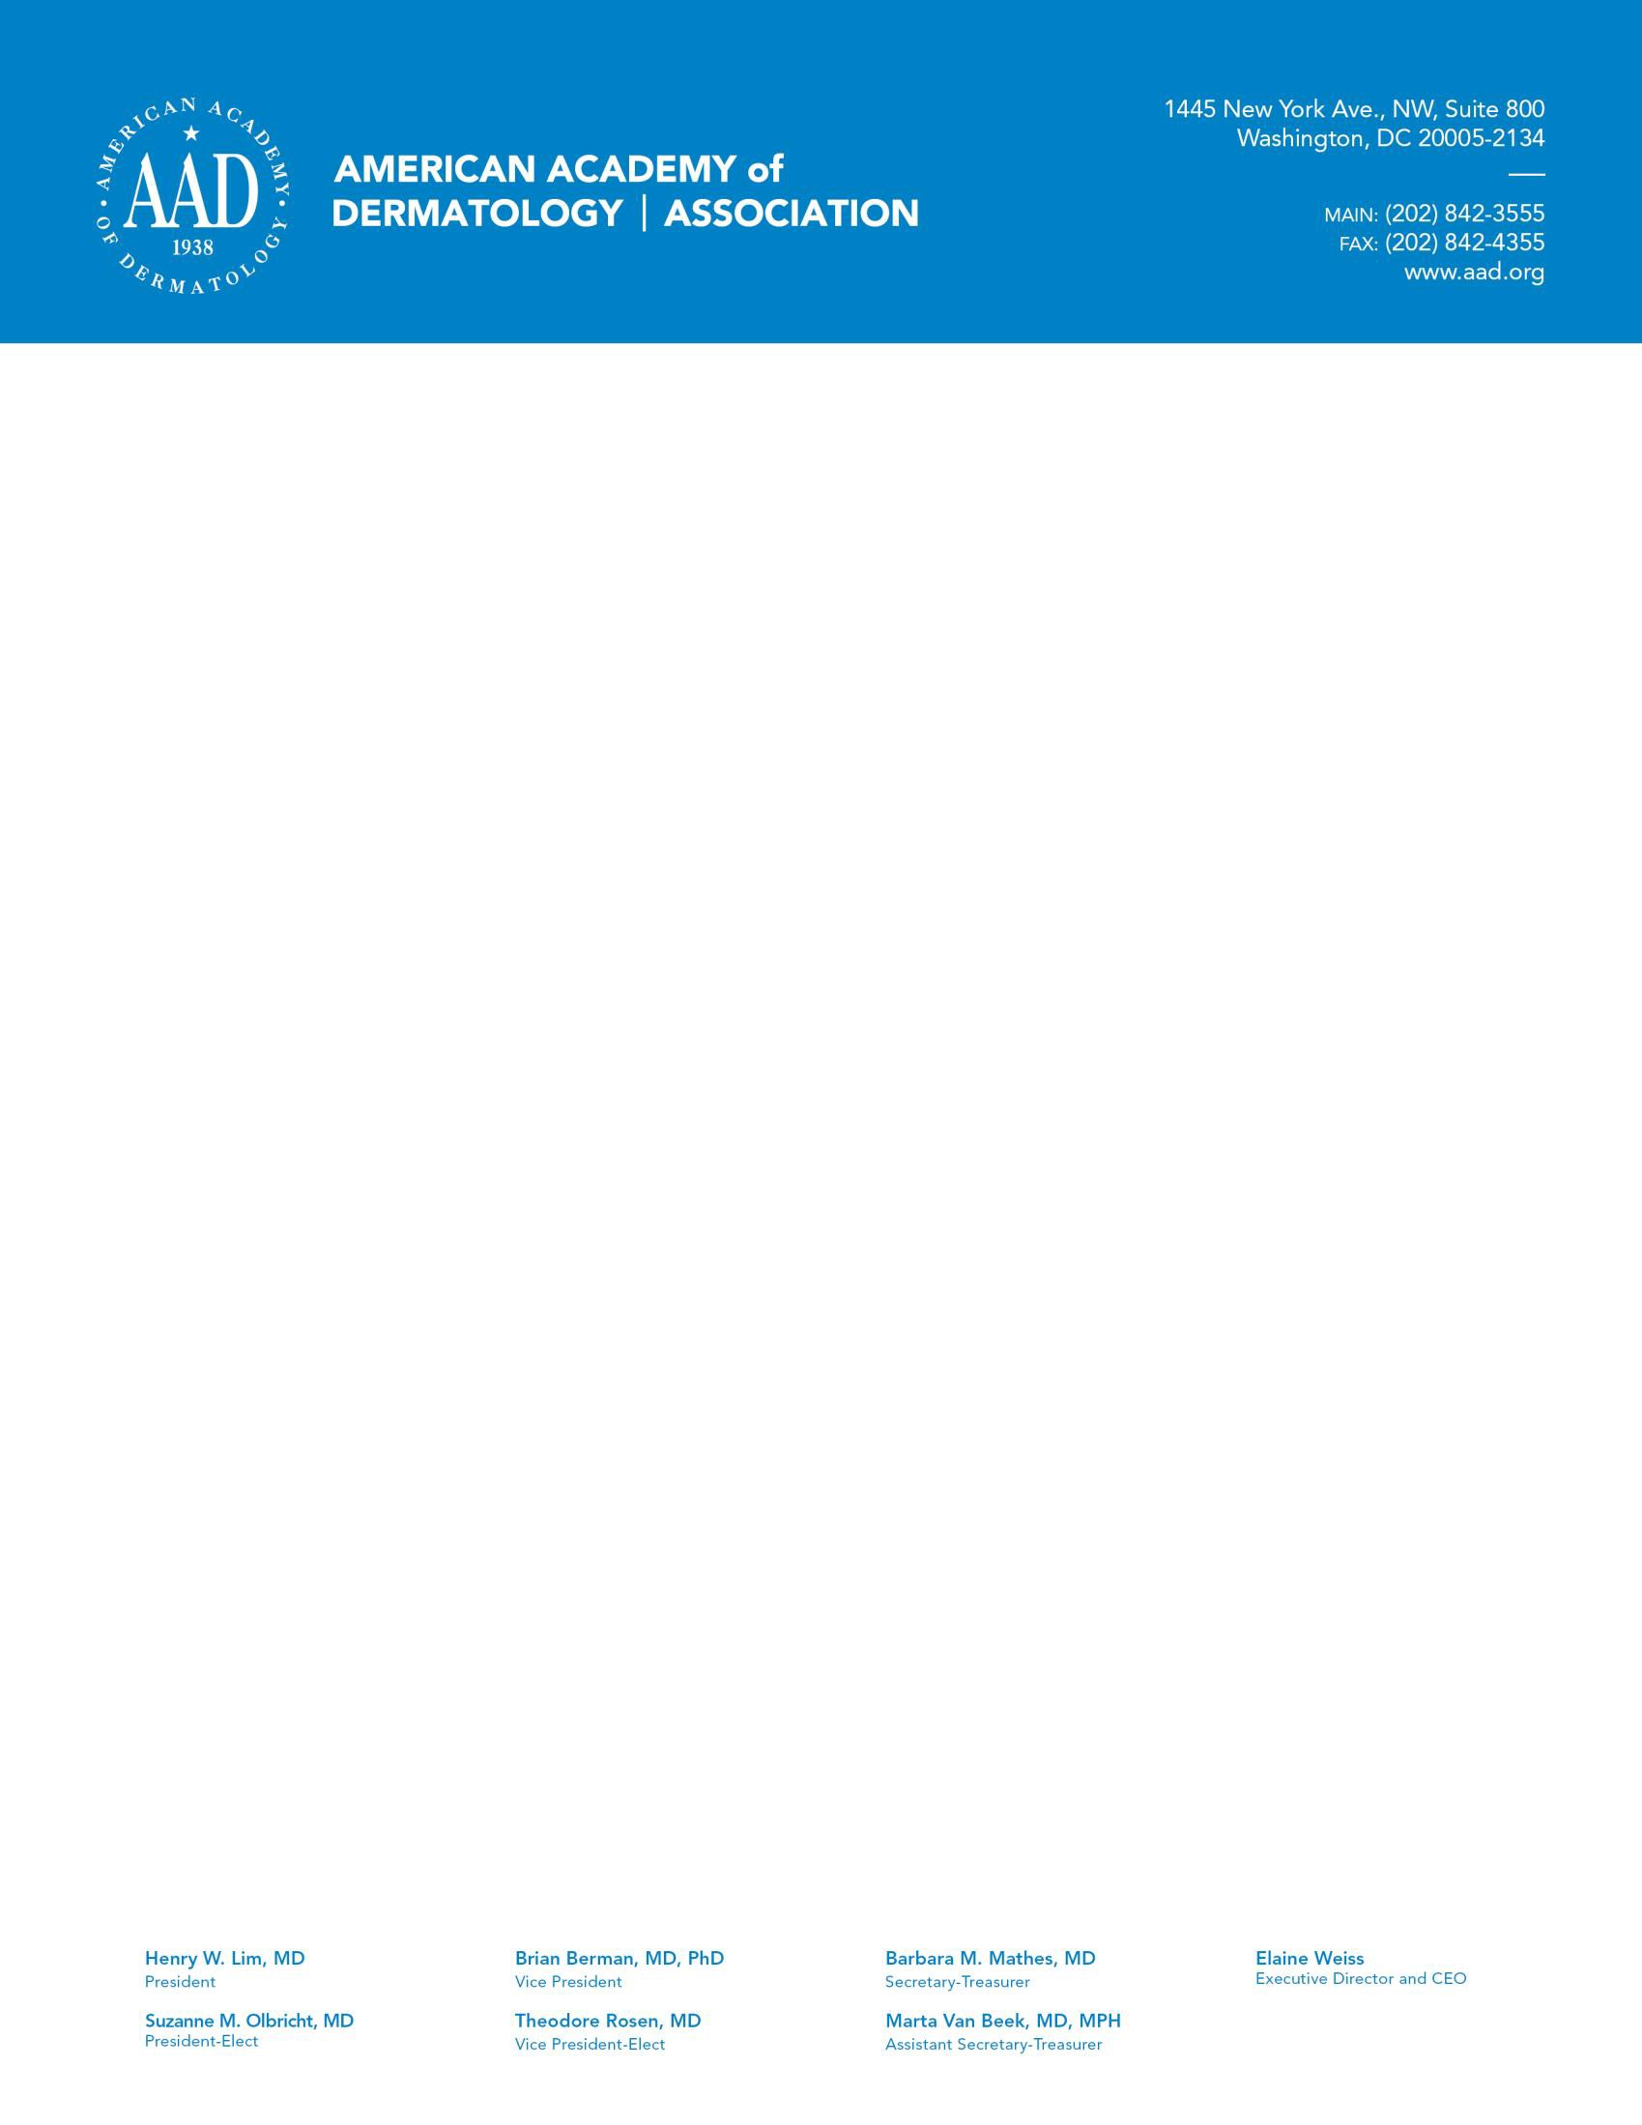

January 16, 2018

Ms. Seema Verma Administrator

Centers for Medicare & Medicaid Services, Department of Health and Human Services, Attention: CMS-4182-P,

P.O. Box 8016,

Baltimore, MD 21244-8016.

## Re: CMS-4182-P: Medicare Program; Contract Year 2019 Policy and Technical Changes to the Medicare Advantage, Medicare Cost Plan, Medicare Fee-for-Service, the Medicare Prescription Drug Benefit Programs, and the PACE program

Dear Administrator Verma:

On behalf of the 13,500 U.S. members of the American Academy of Dermatology Association (AADA), I am writing you regarding the proposed rule for the Medicare Program the Centers for Medicare and Medicaid Services (CMS) published on November 2, 2017. The AADA is committed to excellence in medical and surgical treatment of skin disease; advocating high standards in clinical practice, education, and research in dermatology; and supporting and enhancing patient care to reduce the burden of disease. We appreciate the opportunity to provide comments to CMS on this proposal and hope CMS will take the AADA’s recommendations into consideration when finalizing the policies outlined within the proposed rule.

## Lengthening Adjudication Timeframes for Part D Payment Redeterminations and IRE

CMS proposes to modify the timeline for issuing decisions on payment redeterminations from 7 calendar days from the date the plan sponsor receives the request to 14 calendar days from the date the plan sponsor receives the request. CMS explains that the additional time will allow for plans to collect any missing details for the appeals. Allowing plans additional time to respond to requests may further delay patients from accessing a drug. Delaying necessary treatments for patients can be detrimental to health outcomes. If the proposed extension is implemented, CMS should ensure the additional time is only utilized when more information is necessary for the payment redetermination.

**E-Prescribing and the Part D Prescription Drug Program; Updating Part D E-prescribing Standards** CMS proposes to adopt the NCPDP SCRIPT standard 2017071, but not mandate it. Plans using the previous version, though, must update to this new system. The version has several new features that allow, for example, a new prescription request, prescription transfer messages, and a REMS initiation request. It will help streamline the process for e-prescribing. While the AADA commends CMS for adopting the new standards for electronic prescribing, the AADA recommends CMS also adopt the NCPDP SCRIPT Standard Version 2013101 Prior Authorization transactions in order to encourage adoption of technology that allows for real time prior authorizations. The AADA also recommends that CMS require plans to provide detailed

explanations for prior authorization denials, including the clinical rationale, provide the plan’s covered alternative treatment and provide details on the provider’s appeal rights. CMS should standardize the PA form across all Medicare Advantage and Medicare Part D plans as well as shorten the time the payer has to make and inform the provider of the PA decision and of the appeal period.

## Part D Tiering Exceptions

CMS proposes to update the tiering exception process as the drug landscape has changed considerably over the past few years. CMS proposes to not require plans to grant tiering exceptions for non-preferred brand drugs to have the same costs sharing levels that apply only to generic alternatives. When the physician determines that the preferred drug would not be as effective or would have adverse effects for the individual they can submit a tiering exception, but now the plans do not have to grant approval for them. CMS requires plans approve tiering exceptions for non-preferred generic drugs. Plans would provide the cost sharing level of the tier with the preferred alternative generic even if the tier contains both generic and brand drugs. Formulary tiers have changed over the past few years and this change accounts for the mixed tiers. The AADA commends CMS for clarifying that mixed tiers are not exempt from the tiering exception process which was unnecessarily impeding access to lower cost sharing for patients. Additionally, while the AADA understands CMS needing to control the cost of drugs, we ask that CMS monitor the tiering exception for brand drugs. A medication’s vehicle and formulation are important in treatment. Creams, ointments, gels and lotions that contain the same active ingredient often have distinct formulations that affect drug bioavailability, treatment effectiveness, and can also contain ingredients to which patients are allergic. For these reasons, a preferred generic formulation can be inappropriate or unsafe for a specific patient. Each patient’s circumstances are unique. The recommended course of treatment must be a decision made between a patient and physician. CMS should ensure the appropriate cost sharing is applied in order for the patient to access both an affordable and effective safe treatment.

## Any Willing Pharmacy Standards Terms and Conditions

CMS clarifies that plans are not able to exclude pharmacies with unique or innovative business or care delivery models (ex: retail pharmacy that also operates a home infusion business) from participating in their contracted pharmacy network on the basis of not fitting in the correct pharmacy type classification. Plans can still implement standards for those pharmacies in their networks, but they cannot exclude based on the above classification. The AADA supports patients having access to sufficient pharmacy networks under their respective plans. This provision will give more pharmacies the opportunity to be a part of these networks if they can meet the individual plans’ specifications. It is expected that this proposal will benefit patients located in rural areas and underserved areas.

## Expedited Substitutions of Certain Generics and Other Midyear Formulary Changes

CMS proposes to allow Part D plans to immediately replace brand name drugs with a newly approved therapeutically equivalent generic drug. Plans would no longer have to wait two months to make the change. The plan would only need to include a generic notice to patients when they enroll that such formulary changes can take place. The generic drug must have the same cost sharing status or lower than the brand name drug. This provision would not apply to biologics and biosimilars. The AADA recognizes the benefit of quickly adding newly approved drugs on the formulary, but patients often choose plans based on medication formularies, and those should remain consistent for the entire plan year, and patients should have advance notice of any changes to their current drug plan. CMS also does not propose any requirements for the plan to update their

formulary after these changes. The AADA recommends that if this change is implemented, CMS should monitor the rate at which the formularies are updated to reflect the changes in coverage. Additionally, the AADA recommends that CMS codify a requirement for when the plan must give notice to the patient of this change to their formulary. CMS states that they expect the notice by the plan to be given by the end of the month in which the change took place, but do not make that a requirement.

*Change in Cost Sharing Status or Removal of a Drug*

CMS proposes to the change the days’ *online notice* to current and prospective patients from 60 to 30 when a Part D plan changes the cost sharing level of a drug or removes a drug from the formulary. CMS also proposes to reduce the required days of *direct notice* to affected enrollees from 60 to 30 days. Currently, affected enrollees can request a 60-day refill when this type of formulary change occurs, but CMS proposes to change the refill to only 30 days. CMS states that 30 days will be enough time for the patient to obtain a needed exception if necessary. The AADA recommends keeping the notice at 60 days. Patients, including those whose disease is stable, will not only need to schedule to meet with their health care provider, complete lab work and discuss other therapeutic options, but also there is no guarantee that the new treatment will be effective. The consequences, which cannot be predicted for individual patients include worsening disease, severe flares, therapeutic failure, and risk for greater adverse effects than those associated with current therapy.

## Request for Information Regarding the Application of Manufacturer Rebates and Pharmacy

CMS includes a request for information regarding on whether it should require Part D plans to include at least a minimum percentage of manufacturer rebates received for a covered Part D drug in the drug’s negotiated price at the point of sale. CMS also proposes to require that all price concessions from pharmacies be reflected in the negotiated price that is made available at the point of sale and reported to CMS, even when such concession are contingent upon performance by the pharmacy. CMS cautions that having higher share of rebates be included in the negotiated price may lead to higher premiums for *all* enrollees. Thus, also leading to increased cost for Medicare, because of the subsidies provided for premiums. The change in negotiated price for the patient would likely benefit high utilizers of the drug benefit.

Overall, the AADA supports transparency in the structure in which Pharmacy Benefit Managers (PBMs) operate. In order to protect propriety, cost information and ensure high cost drugs are targeted by this proposal, the AADA supports CMS’ recommendation of plan sponsors being required to pass through at least a minimum percentage of rebates at the point of sale only for specific drugs or drug categories or classes. After calculating the applicable average rebate amount for a particular drug category, the manufacturer rebate amount for each individual drug in that category would be weighted by the total gross drug costs incurred for that drug. If CMS were to only target specific drugs it could use the drug spending and utilization data presented in the annual Medicare Drug Spending Dashboard. The top twenty drugs with the highest total spending or highest cost per user could be required to pass on the rebates as described above. If CMS only targets specific drug classes, it could use the same data to determine the highest cost classes overall for Medicare and then apply the method listed above to determine the new negotiated price.

CMS must acknowledge that consolidation within the industry may make it difficult to implement the proposed policy change. The AADA encourages CMS to continue to explore innovative methods to ensure patients have access to affordable and effective drugs.

## Reducing Provider Burden – Comment Solicitation

CMS recently launched the “patients over paperwork” initiative to help reduce burdensome regulations. The Academy appreciates CMS creating this important initiative and believes it should be applied in this case for reducing audit requests from providers for Medicare Part D audits. Providers should not spend an inordinate amount of time forced to provide medical record documentation to Part D contractors due to these requirements. Accommodations must be made to providers to reduce the number of medical record requests as well as providing clarity to the provider for exactly what is required.

## Conclusion

The AADA appreciates the opportunity to provide comments on the proposed rule. We look forward to additional opportunities to comment on these issues and to provide feedback that may help guide policy development.

We appreciate your efforts to prioritize this issue. Please feel free to contact Ashley John, Senior Specialist in Advocacy and Policy at [ajohn@aad.org](mailto:ajohn@aad.org) or (202) 609-6332 if you have any questions or if we can provide additional information.

Sincerely,

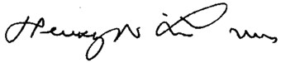

Henry W. Lim, MD, FAAD President

American Academy of Dermatology Association

# Cc:

Elaine Weiss, JD, Chief Executive Officer, American Academy of Dermatology Barbara Greenan, Senior Director, Advocacy and Policy, American Academy of Dermatology Association

Leslie Stein Lloyd, JD, Regulatory and Payment Policy, American Academy of Dermatology Association