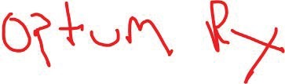

*CoS:.t*

SectionH: Mall Order - Doespharmacy mal l/deliver Q vesQ Ng (If Ng Pleasedisregard

LS) IODK'. ,-- - - - -

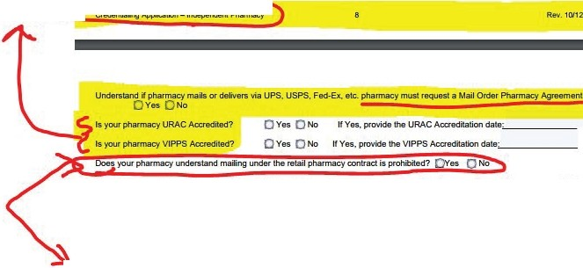

Is l'(llJI" pfla,mitcyicen&ed in udl slatltlhat willmailCoYl!f1ld Pfesa1Jlion s.vices,inclJdingoomplianol!Iwi!hanyncn-resident

pharmacyreqtKemenu.? Ovn 0 No

PIN H bl Neh I ) lha t pharmacymeh Of intends IOma li'ug pooduet,J;

agrNffM-·lfllwilhout11xplic·il-w-rittlln"a"ut"ho'"r"iza"t"ion"f-rom"O"p't'u'"m-.fb.·' txted lroQm mY•Ja '"Omi.No

p@sci;;G\ HMCeaund9ar nilail )