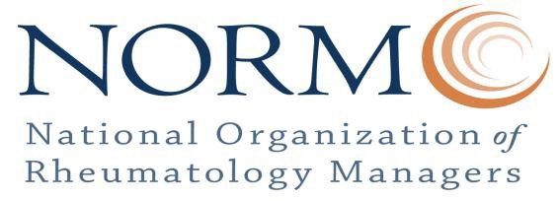

January 16, 2018

Ms. Seema Verma, Administrator

Centers for Medicare & Medicaid Services Department of Health and Human Services Room 445-G, Hubert H. Humphrey Building 200 Independence Avenue, SW Washington, DC 20201

*Submitted electronically via Regulations.gov*

**Re: Medicare Program; Contract Year 2019 Policy and Technical Changes to the Medicare Advantage, Medicare Cost Plan, Medicare Fee-for-Service, the Medicare Prescription Drug Benefit Program, and the PACE Program**

Dear Administrator Verma,

The National Organization of Rheumatology Managers is a 501(c)6 organization representing rheumatology managers, physicians and patients. Our mission proclaims we are a forum by which we promote and support education, expertise and advocacy for access to care of our rheumatology practices and their patients.

On behalf of our manager members, I am writing to share our concerns with Medicare Advantage audits.

Reducing Provider Burden Associated with Medicare Advantage Medical Record Requests

Rheumatology managers are at the forefront of addressing the administrative challenges facing rheumatology practices. For this reason, we appreciate that CMS looks to reduce provider burden associated with Medicare Advantage medical record requests.

Our members field excessive medical record documentation requests from multiple Medicare Advantage Organization (MAOs), distracting them from critical patient care responsibilities and other regulatory and compliance obligations, including those associated with the implementation of the Medicare Access and CHIP Reauthorization Act of 2015 (MACRA). This is a huge administrative burden and a tremendous expense to practices.

Requests for records are frequent, coming in by mail and fax from several MAOs. At least one MAO will send a

“batch” request each month, which will include multiple requests for various patients across long timeframes.

A rheumatology manager shared that, *“One requester blows up our phone lines unnecessarily by calling us to say they are faxing the request, then faxing it, then calling to verify we received it, then calling one or more time to check the progress before they are due. This is most bothersome. EPI Source is the worst about this.”*

Worse yet, MAOs given little time to complete the requests. A rheumatology manager told us, ***“I****t doesn't matter to [the MAO] if it is 2 or 14 charts or 3 months or 2 years, they can make the response time the same. More work should be allotted more time.”*

Auditors are often evasive when asked whether the requests are related to a CMS-initiated Risk Adjustment Data Validation (RADV) audit or an independent audit by the MA plan. We do not believe our practices should be required to comply with requests that are not mandated by CMS. To the extent the requests are associated with a CMS-initiated RADV audit, practices should be compensated for their time and direct expenses.

NORM works closely with the Coalition of State Rheumatology Organizations (CSRO), who urged CMS to take a number of steps to address challenges with MAO audits. Specifically, CSRO urged CMS to require MAOs to:

* Follow a standardized process for all medical record requests;
* Clearly identify the nature of their medical record request (e.g., RADV, other purpose) and provide written documentation when requests are mandated as part of CMS-initiated audits;
* Provide reasonable deadlines for medical record submissions, as well as a process for extending the submission deadline for extenuating circumstances;
* Limit the number and volume of medical record requests (e.g., no more than once per year and no more than 20 records per physician); and
* Allow practices to submit medical records through a secure web-portal, on CD/DVD, or by fax, when possible.
* Reimburse practices for completing medical record requests at a rate no less than is set under State law.

***We urge CMS to adopt these recommendations for improving the MA audit process moving forward.***

We appreciate the opportunity to provide comments on the aforementioned issues of importance to NORM. Should you have any questions, please contact us at 610-692-4666.

Sincerely,

Andrea Zlatkus President, NORM