

National PACE Association 675 N. Washington St. Suite 300

Alexandria, Virginia 22314

Telephone: 703-535-1565

Fax: 703-535-1566

[info@npaonline.org](mailto:info@npaonline.org)

March 5, 2018

Seema Verma Administrator

Centers for Medicare and Medicaid Services Department of Health and Human Services Attention: CMS-2017-0163

P.O. Box 8013

Baltimore, MD 21244-1850. [https://www.regulations.gov](https://www.regulations.gov/)

RE: Advance Notice of Methodological Changes for Calendar Year (CY) 2019 for Medicare Advantage (MA) Capitation Rates, Part C and Part D Payment Policies and 2019 draft Call Letter

Dear Administrator Verma:

This constitutes the response of the National PACE Association (NPA) to CMS’ request for comment on the Advance Notice of Methodological Changes for CY 2019 for MA Capitation Rates, Part C and Part D Payment Policies (Advance Notice) and 2019 draft Call Letter. We appreciate CMS’ consideration of the following comments made on behalf of NPA’s membership including 118 PACE organizations in 30 states:

1. **PACE CMS-HCC Risk Adjustment Model** – NPA supports CMS’ decision to retain the PACE CMS-HCC risk adjustment model that has been utilized for PACE payment since 2012 in CY 2019. Looking forward, however, we strongly encourage CMS to consider the following:
   1. The PACE CMS-HCC risk adjustment model currently in use was implemented in 2012 using a baseline year of 2009 and has not been recalibrated since then. This model reflects the relationship between 2006 diagnoses and 2007 expenditures. We strongly encourage CMS to update the model, if not for CY 2019, for CY 2020. This recommendation is closely tied to NPA’s comments below on the normalization factor.
   2. In addition, we encourage CMS to undertake analyses to evaluate the impact of modifying the PACE CMS-HCC risk adjustment model consistent with some of the

changes that have been made to or are proposed for the MA CMS-HCC model. Such changes include separating the community model into six subgroups based on dual eligibility status, adding additional diagnoses codes for mental health and substance abuse, etc. We feel strongly, however, that future modifications should retain the dementia HCCs currently included in the PACE CMS-HCC model due to the characteristics of the PACE population and the prevalence of dementia and related costs among PACE participants. We request that CMS provide notice of proposed changes to the PACE CMS-HCC model with an opportunity for PACE organizations and other stakeholders to comment. We ask that such notice include analyses of the model’s performance/accuracy as well as its impact on PACE payments.

1. **Normalization Factor** – NPA is concerned about the recent trend in the growth of the PACE normalization factor and why such a substantial increase in the normalization factor is being proposed for CY 2019. Additionally, CMS specifically requested input on whether to apply a different approach to determining the normalization factor for the PACE model.

As proposed, the normalization factor for PACE for CY 2019 has a negative impact on Medicare payments of approximately 6.3%. While this negative impact will be in part offset by the MA growth factor, its impact on PACE organizations is disproportionately negative relative to prior years. This is driven by a misalignment between the time period used to calculate the factor (5 years, 2013-2017) and the length of time since the baseline year (2009) of the current payment model (10 years, 2009 – 2019):

* In calculating the PACE normalization factor, CMS used a 5-year FFS risk score trend (2013-2017). This 5-year trend is applied to estimate the impact of population and coding changes over a ten-year period (2009-2019).
* By using a 5-year trend rather than the 9-year trend (2009-2017) for which data are available, CMS increases the normalization factor applied to PACE by .047 or 4.2%. The increase in this factor results in lower PACE risk scores and consequently lower payments to PACE.

Further, the 5-year trend gives more weight to the most recent two years of changes in population and coding than a 9-year trend would:

* These most recent two years’ increases in the factor (2017-2018, and 2018-2019) are anomalies relative to prior years and distort the overall trend.
* On average, the year-to-year change in the normalization factor between 2012, the first year the current CMS-HCC risk adjustment model for PACE was utilized, to 2017 was zero.

Referring to Chart 1 and Table 1, the two most recent periods used in the Advance Notice of Payment’s (ANP) calculation of the normalization factors saw year-to-year changes that increased the normalization factor by .031 and .077 respectively. These are 2.95% and 7.12% increases in the normalization factor, with corresponding decreases in PACE risk scores,

Change in PACE Normalization Factor, 2012 – 2019 (Proposed) Chart 1

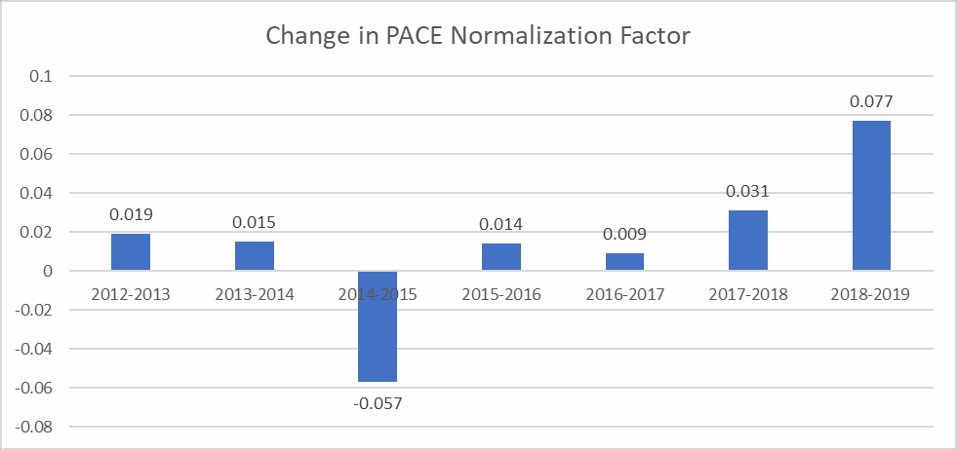

Change in PACE Normalization Factor, 2012 – 2019 (Proposed) Table 1

|  |  |  |
| --- | --- | --- |
| **PACE Normalization Factors 2012-2019** | | |
| **Year** | **Normalization Factor** | **Difference** |
| 2012 | 1.051 |  |
| 2013 | 1.070 | 0.019 |
| 2014 | 1.085 | 0.015 |
| 2015 | 1.028 | -0.057 |
| 2016 | 1.042 | 0.014 |
| 2017 | 1.051 | 0.009 |
| 2018 | 1.082 | 0.031 |
| 2019 | 1.159 | 0.077 |

Referring to Chart 2 below, NPA recommends that for payments in CY 2019, CMS base the normalization factor applied to PACE on a 9-year linear trend to align the factor with the last update of the PACE risk adjustment model (2009) and mitigate the impact of the two most recent years which are outliers relative to previous years. This will have the effect of reducing the trend, i.e., the slope from .0149 to .0107, thereby reducing the size of the normalization factor from the proposed 1.159 to 1.112 and its consequent impact on PACE payment. We believe this is an appropriate means by which to moderate the contribution of the normalization factors calculated for 2016 and 2017 which increased substantially relative to prior years’ scores.

Linear Trends Used to Calculate PACE Normalization Factors Chart 2

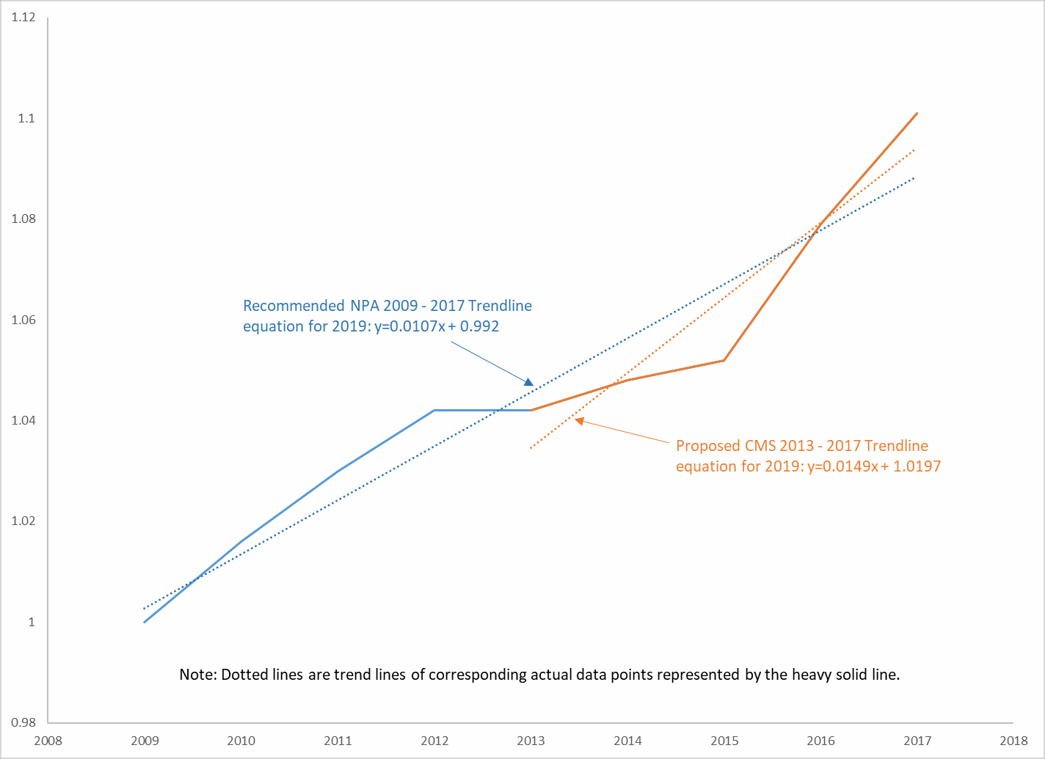

The recommended normalization factor of 1.112 is supported by the available data over a time period more closely aligned with the time since the PACE payment model’s baseline year. Further, the 2018-2019 increase in the normalization factor of .03 would be consistent with the increase in the normalization factor between 2017 and 2018 (1.051 vs. 1.082).

As mentioned above, NPA requests that for future payment periods (after CY 2019), CMS update the PACE CMS-HCC risk adjustment model to reduce the period of time over which a normalization factor needs to be applied and more accurately reflect the current relationship between diagnoses and expenditures.

1. **Use of encounter data, RAPS and FFS claims to calculate risk scores --** NPA supports CMS’ decision to continue the same method of calculating risk scores that CMS has been using since CY 2015, which is to pool risk adjustment-eligible diagnoses from the following sources to calculate a single risk score (with no weighting): (1) encounter data, (2) RAPS, and (3) FFS claims. NPA believes it is necessary to calculate risk scores using all three sources of data with no weighting due to differences between PACE and MA in terms of the availability of comprehensive encounter data.

In addition, because it was not mentioned explicitly, NPA seeks confirmation that CMS also will be pooling risk adjustment-eligible diagnoses from encounter data, RAPS and FFS claims to calculate ESRD risk scores, consistent with what is explicitly noted for risk scores to be calculated using the PACE and RxHCC payment models.

1. **Part D** – Consistent with analyses discussed in detail in correspondence to CMS dated December 27, 2017, NPA would like to take the opportunity afforded us by CMS’ request for comment on the ANP to reiterate that Medicare-only beneficiaries enrolled in PACE are disadvantaged by requirements placed on PACE Part D plans. In particular, NPA points out that Medicare-only PACE participants incur Part D premiums that are much higher than Part D premiums for Medicare beneficiaries outside PACE. PACE Part D plans must include costs that are paid by market place Part D plan enrollees in the form of deductibles and coinsurance in participants’ Part D premiums. Because PACE participants do not incur out- of-pocket costs, they do not have access to manufacturer discounts in the coverage gap and PACE organizations cannot access catastrophic reinsurance. The costs associated with foregoing these Part D benefits are absorbed in Medicare-only PACE participants’ monthly premiums. These costs significantly increase the premium a PACE organization must charge a Medicare-only participant relative to the premium the Medicare-only individual would pay in a non-PACE Part D plan. It is also important to note that the inability of PACE organizations to access reinsurance for their Medicare-only participants puts PACE organizations at extraordinary risk for the costs of catastrophic drug coverage for these individuals.

In its December 27, 2017 letter, NPA proposed that Medicare-only beneficiaries wishing to enroll in PACE be provided with Part D coverage options that would add to, but not replace, the current PACE Part D plan option. We ask that CMS consider alternative Part D coverage options for PACE participants allowable under regulatory waivers and respond to our December 27th letter as soon as possible.

1. **Advanced Alternative Payment Models Program** – The ANP informs Medicare health plans that they will be able to submit applications as part of the Part C bid submission process to determine if their payment arrangements qualify them as Other Payer Advanced Alternative Payment Models under the Quality Payment Program. Conceptually, this is something that PACE organizations also should be able to do if they meet the requirements of Other Payer Advanced APMs. NPA requests CMS provide clarification and guidance on the process PACE organizations should use to apply as Other Payer Advanced APMs since they do not submit Part C bids.
2. **New Enrollee Risk Scores for PACE -** As is done for chronic condition Special Needs Plans (SNPs), we ask CMS to consider a new methodology for calculating new enrollee risk scores for new enrollees in PACE. Because PACE participants must, as a condition of enrollment, meet nursing home eligibility criteria, they are distinguished from typical new Medicare enrollees and their average new enrollee risk score is likely to understate their risk. We ask CMS to consider adapting its methodology for calculating risk factors for new enrollees in chronic condition SNPs to improve the risk adjustment model for new enrollees in PACE.

Thank you for your consideration of these comments and recommendations. Please direct any questions regarding NPA’s comments to Peter Fitzgerald at [peterf@npaonline.org](mailto:peterf@npaonline.org) or (703) 535-

1519, or Charles Fontenot at [charlesf@npaonline.org](mailto:charlesf@npaonline.org) or (703) 535-1558.

Sincerely,



Shawn M. Bloom President and CEO