**Matrix**

Medical Networ

VIA ELECTORNIC SUBMISSION: [www.regulations.gov](http://www.regulations.gov/)

March 2, 2018

Demetrios Kouzoukas, J.D. Principal Deputy Administrator and Director, Center for Medicare

Jennifer Wuggazer Lazio, F.S.A., M.A.A.A. Director, Parts C & D Actuarial Group Office of the Actuary

Department of Health and Human Services Centers for Medicare & Medicaid Services 7500 Security Boulevard

Baltimore, MD 21244

# Re: Matrix Medical Network's Comments on Advance Notice of Methodological Changes for Calendar Year (CY) 2019 for Medicare Advantage (MA) Capitation Rates, Part C and Part D Payment Policies and 2019 draft Call Letter

**(CMS-2017-0163)**

Dear Deputy Administrator Kouzoukas and Director Lazio:

On behalf of Matrix Medical Network (Matrix)LLC. and our approximately 1,800 in-network nurse practitioners (NPs) located across the country, we appreciate this opportunity to provide comments on the Centers for Medicare & Medicaid Services' (CMS) *Advance Notice of Methodological Changes for Calendar Year (CY} 2019 for Medicare Advantage (MA} Capitation Rates, Part* C *and Part D Payment Policies and 2019 draft Call Letter.* Matrix is the nation's leading provider of in-home health risk assessments (HRAs) and is a proud partner in MA plans' efforts to coordinate care and identify care gaps for vulnerable Medicare beneficiaries.

We are pleased that CMS recognizes the value of health risk assessments (HRAs), stating that "a completed HRA is vital to proper care management, improved health, and promotes the efficient use of healthcare resources." We could not agree more. Matrix NPs have unique clinical contact with Medicare beneficiaries, reaching them in their home during visits that last far longer than a simple office visit, and are well-positioned to identify and coordinate their health care needs. During these visits, Matrix NPs identify gaps in care, like missed screenings and overdue preventive care measures. Our in-home HRAs also allow for the assessment of a beneficiary's living environment and social determinants that can impact care planning. Importantly, beneficiaries who receive an in-home HRA take follow-up action concerning their healthcare. Data from one of our largest clients shows that

9201 E Mountain Vie,v Road, Ste 220 Scottsdale, AZ 85258 I 1-877-564-3627 ! matrixforme.com

members who received in-home HRAs are twice as likelly to see their primary care physician than those who did not. In-home HRAs are detecting and closing care gaps by encouraging beneficiaries, especially those with unmanaged medical conditions, to become more engaged in their own health.

As CMS continues to evaluate and consider future changes to the MA Risk Adjustment Model, we encourage the agency to maintain its ongoing recognition of the value and importance of in-home HRAs in the care planning and clinical condition identification process. We look forward to our continued work with you and your staff on these issues. Should you have any questions about comments raised in this letter, please do not hesitate to contact me.

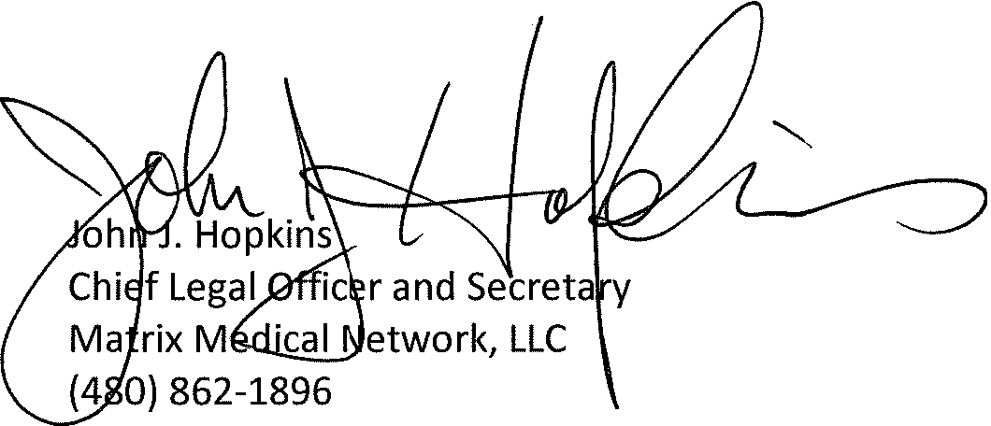Sincerely,