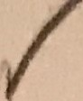E AM: MRI OF THE LUMBAR SPINE '

tNDICA TlON: Back pain for many years radiating to the left leg and toes. COMPARISON: MRI of the lumbar spine 2008.

TECHNIQUE: Multisequence, multiplanar study.

F\NOINGS! There is a moderate dextroscoliosis of the lumbar spine **measuring** 33

d egrees.

body.

•

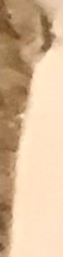

At,L

-2, there is 7 mm of leftward subfuxation of L1 on l2 vertebral

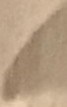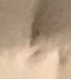The conus medull.ar;is is unremarkable.



•

Prog ressi ve degenerative disc disease at L1-2 is noted with chronic degenerative marrow signal changes involving the vertebral endplates. T'her e is asymmetric facet arthropathy on the left with mild counterclockwise rotation of

. t he vertebral bodies. The facet arthropathy does result in **some** mild

asymmetrical subarticular zone narrowing on the left side. No significant

canal s tenosis .

I L2-3: Progressive severe degenerat1ve disc disease with mild grade 1

I retrolisthesis. There is disc bulging and asymmetrical facet arthropathy on

the left with moderate left lateral recess stenosis. Severe neural foraminal encroachment on the left has developed since the previous **exam** and this may result in irritation of the left L2 nerve root.

L3-4: Degenerative disc disease with disc-osteophyte complex as before.



lateral recess stenosis on the left which has developed since the previous

examination. No significant neural foraminal encroachment.

L4-5: Progressive degenerative narrowing of the disc **space. There** is

mmetricaJ neural foraminal encroachment on the right due to disc-osteophyte,

potentially affecting the right L4 nerve root but unchanged from the previous

ex, am i n ation. Spinal canal is adequate.



L5-S1: Severe degenerative narrowin of the disc space with chronic

degenerative marrow signal changes of the vertebral endplates as onp·r ev ious 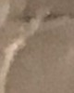

exam. No canal stenosis. Asymmetrical neural foraminal encroachment on the right due to disc-osteophyte approximating the right L5 nerve root, but unchanged from the previous exam.

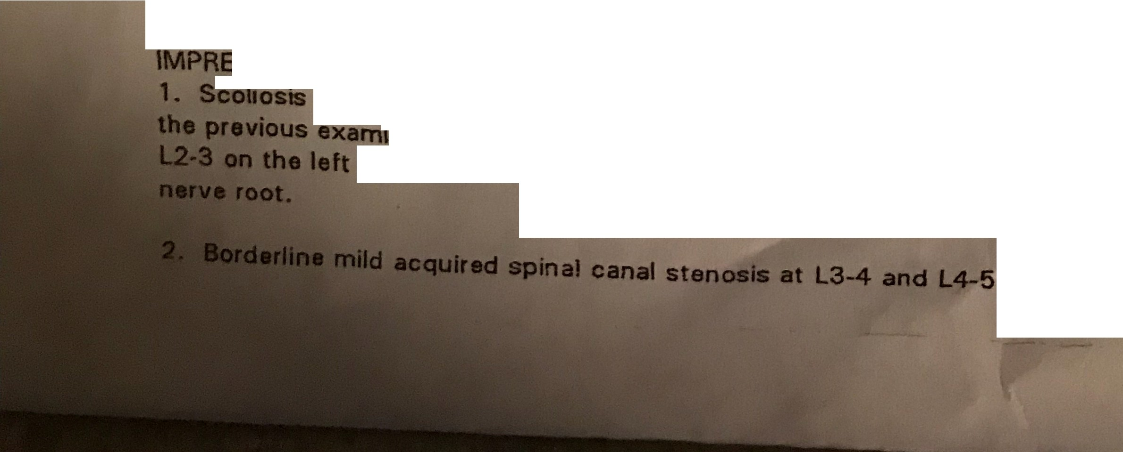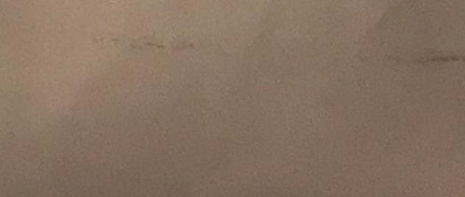

'.$SION:

with **severe** multilevel **de wative** disc **disease.** C ed with

·nation, **there** is now **severe** neural foramina, **eno,oaohment et**

due to f et •rthropathy potentially affecting the left L2

..