Suicides

Associated with non- consented Opioid Pain Medication Reductions

2015-2017

9-27-17

1.

**Phillip Kuykendall** from Statesville, **North Carolina** wasa 63 yr old man, an active member of society and hobbyist whose doctor refused to prescribe medication for his pain disease. After a stay in hospital near Statesville where he went to have his pain disease assessed, he was discharged with no pain medicine. His brother, who was involved with helping him obtain pain control, went to Phillip’s home on December 29, 2016 and found Phillip dead with a self-inflicted gunshot wound in his head. “He took the last, and only, relief he thought he had left” said a person familiar with the situation.

Link to obituary: <http://www.nicholsonfunerals.com/notices/PhillipPhilP-Kuykendall>

2.

**Allison Kimberly,** age 30,of **Colorado** was denied treatment for her intractable pain from interstitial cystitis, and several other painful conditions. Interstitial cystitis can end in suicide from the failure to treat it properly as it is an extreme form of agonizing discomfort. It is said the University of Colorado emergency room in Aurora refused her treatment for her pain.

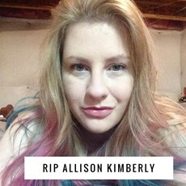

She posted on Instagram describing how she was treated as an addict and sent away without pain medicine. *“I was rushed to the ER because my pain was so out of control I couldn’t take it anymore, I got ZERO help. After 7 hours I was discharged. The nurse has the nerve to say that my kind of pain shouldn’t be that bad and basically I was faking for medication. I am so beside myself I am shaking as I type this. Screaming and begging in pain, needing any kind of help they’d give me and I was just sent home. As soon as I am able I’m reporting my whole experience”* Allison did not have time to file a complaint against the hospital as she violently ended her life while her mother walked her dog, the animal companion that had made her anguish less lonely. No doctors appear to have been charged. The Colorado Hospital Association was in the process of piloting a no-opioid policy for the state. She died in June, 2017.

Link to obituary:

<http://www.legacy.com/obituaries/denverpost/obituary.aspx?page=lifestory&pid=185902615>

3.

**Ryan Trunzo** of **Massachusetts** committed suicide at the age of 26. He was an army veteran of Iraq. He had experienced fractures in his back for which he tried to get effective painkillers, but failed because of the VA’s policy of denying or reducing needed pain medication. His mother stated “I feel like the VA took my son’s life.” Link to obituary:

<http://www.startribune.com/obituaries/detail/18881/?fullname=trunzo,-ryan-j>

4.**Kevin Keller**, a Navy veteran from the USS Independence in the 1980’s was from **Virginia.** He took his own life at age 52. He shot himself after breaking into the house of his friend, Marty Austin, to take his gun. Austin found a letter left by Keller saying “Marty sorry I broke into your house and took your gun to end the pain!” Keller had experienced a stroke 11 years earlier, and he had worsening pain in the last two years of his life because VA doctors would not give him pain medicine. On the subject of pain medication, Austin said that Keller “was not addicted. He needed it.” The suicide occurred one year after the VA announced the “Opioid Safety Initiative” to stop pain medicines for US veterans, like Kevin Keller. The VA would not comment.

Link to story:<http://www.roanoke.com/news/virginia/veteran-s-suicide-draws-attention-to-veterans-affairs-use-of/article_a07a3527-0f33-5cca-9cb5-a5d198b8f193.html>

5.

**Mercedes McGuire** of **Indiana** ended her life August 4th, 2017 after struggling with agony originally suppressed with opioid pain medicine but reappearing after her pain medicine was cut back in a fashion after the CDC regulations. She was in such discomfort she went to the ER because she could not stand the intractable pain by “learning to live with it” as suggested by CDC consultants. The ER gave her a small prescription. She went to the pharmacy where they refused to fill it “because she had a pain contract”. She went home and killed herself. She was a young mother with a 4 year old son, Bentley.

Link to obituary:

<http://www.tributes.com/obituary/show/Mercedes-Kirsten-McGuire-105071405>

6.

**Bob Mason**, age 67 of **Helena, Montana** was denied pain medcine to treat his chronic pain after losing access to his pain control doctor and finding no one else, took his own life in January of 2016. He tried to “deal with his pain” as is recommended by the new pain minimizer CDC consultants. He tried for 7 days to deal with it.

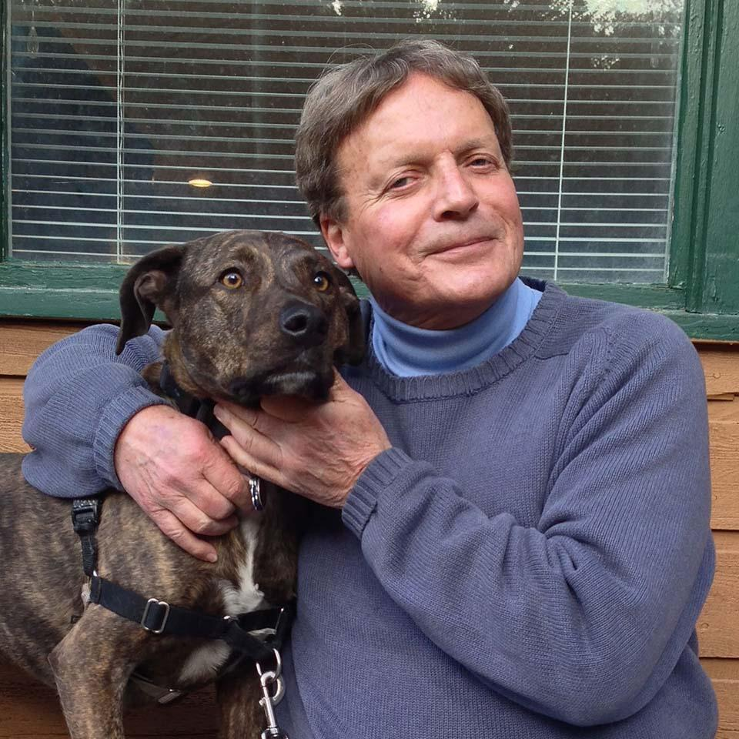

According to Mason’s daughter, Mieska, the last couple weeks up before Bob passed away, there were a lot of tears everyday on the phone," she said, "between the pain and really just the sadness of not being able to walk his dog, but, I’m sure it was more than that. There would be tears, then he would joke," she said, "then he’d call back an hour later and be teary and in pain again. He didn’t like the drugs, but there were no other options.” His suicide became the other option.

7.

**Zach Williams** of **Minnesota** died by his own hand at age 35. He was an army veteran of Iraq and had experienced back pain and a brain injury in battle. He had successfully treated his pain with opiate pain medicine until the VA began reducing prescriptions under the new VA law, December 2015, based on CDC recommendations of reducing or stopping pain medicine to avoid addiction.

Link to the obituary:

<http://www.whitefuneralhomes.com/fh/obituaries/obituary.cfm?o_id=2254657>

8.

**Jessica** was a “pain warrior”, loved by a group of people with similar issues dealing with intractable pain after forcibly reducing her pain medicines as suggested by the contagious disease specialists at CDC encouraging doctors to reduce “opioids” for fear people might addict or die from an overdose. Jessica had particularly painful central pain syndrome that is untreatable except for pain suppression. She would never have addicted as she was already on pain medicine. She ended her life after inadequate treatment by physicians (other details withheld).

9.

A Cleveland, **Ohio** resident (**name withheld**), mother of a teenage daughter, and wife was denied her long term pain medicine reportedly by doctors at the Cleveland Clinic. She had a spinal electrical stimulator implanted, at great cost and discomfort in order to satisfy CDC’s dictum of “alternative” treatment first even if more expensive, painful and less effective. It did little to help. What worked was long term opiate medicine which was successful in the past without side effects or addiction. Her medicine was reduced for no other reason other than honoring CDC “voluntary” directives. She waited for her husband to be out of town and her daughter to with a friend, then took her life to stop the intractable pain in August of 2016.

10.

**Donald Alan Beyer**, living in **Idaho,** had experienced back pain for years. He suffered from a job-related injury resulting in a broken back. After his doctor retired, Beyer struggled without pain medicine for months. He tried his best using other methods, nothing worked except the opiate pain medicine he had been taking long term. . He shot himself on his 47th birthday. His son said he before his death he could not get out of bed to make it to the bathroom. He was a logger and the painkillers allowed him to function. Physicians refused treat him. He had two small grandsons. No doctors were charged as complicit.

Link to obituary:

<http://www.tributes.com/obituary/show/Donald-Alan-Beyer-103570558>

11.

**Denny Peck** of **Washington State** was 58 when he ended his life. In 1990, he experienced a severe injury to his vertebrae during a boating accident. His mother, Lorraine Peck, said “he had been in severe pain ever since,” and his daughter, Amanda Peck, said she didn’t remember a time when her dad didn’t hurt. During the last few years of his life, Peck had received opiates for his pain from a Seattle Pain Center, until these clinics closed after DEA raids. Seattle, the University of Washington Pain Doctors, the State nor the Federal Government and the DEa made made provision for the continuation of care for the estimated 12,000 patients. After suffering and unable to find doctors who would help with his pain, Peck called 911. Becoming a pariah, like many other former patients of any DEA closed clinic, Denny could find no one to continue the previously successful pain treatment. Two days after asking for help at the ER and not getting any, Peck was found dead in his home from a handgun. A note found near Peck read: “Can’t sleep, can’t eat, can’t do anything. And all the whitecoats don’t care at all.”

Link to news story:

<https://www.seattletimes.com/seattle-news/health/the-whitecoats-dont-care-one-mans-desperation-and-death-when-pain-clinics-close/>

12.

**Doug Hale** of **Vermont** killed himself at the age of 53. He had experienced pain from interstitial cystitis, and decided to end his life six weeks after his doctor suddenly cut off his opiate painkillers. He left a note reading “Can’t take the chronic pain anymore” before he shot himself. His doctor said he was no longer willing to risk his license by writing him another “script for Opioids”.

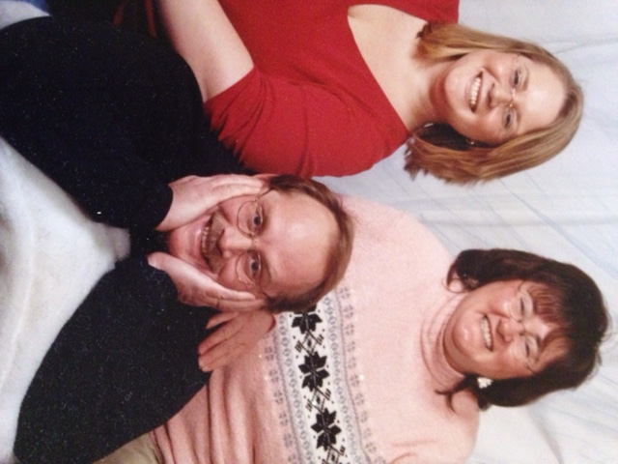

Mrs. Hale can be contacted and is going public with her husband's suicide as a direct result of forcibly without consent, refusing effective pain treatment. His widow feels long term pain patients like Doug are examples of horrible decisions people have to make weighing the options of not being able to function or “resting in peace” all for the fear pain medicines will cause addiction. Doug was not addicted so it made no sense to stop his life giving pain disease medicine, according to Ms. Hale. Doug left his daughter Nicole, 5 younger siblings and their children plus an ‘honorary’ 4 year old grandchild who is still looking for “Grampy”. Doug waited until his family was away so they would not have to watch and relieved his untreated pain with a handgun on 10-10-16.

Link to obituary:

<http://www.tributes.com/obituary/show/Douglas-Ray-Hale-104041270>

Link to news story:

<http://www.slate.com/articles/health_and_science/medical_examiner/2017/08/cutting_down_on_opioids_has_made_life_miserable_for_chronic_pain_patients.html>

13.

**Bruce Graham** committed suicide after living with severe pain for two years. At age 62, the **Californian** fell from a ladder, suffering several severe injuries, had surgery and fell into a coma. After surgery, he suffered from painful adhesions which could not be removed. He had his pain under control on opioid painkillers, allowing him to live normally with the inoperable pain condition. His doctors stopped prescribing the medicine he needed over concerns it might have something to do addicts. Two years after his fall, Graham shot himself to end the pain. The pain ceased.

14.

**Travis Patterson**, a **Texan**, a decorated Staff Sergeant in the Army, combat veteran of Iraq and Afghanistan, was injured by a road side mine, and discharged from the army in 2016. He was in daily severe pain. He could not get pain treatment, and tried to commit suicide and was admitted to a Topeka Kansas VA hospital by his 26 year old wife. The VA refused to treat his war wounds with pain medicine and offered instead a stress ball. Two days later he made sure of his own method for treating his intractable pain by killing himself. He had a future with his wife and studying law but it did not matter. He showed no signs of mental illness, just the stress of failure to treat his underlying war injuries with long term daily pain. One other veteran remarked the US Government was finding other ways to “kill us”

*Additional information: Travis was denied pain medication for this combat wounds by the VA by law passed without knowledge of most 12-15, deep in a 2000 page budget bill. It is now federal law to forcibly taper wounded veterans with intractable pain to “prevent addiction and heroin overdoses” Traviswas a* ***Texas*** *native).*

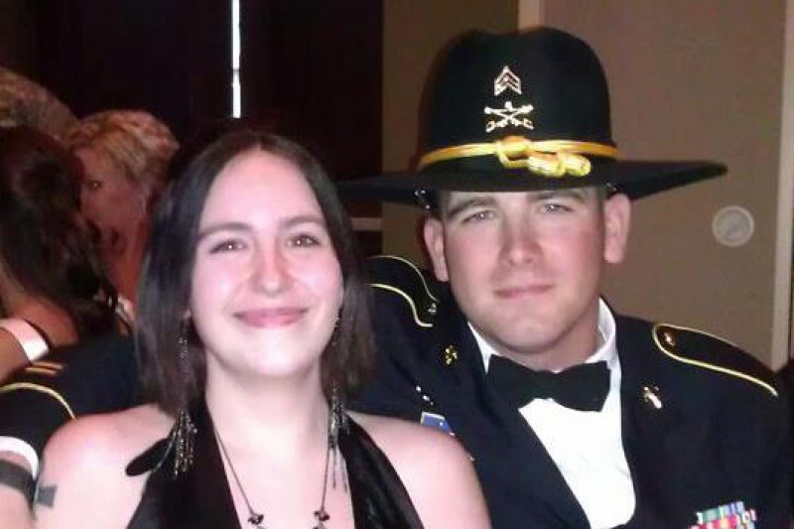

Travis Paterson and his widow

Link to news story:

<http://cjonline.com/news/local/2017-02-20/wife-veteran-says-topeka-va-didn-t-do-enough-help-suicidal-husband>

15.

54-year-old **Bryan Spece** of **Montana** killed himself two weeks after he experienced a major reduction in his pain medication. The CDC recommends a slow reduction in pain medicine, such as a 10% decrease per week, but it was not followed. There was no medical reason to stop the medicine as it was working well. Based on information from his relative, his dose was quickly and severely reduced without his permission, “forcibly if necessary” as one CDC team member later recommended. He died over a concern of addiction which had not happened. His relative felt he should have not been reduced at all as no medical reason was given by the doctor.

Link to news article:

<https://www.painnewsnetwork.org/stories/2017/5/26/patient-suicide-blamed-on-montana-pain-clinic>

16.

In Waldport, a small town in coastal **Oregon**,SonjaMaeJonsson, 42, previously vigorous camper and hiker in the Oregon mountains sustained a traumatic brain injury in 2006 leaving her with pain she describe as an “axe in the back of my head”, She was controlled with pain medication. She was cut off from her pain medicines according to CDC negative portrayal of opioid pain medicine. After her pain medicine was stopped without her permission she had a return of around the clock intractable pain levels previously lessened with opiates. Her now untreated pain was so severe that “even though I don’t want to end my life”, she did  —  recently.

Link to news story:

<http://www.bendbulletin.com/localstate/5356986-151/police-consider-charging-mother-in-bend-suicide>

17-18.

United States veterans have been committing suicide after being unable to receive medicine for pain. These veterans include **Peter Kaisen and** **Daniel Somers** according to a reliable ex-naval medical officer. Their cases are being investigated but their records are on file with DoD/VA

19.

**Sherri Little** was 53 when she committed suicide. She was a **Californian** andrequested her story be told. She related how she had lost her adult friendships, as many do, with her daily painful diseases and in her case: occipital neuralgia, and Fibromyalgia. A friend described Little as having a “shining soul of activism” as she spent time advocating for other chronic pain sufferers. However, Little had other struggles in her life, such as her feeling that her pain kept her from forming meaningful relationships. In her final days, Little she tried to get medical help from a hospital. When she was unable to receive pain medicine Little ended her life in July of 2016.



Sherri Little (left)

Link to news story:

<https://www.painnewsnetwork.org/stories/2016/7/4/pain-warrior-the-life-death-of-sherri-little>

20.

Former NASCAR driver **Dick Trickle** of **North Carolina** shot himself at age 71. He suffered from long-term pain. Although he went through several medical tests to determine the cause of his pain, the results could not provide relief. After Trickle’s suicide, his brother stated that Dick “must have just decided the pain was too high, because he would have never done it for any other reason.”



Link to news story:

<http://www.espn.com/racing/nascar/cup/story/_/id/9286940/dick-trickle-suicide-was-caused-severe-chest-pain-brother-says>

21.

In August 2017, a couple planned a mutual suicide by carbon monoxide poisoning after being cut off from both their pain medicines in Flagler County. **Florida. Katherine Goddard** died after being found by her daughter. Her boyfriend, **Bruce Haughton** was found in the same car with his now deceased girlfriend. Haughton was barely alive. He was arrested for assisting in a suicide, and held without bond. The Flagler County Sheriff said assisting in a suicide was illegal. Doctors whom refused treatment both people apparently have not been charged or sanctioned.

Link to news story:

<http://nypost.com/2017/08/17/man-busted-in-girlfriends-death-after-surviving-alleged-suicide-pact/>

22.

A **40 year old woman** E.C. from Visalia, **California** had lupus and painful joints to the point of “barely being able to stand”. She could only go to urgent care centers since she had no health coverage. They only would provide the lowest dose pain medicine. She pulled away from her friends after suffering on inadequate doses of pain medicine. She had talked about “quitting her life” as a solution. She knew she would never have a husband since the pain immobilized her all day. She had no children and lived with her parents who did not believe in her intractable pain. Without pain relief she was trapped. Finally one day, alone, “She left. She just left,” in the words of her friend.

23.

A **58 year old navy veteran**, **Jay Lawrence** of **Tennessee** had chronic pain following an accident, a common cause of intractable pain. He had surgeries, he tried epidural steroids, nerve blocks, and a spinal cord stimulator as “alternative treatments” to avoid pain medicine, a plan recommended by the contagious disease specialists at CDC. These all failed leaving the opioid pain medicine as the next step which was done. But the Comprehensive Pain Management Clinic decided to reduce the dosage without medical reason apparently afraid of the DEA’s raids and CDC rules. His pain became nearly continuous with the low doses. When asked to restore the previous level of medicine his doctor at the Clinic said “my license is not worth my patient’s quality of life”.

Jay was disabled to the degree that he was award SS disability status, but this made no difference in his pain treatment. His wife wrote his story on Pain News Network, describing Jay’s pain: “A bad day was awful for me to watch, and absolutely horrible for Jay to live.” In the end, as his wife, she assisted in the plan to end the pain once and for all. After his death his wife was charged under the state assisted suicide law. Meredith Lawrence is currently on probation for a reduced charge of reckless endangerment. Neither the Clinic nor the doctor has been charged. Meridith after much soul seraching has decided to go public with how the government bullied Jay’s doctor into doing something unethical.

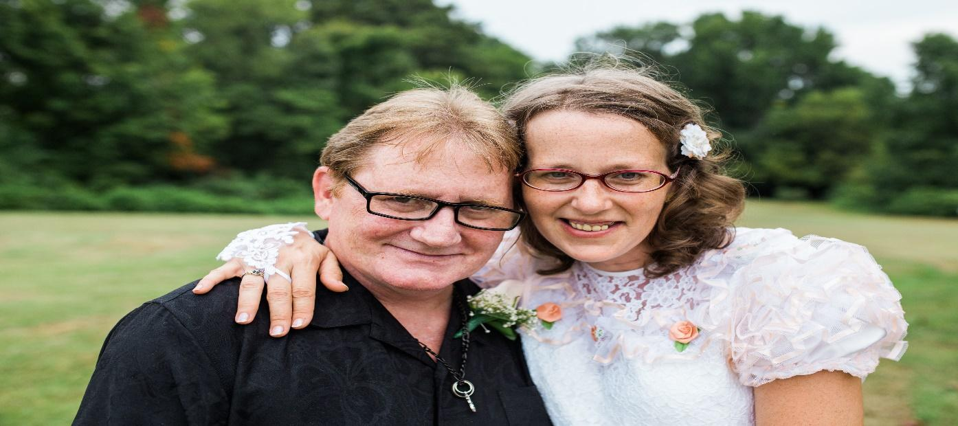

Link to news story:

<https://www.painnewsnetwork.org/stories/2017/9/4/how-chronic-pain-killed-my-husband>

Link to obituary:

<http://obits.nj.com/obituaries/southjerseytimes/obituary.aspx?page=lifestory&pid=184655727>

*Editor’s Note: in reviewing the suicides listed above, many of the circumstances revealed planned deaths, talking with others and families beforehand. These people would have not otherwise been prone to suicide. People counseling chronic pain disease patients to cope with pain and suffering resulting from refusing care as recommended by the U.S. government intervention backed up by the Federal Drug Police, are seeing daily reports of serious thoughts about suicide, how to do it, how to plan for it. People with serious medical pain not treated due to irrational fears of addiction and overdose deaths will continue to seek out this final option. Many suicides go unrecorded due to the shame of “drugs” and the shame of suicide itself. It is hard to tell people with constant pain to “shift their focus from pain and move on with their lives” as suggested by CDC consultants and members of the “Physicians for Responsible Opioid Prescribing” a group espousing blanket restriction of all pain medicines for all reasons, a view not widely accepted by practicing physicians, nor in other countries, nor accepted by the World Health Organization policies on relief of suffering. --T.F. Kline MD, ed.*

Thomas F. Kline M.D.,Ph.D

Raleigh, NC

[thomas@klinemd.net](mailto:thomas@klinemd.net)

Primary Research and Collating :

Maxx Lamb

Additional Research and editing by:

Erin O. Leblanc

Sara E. Mirek

This is not copyrighted and is available to copy and use as needed.

9/27/17