Opioid **Prescriptions at 10 Year Low Overdose Deaths at 10 Year High**

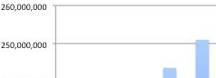    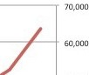

·0a

·c

0

*.8*

240,0,00000 5, 0 000

£

•

*8*

i

230,00, 0 000 4, 0 0 00

,•3

, E 220 ,00,0

z

000 3, 0

000

***11*** - Oploki Prescriptions

, E - o\•erdoseDeaths

"

**0 z**

... 210, 00,0 000 2, 0 000

200,0,00000

190,00, 0 000

2006 2001 2ooa 2 2010 2011 2012 2013 2014 201s 2016

Year

1, 0 0 00

()

.,A.........T_....

.I.P

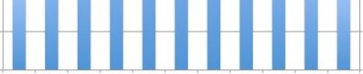

Presctpl tion Oat-a Source: https://[www.](http://www/) dc..go v/d rugove,dose/maps/rxrate-maps.html

Overdose DataSource: htt ps:// [www.](http://www/) dc. go v/ nchs/ da ta/ da tabtlefs/ d b294_table.pdf

_._....

.,.,,...,..,.,._