**Opioid Prescriptions at 10 Year Low**

**Overdose Deaths at 10 Year High**

250 00 ,0 00

# ·B

·-a.

140 00 , 00 50000

,**Y**s**I**

**ro**

c.::

.**a**..**.**..**.**

0...

23 0 . 00 , 0 0

0 40000 J

**Q,I**

|  |  |
| --- | --- |
|  |  |
|  |  |

# .8

0...

E 220 00 ,ODO 30000

**z**::1

*1'* Op:01d Prescrlpnaru

- §

i **z**

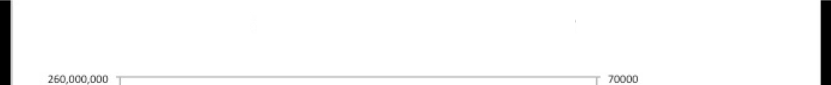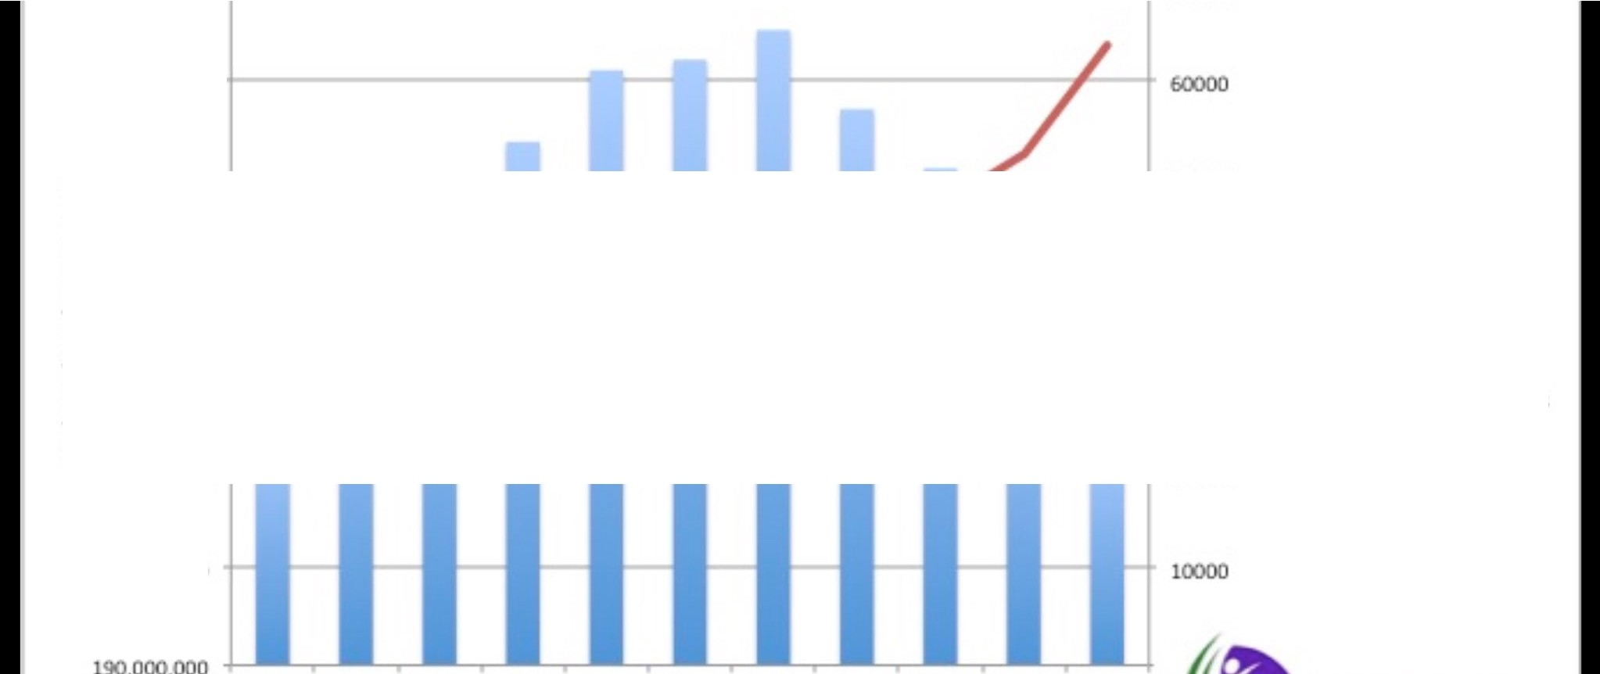

'J.10 , 000 , 0 0 0 20000

200 ,000,0 00

2006 2 01 *1008* 2009 2010 2011 2011 20_3 10 lOlS 2016

**Year**

Prese:rtp on Oat.a Sour ce: htt ps!/ / [www.](http://www/) cdc..go'tl/ d ovetdose/maps/ ncrat e-maps.html O\lerdose Data Sou r ce: htt ps1/ / wlNw.cdc...go 'tJ/ nc h s/ data / databrlef s/ db294_tab1e.pdf

o, rdos.e Deat t1s