'I­Q

t>

C.

400,000

300,000

Prevent able causes of death

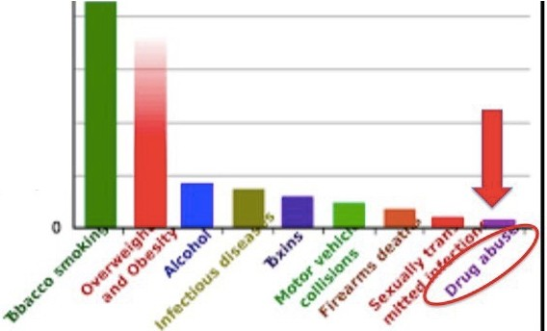*:£* 200 ,0 00

"'

*8* 100 000