Dear CMS,

As an intractable pain patient for the last decade, now on disability, struck down in the prime of my life and at the peak of my career, and as a patient advocate for those who suffer with severe, intractable pain from multiple different horrific diseases; I can tell you firsthand from my own personal abusive experience at the hands of both spine treatment physicians and interventional pain specialists, and that of thousands in the support groups of which I am a member, after these last several years of increasingly strict regulations, and shameful stigma and blame unjustly placed on the innocent of both legitimate pain patients and those who are courageous and compassionate enough to treat them, that placing even more regulations and reducing even more options for physicians to treat pain patient's tremendous suffering, are not only not the right answers, have obviously not been working over the last several years as the data has proven in loss of life and increased addiction rates, but **will most certainly lead to even more patient harm and for certain more death**. It goes against the very essence of the Supreme Court Justices ruling that no federal government agency should be making decisions or policy that will circumvent and/or contradict the treatment decisions of what a physician believes is in the best interest of his or her patient. And yet, that is exactly what you are in fact doing by mandating the amounts and dosages of prescription opioid medications for pain patients regardless of disease, condition, and/or genetic evidence to the contrary that may indicate it is in that patient’s individual best interests to treat them in accordance to proven scientific methods, research and experience learned over these many decades.

We have **serious, out of balance governmental policies that are harming** innocent lives when that is the exact opposite of sound, quality medicine not to mention in direct conflict with compassionate, humanitarian, medical care. **Do no harm**. It is like we’ve become a nation **completely out of control with overzealous regulations and condemnation**, driven by a “created” panic, with shaming, stigma and blame, based on a falsehood perpetuated by the manipulation and misclassification of data to further an anti-**prescription** opioid

agenda. Not an anti-**opioid** agenda. An anti-**prescription** opioid agenda. There is a definite distinction. You can tell the difference in the mass media hype of specific individuals spear-heading the message and the government resources. Purposely driven to try and prove unequivocally that the “amount of prescriptions written” in our country equates to the rise in the overdose death rate when the data does not reflect this to be the truth, hence the manipulation of the data by both the CDC and the DEA, among others, to make it appear otherwise.

And let's not forget, that this “crisis” and massive rise in death rates did not exist BEFORE regulations began to put a chokehold on our country. Some were needed yes, but now the pendulum has swung much, much too far to the detriment of both the addiction and the pain communities.

In the manipulation of the data, we witnessed just between 2015 to 2017, the DEA made it “appear” in their National Drug Threat Assessment (NDTA) as though the overdose death toll from increased each year simply by changing the heading name and criteria,” from **“Opioid Analgesics” in 2015 to “Prescription Medications” in 2016 to finally just “Medications” for 2017.** I wonder what 2018’s new category heading will be and what all will be included? *“This is not the first time the DEA has lumped opioid pain relievers with other drugs. In the 2016 NDTA, the DEA combined opioids with anti-anxiety drugs, but not stimulants or steroids. A year earlier, in the 2015 NDTA, prescription opioids were in a category all to themselves… “The effect of these changing and broadening definitions is significant.* ***Every year the overdose crisis appears to be getting worse and worse.*** *It certainly is for deaths linked to illicit drugs like heroin, cocaine and fentanyl, but not necessarily for prescription drugs and* ***definitely not for opioid pain medication.*** *One has to wonder* ***why these definitions keep changing*** *and* ***distorting the true nature of the overdose crisis****…” [Bold added for emphasis]*

*“This isn’t the first time the federal government has played around with the overdose numbers.* ***As PNN***

***reported****, last December the CDC and the White House Office of National Drug Control Policy released three*

*different estimates of how many Americans died in 2015 from overdoses linked to prescription opioids.* ***Within one week****, the overdose numbers evolved from 17,536 deaths, down to 12,700, and then back up to 15,281 deaths. To use a football metaphor, that is known as moving the goalposts.”* Pain News Network, *How The DEA*

*Change The Overdose Numbers*, by Pat Anson, Editor, October 25, 2017

Yes, there should definitely be shame involved and prosecution of those guilty of falsifying data to further an agenda costing tens of thousands of lives! Shame and blame. But not on the part of the innocent doctors who are compassionate enough to treat their patient’s legitimate chronic and/or intractable pain with the same guilty, overreaching DEA who then tries to ***prosecute innocent physicians*** many times ruining their reputations,

careers and practices in their own defense. But instead by those who are willing to perpetuate lies in order to fool our legislators, mass media and our entire country into believing that the overdose death rates have continued to increase as a result of prescription opioids. And now those among this same group, are trying to remove another option for chronically ill people who suffer from the worst pain diseases imaginable because they cannot comprehend the legitimate use and pharmacogenetic needs for this level of medication. These are not experts in the treatment of horrific, intractable pain. These are addiction advocates who see all pain patients as addicts.

They have no business demanding the removal of critically vital pain medications for those who suffer horrific intractable pain every day of their lives who suffer with genetic, metabolic defects and serve a much needed purpose for many in the complex world of pain disease. How will your regulations address this entire population group?

You need to PAUSE and take a step back. Take a good, hard look at the massive increase in the tens of thousands of lives that have already been lost over just the last two+ years utilizing the current, strict CDC Guideline for Opioid Prescribing that is not based on any sound, credible science, along with increased state

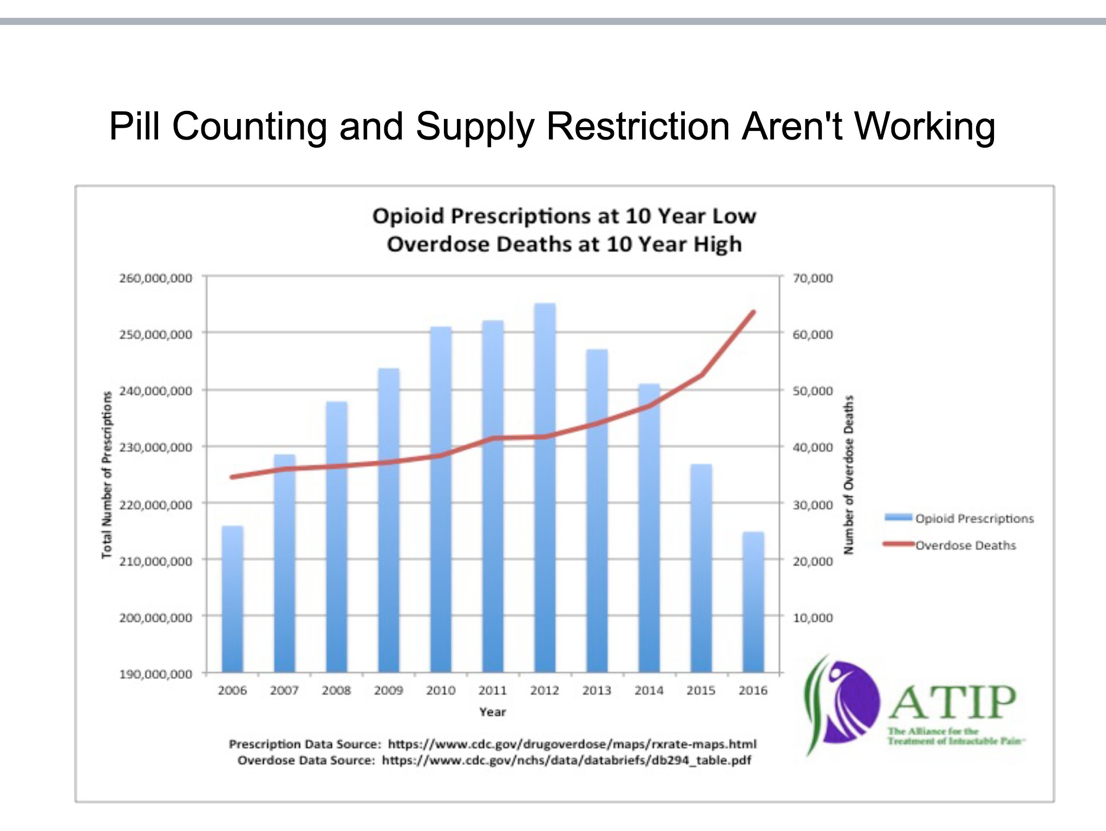regulations that followed suit, and then ask yourselves before moving forward with more of the same and/or similar types of restrictions that have already **failed** - who **else** can we speak to and what **evidence** have we not yet given serious consideration to that might prove **far more successful** in the treatment of chronic pain, the treatment of **intractable** pain which surpasses chronic pain and in many cases even cancer pain, **utilizing opioids as safely as possible yes, of course, while also helping to treat and prevent addiction?** Because it is clear to anyone taking a good hard look at the data, that **current regulations are costing more lives than they are saving while increasing the addiction, suicide and overdose death rates**. It is also clear that some of the experts utilized thus far, from the same group now calling for the removal of all high-dose opioids, have clearly already gotten it seriously wrong, **have no problem manipulating the data** to serve their purposes, have no regard for intractable pain disease or those who suffer from it, and most importantly, **have already harmed a great deal of people as a direct result of their actions.** In fact, opioid prescriptions are at a 10 year LOW,

while the overdose death rate is at a 10 year all-time HIGH. Let me repeat that. Prescriptions = LOW, Deaths = HIGH.

No one can dispute the fact that in the rush to try to reduce overdose deaths, by addressing addiction with the reduction and/or elimination in the prescribing of opioids, millions of pain patients have been kicked to the curb by physicians who have stopped treating pain with prescription opioids, leaving many patients with no other viable solutions to treat their pain, **causing massive suffering, higher rates of addiction and death on a national scale** that this country has never seen before in its history.

As a consequence of these hasty actions and regulations, before viable solutions were ready for pain patients, and due to the tragic miscalculations on the part of state and federal government agencies, **the suicide and overdose death rates have soared while prescriptions for opioids have plummeted**.

If the data were to be carefully scrutinized, one would have been able to deduce as early as 2010 tracking through 2015, disproving quite clearly the theory that, the ratio of more opioid prescriptions written does not equate to more overdose deaths as a result, in multiple states. According to a recent study completed by the British Medical Journal (BMJ) and released in January 2018, the study followed over 568,000 post-surgical patients for an average of 2.6 years between 2008 and 2016. Incidence of diagnoses for opioid abuse disorder or overdose was **0.6 percent.** The number of post-surgical patients who renewed opioid prescriptions for as long as 13 weeks was **less than 1 percent.**

But when state and federal government agencies are only listening to those experts and groups with a severely, biased “anti-**prescription** opioid agenda” who are willing to spread multiple false facts not only to the media but also to our legislators, I suppose we can deduce how we ended up with the tragedy we have today. With tens of thousands of unnecessary lost lives due to both overdoses and increasing suicides from being forced to live with the torturous, unending intractable pain after being dropped by doctors no longer willing or unable to treat

chronic and/or intractable pain, patients were either forced to taper down or were completely withdrawn off stable doses of opioid pain medication from physicians in fear of losing medical licenses and/or hospital privileges, some believing the false rhetoric.

Claiming that opioid "dependence" is the same as a disorder and then taking it one step further and saying that all those who suffer with opioid use disorder are "addicts" shows a complete ignorance and total disregard for the truth from one of the government's top "expert consultants” who has done repeated interviews and was utilized to craft the current harmful CDC Guideline. This mentality is exactly why our government agencies are focusing their time, energy and resources on the WRONG opioid crisis that is literally killing tens of thousands NOT from legitimate prescription opioids for pain patients, but from heroin and illicit fentanyl as well as other illicit substances, like cocaine, methamphetamines and fake pills laced with illicit substances that are deadly and being smuggled in illegally through the mail and across our borders .

**“If we continue to misunderstand the problem, we'll continue to pursue**

**harmful and ineffective solutions that so far have only increased the death rate.”** *Maia Szalavitz, is a reporter and NY Times Best Selling Author, “Unbroken Brain: A Revolutionary New Way of Understanding Addiction”*

Certain groups may be well-funded and well connected politically in order to bend the ear of our politicians and government agencies. However, at some point one has to take a look at the utter devastation being so one-sided and addressing the wrong opioid crisis has wrought on this country by not offering solid solutions to replace effective pain medication for millions suffering from excruciating, intractable pain and take a good, hard look at the public outcry going on all around them.

One day, the CDC, DEA and DOJ along with state and federal regulators, and legislators will be the ones held to account for either joining in with these one-sided groups and not doing their due diligence of looking under the

surface layer of misclassified data to see the true facts there for all to find which have continuously been offered and submitted to you from qualified experts. This level of death & disability cannot be sustained and will not go unpunished. Will CMS join in or stand out amongst the crowd as revealing the truth and going after the real opioid crisis? Protecting its citizens and its disabled or causing them further harm by denying their physicians the discretion to treat them according to their individual medical needs? Especially in the case of extremely complex geriatric medicine where cardiovascular, pulmonary, and endocrine needs already play a major factor with chronic and intractable pain needs, function, and independence of a large population of those who rely on CMS. There are now over 111 Million people over the age of 50 in the United States according to US Census. Each of you will be help to account for the decisions you make today.

Yes, you can continue taking away even more of the vital choices of our physicians all across our country just as critical pain medicine has been forcefully removed from legitimate chronic and intractable pain patients.

However, that will not make a difference in the true opioid crisis before us today. Once again, it will end up harming more of those who have been continually badgered, abused, harmed and literally left to perish by a government who has turned a deaf ear but did and still has sworn to serve, protect and defend - not just a few select groups of politically connected Americans, not just the addicts, not just the multiple millions of pain patients, not just those enrolled in Medicare and Medicaid, but ALL. And it is for ALL that you should be listening to the experts on both sides of this crisis. It is for ALL Americans that **you are responsible to uncovering the truth**, not just the mischaracterization of it, researching all the data not just that which has been manipulated and misclassified, to fit a biased, and harmful agenda that will not stop the overdose death rate from climbing or the increasing suicide rates. This is not an empty statement, this has been reality for the last two+ years, when the CDC Guideline was implemented by the Veterans Administration before the CDC launched the Guideline in

March 2016. You have real numbers to track the soaring death rate. Not the manipulated numbers and data provided to you by the CDC, DEA and former White House Office of National Drug Control Policy.

On a humanitarian level, the **documented evidence shows a callous disregard for the plight of millions** of pain patients who suffer unimaginable agony, as if they were nothing more than collateral damage in the crosshairs of the “anti-prescription opioid campaign” by these government agencies. **Please break from this pattern. We are more than collateral damage. We are multiple millions.**

Before you take any more steps that will harm millions more CMS pain patients, please step back and evaluate what regulations, if any, you and/or other agencies have implemented to date that are working? **Which are harming and why?** After all, this was what was promised would be done by the CDC, and never was. It was also repeated to we, the pain patients, multiple times that it was “**not their intention to take away our physician’s discretion or ability to treat our pain at any dosage should it be medically necessary”**. And yet, regardless of the fact that it was not a rule, regulation or a law, that is exactly how it has been implemented into nearly every state’s regulations, the VA and most likely followed by major insurance carriers because of profit motives one can only assume, as the **death rates have only increased and addiction tallies are higher than ever.** What other possible motives could there be to continue forward with failed methods?

Except death has an enormous price as well. And even with profit motives we should be able to do so much better and find a way to meet in the middle. The other side is asking too much and the consequences are much too high. Now, even the children and babies are suffering with hundreds of thousands in the foster care system bursting at the seams in never before seen record numbers. **“The crisis is so severe —** with a 32 percent spike in drug-related cases from 2012 to 2016 — it **reversed a trend** that had the foster care system shrinking in size over the preceding decade. All told, about 274,000 children entered foster care in the U.S. **last year.** A total of

437,000 children were in the system as of Sept. 30, 20161.” We have an entire generation with a large

percentage of parentless babies being born to addicted and/or overdosed mothers if this continues unabated. Surely, people with your levels of education are able to see what's happening and are not heartless to the plight of our own country’s most vulnerable? These current methods of strict regulation and untreated pain are not working. **Much can be learned from the past mistakes of others** and do not need nor should they be repeated going forward.

# THIS HEMORRHAGING OF AMERICA'S MOST VULNERABLE HAS GOT TO STOP!

From our babies and our youth to our senior citizens, from our veterans to our disabled, from our foster care homes to our senior living communities, the choices you make today affect multiple millions of our citizens. They should not have to endure more needless agony and suffering where the choice for some comes down to “Can I endure living through this torture one more day or should I end it today?” Because the "solutions" available and offered to replace their legitimate opioid pain medications and dosages have not worked to date. And **until viable solutions are available that do work and have been thoroughly tested, you should not be removing even more solutions** for the worst pain imaginable from the horrific diseases that people have to endure - some 24 hours a day, seven days a week, with no end in sight because their disease. While many of these diseases and disorders are incurable and progressive, they do not kill them within a short period of time like some others. Many may endure unimaginable agony for decades if they can somehow successfully manage their pain. They deserve to the chance to live as productive, quality lives as much as is humanly possible. Some are even still able to work and enjoy their families as productive members of society thanks to pain relieving medications and multi-modal therapies.

1 <http://wane.com/2017/12/12/opioid-crisis-strains-foster-system-as-kids-pried-from-homes/>

Please don't take away their only resource in order for them to provide for themselves, and their loved ones and their ability to earn a living for their families. Not only can our entitlement programs not handle this level of disability and massive enrollment, but many more lives will also be lost to those choosing suicide and we will see even more families torn apart ending up needing other forms of government assistance and entitlement programs as a result because the breadwinner couldn't sustain his/her wage-earning employment.

You've already seen what two+ years of failed regulations have wrought listening to biased so-called experts who have spewed forth skewed, mischaracterizations of the truth with misclassification of the data. It's time to try listening to experts who are utilizing quality, sound medical evidence with decades of expertise in successfully treating chronic and intractable pain. Who are not driven by underlying profit motives. Whose only goals are to treat both pain and addiction with real solutions that have proven tract records of success, thereby reducing the death rates caused by pain, overdose and suicide.

A very wise physician, educator and clinical pharmacist, Dr. Jeffrey Fudin, stood in Washington DC across from the White House at a rally in support of pain patients on October 22, 2016, and spoke these powerful words during a speech that he gave, “Two hundred and forty-one (241) years ago and 100 miles southwest of here,

# Patrick Henry said, “Give Me Liberty or Give Me Death”. Many victims gathered here today are contemplating death, others that have not made it here have chosen death, and all because they have

**been stripped of their liberty.**” [Emphasis of specific wording added]

This is the reality of those who cannot endure the excruciating, unending torture of living with disease and injury that causes this magnitude of intractable pain which many times equals and in some instances even surpasses that of cancer pain. I would strongly encourage you to click on the link below to read the entire short, but

incredibly powerful speech that speaks truth to the continued daily plight of pain patients all across our country causing them to choose suicide over their tortured existence either living without their opioid pain medication or their severely reduced undertreated pain. This due to the actions and false propaganda spread by those who are not experts in treating severe, intractable pain disease, injury and disorders. No pain patient that I know of chooses to be on opioid medication and would prefer to be on none! They have typically failed standard care protocols repeatedly and have been subjected, predominantly against their will, to multiple invasive procedures many times exacerbating pain conditions and/or potentially causing further harm all in following “treatment plans” prior to receiving simple pain medication.

Dr. Fudin’s Speech: [**http://paindr.com/rally-against-pain-in-washington-dc-was-a-success/**](http://paindr.com/rally-against-pain-in-washington-dc-was-a-success/)

***“We can do better if we have the will.”***

*Dr. Lynn Webster, Past President, American Association of Pain Medicine*

“We need a short-term strategy and a long-term strategy. In the near term, we must increase access to eﬀective alternative therapies, which exist but are too seldom covered by insurers. Every time a regulator complains about the harm from opioids, he or she should also oﬀer to support making available eﬀective alternatives. We need guaranteed minimum insurance coverage for pain therapies. We also need better education about the risks and benefits of **all treatment options**, not just opioids. In the long term, we need Congress to create incentives for industry to **develop safer and more eﬀective therapies**… I agree with the Institute of Medicine that **we need a cultural transformation**.”

“**Access to appropriate and safe pain treatment should be viewed as a human right—a civil liberty.** I am working on a television documentary profiling the lives of people in pain, which, tentatively, is planned for national broadcast in fall 2015.” *Dr. Lynn Webster*

Watch ***“The Painful Truth - Documentary”*** produced by Dr. Lynn Webster here: <http://www.pbs.org/show/painful-truth/>

Find out more about this powerful documentary here: [http://thepainfultruthdocumentary.com](http://thepainfultruthdocumentary.com/)

# Suggestions for excellence and truth through research:

1. The Lawhern Files: <http://face-facts.org/lawhern/>
2. ***Do Alternatives to Opioids Really Exist?*** By Dr.’s RICHARD A. LAWHERN & MICHAEL E. SCHATMAN https://morningconsult.com/opinions/do-alternatives-to-opioids-really-exist/
3. ***The Myth of What’s Driving the Opioid Crisis*** by Dr. Sally Satel [https://www.politico.com/magazine/story/2018/02/21/the-myth-of-the-roots-of-the-opioid-crisis-217034](http://www.politico.com/magazine/story/2018/02/21/the-myth-of-the-roots-of-the-opioid-crisis-217034)
4. Reason Magazine April 2018 Issue: Senior Editor, Jacob Sullum ***“America’s War On Pain Pills Is Killing Addicts and Leaving Patients In Agony”*** due to hit the stands in March, 2018. (See attached PDF) One of the best, most hard-hitting articles I've read to date.
5. An excellent, thoughtful and wide-ranging interview between highly respected and fellow Hoosier, Stephen Ziegler, Ph.D., and the award-winning, investigative journalist, George Knapp. The **dialog eﬀectively demolishes the hysteria and hype that surround our public conversation on drug addiction and the treatment of pain.** It also points the way toward a major redirection of government policy in this important public health issue.

https://[www.youtube.com/watch?v=Ci_snaj4mkE&feature=youtu.be](http://www.youtube.com/watch?v=Ci_snaj4mkE&amp;feature=youtu.be)

I am urgently asking you to help us. Please join with us. Allow us to share with you the **expert physicians and excellence in research that can bring powerful ideas and high value solutions to turn this crisis around** before we lose tens of thousands more innocent lives, and pain patients continue to suﬀer in more needless agony while doctors continue to cower in fear of losing their licenses for simply providing compassionate care to their patients in legitimate need, or who are quitting their practices, retiring or simply outright refusing to treat pain patients. Those who have courageously remained treating pain with opioids where appropriate are getting persecuted continually. **This persecution of pain needs to stop.**

# Let's begin the process of healing and end this era of patient neglect, abuse and harm.

Respectfully submitted,

Denise R. Molohon, LTCP, CLTC Westfield, Indiana, USA

Intractable Pain Patient & Pain Patient Advocate Arachnoiditis Society for Awareness & Prevention, ASAP Arachnoiditis .co.uk, (UK & EU) Administrator

The Alliance for the Treatment of Intractable Pain, ATIP Families for Intractable Pain Relief, FIPR

Arachnoiditis Together We Fight (US) Arachnoiditis (Canada & US)