**0 0 0 !Ml** '9' i1 6'/. 6:34 PM

i ort2-1.xx.fbcdn.net ••

Heart failure due to 'stress cardiomyopathy': a severe manifestation of the opioid withdrawal syndrome

El:l!m!'

.1 t,1ess,w:tco Zorzt,1 .' ·' Msrc.o..Megg(Qfa(Qn.

and GIOYAAOIMsda

1Uni\lt t::tyol ·,:iP.:ilfcr.-.::,i 11:ty

2 A!i'1owi H e111t Co.nb:.rA!l"it.'ffll, Cgt?!

ni ..,. , H)'ti t.,1ofPod:w P,u:lcmt, ltd:,­

ni:111,g {IWl(:1

Maf'OO Me,J:)1¢lJirl), OM$10n OIAM&tieele l00'(<1t"l\1lntel'<S1l <8 Cfre,Vnl rsil'{H plt,11 YiaGU& no:llnl 2. 31 l()OP O'/il,, IIW;, Em81'1;

Cle:iU:OrnMOO@•Mror,

R(! Ye02tl12 Nov5; Aee(1)1 2012 0$¢ 24.

CsllltW.\llO lit"Eu1Q 11Sod,:tf<if C111diolu1r, 201



Abstract Goto'

Takotsubo c3.fdi om yop atby(( TC)isat(aosieu1Jett vt .mricular(LV) dysti.lJlCtiondue 10 ak.itlcsi., of til e LVmid-upiL-.1. 1sq ;.mcnls (' api..:ul ballooning') in the absence of l"rit i..:ulcumnmy stcnoses whid1can be complk 11cd in the acu lc ph:tSc by heart f:1ilurc, mi1.rnl n:g:u 111ion. li-fc 1hrc:tlcL1io g vc mric11la.r

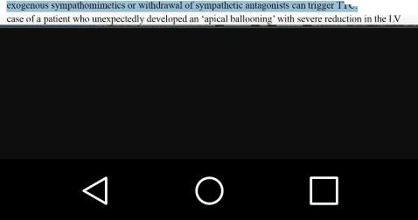

fnrhythmia....;, or a pi<:t1J LV thr(>m bosi s.. lie yntln1meis typi...:a11y p1 .:ipil1.nJi:.*by* i.nk us .:tn(llional u phyt-ical :-.lfl!i li-; howcvCf, otherc11u,...cs of sym palhctic ovcn;iimulati,m including admini-11r uono

* Wereport the