Opioid Prescrip tions at 10 Year Low Over dose Deaths at 10 Year High

260,000,000 ..-------------------------

.o.000 +-- - - - - - - - -f -..--1

*t* 240.000.000

t

! +-- - - - -1

2.I0.000.000

0

t 220.000.000 -1 1

*i*

4

•

t- l l0.000.000

- - - - -t ,a.mo•

'a

i

40 . 000

;

c5

1-- - --1- 30J)OO 15

j

zI

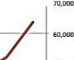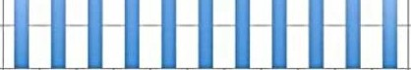

200.000.000 10.000

190,000JXJO



ATIP

.2.0.1.1 2012 20LJ l0 l 4 10!S 1016

2006 *?001* 1oc:. 2009 2010

,, . sc,1, t,onDtu Soutc.1 h'1p1:// [WWW.C.dc..JfN/dfUfovt-fdOH/](http://WWW.C.dc.JfN/dfUfovt-fdOH/) m1PJ,/N • tt,.ffl• Pf.,hl MI

Overdose So w u ; htlp s:/[/www](http://www/).<dt.p / ndu /cbta/dat.abtlfflr/dblM_tl ble.pdf