**Opioid Prescriptions at 10 Year Low Overdose Deaths at 10 Year** High

! 2 4, 0 00,0 000 **+-- - - - - - - -t**

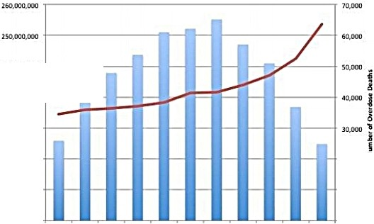

i

j230.000,000 + 1

0

**f** 220. 000.000 **+ 4**

*i*

- Oplc>ld Prescriptions

3

*;!* 21 0 , 000 , 000

200 . 000.000

z

20, 000

10,000

-0...ersoOeaths

190, 000, 000

2006 2007 2008 2009 2010 2011 2012 2013 2014 2015 2016

Yu r

P,esut ptk>n Da ta Sourct : hn.ps:// [www.cdc..gov](http://www.cdc.gov/) / dfucow , dow / maps/rxr1 tt- m1ps.html Overdose DataSource: https:// www.cdt. gov/nchs/data/databrlefs/ d b294 _tab le. pdf

ATIP