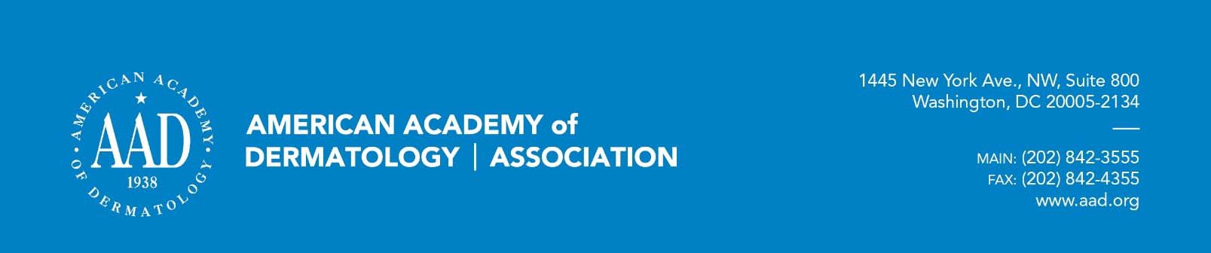

March 5, 2018

Seema Verma Administrator

Centers for Medicare and Medicaid Services Department of Health and Human Services Mail Stop 314G

200 Independence Avenue, S.W. Washington, DC 20201

Re: CMS-2017-0163: Draft CY 2019 Medicare Advantage Call Letter Dear Administrator Verma,

On behalf of the more than 13,500 U.S.-based members of the American Academy of Dermatology Association (AADA), I am writing to provide comments to the Centers for Medicare and Medicaid Services (CMS) Draft 2019 Medicare Advantage Call Letter released February 1, 2017. The AADA is committed to excellence in medical and surgical treatment of skin disease; advocating high standards in clinical practice, education, and research in dermatology and dermatopathology; and supporting and enhancing patient care to reduce the burden of disease. We appreciate the opportunity to provide comments to CMS on this proposal and hope CMS will take the AADA’s recommendations into consideration when finalizing the policies outlined within the final Call Letter for 2019.

# Section I – Parts C and D

## *Enforcement Actions for Provider Directories*

CMS continues to stress its prioritization of ensuring Medicare Advantage enrollees have access to accurate provider directories in the draft Call Letter. The AADA agrees with CMS’ assertion that inaccurate provider directories impede patient access to care and applauds CMS for taking enforcement action when it determines plans are in noncompliance with directory accuracy standards.

The AADA encourages CMS to continue transparency of its enforcement action and publish the plans that have been reviewed for directory accuracy, their compliance level, and if any enforcement action was taken.

In addition, while not specifically mentioned in the CY 2019 Call Letter, CMS has previously acknowledged that Medicare Advantage, Qualified Health Plans (QHPs) and Medicaid managed

care programs provider directory guidelines consist of varying data elements and readability requirements. The AADA re-states its support for CMS to standardize these requirements and supports CMS in its efforts to standardize the required data elements.

# Section II – Part C

## *Transparency & Timeliness with Prior Authorization Process*

The AADA commends CMS for including language on Medicare Advantage Organizations (MAOs) use of Prior Authorization (PA) in Part C. CMS requests that MAOs be transparent and provide adequate notice of any coverage restrictions, such as PA requirements, to providers and enrollees. Dermatologists and their staff often find it is difficult to determine the PA requirements and find the necessary PA form. The AADA supports CMS calling on plans to include this information in the Evidence of Coverage (EOC) and make sure the forms are easily accessible. Additionally, in the letter CMS reminds MAOs about the required timelines for plan determinations on PAs. PAs can lead to a delay in treatment of the patient and potentially disrupt the continuity of care of a patient therefore; AADA supports CMS highlighting the required timeframes for determining PAs.

PAs continue to be a method that plans use to inappropriately deny access to medically necessary procedures. These practices are not aligned with current CMS guidance. While the AADA appreciates CMS highlighting some of the PA requirements in the Call Letter, it is recommended that CMS begin to audit plans to ensure the PA practices are in compliance. The AADA calls on CMS to begin this work to help address the burden of PAs to ensure physicians get patients the affordable and effective treatments they require.

# Section III – Part D

## *Tier Composition*

We once again commend CMS’s efforts to survey the brand/generic composition of the non- preferred brand tier and non-preferred drug tier for adverse tiering and high cost sharing that may discourage enrollees from accessing these drugs. High out of pocket costs can impact significantly the ability of patients to access the treatment they need, costing patients hundreds, and in some cases, even thousands, of dollars per month for a single medication. This can place medically necessary treatments out of reach for average Americans.

## *Specialty Tiers*

The AADA supports CMS continuing to evaluate the threshold and composition of the specialty tier since it is exempt from the tiering exception process. While the AADA recognizes that the high cost of the drugs leads to them being exempt from the tiering exception process, it is recommended that there be exceptions for patient characteristics and current treatment, including if the provider believes the recommended course of action by the carrier could cause harm to the patient. In general, patients must be able to have access to alternative treatments if the first line or preferred option is not optimal or contraindicated.

# Conclusion

The AADA appreciates the opportunity to provide comments on the Draft 2019 Call Letter. We look forward to additional opportunities to comment on these issues and to provide feedback that may help guide policy development.

Please contact David Brewster, Assistant Director, Practice Advocacy, at (202) 609-6334 or [DBrewster@aad.org](mailto:DBrewster@aad.org) if you require clarification on any of the points or would like more information.

Sincerely,

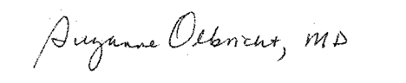

Suzanne Olbricht, MD, FAAD President

American Academy of Dermatology Association

CC:

Elaine Weiss, Executive Director & CEO, American Academy of Dermatology

Barbara Greenan, Senior Director, Advocacy and Policy, American Academy of Dermatology Association Leslie Stein Lloyd, JD, Regulatory and Payment Policy, American Academy of Dermatology Association David W. Brewster, Assistant Director, Practice Advocacy, American Academy of Dermatology Association