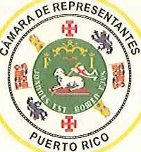Juan Oscar Morales Rodriguez Representante Distrito 3 (San Juan) Presidente de la Comisi6n de Salud

March 5, 2018

Hon. Alex Azar Secretary

The U.S. Department of Health & Human Services Hubert H. Humphrey Building

200 Independence Avenue, S.W. Washington, D.C. 20201

**Re: Request for Action to improve the funding for Medicare beneficiari es in Puerto Rico**

Dear Secretary,

As Chairmen of the Health Committees for the Puerto Rico House of Representatives and the Puerto Rico Senate, respectively, we strongly request that CMS uses the full scope of its authority to help the Medicare Advantage (MA) beneficiaries in Puerto Rico.

The Puerto Rico legislature approved the attached Concurrent Resolution 57 on December 15th, 2017 in support for improvement of funding resources in the island's MA program and joining the advocacy efforts of the Puerto Rico Healthcare Com munity. Medicare is one of the most important pillars of Puerto Rico's healthcare system, thus, the island needs adequate and equitable funding to service the healthcare needs of the more than 580,000 MA beneficiaries, among them 280,000 Dual Eligible (Medicaid & Medicare, Platinos), more than half of the dialysis patients in the island, and the majority of our elders. The funding of the MA program in Puerto Rico needs to be closer to the U.S. national average, or at least at the level of the U.S. Virgin Islands. To this effect, we fully endorse the proposals submitted by the Medicaid and Medicare Advantage Product Association (MMAPA) and the Puerto Rico Healthcare Community.

Taking swift and bold action now to stabilize Medicare in Puerto Rico will (1) enhance the quality of care for the most vulnerable beneficiaries, (2) motivate US residents and key healthcare providers in the island to forgo additional migration to the US mainland, and (3) encourage future investment in Puerto Rico's health care system infrastructure; all of which are needed after the. tragedy caused by Hurricanes Irma and Marfa.

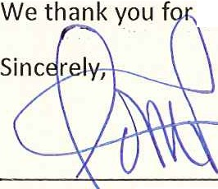your continued attention and stand ready to work with your agency.

Represen ative Juan Oscar Morales Rodrfguez Chairman, ealth Committee

Puerto Rico ouse of Representatives

El Capitolio, Apartado 9022228, San Juan, Puerto Rico 00902-2228 • D. 787-723-8745 T. 787-721-6040 Ext 2034 Oficina de Servicios: T. 787-945-2003

