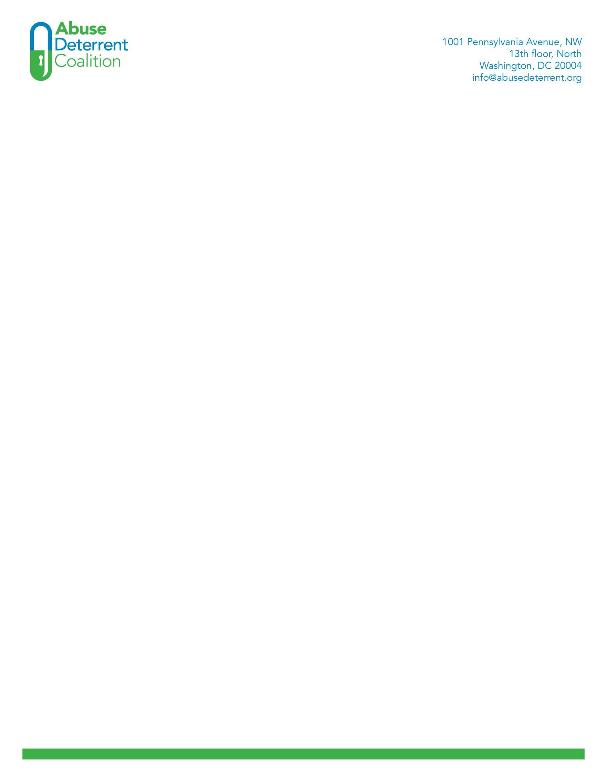

March 5, 2018

Seema Verma

Centers for Medicare & Medicaid Services

U.S. Department of Health and Human Services Attention: CMS-4182-P

* 1. Box 8013

Baltimore, MD 21244-8013 Dear Administrator Verma,

The undersigned members of the Abuse Deterrent Coalition (ADC) offer the following comments for consideration on Docket No. CMS-2017-0163 “2019 Medicare Advantage and Part D Advance Notice Part II and Draft Call Letter.”

The ADC is a forum of abuse-deterrent formulation technology innovators, patient and issue associations and pharmaceutical manufacturers created to educate the public, policy makers and related regulatory agencies on the importance of abuse-deterrent (AD) opioids technologies utilized in the fight against prescription drug abuse. The Coalition serves as a unified voice for legislative and regulatory initiatives that support the required use of AD opioids for prescription drugs that have a high potential for abuse.

In the proposed 2018 Draft Call Letter*,* CMS’s oversight through the overutilization monitoring system (OMS) suggests it has reduced very high-risk overutilization of prescription opioids in the Part D program, but that it is just one of several key tools CMS uses to combat opioid overuse. Given the urgency and scope of the continuing national prescription opioid epidemic, CMS has proposed several new strategies to more effectively address this issue for patients in Part D, including the following two items on which we focus for comment in this letter:

* + - Expecting all sponsors to implement hard formulary-level cumulative opioid safety edits at point-of-sale (POS) at the pharmacy (which can only be overridden by the sponsor) at 90 morphine milligram equivalent (MME), with a 7 days supply allowance.
    - Implementing a supply limit for initial fills of prescription opioids (e.g., 7 days) for the treatment of acute pain with or without a daily dose maximum (e.g., 50 MME).

Addressing and curtailing the abuse of prescription opioids is a multi-modal process requiring action from multiple stakeholders. For example, the Opioid Action Plan developed by the U.S. Food and Drug Administration (FDA) in February 2016 appropriately focuses on both patients and the community at large to ensure balanced access to effective pain medications, while reducing the societal burden of opioid abuse, misuse and diversion.

In the implementation of both prescription limitation recommendations, the focus in the Draft Call Letter is solely on the scripted moiety without an additional recommendation

for a product to include the latest advance in FDA approved abuse-deterrent technology: this is a missed opportunity.

The President’s Commission on Combating Drug Addiction and the Opioid Crisis also recognizes the value AD opioids can provide as an alternative to non-AD opioid medications.**1** In addition to effective treatment of the negative consequences of opioid abuse (i.e., Naloxone for overdose and medication assisted therapy [MAT] for addiction), supporting the development and increasing the availability of AD opioids represents a critical component of drug abuse prevention efforts.

In administering Part D, CMS has a tremendous opportunity to add to the effort to reduce and deter the abuse of prescription opioids. The agency’s own statistics show that opioid use by Medicare beneficiaries is ubiquitous: one in every three Medicare Part D beneficiaries received at least one prescription opioid in 2016,2 and 500,000 beneficiaries received high amounts of opioids through Medicare Part D for extended periods of time.3

CMS has estimated that over 319,000 beneficiaries could be potentially at-risk for opioid overutilization under varying scenarios.4 The Department of Health & Human Services Office of the Inspector General (HHS OIG) also has acknowledged that although beneficiaries may receive opioids for legitimate purposes, these high number of at-risk beneficiaries appropriately raises concern.5

It is important to note that AD opioids are a currently available tool specifically designed to help reduce the risks associated with abuse, misuse and diversion of prescription opioids. Moreover, AD opioids not only deter abuse, misuse and diversion of the drug for whom they are prescribed – in this case, Medicare beneficiaries – but also others who may have access to the products in the home (family members, household staff, etc.).

Opioids with abuse-deterrent properties are not abuse-proof and do not prevent or reduce the risk of addiction. AD opioids do offer the promise of a significant public health benefit by deterring the illegal diversion of opioids. Deterrence (prevention) of prescription opioid abuse is a cost-effective approach that goes hand-in-hand with efforts to “right size” prescriptions.

While the FDA has encouraged the development and licensure of AD opioids—ten AD opioids have received a label of abuse deterrence by the FDA and six are currently available on the market—utilization remains very low. 6 As FDA Commissioner Scott Gottlieb, M.D., has noted, “[AD opioid] uptake has been slow among doctors who are treating patients in pain.”

1 Available at: [https://www.whitehouse.gov/sites/whitehouse.gov/files/images/Final_Report_Draft_11-1-](https://www.whitehouse.gov/sites/whitehouse.gov/files/images/Final_Report_Draft_11-1-2017.pdf) [2017.pdf.](https://www.whitehouse.gov/sites/whitehouse.gov/files/images/Final_Report_Draft_11-1-2017.pdf)

2 Department of Health and Human Services Office of Inspector General, Opioids in Medicare Part D:

Concerns about Extreme Use and Questionable Prescribing, OEI-02-17-00250, available at <https://www.oig.hhs.gov/oei/reports/oei-02-17-00250.pdf>

3 Cite Part D rule

4 HHS Office of Inspector General, Semiannual Report to Congress, November 2017 (pg. 6) available at <https://oig.hhs.gov/reports-and-publications/archives/semiannual/2017/sar-fall-2017.pdf>

5 Ibid.

6 AD opioids constituent less than 4 percent of the total opioid marketplace in Medicare Part D. need cite

The reason for their more limited use is likely multifold. We know there can be a learning curve that comes with new technologies. Some prescribers may not be aware of the existence of these drugs or may be uncertain of when to prescribe the abuse-deterrent versions. But we also know a significant barrier to use can be price. Because these new formulations are currently only available as brand-name products, they’re inherently more expensive than the numerous non-abuse-deterrent formulations that are also available in generic formulations.7

To more effectively combat the prescription opioid abuse crisis, CMS has an opportunity to provide valuable assistance through the Draft Call Letter to ensure both improved education among providers, particularly those treating at-risk beneficiaries, as well as adequate access to AD opioids on plan formularies.

CMS should use the Draft Call Letter to educate providers when writing appropriate prescriptions to include the use of opioid abuse prevention and mitigation efforts, including the use of AD opioids.

In the 2017 plan year, many Part D plan sponsors did not include AD opioids on their allowable prescription drug formularies; and even in instances when the AD opioid was technically a covered service, many Plans employed a variety of coverage restrictions, preauthorization, “fail-first” and other formulary tools to limit provider choice and deter greater patient access to AD opioids.

While these drug management techniques are not unique, due to the gravity of the prescription opioid abuse crisis several states have enacted policies in commercial markets to:

* + - Covering AD opioids on formularies on a basis that is not less favorable than non-AD opioid products;
    - Prohibiting plans from requiring patients to “step through” a non-AD opioid before receiving an AD opioid;
    - Requiring coverage of AD opioids at the same cost-sharing tier as non-AD opioids; and
    - Requiring prior authorization for AD opioid only if prior authorization for non- AD opioids is also required.[1]

As Dr. Gottlieb has stated, “Transitioning from the current market, dominated by conventional opioids, to one in which most opioids have abuse-deterrent properties, holds significant promise for a meaningful public health benefit.” We urge the CMS to review

7 Statement from FDA Commissioner Scott Gottlieb, M.D., on steps to promote development of generic versions of opioids formulated to deter abuse. Nov. 21, 2017. Available at: https://[www.fda.gov/NewsEvents/Newsroom/PressAnnouncements/ucm586117.htm](http://www.fda.gov/NewsEvents/Newsroom/PressAnnouncements/ucm586117.htm)

[1] See: Massachusetts: Mass. Gen. Laws ch. 258, §9 (2015) available at <https://malegislature.gov/Laws/SessionLaws/Acts/2014/Chapter258>; Florida: Fla Stat. §422 (2016) available at [https://www.flsenate.gov/Session/Bill/2016/0422/ByVersion;](https://www.flsenate.gov/Session/Bill/2016/0422/ByVersion) Maryland: Md. Ins Code § 15- 849 (2015) available at [http://law.justia.com/codes/maryland/2015/article-gin/title-15/subtitle-8/section-15-](http://law.justia.com/codes/maryland/2015/article-gin/title-15/subtitle-8/section-15-849) [849;](http://law.justia.com/codes/maryland/2015/article-gin/title-15/subtitle-8/section-15-849) West Virginia: W. VA Code §4146 (2016) available at: [http://www.legis.state.wv.us/Bill_Status/bills_text.cfm?billdoc=HB4146%20SUB%20ENR.htm&yr=2016](http://www.legis.state.wv.us/Bill_Status/bills_text.cfm?billdoc=HB4146%20SUB%20ENR.htm&amp;yr=2016&amp;sesstype=RS&amp;i=4146) [&sesstype=RS&i=4146;](http://www.legis.state.wv.us/Bill_Status/bills_text.cfm?billdoc=HB4146%20SUB%20ENR.htm&amp;yr=2016&amp;sesstype=RS&amp;i=4146) Maine: 24-A MRSA §4320(2016) available at [https://legislature.maine.gov/legis/bills/bills_127th/billtexts/HP063801.asp.](https://legislature.maine.gov/legis/bills/bills_127th/billtexts/HP063801.asp)

plan formularies to ensure adequate access to AD opioids and consider formulary management restrictions where appropriate.



Additionally, as prescription opioid diversion is a significant factor in the opioid abuse crisis, AD opioids provide a public health benefit through not only deterring abuse by the prescribed patient but also misuse and diversion by others who may have access to the patient’s prescription in the home.

In the Draft Call Letter, CMS identified several strategies to reduce unwarranted exposure to opioid medications, including the two referenced above. Including technical advances of abuse-deterrent technologies as part of the medications themselves will enhance the deterrence effort that CMS seeks.

**Recommendation:**

As AD opioids are designed, and appropriately prescribed, for patients with acute or chronic pain, the undersigned Members of the ADC urge the CMS to consider and encourage the preferential utilization of AD opioids in the context of the Opioid Overutilization Policy discussed above when finalizing the Draft Call Letter.

President Trump has declared the opioid crisis a nationwide public health emergency. The FDA’s Opioid Action Plan incorporates AD opioids as a critical tool in the effort to reduce abuse, misuse and diversion of prescription opioids. The CMS can add to the effort to promote the deterrence of the deliberate misuse, abuse and deterrence of prescription opioids by ensuring appropriately broad and favorable Medicare beneficiary access to AD opioids by allowing complete and equitable formulary access to these innovative products.

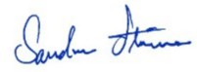Sincerely,

  

|  |  |  |
| --- | --- | --- |
| **Dan Cohen**  *Abuse Deterrent Coalition*  Chairman | **Robert B. Jones**  *Acura Pharmaceuticals*  President & CEO | **Travis Mickle**  *KemPharm*  President, CEO & Co-Founder |
| **Bob Radie**  *Egalet*  President & CEO | **Sandra Stimson**  *National Council of Certified Dementia Practitioners & International Council of Certified Dementia Practitioners*  Founder and CEO | **John Hsu, MD** *QuiVive Pharma* CEO & Founder |
| **Gregory Sturmer**  *Elysium Therapeutics, Inc.*  President & CEO | **Mike Heffernan**  *Collegium Pharmaceutical, Inc*  CEO | **Dr. Klaus-Dieter Langner** *Grünenthal GmbH* Member of the Corporate Executive Board (CSO) |



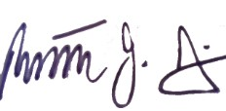 

|  |  |  |
| --- | --- | --- |
| **Craig Landau, MD**  *Purdue Pharma L.P.* President and Chief Executive Officer | **Peter Pitts**  *Center for Medicine in the Public Interest*  President | **Brian Kennedy** *Alliance for Patient Access Alliance for Balanced Pain*  *Management*  Executive Director |
| **Sherrie Dornberger RN**  *NADONA/LTC*  Executive Director | **Fred Brason** *Project Lazarus* President and CEO | **Bob Twillman, Ph.D., FAPM** *Academy of Integrative Pain Management*  Executive Director |