March 5, 2018

Ms. Seema Verma Administrator

Centers for Medicare and Medicaid Services Department of Health and Human Services Attention: CMS-5522-P

* 1. Box 8013

Baltimore, MD 21244-8013

# RE: Advance Notices of Methodological Changes for Calendar Year (CY) 2019 for Medicare Advantage (MA) CMS-HCC Risk Adjustment Model, Capitation Rates, Part C, and Part D Payment Policies and 2019 draft Call Letter

Dear Administrator Verma:

Chronic Care Management, Inc. appreciates the opportunity to provide comments on the Advance Notices of Methodological Changes for Calendar Year (CY) 2019 for Medicare Advantage (MA) CMS-HCC Risk Adjustment Model, Capitation Rates, Part C, and Part D Payment Policies and 2019 draft Call Letter (Advance Notices).

Chronic Care Management, Inc. is a care coordination and management company based in Cleveland, Ohio. The company supports CMS interest in improving care and reducing cost for Medicare beneficiaries by supporting care management services across a variety of providers and settings. These include traditional Part B providers as well as providers rendering services for ACOs, through other Medicare demonstrations and through Part C Medicare Advantage plans. Company services are focused on those who qualify for Medicare’s care management services such as chronic care management (“CCM” - CPT 99490). These beneficiaries also include the highest risk and highest cost co-hort of Medicare beneficiaries, including the home limited.

The company focus is on the compliant fulfillment of the requirements of CCM in order for providers to effectively render this in-between visit care coordination and care management. This is important, since as we know, care coordination and management is identified as a critical element to improving care, beneficiary satisfaction and reducing cost. And Mathematica Policy Research recently completed a report for the agency’s Center for Medicare and Medicaid Innovation whose results reflect that chronic care management is underutilized, and, yet also effective at reducing cost (Medicare Part A and B costs are $74 per beneficiary per month less ((after accounting for the CPT 99490 payment)), for beneficiaries receiving CCM as compared to those not receiving CCM services.

Given the value of care coordination and care management and its low utilization, we believe that such services should be required across Medicare’s delivery and payment models. This includes additional opportunities in traditional Medicare Part B, across ACOs and Medicare demonstrations, within the Medicaid program, and, in the Medicare Part C program. Accordingly, we applaud CMS for proposing its interest in expanding the role of care coordination and care management measures in this Advance Notice.

Moreover, we believe that other steps would be beneficial to increase the diffusion and benefits of care coordination and care management services such as chronic care management that we later discuss.

In its Advance Notices, the agency is proposing several changes to the MA program and to the risk adjustment (RA) model. The Company comments in response to these proposed changes, outlined as follows:

* + - Adding Dementia HCCs to the RA Model.
    - Frailty Adjustment for PACE Organizations and FIDE SNPs.
    - Health Related Supplemental Benefits.
    - Rewards and Incentives for Completion of a Health Risk Assessment (HRA).
    - Potential New Measures for 2020 and Beyond
    - Other Steps CMS to Encourage Diffusion and Benefits of Care Management Services

However, before moving onto our detailed comments regarding the Advance Notice, we provide data below reflecting the benefits of the CCM service. The first table reflects the 50 percent reduction in 30 day readmission rates for providers receiving Chronic Care Management, Inc. service in 2017 as compared to national benchmark.

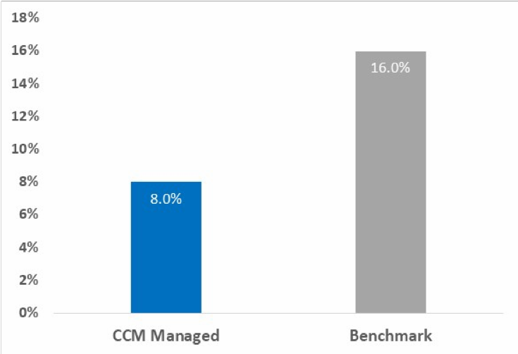

This second table reflects the 30% in overall improvement in ACO Quality Measure scores in 2017 for Chronic Care Management, Inc. ACO client organizations.

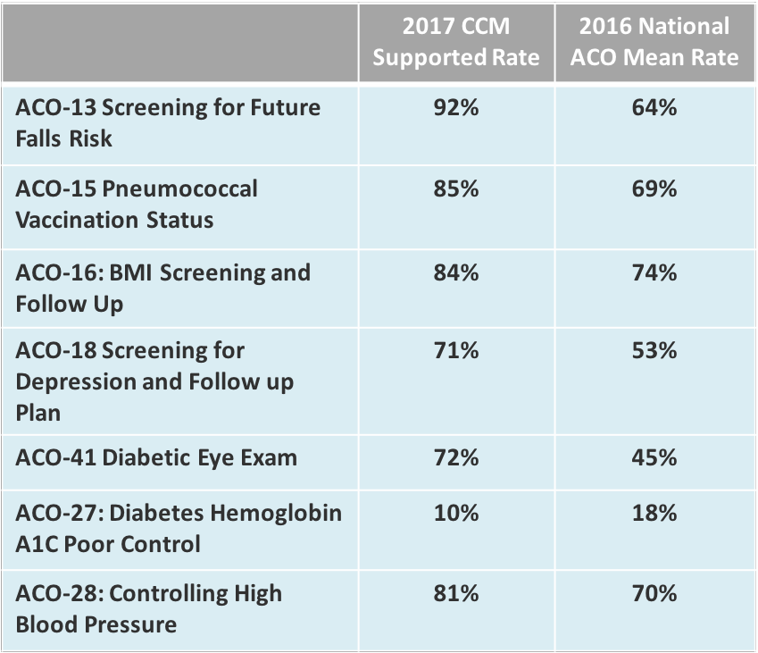

# Adding Dementia HCCs to the RA Model

CMS, in accordance with the 21st Century Cures Act conducted an analysis of various approaches to take into account the total number of diseases or conditions of individuals enrolled in an MA plan as part of the RA model. CMS evaluated the impact of a “payment condition count model,” which only included those HCCs eligible for payment, as well as the impact of an “all condition count model,” which included non-payment HCCs. Regardless of the model selected, Chronic Care Management, Inc. concurs with others that CMS should assure that HCC 51 (Dementia with complications) and HCC 52 (Dementia without complications) are included as part of the model. These conditions are currently included in the end-stage renal disease (ESRD) RA model but excluded as payment conditions from the MA HCC RA model, even though they are clinically meaningful and costly conditions with prevalence of 30% to 50% in the complex, and seriously ill population. We believe that the incorporation of these HCCs aligns with and supports CMS’ efforts to increase the predictive accuracy of the RA model.

Furthermore, since the RA model is used not only in MA, but also in other Medicare programs, including Accountable Care Organizations (ACOs) and other alternative payment models (APMs), the underprediction of this serious ill and complex patient population is a prevalent and significant issue in those programs as well. Updating the RA model to include HCCs 51 and 52 will ensure that Medicare providers regardless of Medicare payment model are not penalized for providing access and quality care to the most complex Medicare beneficiaries.

# Frailty Adjustment for PACE Organizations and FIDE SNPs

CMS is also proposing updated frailty factors based on this new model. These frailty factors are included in the calculation that determines frailty scores for Fully Integrated Dual Eligible Special Needs Plans (FIDE SNPs). Chronic Care Management, Inc. supports this proposal to increase the predictive accuracy of the RA model in its application across other programs.

Again, we encourage CMS to streamline the RA model across all programs to the extent possible—MA, Medicare programs, PACE, and ESRD, and to update these models at the same time, rather than at varying and arbitrary periods of time. Such RA streamlining and application should reach to the measures and performance comparison in the Quality Payment Program, and the measures and payments required under the IMPACT Act, etc.

# Health Related Supplemental Benefits

CMS proposes to expand the scope of the primarily health related supplemental benefit standard. Under its proposed interpretation, in order for a service or item to be primarily health related, *“it must diagnose, prevent, or treat an illness or injury, compensate for physical impairments, act to ameliorate the functional/psychological impact of injuries or health conditions, or reduce avoidable emergency and healthcare utilization.”* Supplemental benefits under this broader interpretation must be medically appropriate and ordered by a licensed provider as part of a care plan if not directly provided by one; supplemental benefits could not include items or services solely to induce enrollment by MA plans.

Chronic Care Management, Inc. supports this proposed interpretation. This will be a valuable modification to the program for seriously ill and complex patients who will benefit from receiving additional supplemental benefits that contribute to daily management of their conditions. Furthermore, we encourage CMS to expand the application of the agency’s new interpretation to other programs and models, including ACOs, and demonstrations such as Independence at Home (IAH), etc.

# Potential New Measures for 2020 and Beyond

Chronic Care Management, Inc. supports the CMS proposal of new measures for 2020 and beyond. These will contribute to improved care and reduced cost as they require enhanced tracking and management of Medicare beneficiaries across sites of care and in assuring follow- up care. This will also encourage closer relationship between MA plans and their contracted providers and this is a positive result. We, again, encourage that such requirements be applied more broadly (to the extent they do not already exist), in the traditional program as well as ACOs and demonstration. In particular, we support the development of the following measures that the agency proposes.

Transitions of Care (Part C)

1. Notification of Inpatient Admission
2. Receipt of Discharge Information
3. Patient Engagement After Inpatient Discharge
4. Medication Reconciliation Post-Discharge (which is currently a HEDIS measure)

Chronic Care Management, Inc. supports the development of this measure to improve the care coordination and care management of beneficiaries receiving care through MA plans.

Follow-up after Emergency Department Visit for Patients with Multiple Chronic Conditions (Part C). The Company supports the development of this measure. We note that the 7 and 14 day timeframes are those that correspond to the Part B Transitional Care Management (TCM) codes. We also note that most literature supports the provisions of follow-up within 14 days if not within 7 days and that there are less benefits upon further reduction across the Medicare population. We support at this time the alignment of this measure with the TCM requirements and this will serve to enhance the delivery of follow-up across Medicare payer models.

Assessment of Care for People with Multiple High-Risk Chronic Conditions (Part C). The Company supports the development of this new that would apply to all Medicare plans and would target the population of people with two or more high-risk chronic conditions. This criterion reflects that required under CCM thereby supporting the same provision of minimum services across Medicare payment models. We support the suggested components in the measure: physical function assessment, cognitive function assessment, pain assessment, fall risk assessment, goals of care discussion, and advance care planning) and we support the broadening of this measure across Medicare models.

Readmissions from Post-Acute Care (Part C). The Company supports the development of this measure. Medicare providers need to become more comfortable and competent at treating Medicare beneficiaries across models and settings. This measure will support this outcome and will help to reduce the readmissions that occur from skilled nursing facilities. This is especially important as the payer and provider community work more closely together to move care to the most appropriate and least cost setting.

# Rewards and Incentives for Completion of a Health Risk Assessment (HRA)

CMS recognizes that HRA tools must be designed to objectively assess and analyze the medical, functional, cognitive, psychosocial and mental health needs of each beneficiary, and therefore do not consist of material that is susceptible to bias like other enrollee satisfaction and outcome surveys. Accordingly, CMS is proposing to permit MA plans to include the completion of an HRA as a permitted health-related activity in an RI (Rewards and Incentives) Program.

Chronic Care Management, Inc. assists providers in the rendering, capture, and documentation of such health needs and commends CMS for permitting completion of an HRA as an activity in the RI Program. We believe that it is important that beneficiaries receive the same minimum range of services regardless of the model under which they receive their Medicare benefits. Including the HRA assessment in the RI program will encourage patients to complete these assessments and contribute towards ensuring that their specific needs are being met.

**Other Steps CMS to Encourage Diffusion and Benefits of Care Management Services** The Company, as comments within provide, supports the provision of services that provide at least the same minimum access across Medicare delivery and payment models. Accordingly, we note two additional areas where the agency should take steps to assure that all Medicare beneficiaries have access to the benefits of care coordination and care management services. One area is that we learning that MA plans have instituted co-payment amounts that are dissuading their Medicare plan members from receiving the CCM service. These amounts are up to $20.00 per CCM service. MA plan members include those like that of the general Medicare population of limited resources and this level of co-payment is counterproductive to the goals of care management and reduced cost. We respectively request that the agency review the impact of such co-payments in MA plans as we also recommend for the traditional program.

The second area that we recommend CMS conduct review is how the current Stark Laws could be reducing collaborative relationships that would encourage the use of CCM and its benefits. In particular, we would recommend the development of an exception for care coordination and care management services.

# Conclusion:

Chronic Care Management, Inc. supports CMS’ efforts to update the MA program, including development of additional care coordination measures, as well as the improvement in the RA models to improve predictive accuracy for the benefit of the high risk, high cost beneficiaries regardless of the Medicare model through which they receive their Medicare benefits. We also appreciate your consideration of the other steps that would encourage the diffusion and benefits of Medicare’s care management services. Thank you for work in this area and please contact Gary Swartz, JD, MPA at [gswartzconsult@gmail.com](mailto:gswartzconsult@gmail.com) or 317-679-5857, if we can answer any questions or be of additional assistance.

Sincerely,

*Gary Swartz*

Gary Swartz, JD, MPA

Chronic Care Management, Inc. Policy Advisor