**Puerto Rico Healthcare Community**

December 8, 2017

Hon. Eric D. Hargan Acting Secretary

The U.S. Department of Health & Human Services Hubert H. Humphrey Building

200 Independence Avenue, S.W. Washington, D.C. 20201

Re: Request for Action to improve the funding for Medicare beneficiaries in Puerto Rico

Dear Secretary,

As advocates of the Puerto Rico healthcare community, we strongly request that CMS uses the full scope of its authority to help the Medicare Advantage (MA) beneficiaries in Puerto Rico.

Medicare is one of the most important pillars of Puerto Rico's healthcare system, thus, the island needs adequate and equitable funding to service the healthcare needs of the more than 580,000 MA beneficiaries, among them 280,000 Dual Eligible (Medicaid & Medicare, *Platinos),* more than half of the dialysis patients in the island, and the majority of our elders. The funding of the MA program in Puerto Rico needs to be closer to the U.S. national average, or at least at the level of the U.S. Virgin Islands.

Taking swift and bold action now to stabilize Medicare in Puerto Rico will (1) immediately enhance the quality of care for the most vulnerable beneficiaries, (2) motivate US residents and key healthcare providers in the island to forgo additional migration to the US mainland, and (3) encourage future investment in Puerto Rico's health care system infrastructure; all of which are needed after the tragedy caused by Hurricanes Irma and Maria.

We thank you for your continued attention to these matters and stand ready to work with your agency. Sincerely,

Advocates of the Puerto Rico Healthcare Community



## Re: Request for Action to improve the funding for Medicare beneficiaries in Puerto Rico 12/8/17

**Signature** & **Name Entity/ Occupation**

*I'< Uv«kr:* .,

*oJrz* c bt eu -t

*t?72. fk,.//J Y._,,.;,,,-d.,,J,. r/J%*

I



*flb-1-vrlJv faLc_,* s

*r a, l* '

***e***

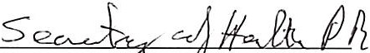

I,...... f' *a..*v \J-c / L L C .



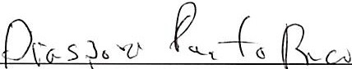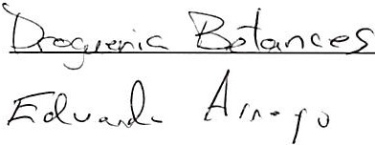

Signature & Name Entity/ Occupation

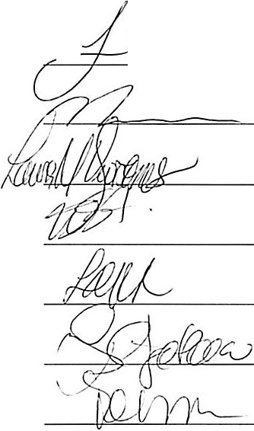

- -





1f=w - l)clp !,lcc\,e,o *AUiJi*

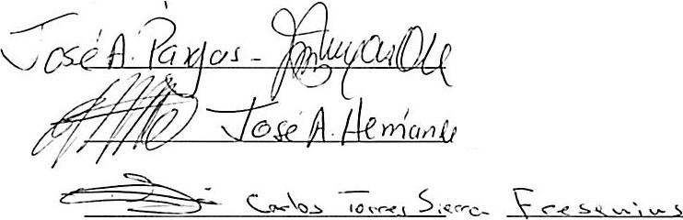*--:Jl<RJo H;udfosffli2h* \



'-,,L------'> -z *·jl-4 fZV ''l* 0





Sign ature & Name Entity/ Occupation





· =,==u

I

. Jo *c.* - ' ........ fn",,.:,...- c._(l'_"'\,._

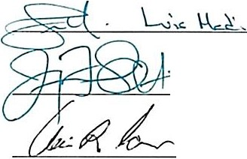

_ ---J-_ J c=...i...c::::\...:A....:.:A....:..._d-.=..-.-K- _- -



)'1,( o

l 0f ro -

*110 ib k ,I'* 0 2<1

*llk Jt4;...,*

*_ Al,,<,,_; ,<?*

*/'* **-,,f: .*'-"'M o _4 :rv,***

*i{VJL..* - 4c. *11V.·1/c(1w, \J*

VJ...... *,PP._*

*/<PS ;u ec!t'e,ev/ Y.Yv*·

*£ d $e!v£ Sc t/ / .1<' 4L q -<·u*

*I*

*1* /

*., }#*

*7*

*f*// *R{) Ilr l<"aA 5e* /

*7*

*FJ>dv> j .,...*t. *-p..,,cAv-,,,*

Li ;*/,<af*

*(" t:&j?t-11- fo; 111a. t·,*

*; k [c, ,v m* /

*v f 1*

*A/,rn,-,$J'. v*



# ..=::.._--J.. :..!::::.\,.-- .....:.u.....:...-/,S;

*:e-/ - - - - - - - - -*

) 1"lol.ul0-,*<fJ«u.·.u .,*Oo:Lt *9.*

, c;;::::::::==========--==-- -----

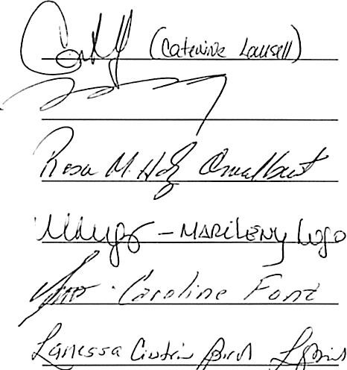**Signature** & **Name Entity/ Occupation**

*UC!.-:;iI C!.d-iJiMk*· ,*&ivr/J dL?r?f*

*11..)c .---p( ctirv\(* C o;, pV.J,Wel(ml-J



o.tc*-cl* SUPqi C?CtP'!t4

*I' E11 /J* - ***A/ v//7*** /

!.

*f(,R_Ck,* • }J,r"<*o}-.; ff lu,{ uL<-<-,,,'*

***/ k «b*** - ***<' 0'7***

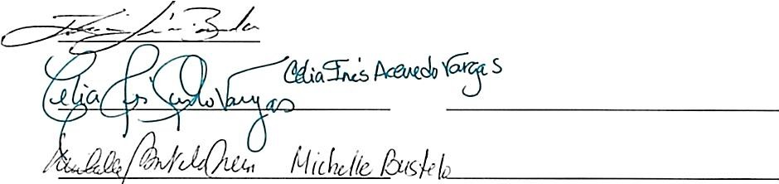

,.....: ._..:::;

..£.

*,.,i(;m°,; Lc;, v oA/?Jlrll>A A_5a;.*4L,,,- *0-. ,4: o-.P4*

_

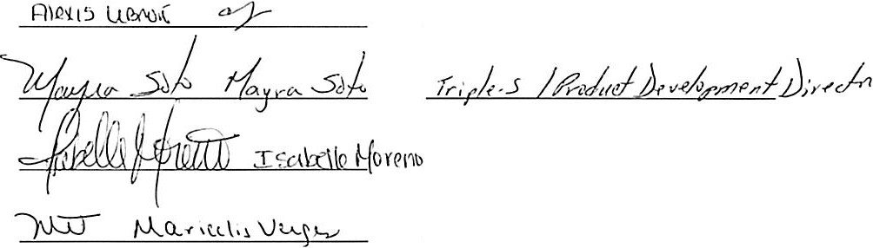

Tnrl.t._- / *e'1'- +* O w ..Llb -r,\J\..l·.=t

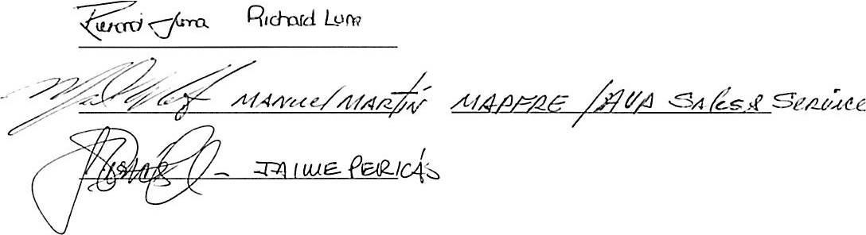

mes / SJloa v,o *Pt ia.mf-* /Tlh1\ ship

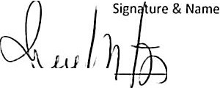Entity / Occupation

--->-"'--l,,.,W. +'-I--, ·_J_ ----=..:"n-'--'-'-_Fv_*:*l*:fi*tt/.' c?f1:{{1.)c J_ a(N.5J

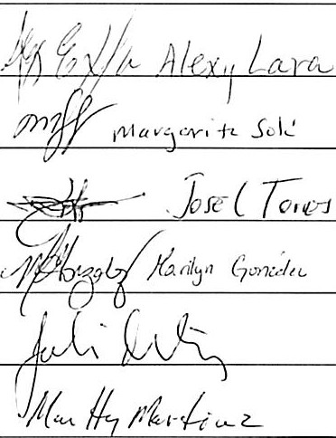c,,."'c.....Go,.,U>lc..2-



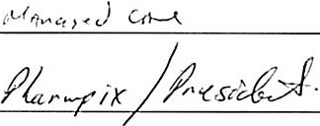 *1 /42-r*



*C\,,nq M3-uo..1tr=-*  Scl-,v,*', -±Juilo / /\"='/

?]*£:)(* .Jtn(/\ *f3 . l'lo c=.clo O-_t/·_-o¥_' _n.._e.\,_, J* _ _ _

*1',!o_&e.\\ve* Mu.,J, o:; g"  *D\n"-""'*( c;.&>,. L

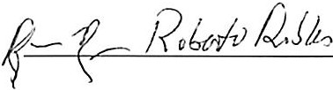L9€;,(5,.k

Re: **Request for Action to improve the funding for Medicare beneficiaries in Puerto Rico 12/8/17**

**Entity/ Occupation**

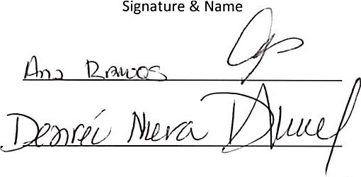

*/ ado* Ac

*,,l,,d,'"*

*1*

*6 7) 5 (/'*

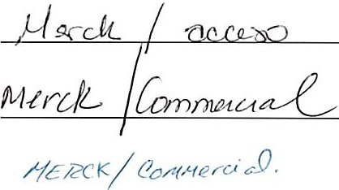

{Jl;ff*7 (r}/c0 vv4 e a A/ucJo/*

ef'\c'.r, *&o -.l),*  \ ,:; p\z D &- 0JL

*t#rfa* ***----:..........1)"""""'--{_!_3_ _***

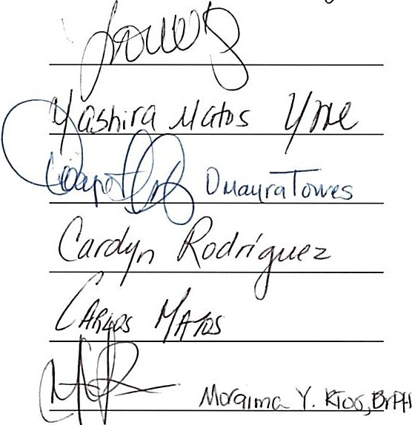7 *_M----=c==-s _*



*/>ha,m ,;u &-1- /#{!S*

*Jlts*

**.AACS**