JENNIFFER GONZALEZ-COLON

PUERTO Rico

**<ttongregg of tbe Wntteb £5,tateg**

1!,ouse of ll\epre entatibets

mlasbington. :;»QC 20515-5400

1529 LONGWOKfH House OFFICE BUILDING

(202) 225-2615

December 18, 2017

The Honorable Seema Verma Administrator

Centers for Medicare and Medicaid Services 200 Independence Avenue SW

Washington, DC 20201 Dear Administrator Verma:

The following letter is to respectfully request assistance from the Centers for Medicare and Medicaid Services (CMS) regarding administrative disparities, which continue to place Puerto Rico at a disadvantage regarding proper access to quality health care services.

As you know, Puerto Rico was hit by Hurricane Maria on September 2Qth and has not yet fully recovered. The hurricane left most of Puerto Rico without proper access to electricity, drinkable water and with critical infrastructure problems. These challenges have exacerbated the effects of ongoing disparities related to health care services, including Medicare Advantage (MA) payment rates and funding levels for both Medicaid and Medicare. Over half of Puerto Rico's 3.4 million American citizens are enrolled in Medicaid and/or Medicare. Therefore, it is critical that both programs have sufficient levels of support and funding to ensure high-quality care.

Congress is working to address the looming Medicaid funding cliff through legislation. However, CMS continues to have an important role as well. For instance, CMS should address difficulties caused by delays in patients displaced by the hurricane receiving non­ emergency care from out-of-network providers in the states. Additionally, Section 1115 Medicaid waivers can be an important part of disaster response efforts. We hope that you will work with the Puerto Rico Health Insurance Administration (ASES) to grant them the authority needed to address the hurricane's impact on public health.

Puerto Rico's healthcare system is also highly reliant on Medicare Advantage, with roughly 75 percent of eligible Medicare beneficiaries enrolled in the program. Despite havinghigher enrollment rates and often higher input costs , MA payment rates in Puerto Rico are currently 43 percent below the national average. This underfunding contributes to larger systemic problems, including lower provider reimbursement rates, provider shortages, and high-levels of migration off the island.

In order to ensure MA enrollees continue to receive high-quality care as theisland recovers, we strongly urge you to address the significant disparity between MA payments rates in the 50 states versus Puerto Rico. CMS should take administrative action in the upcoming 2019 Advanced Notice to address the broader disparity in MA reimbursement.

PRINTED ON RECYCLED PAPER

Given the very small number of Puerto Ricans left in traditional fee-for-service, it seems highly probable that this population no longer reflects the resource needs of the much larger Medicare Advantage population. This anomaly could be easily addressed by using a proxy payment rate that more appropriately meets MA funding needs on the island.

Lastly, CMS should take immediate action to address the fact that many vulnerable End Stage Renal Disease (ESRD) patients are leaving the island to get life-sustaining care and provide immediate reimbursement relief for higher-cost ESRD services provided in the states.

Puerto Rico's health care infrastructure is in desperate need of our support. Congress must do its part to ensure the Medicaid program receives adequate funding. But we are also counting on CMS to take the appropriate administrative measures to ensure the 3.4 million American citizens in Puerto Rico continue to have access to high-quality health care.

Thank you for your attention to this important matter.

Sincerely, */1d/*

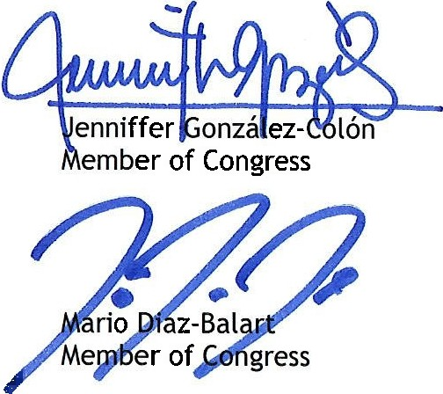

/2

*k*

Thomas MacArt r

Member of Congress

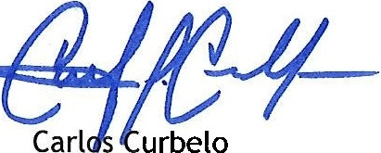

Member of Congress

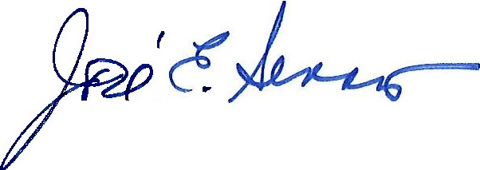

Jose E. Serrano Member of Congress

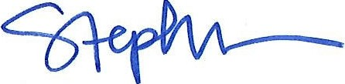

Stephanie Murphy Member of Congress

Member of Congress

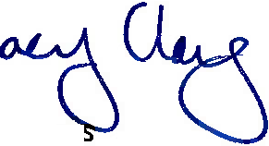Member of Congress

w .

*i ?Jf*

Wm. Lacy Clay Member of Con gres

-

Ileana Ros- Lehtinen

Member of Congress

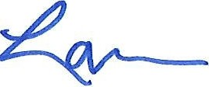ohn BB. Larso-n ember of Congress

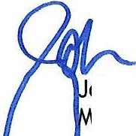

--

Peter King ***'-"'l/***

Member of Congress

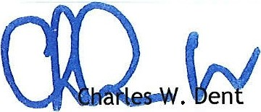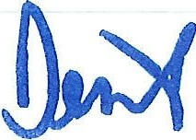

Member of Congress

**PMJ**

Member of Congress

*i ff.*

Member of Congress

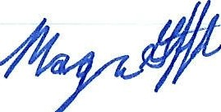*fl*

H. Morgan Griffith

Member of Congress

**./jl**