### Submitted electronically to [https://www.regulations.gov/,](https://www.regulations.gov/) Docket Number “CMS-2017-0163”

*Medicaid and Medicare Advantage Association of Puerto Rico: Comments and Proposals*

To the *CMS Part C & D Advance Notice and Draft Call Letter 2019*

March 5, 2018

The Honorable Alex Azar

Secretary of the US Department of Health and Human Services 200 Independence Avenue, S.W. Washington, D.C. 20201

cc/ Seema Verma, CMS Administrator

Demetrios Kouzoukas, Principal Deputy Administrator for Medicare and Director

Jennifer Wuggazer Lazio, F.S.A., M.A.A.A., Director of the Part C & D Actuarial Group, OACT

**Tangible Action is needed to implement urgent and critical policy adjustments to assure appropriate Medicare Advantage Puerto Rico funding for 2019 and beyond**

***PR MA benchmarks were 24% below the US Average in 2011, Now they are 43% below the US average in 2018***

## Organization of This Submission Package

As comments to the Advance Notice 2019, MMAPA is submitting a package of documents that we are requesting CMS to review in its totality and as parts to one overarching policy request. The submission has 3 main parts:

### Main comment letter: Request for Administrative Action, Pages 2-7

Main comments and proposals requesting a meaningful step from CMS t address the core issue of MA benchmarks in the 2019 Final Announcement and Call Letter.

### Addenda (Also part of this document, Page 8)

Additional sections with more detail and analysis of particular points and proposals.

* + **Section 1** – Why are the current MA rates in Puerto Rico wrong?
  + **Section 2** – What is our main policy proposal and why?
  + **Section 3** – MA ESRD Benchmarks, a harmful outlier at the bottom
  + **Section 4** – How is this proposal going to mitigate harmful impacts in our health care system?
  + **Section 5** – Selected Quotes from Supporting Documentation

1. **Appendix: R**ecent studies, analysis and support letters as part of an appendix in separate files.
   * Appendix 1 – The Moran Company: New Analysis of FFS Data from Puerto Rico, Feb. 2018
   * Appendix 2 – Illustration of alternative AGA floor options
   * Appendix 3 - Milliman Analysis of Profit Margins of MA Plans in PR vs US Total, Jan. 2018
   * Appendix 4 – Letter from Governor of Puerto Rico to Acting HHS Secretary, Jan. 5, 2018
   * Appendix 5 – Letter from Congresswoman Gonzalez and US Representatives, Dec. 18, 2017
   * Appendix 6 – Letter from US Senators to HHS Secretary, Dec. 22, 2017
   * Appendix 7 – Letter to CMS, Demetrios Kouzoukas, Nov. 21, 2017
   * Appendix 8 – Emergency Letter to Seema Verma for Recovery Action with MA, Oct. 20, 2017
   * Appendix 9 - Paper on History of Medicare Policy in PR
   * Appendix 10 – Community Letter to HHS led by PR Chamber of Commerce, Dec. 8, 2017

## A. Main Comment Letter: Request for Administrative Action

***Widely supported policy proposal.*** Multiple community organizations, including the Medicaid and Medicare Advantage Products Association of Puerto Rico (MMAPA), have presented new proposals, evidence, and updated analysis in support of a meaningful positive adjustment in the Medicare Advantage (MA) rates for Puerto Rico counties in 2019. These include an “Emergency Letter” sent to CMS Administrator Verma on October 20th, 2017 after hurricane Maria hit Puerto Rico, and a supporting package sent to CMS Deputy Principal Administrator Demetrios Kouzoukas last November 21st, 2017. Letters supporting administrative action with MA rates in Puerto Rico have also been sent by 16 members of the US House of Representatives led by Rep. Jennifer Gonzalez (December 18, 2017), 6 US Senators (December 22, 2017), and the Governor of Puerto Rico Ricardo Rosselló (January 5, 2018).

**A meaningful adjustment in MA has been defined repeatedly referring to the current MA and MA ESRD payment levels for the US Virgin Islands (USVI) or to a 0.70 average geographic adjustment (AGA) for MA rate setting, which is at the lowest levels of any county in the states.** All these communications have a key common points: **(1)** there are anomalous historic factors that make MA rates in Puerto Rico abnormally low,

1. this basic anomaly harms the system and accelerates provider and beneficiary migration, and **(3)** HHS and CMS should take administrative action to make adjustments that can meaningfully reduce the harmful funding gap for MA in Puerto Rico.

***Puerto Rico is thankful of steps taken to date, but data reveals the ongoing fundamental problem.*** We are appreciative and acknowledge important adjustments that CMS has made and proposes to maintain, in particular: using Medicare A & B beneficiaries to estimate FFS costs, adjusting for a much higher proportion of zero-claimants in FFS, adjusting STARs methodology to reflect the exclusion of Part D Low Income Subsidy (LIS) and the Supplemental Security Income (SSI), and re-interpreting the test for the STARs double bonus eligibility. CMS also established a new policy to use a 1.0 GPCI (Geographic Practice Cost Index) to calculate Part B physician reimbursement in Puerto Rico as it had done for many years for the USVI and maintained the use of proxy data to calculate Part A DSH-Uncompensated Care payments for hospitals.

***Unfortunately, these changes have not been enough.*** The MA benchmark numbers continue to deteriorate, and Puerto Rico is now 43% below the US average compared to 24% below the US average MA benchmarks in 2011 (before the ACA). We have done extensive analysis of the underlying FFS data with third party experts. Just recently, in February 2018, **The Moran Company** released the most recent update to a comprehensive analysis of FFS data from Puerto Rico after adding NEW data for 2015 (***See Appendix 1***). **Conclusion: the new data reveals the situation is getting worse.** The eroding Traditional Medicare (FFS) population continues to create anomalous results in FFS data, which makes it unusable for rate setting.

***MA program penetration in Puerto Rico should encourage, and not discourage, meaningful action on MA rates.*** Based on an isolated review of the Puerto Rico MA program, in particular given the high participation rate, or the critical supplemental benefits offered, it may suggest that rates are appropriate or adequate. However, as we explain in ***Section 1*** below, this is far from the case. The MA program in Puerto Rico has been forced to adapt to historic anomalies and underfunding. Absent of a meaningful administrative fix, standard rate setting formulas create a cycle where extremely low payment levels are self-perpetuated and worsen disparities. In Puerto Rico, MA plan offerings fill unique gaps in benefits and provider compensation with the limited funding available. However, the resulting harmful side effects are reflected in additional disparity in professional compensation, accelerated migration of providers and patients, and finally an underdeveloped health care infrastructure.

When assessing our proposals, we urge CMS to look at MA as the largest component of a comprehensive system of health care provision. MA policy decisions must be beneficiary-centered, beyond the independent review of programs (MA, Part A, Part B, Part D, Medicaid). The disparity is so large, that we urge CMS to also make an assessment beyond the shores of an island. We are seeing Medicare competing within itself when

physicians and health professionals from Puerto Rico go to Florida or other states to get 2-3 times more compensated, by the same program. We urge HHS and CMS to consider the input of federal officials who have been in Puerto Rico first hand, especially after the recent natural disaster. Crucial evidence for past and new policy adjustments in Puerto Rico is not necessarily evident in the regular documentation and bid process.

**The relative attractiveness of the MA program as a successful health care policy for the neediest should not be a deterrent for the implementation of tangible policy adjustments to mitigate the gap in MA rates.** Puerto Rico poverty rate is three times higher than the average of all States, but our beneficiaries are excluded from key programs like the Part D LIS, and the SSI that support and fill critical gaps for the neediest of patients. High MA penetration and the higher cost of supplemental benefits within MA are just a reflection of (A) our socio-economic structure, and (B) particular gaps in benefits created by the exclusion or fragmented implementation of Medicare, Medicaid and Social Security benefits that are available in the states for similarly situated individuals. HHS and CMS have formally recognized this already in past policies, including the zero- claims adjustment implemented following guidance from the Secretary of HHS.

Historic statutory differences, along with new evidence of market and data anomalies, are the primary causes of the deficient MA rates that persist today. Puerto Rico will continue to be the most cost-effective MA program in the United States even after the implementation of the proposals listed below that address the aggravating anomalies.

**Main Proposal**

* 1. **We request HHS and CMS to use administrative flexibility to meaningfully adjust MA rates in Puerto Rico for CY2019 in the Final Announcement and Call Letter for CY2019**, after recognizing new evidence of data anomalies and the harmful effects of the recent natural disaster.
  2. **We request HHS and CMS to establish a proxy methodology for the 2019 MA and MA ESRD benchmark in Puerto Rico or a national floor for the Average Geographic Adjustment (AGA floor) of 0.70 for all counties in MA rate-setting.** The latter would move Puerto Rico counties to an AGA closer to other Caribbean Territories and protect all the counties in the Nation from cases of extremely low AGAs resulting from clear data deficiencies and unexpected fluctuations. Implementing an AGA floor now will prevent further erosion and irreparable harm to the healthcare system. An equivalent approach should be used to calculate the ESRD benchmark to ensure resources are available to properly care for this vulnerable population.
  3. **CMS can phase-in the impact of the proposed policy for MA benchmarks in a period of 2-3 years, starting in 2019, and monitor closely the effects on the system.** MA plans in Puerto Rico are committed to work with CMS in defining additional bid requirements, bid to benchmark ratio parameters or monitoring tools to measure the impact of the adjustment in relation to provider compensation and development of value-based payment models. Additional detail on the AGA proposal is included in ***Section 2***.
  4. **A solution in Puerto Rico is cheaper for the Federal Government.** County rates in Puerto Rico are such outliers in 2018 that the level of payment proposed would still be at least 15% lower than the average MA rates in the state with the lowest average. The additional funding will provide the necessary inflow to support recovery efforts for our health system while remaining as the lowest cost option. It would also provide critical support to mitigate the migration of providers and patients, **ultimately saving costs to the Federal government.** Prior to the hurricanes, approximately 10,000 Medicare beneficiaries per year were leaving Puerto Rico for the states. Initial estimates indicate that the rate has more than tripled after the hurricane and are expected to remain at significant higher rate for the foreseeable future. We provide

more analysis on the cost savings opportunity for the Federal Government that could result from properly funding the Puerto Rico health system in ***Appendix 7***.

* 1. **Puerto Rico has higher costs of living than the US average. The unsustainably low pricing of health care is partly the result of historic anomalies in Medicare that continue to push compensation down, while accommodating increases in the price of other inputs like prescription drugs.** There is precedent in CMS regulation of the use of proxy factors and alternative methods when data elements of a statutory formula are simply not present or deficient. Puerto Rico MA rates after the ACA are a clear case, and a step to break the spiral to the bottom is needed now more than ever. Given the socio-economic scenario, and the recent natural disaster, Puerto Rico MA plans are also increasingly spending additional resources to tackle social determinants of health. Transportation, care coordination, community outreach are just a few of the efforts that have become harder and costlier, but also more critical for MA beneficiaries in Puerto Rico. The increase in costs of all other costs continue to divert from the ability of MA plans to properly fund at higher levels professional and other services. This will continue to exacerbate access and infrastructure issues unless the gap in MA rates is meaningfully mitigated in the short term.
  2. **The Puerto Rico Community is appreciative of policy adjustments already taken by the Administration.** We support CMS proposal to continue to provide Puerto Rico plans special consideration due to the program inequities in the Star rating measure, in particular the proposed hold harmless methodology due to the impact of the natural disaster. We also support that the zero-claim adjustment implemented in 2017 and 2018 remain. Finally, we also support the 2018 decision to assign double bonus status to most counties in the Island and would request CMS to evaluate expanding the policy to cover all 78 municipalities. **However, new evidence studied this past year suggests that these current adjustments are far from enough. The continued deterioration requires a higher-impact policy action to stop the harmful and increasing funding gap.**

With close to 50% of the health care expenditures in Puerto Rico tied to the Medicare Advantage program, it is inevitable that breaking the spiral of underfunded health care must start with a solution in MA rates. Puerto Rico also has the highest MA penetration in the nation (over 570,000, 75%), and the largest D-SNP (*Platino*) program that integrates Medicare and Medicaid with approximately 275,000 beneficiaries. Moreover, the program has the most developed administrative structure, with proven pay for performance methods, quality measures, as well as fraud, waste and abuse mechanisms.

The positive pillars created by the MA program in Puerto Rico should not deter the implementation of solutions for the continued deterioration of the MA rates even after the ACA reductions have been implemented. As the recent natural disaster validated, Puerto Rico offers an unstable and fragile platform for providers who continue to flee to the US mainland, while infrastructure keeps falling behind. MA rate reductions have provoked reductions in benefits, network adjustments, and provider migration, all with direct impact to beneficiaries. We encourage CMS to include in the final Call Letter a process to use the bid review mechanism, the minimum MLR test rules, and special parameters in the bid to benchmark ratio that will ensure that the additional funding provided to the healthcare system is appropriately allocated to maximize the benefit for the providers, beneficiaries and ultimately the healthcare system.

The resulting underfunding of Puerto Rico is directly related to the ACA Medicare cuts, which disproportionally affected the Puerto Rico benchmarks, even when actual medical cost and overall Medicare Advantage payments have increased. The overall impact has been a reduction of over 20% since 2012, even when Medicaid and all other expenses continue to increase. Prospectively, due to the economic and fiscal condition of the Puerto Rico Government, both Medicaid and Commercial health segments are significantly limited, leaving MA as the crucial and most structured program to channel forward progress in health care resources to support the health system for all the US citizens in Puerto Rico. We acknowledge that the need for comprehensive health

system reform in Puerto Rico but marked improvement in the health care system in Puerto Rico will not occur without addressing the fundamental disparity in MA funding.

**Alternative Proposals with Partial Impact**

Short of an adjustment based on a phased-in AGA floor or similar, we urge CMS to maintain and implement smaller technical fixes that at a minimum will assure Puerto Rico MA and ESRD rates move forward from 2018 to 2019 at a level consistent with the MA National growth rate. Without discarding other possibilities, we request that CMS considers the following proposals:

**Proposals that CMS Should Maintain**

1. **Maintain the zero-claims adjustment** in the estimate of FFS costs and establish a hold harmless if the calculation results in less than the current 4.4%. The update analysis continues to support the higher proportion of Puerto Rico beneficiaries with no claims experience in the FFS period, so to assure stability this adjustment should be the same or higher than in 2018.
2. **MA ESRD Part A and B pricing adjustments** - The Medicare FFS ESRD costs and payments for Puerto Rico are impacted by significant changes in FFS pricing for Part A, Part B and dialysis payment anomalies identified in recent years by CMS and documented in FFS regulation. We support CMS intent to reprice ESRD base period experience similarly to the process used to develop MA benchmarks but are concerned that the adjustment would not be sufficient to address additional Puerto Rico issues, including the difference in the coordination period with the local Medicaid agency of a 90-day coordination vs. the 30- month period CMS typically applies.
3. **STARs Hold Harmless** – We are appreciative and in full support of the hold harmless proposals from CMS in relation to the STAR rating methodologies. We also request that CMS includes the hold harmless test at the star rating level, to avoid a scenario where changes in the thresholds become the only reason for a STAR to change for an MA plan in a disaster area. A disaster area plan is not only affected in data collection, but also disadvantaged with regards to the implementation of initiatives to improve performance.

**Supplemental Policies CMS should include as part of the Puerto Rico Adjustments**

1. **Establish a hold harmless policy in 2019 MA rates for Puerto Rico as a disaster recovery area -** Absent of the main proposal requested (AGA floor), it is uncertain if the MA rates for counties in Puerto Rico for 2019 will keep at par with the 2019 MA growth rate for the Nation. In consideration of the anomalous MA rates, evidence of new FFS data analysis, and the developing impacts of the recent natural disaster, we request CMS to define a minimum 2019 MA rate change for Puerto Rico by applying the National MA rate growth to 2018 rates. This minimum county MA benchmark would be applicable only if the current methodology and adjustments result in a lower MA rate for each individual county.
2. **Adjustment for Dual Bias in Benchmark:** Define adjustments at the MA benchmark level to reflect the minimal and biased representation of dual eligible beneficiaries in the FFS population. The difference in dual proportion in MA vs FFS Medicare in Puerto Rico is so large that risk scores alone cannot fix the large discrepancy that exists between the two populations without an adjustment at the base rates (MA benchmarks).
3. **Define Part B Member Premium Support as a Core A/B Benefit for Duals:** In line with the policy to define Part A and B deductibles and cost-sharing as part of the A/B Bid, CMS should consider Part B member premium reductions for full benefit duals as part of the core A/B benefit in Puerto Rico. Medicare Savings Programs (MSPs) and Part B Buy-in programs are not available given the history of the statutorily fragmented and capped Medicaid program funding in Puerto Rico. Similarly situated beneficiaries residing in states get the Part B premium paid under Part B Buy-in programs as a core mandatory benefit. This helps to alleviate the benefit differential for the most fragile population.
4. **Extend double bonus eligibility to all 78 counties:** We are appreciative of the CMS re-interpretation of the statute to define eligibility of counties for the stars double bonus. We respectfully want to request CMS to consider the extension of the eligibility to all 78 counties for 2019, at least as a temporary measure. There are two main reasons to support this extension, especially in the short term: (a) Puerto Rico unique definition of the county, which result in a total of 78 counties within a very limited territory, results in beneficiaries in non-eligible counties getting care in eligible counties, and (b) the need to cover the full 78 counties as part of the hurricane Maria disaster relief measures.

Medicare beneficiaries in Puerto Rico, the entire health care system, and the economy, need administrative action by HHS and CMS for 2019 MA rates. The Secretary has taken action in the past to guide policy adjustments such as the zero-claims adjustment, while CMS has used national geographic adjustments like the 1.0 GPCI as proxy to create consistency in Medicare payment policy with the USVI (Part B). The issues, the questions, and, moreover, the policy solutions we are requesting will not be unprecedented as legitimate administrative action. However, in no affirmative action is taken Puerto Rico’s 78 counties benchmark continue to be an abysmal outlier compared to the payment rate for all other jurisdictions, while disaster related needs are mounting. There is no doubt that a meaningful step in MA rates will define the new path for recovery and development of cost-effective high-quality care. We urge the Secretary and CMS to take action now and break the spiral to the bottom that the ACA fueled to the detriment of providers, beneficiaries, and US citizens of Puerto Rico.

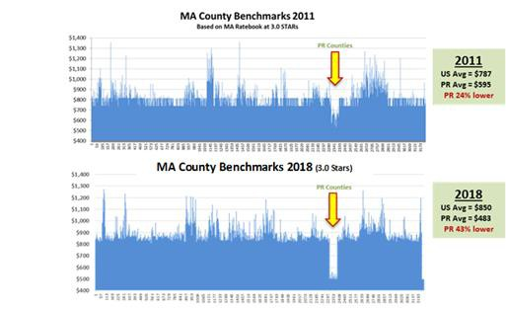

Sincerely,



Richard Shinto, MD James P. O’Drobinak,

MMAPA President and Board Member MMAPA Past President & Board Member

CEO of MMM Holdings, Inc. CEO of Medical Card System, Inc.



Roberto Garcia Luis Torres Olivera

MMAPA Past President & Board Member MMAPA Board Member

President & CEO Triple-S Management Corp. Market President of Humana



Carlos A. Carrero Juan Domínguez

MMAPA Board Member MMAPA Board Member

President Molina Healthcare of PR, Inc. First Medical Health Plan, Inc.

# Addendum

**Section 1 - Why are the current MA rates in Puerto Rico wrong?**

The Affordable Care Act (ACA) derailed the Medicare Advantage program in Puerto Rico, pulling MA rates into an accelerated downward spiral to the bottom of funding that continues to depress rates even after the completion of the six-year phase in period. Average MA benchmarks for counties in Puerto Rico were 24% below the US average in 2011, and now are 43% below the US average in 2018. **Chart 1** below illustrates the MA benchmarks of all the counties in the US. The observed depletion in the graph reflects how much lower the funding is for all of the 78 counties of Puerto Rico. Regardless, the Medicare Advantage program is intended to provide the same benefits across the nation, including Puerto Rico. In fact, health care in Puerto Rico follows the same rules, same managed care manuals, same compliance requirements, and same audit processes. Moreover, beneficiaries pay the same ***Medicare Payroll Tax***, and physicians take the same boards, while our hospitals get accredited by the same JCAHO.1

### Chart 1: Comparison of MA benchmarks by Counties in All US for 2011 and 2018

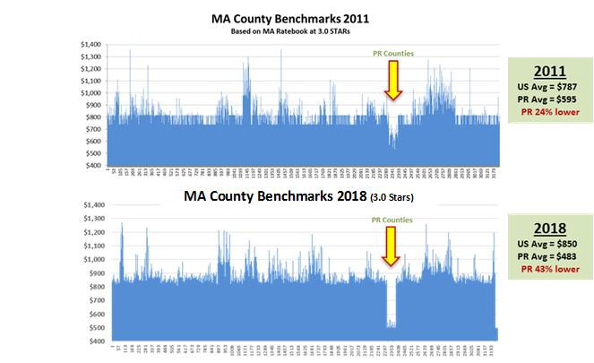

Supported by the policies in the BBA (1997), BIPA (2000), and the MMA (2003), Medicare Advantage became the backbone to the Puerto Rico health care system during the years preceding the ACA. MA and Part D under the MMA made Medicare a program truly accessible to beneficiaries, and a core element of our socio- economic structure. However, by linking MA rates to the local FFS rates, the ACA is progressively degrading Puerto Rico’s Medicare and highlighting the anomalies and deficiencies of a Medicare FFS program that has a history of unique treatment in statute. Some of these include the discounted Part A payments, the lack of Supplemental Security Income (SSI) and the lack of Part D Low Income Subsidy (LIS). The best evidence of the distinctly non-functional link between MA and FFS Medicare in Puerto Rico is that t**here was never any Medicare managed care offering for beneficiaries in Puerto Rico before 2001. It was not viable**, and a break in the current downward spiral is needed to protect the program and beneficiaries on the island from going back to that scenario.

1 JCAHO = Joint Commission on Accreditation of Healthcare Organizations

These same programmatic deficiencies, along with extreme socio-economic factors, have made MA the choice of nine out of every ten eligible beneficiaries in Puerto Rico. Before MA, beneficiaries would use the limited public system, would stay in the challenged Medicaid program, or simply did not get care given the high cost-sharing to access care in the traditional Parts A & B Medicare program. Puerto Rico has much higher rates of poverty and significantly lower income than any state, and Medicare FFS was implemented with too many statutory exceptions and gaps. Traditional Medicare in Puerto Rico never served the population as it does in the mainland. Consequently, the MA program in Puerto Rico has the highest penetration (75%) primarily because it was able to close the accessibility gap and address the deficiencies in the disjoined traditional Medicare and Medicaid programs available at the time. The Medicare Advantage program quickly developed as the only reliable health care option for our elderly, disabled and poor. This is also the same reason why more than two thirds of the beneficiaries remaining in FFS Medicare DO NOT enroll in Part B. (See ***Appendix 9 – For more details on the History of Medicare in Puerto Rico***).

On the other hand, scarce resources have also created a unique dynamic where market forces balance MA supplemental benefits and provider compensation in a different manner as the states. There are tangible extraordinary elements that require the funding of critical supplemental benefits for Puerto Rico beneficiaries, many which are covered by additional Federal or State programs that are not available in Puerto Rico. Some of the key drivers for the need of this supplemental benefits are:

1. Cost of living estimates are for Puerto Rico are on average 8%-12% higher than the US average.2
2. Non-labor costs and other the cost of other resources and inputs, like prescription drugs, utilities and equipment, are significantly higher in Puerto Rico than in the mainland,
3. Deficiencies in the federal programs exclude core benefits for the low-income beneficiaries like a Medicaid Part B buy in program (help to pay part B premium) and the Part D Low Income Subsidy, and,
4. The significantly higher poverty rate makes the purchasing of supplemental policies (i.e. Medigap), standalone Part D (PDP) coverage or even paying for the Part B premium a significant challenge to many beneficiaries that must forgo access to care due to the high cost of entry barriers.

All these factors combined create unique pressure towards the use of MA funds to cover basic gaps in benefits which fall outside of the MA A/B bid. Consequently, the relative attractiveness of the MA program as a successful health care policy for the neediest should not be a deterrent for the implementation of tangible policy adjustments to mitigate the gap in MA rates. Puerto Rico will continue to be the most cost-effective MA program in the United States even after the implementation of the proposals listed below that address the aggravating anomalies.

## The Widening Gap in Benchmarks is Impacting the System

**Accelerating Physician Migration**. A direct consequence of the extremely low MA benchmarks is the persisting gap in provider compensation that fuels physician migration. The Puerto Rico College of Physicians and Surgeons maintains a registry of active doctors. Last year, before the hurricanes hit, they reported that over 5,000 physicians left Puerto Rico from 2006 to 2016, which is a 36% decline in the total amount of physicians available to care for over 3 million residents. In addition, early estimates indicate that another 500 to 700 physicians may have left the island in the past year3 and while it is too early to have a clear view of post-hurricane numbers, all indications are that the situation has gotten worse.

On the other hand, as stated in the White House Task Force on Puerto Rico End of Administration Report, the U.S. Department of Health and Human Services includes in the future goals and sections the importance of

2 <https://www.c2er.org/> <http://www.estadisticas.gobierno.pr/iepr/Publicaciones/Encuestas/IndicedeCostodeVida.aspx> Based on the review of the reports for the last 4 Trimesters between 2016 and the beginning of 2017.

3 <http://www.colegiomedicopr.org/peligrosa-fuga-de-miles-de-medicos/>

working with Puerto Rico to address health care provider shortage4. Also, the Office of the Assistant Secretary for Planning and Evaluation has recognized that “Puerto Rico has less than half the rates of emergency physicians; neurosurgeons; orthopedists and hand surgeons; plastic surgeons; and ear, nose, and throat specialists, compared to the availability of these providers on the U.S. mainland. Available evidence clearly indicates a shortage of specialists, and anecdotal evidence suggests a significant emigration of health care professionals to the U.S. mainland.”5 Urban Institute also analyzed this situation and concluded that: “Our environmental scan and site visit also provided some evidence of long wait times to see specialists. One government official has stated that specialized services have exceptionally longer waiting times, as many as nine months for some specialties. Separately, several site visit respondents also stated that long waiting times are a problem for adults and children, especially when making appointments with specialists.”6

This situation is also reflected thru the Health Resources and Services Administration (HRSA) within the US Department of Health and Human Services, Health Professional Shortage Areas (HPSAs) Designation. The Shortage Designation Branch in the HRSA, Bureau of Health Professions National Center for Health Workforce Analysis, develops shortage designation criteria and uses them to decide whether or not a geographic area or population group is a Medically Underserved Area.

### Chart 2: Health Professional Shortage Areas (HPSAs), Puerto Rico: January 2018 7

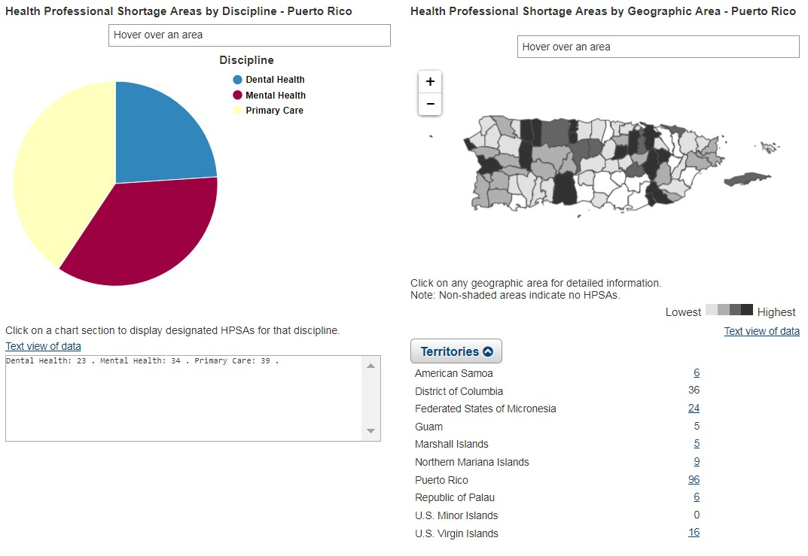

4 Department of Health and Human Services, White House Task Force on Puerto Rico End of Administration Report; November 18, 2016.

5 Department of Health and Human Services Office of the Assistant Secretary for Planning and Evaluation, ASPE Issue Brief: Evidence Indicates a Range of Challenges for Puerto Rico Health Care System; January 12, 2017

6 Urban Institute, Environmental Scan of Puerto Rico’s Health Care Infrastructure; January 2017

7 Health Resources and Services Administration (HRSA) Data Warehouse, Health Professional Shortage Area (HPSA); January 2018, Retrieved February 20 2018 at https://datawarehouse.hrsa.gov/topics/shortageAreas.aspx

According to the HRSA Data Warehouse in February 2018, all of Puerto Rico counties (78) were designated Medically Underserved Areas8. When performing a more detailed analysis, 72 out of those 78 had an Index Score of 0, which is the highest score that a county can receive representing that its residents have a shortage of personal health services. Also, as presented in figure 2, Puerto Rico currently has 96 HPSAs spread among 66 counties ranging between 1 to 7 areas per county.

### The Puerto Rico Medicare uniqueness has been acknowledged in the past, and common sense regulatory adjustments have been made to make the programs work.

The MA bids for counties in Puerto Rico reflect adjustments related to pre-existing anomalies in the program and the FFS data. Particularly, the dual Special Needs Plans (D-SNPs) bids are different to mainland D-SNPs given the statutory exclusion from the regular Part D Low Income Subsidy (LIS) program, compared to beneficiaries residing in the US. The MA bids for Puerto Rico were purposely adapted with the approval of CMS to manage the disparity in treatment under the statute. Puerto Rico has an MA benchmark that is too low, but plans are forced to adapt, and one of the results is that prices of professional health services are forcefully kept low to make the system work under the available budget (MA benchmark).

The apparent margins in the gain/loss portions of the MA bids are just an adaptation of the system to such anomalies as the lack of LIS. As such, Puerto Rico bids reflect a margin in gain/loss that allows plans to cover the losses incurred providing coverage for the Part D gaps for dual eligible beneficiaries. Therefore, this apparent margin does not translate into profit to the plan, but rather serves as a mechanism within the bid to cover a shortfall in financing support that US citizens of similar demographic and coverage qualifications enjoy elsewhere.

#### Milliman analysis of MA profit margins reveals that margins in Puerto Rico are consistently lower

To better understand the actual profit margins of MA plans in Puerto Rico, the Actuarial firm Milliman reviewed the financial statements submitted by MA companies across the nation to the National Association of Insurance Commissioners (NAIC). The financial statements from 2012 to 2016 reflected that US mainland MA plans reported profit margins that were 2.25 times higher than the profit margins of MA plans in Puerto Rico during the period. The MA program and the dual eligible program in Puerto Rico are cost efficient and have demonstrated lower than average margins while continuing to improve quality as exhibited by the higher STARs Ratings achieved by Puerto Rico plans. (See ***Appendix 7 – Comparison of Medicare Part C and Part D Margins in Puerto Rico and the Total United States***)

# Section 2 - What is our main policy proposal and why?

### Establish a Floor for the Average Geographic Adjustment (AGA) Factor, Phase-in Period

The benchmarking process for Puerto Rico continues to create inadequate funding for the healthcare system. The ratio of having 10% of the population that remains in the Medicare fee for service being used to represent the other 90% of beneficiaries that select an MA plan creates significant concerns that the small minority of members left of the fee for service may be credible but not representative of the larger population. This deficiency is even more pronounced for the dual eligible members, where approximately 6,000 dual beneficiaries are representing almost 275,000 duals enrolled in the D-SNP Platino program. Please refer to ***Appendix 1*** for The Moran Company Report detailing the anomalies in the data for Puerto Rico beyond just the pure population size

8 Health Resources and Services Administration (HRSA) Data Warehouse, Medically Underserved Areas (MUA); February 2018, Retrieved February 13 2018 at https://datawarehouse.hrsa.gov/tools/DataPortalResults.aspx?paramServiceId=MUA&paramFilterId=D

issue. We believe this discrepancy requires further research beyond the standard credibility review, but in the meantime, action is required to prevent significant damage MA program.

This issue is highlighted is in the resulting AGA factors for Puerto Rico that are extreme outliers. In simplest terms, the AGA factor is the ratio to National Average (1.0) fee for service cost for a given county and it is used to determine the benchmark or payment rate for each county. **The table below shows that the overwhelming majority of counties have AGA factors within a range of 0.70 and 1.30 of the National Average.** There is a single county with very low MA penetration in the high end of the distribution, there is a relatively large distribution of beneficiaries below this threshold. Out of the 79 counties in the low end, 78 of them are in Puerto Rico while the other is again a very low MA penetration rate county. This dispersion in relative payment rate, especially will virtually all other counties within a reasonable range but all of the Puerto Rico counties as a significant outlier illustrates the underfunding of MA payments for Puerto Rico counties. See **Chart 3** below for additional details on the disparity of the distribution of AGA factors across all areas.

### Chart 3: Distribution of MA Enrollment by ranges of county MA Benchmarks

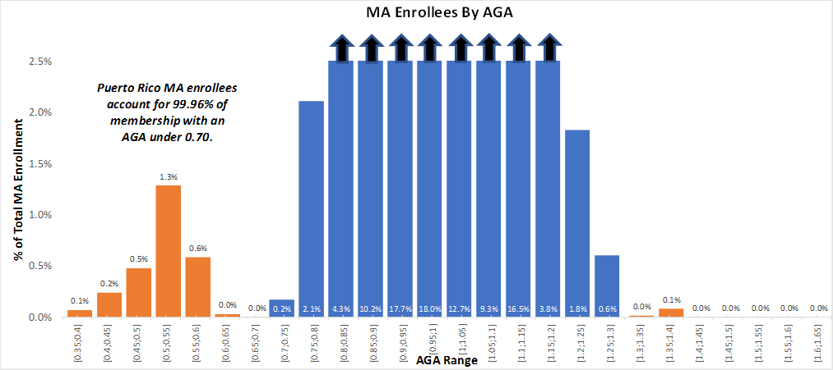

Assuming the utilization of services for Puerto Rico beneficiaries in the MA plans is consistent with utilization patterns in the US, the conclusion one draws from the chart above is that there is a severe underfunding that will hinder the ability to properly fund the cost per service component. While some contracting efficiencies can and should be expected, this large disparity points to a more systemic problem. When viewed considering the realities of the Puerto Rico healthcare system, including but not limited to the mass migration of physicians and basic health care infrastructure deficiencies, it is evident that the benchmark development process is not appropriate when data anomalies are as evident as they are for Puerto Rico.

While these objective data points provide insight into cause and effect, we have also calculated a Relative Benchmark to GPCI measure to validate if there is a disparity between the Physician Fee Schedule (RBRVS) payments and the funding provided to MA plans. We took the MA Enrollment Weighted Average Benchmark to national average ratio divided by the Weighted Average GPCI for each Medicare Locality to see how the main Medicare Fee Schedule component compares to MA reimbursement. Once again, Puerto Rico is an extreme outlier on the low end, validating the disparity between expected fee schedule levels and MA funding. As provided in **Chart 4** below, the index for Puerto Rico is 0.59 on this scale, while US Virgin Islands (USVI) is the next closest at 0.76 and finally Alaska is the next closest locality at 0.81 and the weighted average for this measure is

0.99. The weighted GPCI is the same for Puerto Rico and USVI, yet Puerto Rico benchmarks on average are approximately 26% below the USVI, a disparity highlighted by this measure. When considering that Puerto Rico MA utilization is on par with the National MA metrics, it is clear there is significant pressure on reimbursement that a system should not be expected to bear.

### Chart 4: Ratio of MA Benchmark to GPCI Factor

Benchmark Factor to GPCI Factor

*[(2018 Avg Benchmark/2018 National Avg Benchmark)/Weighted GPCI Factor]*

1.500

1.400

1.300

1.200

1.100

1.000

0.900

0.800

0.700

0.600

0.500

**Alaska, 0.814**

**Virgin Islands, .761**

**Puerto Rico, .587**

Weighted GPCI Factor by Locality

We believe further study is required to ensure that the Puerto Rico healthcare system is properly funded. There is great concern in the fact that fee schedules and other areas with existing adjustments for Puerto Rico’s unique circumstances seem to be swallowed up by a calculation reliant on the very data that continues to result in anomalous large decreases beyond the ACA cuts that already imposed over a 20% decrease to rates. We realize this will take a significant amount of time to properly analyze and identify all the drivers of the issues identified so far for Puerto Rico. As such, we are recommending that an AGA floor be implemented now to prevent further erosion and irreparable harm. Therefore, **we strongly suggest CMS implement for 2019 an AGA floor of 0.70 phased in over a 2-3-year period to provide sufficient time to study and determine a long-term solution.** Even after this adjustment, Puerto Rico will lag well behind the payment for even the lowest State and areas similar in non-healthcare cost of living, but this will be a significant step in bridging the gap and at least bring Puerto Rico on par with USVI.

0.895

0.916

0.918

0.925

0.930

0.943

0.948

0.954

0.958

0.966

0.970

0.977

0.979

0.986

0.995

1.001

1.002

1.008

1.013

1.020

1.025

1.025

1.025

1.025

1.026

1.031

1.036

1.043

1.053

1.059

1.067

1.076

1.090

1.100

1.126

1.159

1.162

1.294

**Creating Consistency in Medicare Payment Policy across Caribbean Territories**

Our proposal focus on referencing the USVI benchmarks to define an alternative for Puerto Rico’s MA benchmark is driven by CMS’s prior use of geographic factors to determine payment policies when analogous situations are present. The most relevant case is CMS’ decision to treat Caribbean Island territories (the Virgin Islands and Puerto Rico) in a consistent manner by applying the 1.0 National Average GPCI Index to both Puerto Rico and USVI. The underlying conditions that drove the use of alternate factors by CMS for territories in Part B is due to data insufficiencies and anomalies identified in the underlying data used to develop such factors. We believe that is the exact same situation that is driving the underfunding of MA rates, as support CMS in taking similar steps to address such issues.

Below is the discussion provided by CMS supporting their policy change, and the data anomalies referenced are consistent with the findings identified in the The Moran Company study (***See Appendix 1***).

#### From CMS Final Rule – Medicare Physician Fee Schedule 2017

[…] For all the island territories other than Puerto Rico, the lack of comprehensive data about unique costs for island territories has had minimal impact on GPCIs because we have used either the Hawaii GPCIs (for the Pacific territories) or used the unadjusted national averages (for the Virgin Islands). In an effort to provide greater consistency in the calculation of GPCIs given the lack of comprehensive data regarding the validity of applying the proxy data used in the States in accurately accounting for variability of costs for these island territories, **we proposed to treat the Caribbean Island territories (the Virgin Islands and Puerto Rico) in a consistent manner.** We proposed to do so by assigning the national average of 1.0 to each GPCI index for both Puerto Rico and the Virgin Islands. We did not propose any changes to the GPCI methodology for the Pacific Island territories (Guam, American Samoa, and Northern Marianas Islands) **where we already consistently assign the Hawaii GPCI values** for each of the three GPCIs. […] 9

Chart 4 below illustrates the discrepancy between PR and USVI as it relates to GPCI ratios and the MA and ESRD benchmarks.

**Chart 4: PR Part B GPCI Change, relation to USVI Levels, and Comparison with MA Benchmarks**

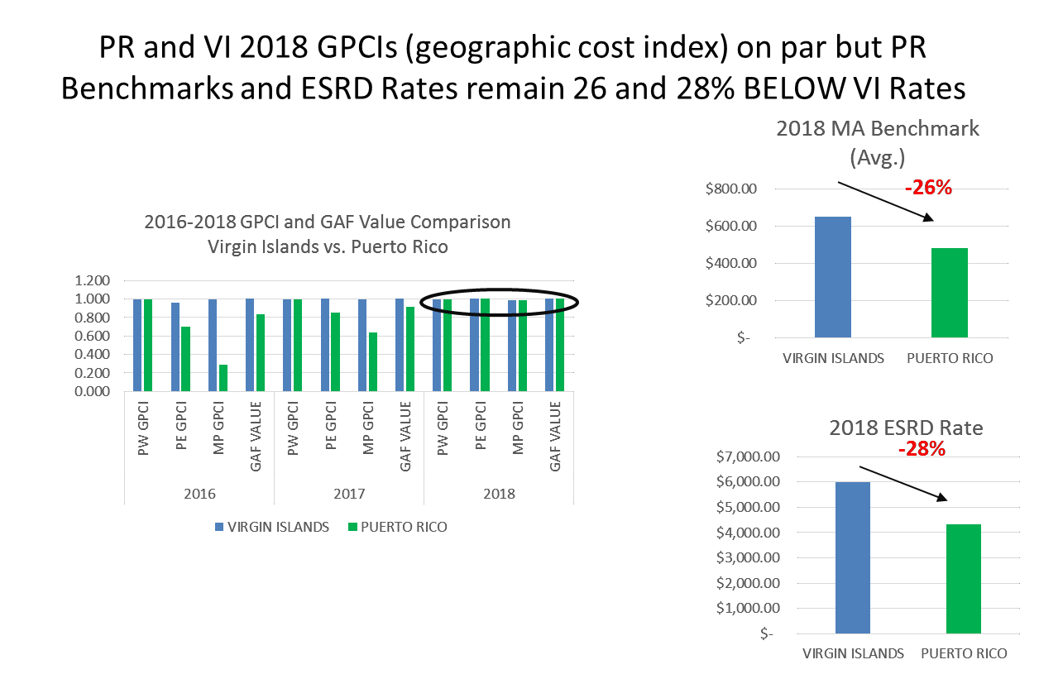

9 **Federal Register** /Vol. 81, No. 220 /Tuesday, November 15, 2016 /Rules and Regulations **80269**

MMAPA has worked for over 2 years with CMS and the Moran Company to analyze the universe of Traditional Medicare (FFS) data from Puerto Rico. The most recent study, just finalized in February 2018, revealed continuing deterioration in the data for Puerto Rico. Due to historic statutory disparities, socio-economic differences, and the high MA penetration the Moran Company concluded that anomalies make the data unusable for rate setting. We should also note that the inconsistency in policies within the Medicare program in Puerto Rico are also creating aggravating situations. For 2018, the geographic adjustment for Part B payments is 1.0 like the USVI, but the AGA factor used for the MA benchmarks is **0.49, or 33% lower than the 0.73 average AGA for the 2 counties in the USVI**. Moreover, for 2018, there is only one county across all the states with an AGA of less than 0.70.

## Linking Puerto Rico to Areas with Similar Cost of Living

We have also reviewed the relationship between cost of living statistics and the overall MA rates for counties with similar cost of living. We analyzed the COLI (<http://coli.org/>) survey to look for counties that have the same non-health care cost of living as Puerto Rico and compare their MA benchmarks. As presented in the table below, Puerto Rico’s factor is higher than the average for non-health care cost. Out of 21 metro areas found between 100 (average) and 106 score in the index, Puerto Rico is the only area with a MA benchmark of less than $700. Alternatively, if CMS intended to make the full correction of the historic program anomalies and deficiencies in the pricing of health care in Puerto Rico, the MA benchmarks of a jurisdiction of similar costs of living index would be an appropriate estimate. Puerto Rico would have MA rates similar to Maddison, Wisconsin, which has an average of $794 (compared to $544 in the San Juan Metro area, or $653 in the USVI)

.

### Table 1: Cost of Living Index of Metro Areas that are 100 to 106 Score, and Ratio to MA Benchmarks

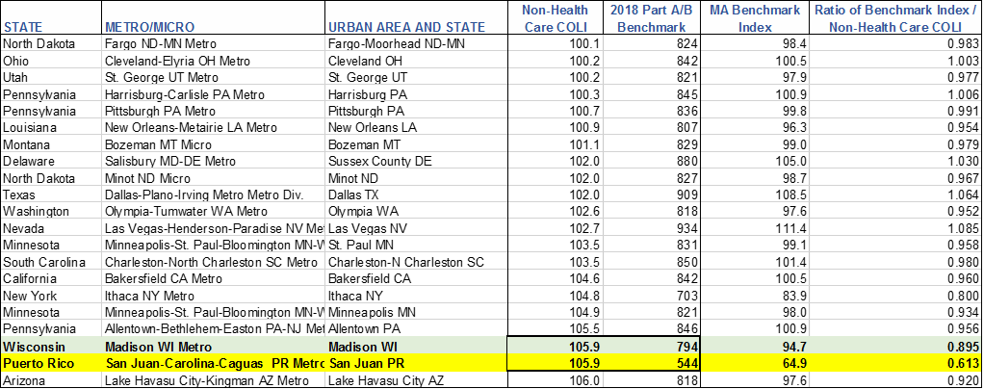

As explained in our letter to CMS Principal Deputy Administrator, Demetrios Kouzoukas (***See Appendix 7***), the cost of living metrics in Puerto Rico reveals the sharp contrast of healthcare costs compared to the rest of the economic inputs of the local market. Overall costs of living in Puerto Rico is higher than 260 metro areas around the nation. This means that the costs of utilities, transportation, equipment, prescription drugs, food, and other goods and services are the higher. The survey also highlights that healthcare costs are an extraordinary anomaly, at a 63.4 index (100.0 = US average). This supports our position that the **systematic underfunding in health programs depresses the investment in healthcare infrastructure and professional compensation as the system works to function with the limited resources available.** This does not go without harm and is unsustainable within the US economy and within the national MA program.

### Cost Index of Selected Goods and Services in Puerto Rico compared to Florida and New York10

|  |  |  |  |  |  |
| --- | --- | --- | --- | --- | --- |
| **Goods and Services** | **San Juan, PR** | **Orlando, FL** | **Brooklyn, NY** | **Tampa, FL** | **All United States** |
| Milk | $3.02 | $2.33 | $2.59 | $2.45 | $2.06 |
| Eggs | $2.58 | $1.94 | $2.58 | $1.89 | $1.92 |
| Banana | $0.71 | $0.59 | $0.71 | $0.61 | $0.58 |
| Letuce | $2.28 | $1.73 | $2.07 | $1.69 | $1.41 |
| Frozen Foods | $3.62 | $2.69 | $3.12 | $2.55 | $2.54 |
| Price of a House | $320,623 | $281,422 | $1,078,070 | $222,991 | $329,131 |
| Total Energy | $379.39 | $165.07 | $230.49 | $152.24 | $164.97 |
| Telephone | $20.35 | $28.36 | $30.29 | $41.46 | $28.41 |
| Gasoline | $2.32 | $2.04 | $2.26 | $2.04 | $2.06 |
| Health Care Related | | | | | |
| Optometrist Visit | $46.25 | $72.59 | $97.14 | $98.02 | $100.68 |
| Physician Visit | $24.97 | $73.43 | $114.35 | $97.17 | $107.38 |
| Dentist Visit | $34.09 | $77.75 | $114.16 | $88.61 | $90.99 |
| Ibupropfen | $9.75 | $9.54 | $9.60 | $9.49 | $9.28 |
| Lipitor | $456.92 | $443.57 | $415.74 | $420.27 | $426.51 |
| <http://www.estadisticas.gobierno.pr/coli/> | |  |  |  |  |

**Cost of Living Index (COLI) Summary for Third Semester 201711**

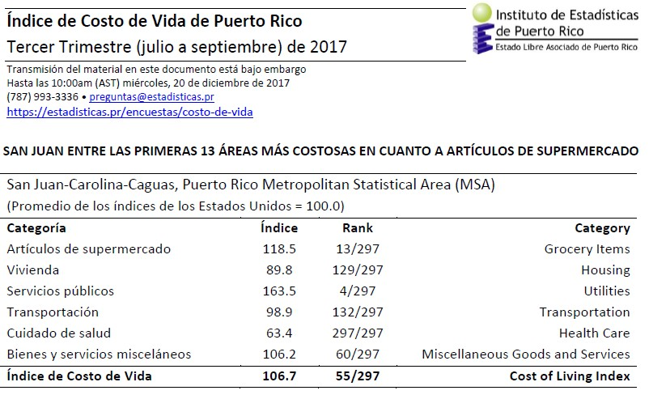

**Section 3 - MA ESRD Benchmarks – Puerto Rico an Outlier at the Bottom**

**MA ESRD Benchmarks – Puerto Rico an Outlier at the Bottom**

The discrepancy in MA payment benchmarks is even pronounced for End Stage Renal Disease (ESRD) beneficiaries. The most recent ESRD benchmark for **Puerto Rico is $4,314 in 2018, compared to a national average of $6,753 and $5,996 for the US Virgin Islands**. There are 3,500 ESRD patients in the MA program in Puerto Rico and due to the high incidence of diabetes and other co-morbidities, these patients have a clinical

10 *From: Puerto Rico Institute of Statistics, Council of Community and Economic Research,* [***www.coli.org***](http://www.coli.org/)

11 Ibid

profile even more complicated than ESRD patients on the mainland. Consistent with the request to establish an AGA floor in the development of the non ESRD benchmark, we request CMS to establish a minimum ESRD benchmark that would reduce the disparity between the Puerto Rico benchmark and the actual cost of providing services to this vulnerable population.

The PR ESRD benchmark is 28% below the USVI and this creates a fundamental issue of providing even the core, basic health care services such as dialysis required for these patients. We recognize CMS proposes to complete the repricing of fee for service cost to the 2019 cost level, but we are concerned that will not be sufficient to properly address the needs of our dialysis patients and access to care concerns. FFS costs of dialysis in Puerto Rico are nowhere near the prices that MA plans are having to pay the only 2 dialysis providers on the island. Again, FFS data in Puerto Rico does not tell the health care story that Congress envisioned when they tied the MA rate stetting with the documented costs of FFS in each area.

**Section 4 - How is this administrative policy going to mitigate harmful the issues in the Puerto Rico healthcare system?**

### Establish NEW Technical Parameters and Monitoring

MA plans in Puerto Rico propose to work with CMS in defining additional reporting or bid-related parameters to demonstrate that the allocation of resources under an adjusted MA benchmark would increase effectiveness and efficiency of care delivery for better outcomes. The MA plans understand that transparency and accountability of the MA program is fundamental to innovate the Puerto Rico health care system and support economic recovery. Plans are aware that MA funds must reach physicians, hospitals and all other health care providers to enable the needed change, and to mitigate system deterioration and accelerated migration to the mainland. Having a bid to benchmark ratio constant from previous years would help to ensure that most of the increased revenue would go to providers via increased fees. There are already guidelines built into the MA program that would help the intended policy aims of CMS are achieved, as listed below.

### The 85% MLR requirement

* 1. With increased revenue, plans would still be required to spend 85% of revenue on claims or quality initiatives.
  2. This includes both Medicare-covered and mandatory supplemental benefits.

### The various margin tests associated with the bid submission.

* 1. Plans margins must be within 1.5% of what the parent organization makes on all lines of health insurance business or, in the absence of other lines of business, a corporate margin target.
  2. Plans must keep margins relatively consistent from year to year which would limit a plan increasing margin significantly due to increased revenue.

**Adding Value Based Health Care Metrics, Social Determinants of Health**

The high MA penetration in Puerto Rico enables testing and demonstrating innovations that are successful in improving access and quality of care while lowering total health care costs. A new benchmark will distribute funds to providers and ultimately beneficiaries that will likely involve unique payment methodologies and risk sharing arrangements. The Puerto Rico MA plans propose to work with CMS to introduce parameters to measure outcomes that account for the social determinants of health. Puerto Rico MA beneficiaries may face structural, economic and physical barriers to their health care while providers seek strategies and opportunities to improve access and outcomes. The revised MA benchmark would enable sustainable funding for health care services,

access to care, care coordination, chronic disease prevention and management, health literacy, and outreach and education.

Naturally, these considerations must be evaluated within the scenario of the recovery from a natural disaster. CMS could define a path to a new AGA floor that takes MA levels to a level similar to the USVI, at least as a temporary recovery policy, that considers undefined data issues, and defines a monitoring process to closely measure the effects of the increase in benchmarks for beneficiaries and providers.

# Section 5 – Selected Quotes from Supporting Documentation

### Analysis of Puerto Rico Fee-For-Service Medicare Experience

**Implications for Setting Medicare Advantage Benchmarks (The Moran Company)**

[…] (*In Appendix 1*)

**Study Conclusions (Pages 2-3)**

*Evidence exists to argue that the eroding size of the FFS population, its characteristics, and utilization patterns are not representative of the much larger MA population and therefore do not provide a valid basis for MA benchmarks, which are intended to represent the average cost to Medicare of the FFS population in the area. Use of FFS experience as the basis for MA benchmarks assumes that MA enrollees are similar to FFS beneficiaires, or at least that there is no significant selection bias. This assumption is based on MA penetration that has historically been well below 70% nationwide. Puerto Rico’s extremely high MA penetration may eventually be matched elsewhere in the US. Selection bias is increasingly differentiating these two populations in PR. Furthermore, the price basis for FFS services and historical differences in services covered in PR compared to the mainland US (e.g., Part D low income subsidies not available in PR) have depressed historical FFS PMPM payments. While CMS has made some adjustments to correct for historically depressed payments to hospitals and physicians, other payments may remain depressed. The net effect of differences in utilization and demographics for the two populations, and historically depressed Medicare cost, leads to the conclusion that the FFS utilization under-estimates appropriate benchmarks for MA. […]*

#### “Puerto Rico Medicare Advantage and Prescription Drug (MAPD) plans have consistently had a lower profit margin compared to the national average for all MAPD plans from 2012 to 2016.”

*Milliman Analysis, January 2018*

*(Appendix 3)*

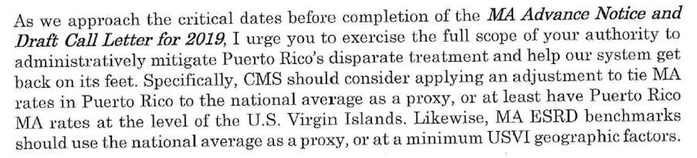

#### Governor of Puerto Rico Ricardo Rossello, January 2018

*(Appendix 4)*

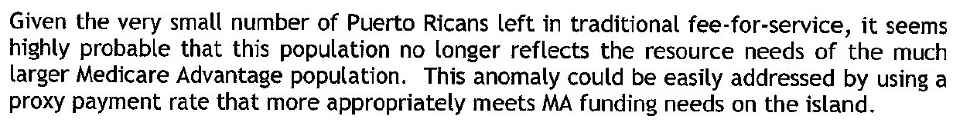

#### Jennifer Gonzalez and 16 US Representatives, December 18, 2017

*(Appendix 5)*