**tinitcd tatcs cnatc**

WASHINGTON. DC 20510

December 22, 2017

Ms. Seema Verma Administrator

Centers for Medicare and Medicaid Services

U.S. Department of Health and Human Services 200 Independence Avenue, SW

Washington, D.C. 20201

Dear Administrator Verma:

We respectfully request that you exercise your regulatory authority as the Administrator of the Centers for Medicare and Medicaid Services(CMS) to address the immediate health care needs of Puerto Ricans to ensure they can access necessary health care services as the Island continues to recover.

Puerto Rico continues to grapple with its recovery after both Hurricanes Maria and Irma. The hurricanes left most of Puerto Rico without access to electricity or potable water, and crippled the island's infrastructure. Thesechallenges exacerbated ongoing disparities related to health care payments and service delivery, including Medicare Advantage (MA) and Medicare payment rates and funding levels for Medicaid. Nearly sixty percent of Puerto Rico's 3.4 million American citizens are enrolled in Medicaid and/or Medicare. It is critical these programs are sufficiently funded to ensure high-quality care for those individuals who rely on them and stability for the overall hea°Ith care economy.

While Congress must address the looming Medicaid funding cliff through legislation, we believe there are steps CMS can take to provide immediate relief without Congressional action. For example, CMS can use its authority to address how displaced Medicaid beneficiaries access care from out-of­ network providers on the mainland. Additionally, following the declaration of a Public Health Emergency, CMS can delay Medicaid redeterminations, streamline program eligibility, and waive or modify other program requirements.

In Puerto Rico, seniors have enrolled in MA plans at a rate nearly double that of any state. Despite having higher enrollment rates and often higher input costs, MA payment rates in Puerto Rico are currently 43 percent below the national average. This underfunding aggravates larger systemic problems, including lower provider reimbursement rates and high-levelsof migration off the Island by providers leading to shortages. In its 2016 report, the Congressional Task Force on Economic Growth in Puerto Rico recommended that CMS consider whether additional administrative steps are warranted to ensure that MA plans, including those in Puerto Rico, "are being fairly and properly compensated for the services they provide to beneficiaries." CMS can also recalculate Puerto Rico's Medicare Disproportionate Share Hospital payments to account for the fact that residents of Puerto Rico are ineligible for Supplemental Security Income. In light of the recent devastation after Hurricane Maria, we believe these additional steps are ripe for action.

We urge CMS to follow through that bipartisan, bicameral recommendation and take administrativeaction in the upcoming 2019 Advanced Notice to address the significant disparity between MA payments rates in the 50 states versus Pue1to Rico. CMS has previously addressed MA

reimbursement disparity in earlier call letters, and we encourage CMS to do so again. Since there are fewer Medicare beneficiaries in Puerto Rico enrolled in traditional Medicare compared to enrollment in mainland states, the traditional Medicare enrollment numbers are not an appropriate measure to use to gauge the resource needs of the much larger MA population. Establishing an alternate proxy rate to calculate MA rates for Puerto Rico using either the U.S. Virgin Islands or mainland average is one way to provide both beneficiaries and providers the resources needed to ensure the health of those relying on Medicare.

Finally, we request CMS provide guidance and temporary relief to address the many vulnerable End Stage Renal Disease (ESRD) patients leaving the Island to access life-sustaining care on the mainland. We ask that you provide payment equity for higher-cost ESRD services provided in the states where patients seek services.

Puerto Rico's health care infrastructure was in crisis prior to the hurricanes and remains in need of immediate regulatory relief. We recognize and believe that Congress must do its part to ensure the Medicaid program receives adequate funding. However, we believe if CMS takes the actions outlined in this letter, the agency can help to provide both pennanent and transitional relief to ensure the 3.4 million American citizens in Puerto Rico are able to access high-quality health care. Thank you for your attention to this important matter.

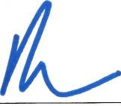Sincerely,



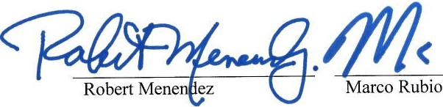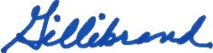.Ow--

Bill Nelson

Richard Blumenthal

-K-

ir-sten-G-illibrand-----

Z. ;

o oker