November 21, 2017

Demetrios L. Kouzoukas

Principal Deputy Administrator & Director of the Center for Medicare Centers for Medicare & Medicaid Services

200 Independence Ave, SW Washington, DC 20201

# RE: 2019 Medicare Advantage Advance Notice and Draft Call Letter

Dear Mr. Kouzoukas:

We appreciate the time and attention you and the staff and officials of the Centers for Medicare & Medicaid Services (CMS) have given to the unique challenges faced by the Puerto Rico health care system. We are particularly grateful for swift and meaningful response by CMS following the devastation of Hurricane María.

In response to our productive meeting with you on November 14, 2017, the undersigned members of the Medicaid and Medicare Advantage Products Association (MMAPA) write now to provide requested information and outline suggested reforms to the Medicare Advantage benchmark setting process that CMS can now take to improve equitable reimbursement for care of Medicare beneficiaries in the Commonwealth. **As you will see in our analysis in *Appendix 3*, a Medicare Advantage adjustment to the USVI MA rates could support keeping 100,000 Medicare beneficiaries in Puerto Rico and generate $1.1 billion in annual savings for US taxpayers. Conversely, if no action is taken to change current trends, 100,000 more Medicare beneficiaries from Puerto Rico moving to the mainland would result in $2.8 billion additional costs to US taxpayers due to higher overall program costs.**

As we discussed at the meeting, Puerto Rico is amidst unprecedented migration. Movement of local populations from US jurisdictions due to natural disasters has reached up to 6% of the total population leaving (Louisiana after hurricane Katrina). In the case of Puerto Rico, it has been reported that approximately 100,000, or 3% have already left the island to move to the mainland United States in the 50 days following Hurricane Maria. This impact is incremental to the close to 2% annual exodus that had already been occurring before the natural disaster hit.1 Recent estimates from research at Hunter College are that Puerto Rico may lose approximately 14% or 470,000 citizens just between 2017 and 2019.2 The gravity of the situation was also described in similar projections by Lyman Stone, at the recent public meeting of the ***Federal Financial Oversight and Management Board of Puerto Rico***.3 Extrapolating the recent overall population data to movement of the Puerto Rico Medicare beneficiary population, the impact of the hurricanes could generate a massive exodus of Medicare beneficiaries or citizens close to Medicare age resulting in

1 The Wall Street Journal. [https://blogs.wsj.com/economics/2016/01/04/how-not-to-fix-a-fiscal-crisis-puerto-ricos-](https://blogs.wsj.com/economics/2016/01/04/how-not-to-fix-a-fiscal-crisis-puerto-ricos-population-loss-accelerates/) [population-loss-accelerates/](https://blogs.wsj.com/economics/2016/01/04/how-not-to-fix-a-fiscal-crisis-puerto-ricos-population-loss-accelerates/) ; also in [http://diariodepuertorico.com/2016/01/how-not-to-fix-a-fiscal-crisis-puerto-ricos-](http://diariodepuertorico.com/2016/01/how-not-to-fix-a-fiscal-crisis-puerto-ricos-population-loss-accelerates/) [population-loss-accelerates/.](http://diariodepuertorico.com/2016/01/how-not-to-fix-a-fiscal-crisis-puerto-ricos-population-loss-accelerates/)

2 *Estimates of Post-Hurricane Maria Exodus*. Center for Puerto Rican Studies. Hunter College, October 2017.

3 <https://juntasupervision.pr.gov/index.php/en/documents/>

unprecedented, unbudgeted increases in Medicare and Medicaid costs for the United States when comparing the funding disparities for Puerto Rico versus US mainland states. 4

As we have documented in the past, costs for the Federal Government can be 2 to 4 times higher for each Medicare beneficiary in the US mainland resulting from an accelerated wave of migration without any meaningful, immediate action to change the course. It is within this context that a basic policy fix in the MA program for Puerto Rico becomes the quickest, most meaningful and financially safe-guarded way of helping the population and creating change for the health care system and economy. This is an unprecedented opportunity to improve the overall quality of the Puerto Rico health care system, to make it better than it ever has been. With the highest MA penetration (percentage) in the nation, and the largest D-SNP program, MA serves almost 600,000 beneficiaries in Puerto Rico. However, after becoming the backbone of our system, historic programmatic and data anomalies exacerbated harmful funding reductions from the Affordable Care Act. Our proposal is based on the possibility of administrative action thru the 2019 Call Letter to establish a proxy methodology for MA rates that can alter the spiral to the bottom, now accelerated by hurricane Maria.

Furthermore, the gap between PR’s current MA funding at the bottom of the MA rates is such that even if Puerto Rico were increased to the USVI MA rates, Puerto Rico would still be the lowest cost MA program in the nation, by far. By way of example, an MA fix at the USVI MA rates could support keeping 100,000 Medicare beneficiaries in Puerto Rico, and still generate approximately $1.1 billion in annual savings to the Federal government compared to a scenario where this MA population is served by the programs in the mainland. The adjustment would support access to care, extra help for the part B premium payment for the dual eligible, and crucial investments in health care infrastructure and support for our providers. Increasing funding disparities have created a large imbalance that pulls away our best physicians and health care professionals. Keeping physicians in Puerto Rico will keep beneficiaries in Puerto Rico, and nurture the most cost-efficient Medicare program in the nation.

In summary, these exodus and anomalies are destined to continue and get worse, unless action is taken by CMS administratively in MA to help Puerto Rico and break the spiral. Puerto Rico’s health care system cannot be fixed with its currently underfunded MA program, and our economy cannot be supported if meaningful action is not taken. We are confident that the MA program in the island is the most organized, structured, performance-based health care program in Puerto Rico, which relies on strong competition and effective fraud, waste and abuse programs to make the most efficient use of resources for our beneficiaries and providers.

4 The Moran Company. Report 2017. Included as Attachment 1.

**From “*Estimates of Post-Hurricane Maria Exodus from Puerto Rico*” October 20175**

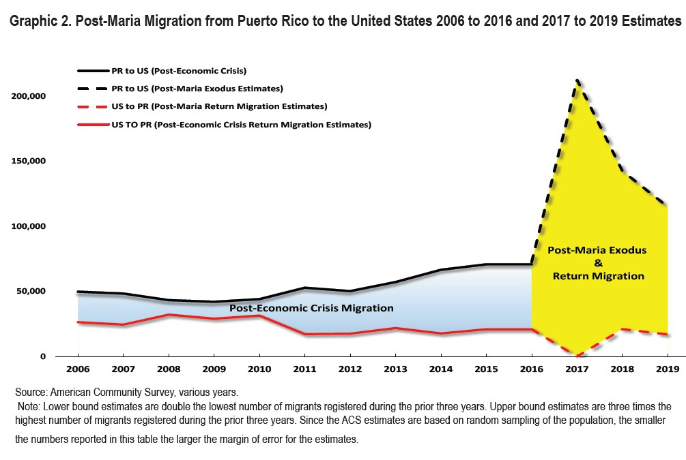

Our recommendations are outlined and explained below, prior to your drafting of the 2019 Advance Notice and Draft Call Letter. We welcome the opportunity to answer any questions you may have or discuss these proposals further, at your request.

# The MA benchmarks for Puerto Rico are Wrong

## *The underlying data supporting the current MA benchmark process is unreliable and* thus cannot be used to accurately predict what would be the costs of a Medicare FFS program in Puerto Rico.

It is factually apparent that the Medicare FFS program that Congress established as the basis for MA rate setting has eroded in Puerto Rico and no longer aligns with the assumptions underlying its use for MA benchmarks. In 2017, the Moran Company worked on an analysis of the FFS data from Puerto Rico for the past years. After several exchanges of information and reports with CMS, The Moran Company finalized its report which addresses the following causes of benchmark deficiency and is found at ***Appendix 1***.

# Contrasting Duals Proportion and Utilization Habits

The difference in the proportion of duals MA and FFS populations in Puerto Rico is so large that risk scores alone cannot correct the large discrepancy that exists between the two populations without an adjustment at the base rates. Puerto Rico has the highest enrollment MA Dual Eligible Special Needs Plans (“D-SNPs”) at more than 283,000, which is greater than Florida, New York, or

5 Hunter College, October 2017.

Texas. These beneficiaries have selected the integrated MA, Part D and Medicaid program (Medicare Platino) voluntarily since 2006. However, as presented in **Table 13** of The Moran Company report (***Appendix 1***), in 2014 there were only 5,837 beneficiaries Medicare FFS with Parts A & B in Puerto Rico. This means that 98% of all the dual Medicare A & B population are served by the MA program, and only 2% are served by FFS. *This fact alone negates the reliability of Puerto Rico FFS data as a predictor of what would be the Medicare FFS costs in Puerto Rico.*

The very low and eroding number of dually eligible beneficiaries in the Puerto Rico FFS data suggests that this portion of the data used to set MA benchmarks is distorted by selection bias, and reliance on different data in Puerto Rico is needed from that used in the mainland US. The Moran Company report shows a significant number of Puerto Rico resident duals with Medicaid enrollment in the States should not be used in setting the benchmarks. Those beneficiaries have vastly higher PMPM cost compared to Puerto Rico residents with Medicaid enrollment from Puerto Rico. The FFS duals represent a particular case of selection bias in using their data to set MA benchmarks for the vast majority of dually eligible beneficiaries in MA plans. Risk adjustment by itself cannot correct for this selection bias.

In addition, the difference in how the dual eligible beneficiaries are managed in Puerto Rico presents a unique challenge to the development of accurate benchmarks for the overall Medicare population. Two aspects could likely result in the overall benchmark underestimating the true cost of a Medicare FFS program for Puerto Rico beneficiaries.

First, since the Puerto Rico Medicare Platino program basically provides full cost share buy- down for Part A/B and D services and no other government programs are available to provide similar coverage, the dual population remaining in Medicare Fee For Services (less than 7,500 as of 2014) likely faces significant financial and/or accessibility issues. The distinct accessibility issues may be causing dual members not enrolled in Platino plans to not seek needed medical care, or most likely use a significantly different model to access care through Puerto Rico Medicaid (Mi Salud).

Second, the dual population represents 50% of MA enrollment, but 10% of the remaining FFS population. This discrepancy significantly leverages the impact of misestimating the dual eligible population. For example, a 10% change in the dual population cost results in approximately 1.2% impact on the overall fee for service cost, but 5.5% impact for the equivalent Medicare Advantage dual distribution.

We lack sufficient data to evaluate the likely impact of the dual issues identified. The dual population for the 5% sample and 100% CMS Statistical Analytical File (SAF) appears to identify dual members flagged in other stateside Medicaid buy-in programs, as the Puerto Rico Medicaid program does not provide such coverage. This population represents about 2% of the fee for service population (approximately 1,600 members out of approximately 74,000 in 2014). The dual population’s normalized cost is more than double the cost for the non-dual Puerto Rico population, likely indicating that the actual cost for dual members once they are engaged in other health care assistance programs is significantly higher than for those duals that remain in Puerto Rico without access to the Platino program.

# CMS Has Previously Recognized the Underlying Benchmarks Problems Through Successive Short-term Administrative Adjustments for “Zero-Claims”

The FFS population utilization experience in Puerto Rico is not representative of the larger MA population and exhibits selection bias. Utilization of services is also distinctly higher in MA, and FFS beneficiaries show consistently much higher rates of zero-claims (no use of Medicare services over significant periods of time), ranging up to three times higher than the national average.

Puerto Rico MA reimbursements may decline by more than $150 million if CMS does not maintain in 2019 the “zero claims adjustment” previously granted by CMS. In 2017 and 2018, CMS included an adjustment for Puerto Rico, the “zero claimants’ adjustment,” to account for the anomaly in the Parts A and B FFS beneficiaries’ data showing many more beneficiaries exhibiting no claims- related encounters or expenses than in the 50 States or DC, in essence corroborating our “lack of reliable baseline data” position set forth in Section 1.i. above.

Approximately 26% of the FFS beneficiaries in Puerto Rico report zero claims, compared to a national average of less than 8% in a given year for those beneficiaries enrolled in both Medicare Parts A and B. Such an anomaly of a higher proportion of enrolled FFS months without any corresponding utilization in the denominator depresses the benchmark calculation. This selection bias of those who remain in FFS versus those who opt into an MA plan further distorts the FFS data leading to a significant underestimation of what the FFS costs would be in Puerto Rico relative to other jurisdictions.

Without the zero-claimants adjustment, the position of the payment levels for MA in Puerto Rico would continue to deteriorate, increasing the disparity with other jurisdictions and fueling the continuing exodus of beneficiaries and health care providers to the states.

# Diminishing Claims Sample Cannot Continue to Project for Ever Growing MA Population

* + 1. Can Any 10 Percent Sample Accurately Project Costs of what would be the regular Medicare FFS program operating in Puerto Rico?

In general, not only do the FFS data represent only approximately 10% of the Medicare A & B population in the island, but the findings confirmed that the Puerto Rico FFS population is a group of beneficiaries that self-selected themselves out of MA, with particular and significant differences in character and utilization patterns. Also, Medicare FFS member months have decreased 27% over five years, with a much higher rate of switching to MA compared to the U.S. mainland.

The trends suggest the discrepancy will grow further. Approximately 30% of FFS beneficiaries in Puerto Rico switch to an MA plan annually. This is in contrast to a 3 - 5% national average switch rate to MA.

* + 1. MA Enrollment Trends Indicate that Some Jurisdictions in the States will Soon be Faced with the Same Problem

CMS has an opportunity now with Puerto Rico to tackle the problem, unanticipated by Congress, of a minority of a jurisdiction’s beneficiary population in Medicare FFS being used to project the benchmark for services provided to a majority MA enrollee population. It is not disputed that there is a “tipping point” at which an ever diminishing FFS population is too small to project with any actuarial equivalence, the likely Medicare FFS costs of an MA population. Obviously, it is our belief that Puerto Rico has far surpassed this “tipping point”.

Under current trends, counties in Minnesota and Oregon with very high MA penetration rates should be the next jurisdictions to be faced with this problem. Outgoing MedPAC Director, Mark Miller, agreed this was an emerging problem for the Medicare Advantage program. During meetings, Mr. Miller stated that MedPAC staff were conducting research into the impact of MA enrollee majority jurisdictions and possible policy remedies.

# Based on Unreliable Data Currently Used to Compute the MA Benchmark, a Proxy Methodology Should be a Substitute for Puerto Rico’s Ratemaking Computation

## *Use of an MA benchmark proxy will improve the health care system immediately.*

* 1. **Puerto Rico’s historically underfunded health care system has created a frayed infrastructure which necessitates immediate improvement in the crisis state post Maria.**
     1. Medicaid Funding is Arbitrarily Capped by Statute

Unlike Medicaid programs in the States, a statutory cap has been placed the federal contribution to the Medicaid program in Puerto Rico.6 Congress further prescribed different Medicaid Federal medical assistance percentage (“FMAP”) rates for States and Territories. For States, the FMAP is determined on a per capita income basis,***7*** while Congress established fixed FMAP rates of 55% for the Territories.***8*** Current levels of funding are 60% below the average in the mainland. Puerto Rico is hopeful that current efforts in Congress will provide at least $1 billion stability through the currently proposed CHIP bill.

* + 1. Outmigration Leads to an Older, Sicker, and Poorer Population that Strains the System

Since 2011, approximately 400,000 residents of Puerto Rico have migrated to the States. The population of Puerto Rico declined by 7.3% between 2004 and 2014, the first sustained decline in population in approximately 500 years. The younger population groups make up the majority of migration, leading to the median age of Puerto Rico residents surpassing the median age of the U.S. average for the first time. The population over 65 years of age has the lowest rate of migration from Puerto Rico over the last ten years. However, if only 10% of the migrants since 2011 were around 65 years old, the amount of incremental Medicare beneficiaries in states resulting from Puerto Rican migration is certainly significant. The recent natural disaster, coupled with the deteriorating

6 See Social Security Act § 1108.

7 S.S.A. § 1903(a)(1).

8 *Id*. § 1905(b), *as amended by* A.C.A. § 2005(c).

economic situation, has been the basis for experts to estimate an exodus even larger than the one since 2011.

The historical underfunding of health care in Puerto Rico is a contributing factor to the mass migration of residents to the continental United States. The migrating residents include doctors, nurses, and other medical personnel, seeking better salaries and reimbursement for their services, given the significant funding cuts in MA seen thru the ACA. It has been estimated that 310 doctors migrate from Puerto Rico to the States every year, nearly one each day, leaving fewer to treat a more complex patient base9 - the prevalence of chronic conditions among adults over 65 in Puerto Rico is higher than the U.S. average.10 The median household income in Puerto Rico is by far the lowest of any U.S. jurisdiction, while the unemployment rate is the highest.

# Recent legislation has fatally hurt the MA system, and undermined its capacity to generate the change needed to keep beneficiaries and professionals on the island.

MA remains the largest source of federal health care funding in Puerto Rico and is therefore the foundation of its health care system. MA plans account for 46% of all funding to the Puerto Rico health care system.11 In contrast, Medicaid funds 25%, commercial insurance funds 23%, and Medicare FFS funds 6%. Puerto Rico is a unique jurisdiction in overwhelmingly embracing MA early, with the nation’s eighth largest enrolled MA population12 and an MA penetration rate of 90% among the Medicare eligible (with Parts A & B), the highest penetration in the United States. Unfortunately, the capacity of the MA program suffered significant setbacks due to the ACA cuts. Puerto Rico MA benchmarks were 24% below the US average in 2011, and are now 43% below the US average in 2018 after the implementation of the ACA formula based on our deficient and anomalous Medicare FFS program and data.

* + 1. ACA-Imposed Reduction Fell Hardest on Puerto Rico

In spite of Puerto Rico’s reliance on MA, Congress enacted a revised MA “blended benchmark” methodology for plans as a part of the Affordable Care Act (ACA). It is not clear if Congress specifically intended the level of reductions for Puerto Rico, but MA rates have subsequently been reduced by over $100pmpm and approximately 20%. In 2011, Puerto Rico was already lower than the average MA benchmark in any state.

In fact, as seen in the Table below, actuaries have estimated that after accounting for the Section 9010 Health Insurance Providers Fee, the base payment change (not including stars quality bonus) for 2018 is -0.5%. Based on the 2018 MA Ratebook, Puerto Rico MA rates are still 43% below the national average, 39% below the average in the lowest state, Hawaii, and 26% below the rates in our neighboring Territory the US Virgin Islands.

9 Based on Public Use Microdata Sample of the American Community Survey of 2011.

10 Centers for Disease Control and Prevention; Behavioral Risk Factor Surveillance System 2015

11 Including Dual Eligible Special Needs Plans.

12 577,842 MA enrollees in May 2017.

Table: 2011- 2018 MA Rate Comparison

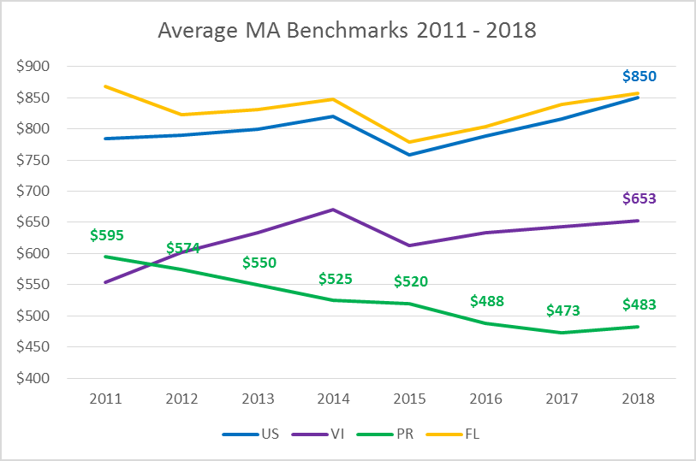

* + 1. Sec. 9010 Health Insurance Providers Fee Taxes Puerto Rico Plans to Fund Services in the States

MA plans in Puerto Rico are also subject to the health insurance plan tax authorized by section 9010 of the ACA, even though Puerto Rico is exempt from Title I of the ACA and has received none o the coverage or quality benefits from the ACA. Congressional offices and officials at the Department of the Treasury over two successive Administrations have agreed that is unfair and intended that plans in the Territories be subjected to this tax, but neither will take legislation or regulatory initiative to provide relief to the Territories. As such, approximately $200 million is expected to be collected from health plans in Puerto Rico in 2018 in order to fund Exchanges and premium subsidies in the 50 States.

* + 1. Beneficiaries in the Territories are Excluded from Low-Income Prescription Drug Assistance

When establishing the Medicare Prescription Drug Benefit, Congress also established the prescription drug assistance program for dual-eligibles known as the Low-Income Subsidy (“LIS”)***13***

13 SSA § 1860D-14, *as amended by* Medicare Prescription Drug, Improvement and Modernization Act of 2003, § 101.

Page 8

Yet, Congress excluded beneficiaries residing in the Territories from participating in the program.***14*** Instead, Congress created a separate program known as the “Treatment for Territories,” or Enhanced Allotment Plan (“EAP”), to provide a modicum of support for the provision of prescription drugs to dual-eligible.

Under the EAP, Territories may receive a substantially limited grant of funds to provide prescription drug assistance.***15*** However, CMS has chosen to use its discretionary authority to apply the FMAP requirement to the EAP funds, requiring Puerto Rico to match payments under the program in order to access the full amount allotted under statute. This CMS action further limits the levels of federal prescription drug assistance to Puerto Rico to only a fraction of what it would receive under the LIS. Given the limited resources of the Medicaid program, MA plans in Puerto Rico have been using funds to make up the difference.

## *MA is the best platform for immediate improvement in Puerto Rico’s health care* delivery system.

In spite of Hurricane Maria’s devastation to the Island and continuing struggles with electrical grid challenges, health plans are operational and devote all efforts to address the care of the most vulnerable. Our plans have implemented immediate administrative flexibility measures that have facilitated open access to care and accelerated payments to hospitals, while supporting the steadfast reactivation of provider operations and coordinated care. Even when progress is being made, the deterioration and underdevelopment of health care operations on the island is now more evident in the post-Hurricane Maria scenario. Plans now face exponentially more difficult challenges as the storm impact increases the resource gap for care.

As an immediate problem, many enrollees have evacuated to the mainland States, where they are receiving care for which MA plans are financially responsible. Such services are often two to three times more expensive than the care they would receive in Puerto Rico. When MA enrollees leave the Island, they most often seek medically necessary services from out of network providers that bill at rates greatly in excess of what providers receive on the island. Although PR is currently under a CMS waiver and required to pay stateside rates, managed care organizations in Puerto Rico will be unable to pay these disproportionately higher rates over the long-term compared to local rates. As you know this payment disparity for hurricane-related out-of-network care is not reflected in the current benchmark for Puerto Rico counties.

As a result of the hurricanes, it is becoming more expensive to provide the care to those enrollees who remain in Puerto Rico. History has shown that patient acuities increase in the weeks and months following disasters of this type. Based on reports by the Puerto Rico Government, as of October 18, 35% of the population is still without running water, while most lack access to clean potable water, and over 80% do not have electricity. All health plans are reporting increasing cost trends as more facilities electricity/ connectivity increase.

14 *Id*. at § 1860D-14(a)(3)(F); § 1935(e)(1)(A).

15 *Id*. at § 1935(e)(1)(B); 1935(e)(2); 42 C.F.R. § 423.907.

For similar reasons, the costs of ensuring continuous ESRD treatment will soon increase to an unsustainable level; and of course, the ESRD system in Puerto Rico was already underfunded before Hurricane Maria. Moreover, the costs will inevitably rise even more due to the increasing number of our ESRD beneficiaries moving to the US to get treatment. These increases costs automatically for the system and to Medicare.

The aforementioned context is one that can be tackled with meaningful support to the proven MA platform in Puerto Rico. The MA program contracts directly with private industry, and partners with managed care organizations that are closely regulated, audited and monitored by CMS, as well as external auditors. In addition, the vast majority of MA plans in Puerto Rico have obtained 4 stars for 2018, and all maintain integrated care management systems far in advance of any other line of business in Puerto Rico. For example, the MA program in Puerto Rico takes care of the most fragile population in our system, including 98% of all the dual eligible and over 50% of all the Medicare beneficiaries with ESRD. Fraud, waste and abuse programs, and the positive pressures of market competition have also been evident in the recent performance of the program on the island.

# CMS Has Authority Under Statute to Take Action in its Ratemaking Methodology in the Absence of Reliable Data

## *Statue allows to use data from another jurisdiction as a proxy in setting the MA* benchmark for Puerto Rico

We have shared with CMS an October 11, 2017 legal memorandum from Epstein Becker & Green, P.C. that demonstrates that the use of an MA benchmark proxy would be consistent with authority provided to the Secretary of HHS by Congress. (***See Appendix 2***) Specifically, the statute explicitly allows the Secretary to use alternative FFS data sources from “a similar [geographic] area,”16 when the data from the jurisdiction is not reliable for use in setting the benchmark. Further, courts recognize broad authority of agencies like CMS to effectively administer programs, such as MA. Finally, the legislative and regulatory history demonstrates that Congress anticipated the use of proxy data sources in establishing Puerto Rico MA benchmarks.

In this case, we recommend that CMS apply the average geographic adjustment (AGA) for counties that have a similar Cost of Living Index (COLI) to Puerto Rico using a nationally recognized survey.17 Given that anomalous health care economics and Medicare FFS data are not a reliable source in Puerto Rico as Congress assumed, using the MA factors of similarly situated counties in terms of COLI provides a rational basis for a proxy. Alternatively, the use of the factors applicable to the U.S. Virgin Islands (USVI) when calculating the Puerto Rico MA benchmark is also a possibility, supported by recent policies formalized by CMS for Part B payments.

16 SSA § 1876(a)(4).

17 The Council for Community and Economic Research. <http://coli.org/>

# The MA Benchmark Proxy is Supported by Regulatory Precedent

## *Information is provided to tie Puerto Rico counties to the level of similarly situated* counties in terms of (non-health care) costs of living, or at least to the level of the USVI MA benchmark

* 1. Using similarly situated counties in terms of cost of living

Historic statutory differences and data anomalies in Puerto Rico have generated a deficient health care economy that is self-perpetuated and exacerbated by standard formulas used in rate setting. As an alternative to identify an appropriate proxy for MA rates, we propose that CMS uses the COLI done by the ***Council for Community and Economic Research*** to identify counties with similar costs of living and use their MA benchmarks as a proxy for Puerto Rico’s.

If we review the ranking of cities in the COLI with the most recent data, we find that Madison, Wisconsin, has the same non-health care COLI as San Juan Puerto Rico, and has an MA benchmark of $794, compared to the $544 in the San Juan – Metro area (*see Table below*). As an applicable proxy, we propose that CMS applies a factor to Puerto Rico counties corresponding to the difference between the MA benchmark in San Juan Metro and Wisconsin. This would base the definition of the proxy on the connection between Puerto Rico and a similar geographic area in terms of cost of living.

# Table: Relation of COLI to MA Benchmarks (Areas with COLI of 100 to 106)

|  |  |  |  |  |
| --- | --- | --- | --- | --- |
| **STATE** | **METRO/MICRO** | **URBAN AREA AND STATE** | **Non-Health 2018 Part A/B Care COLI Benchmark** | |
| North Dakota | Fargo ND-MN Metro | Fargo-Moorhead ND-MN | 100.1 | 824 |
| Ohio | Cleveland-Elyria OH Metro | Cleveland OH | 100.2 | 842 |
| Utah | St. George UT Metro | St. George UT | 100.2 | 821 |
| Pennsylvania | Harrisburg-Carlisle PA Metro | Harrisburg PA | 100.3 | 845 |
| Pennsylvania | Pittsburgh PA Metro | Pittsburgh PA | 100.7 | 836 |
| Louisiana | New Orleans-Metairie LA Metro | New Orleans LA | 100.9 | 807 |
| Montana | Bozeman MT Micro | Bozeman MT | 101.1 | 829 |
| Delaware | Salisbury MD-DE Metro | Sussex County DE | 102.0 | 880 |
| North Dakota | Minot ND Micro | Minot ND | 102.0 | 827 |
| Texas | Dallas-Plano-Irving Metro Metro Div. | Dallas TX | 102.0 | 909 |
| Washington | Olympia-Tumwater WA Metro | Olympia WA | 102.6 | 818 |
| Nevada | Las Vegas-Henderson-Paradise NV Met | Las Vegas NV | 102.7 | 934 |
| Minnesota | Minneapolis-St. Paul-Bloomington MN- | WSt. Paul MN | 103.5 | 831 |
| South Carolina | Charleston-North Charleston SC Metro | Charleston-N Charleston SC | 103.5 | 850 |
| California | Bakersfield CA Metro | Bakersfield CA | 104.6 | 842 |
| New York | Ithaca NY Metro | Ithaca NY | 104.8 | 703 |
| Minnesota | Minneapolis-St. Paul-Bloomington MN- | WMinneapolis MN | 104.9 | 821 |
| Pennsylvania | Allentown-Bethlehem-Easton PA-NJ Met | Allentown PA | 105.5 | 846 |
| **Wisconsin Madison WI Metro Madison WI** | | | **105.9 794** | |
| **Puerto Rico San Juan-Carolina-Caguas PR MetroSan Juan PR** | | | **105.9 544** | |
| Arizona | Lake Havasu City-Kingman AZ Metro | Lake Havasu City AZ | 106.0 | 818 |

The analysis of the COLI includes the comparison of the costs in 267 metropolitan areas formally surveyed. When comparing the COLI for each area and its corresponding MA benchmark,

it is evident that Puerto Rico is an outlier too far below in terms of MA benchmark payments considering it more expensive to live there than in the average area in the US.



**Relation between Cost of Living Index (COLI)**

**and the MA Benchmarks 2018**

$1,300

$1,200

$1,100

$1,000

$900

$800

$700

$600

$500 **PR**

$400

0.0 50.0 100.0 150.0

200.0

250.0

300.0

**COLI for the Area**

**MA Benchmark**

Out of the 267 metro areas, the chart below includes all of the ones with a COLI between 100 and 106. The extraordinary gap for Puerto Rico is evident, and of the 21areas, all of them have benchmarks over $700 and 18 have benchmarks over $800.

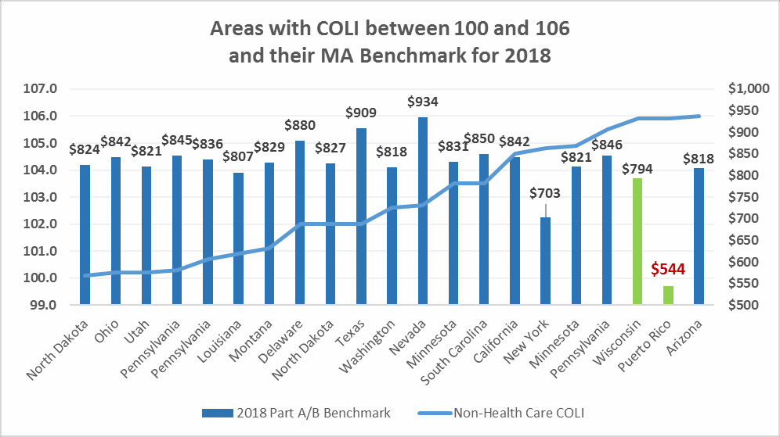

## *USVI factors could also Provide an Analogous Cost Estimate*

The factors used by CMS for the USVI are a second alternative that CMS may use to define a reasonable estimate of what would be the costs of a real Medicare FFS program in Puerto Rico. The territorial condition, a history of unique statutory distinctions in the Medicare program, and geographic proximity are just some of the reasons why the use of the USVI makes sense. In 2018, the simple average of benchmarks in the USVI is $653, compared to $483 in Puerto Rico. This level is the next lowest payment level in the entire nation, and is still 17% below the average of the state with the lowest MA benchmarks (Hawaii).

## *Precedent for Use of USVI factors as a Proxy for Puerto Rico under Physician Fee* Schedule

Such a use of a proxy would be consistent with similar actions taken by CMS for the Medicare FFS program. Under the Physician Fee Schedule, CMS earlier used the national average Geographic Practice Cost Index (GPCI) as a proxy to be used in calculating rates for the USVI and other Territories because insufficient data in those Territories to establish a specific GPCI. Later, CMS determined to extend that national average GPCI proxy to Puerto Rico as well in the interest of consistency across Territories.18 In the present case, Puerto Rico similarly lacks sufficient or reliable data to effectively calculate MA benchmarks, which calls for the use of a proxy. Similarly, CMS can promote consistency among Territories, especially those within miles of each other, by using the USVI MA AGA factor in the calculation of Puerto Rico rates.

# The MA benchmark proxy is the most cost-effective solution for the Federal Government

## *Cost Benefit of Using USVI Proxy to Reduce Outmigration of MA Enrollees*

Addressing the anomalies in MA rate setting for Puerto Rico by establishing a payment proxy will result in savings to the Federal government. Migration to the states has accelerated since Hurricanes Irma and Maria, with estimates of over 100,000 people leaving in just 2 months. This is similar to the volume leaving in one year, based on recent trends. MA transactions have also evidenced that beneficiaries are enrolling in mainland MA plans rapidly. We estimate that over 5,000 have already enrolled as of November 1st, since the day of Hurricane Maria. Fixing MA in Puerto Rico is crucial to keep more beneficiaries residing on the island.

As US citizens, when Puerto Rican beneficiaries go to states they automatically increase expenses for the Federal government, for example:

* MA benchmarks are much higher anywhere in the US, especially in Florida and New York, where Puerto Ricans are mostly moving to.
* There are additional health care expenses for programs and benefits not applicable in Puerto Rico, to which beneficiaries would be entitled automatically like the Part D LIS and Medicaid institutional long-term care.

18 See 81 Fed. Reg. 80,269 (Nov. 15, 2016).

* All the dual eligible leaving from Puerto Rico are 87% FPL or lower, which makes them eligible for the Supplemental Security Income (SSI) not applicable if you reside in Puerto Rico.

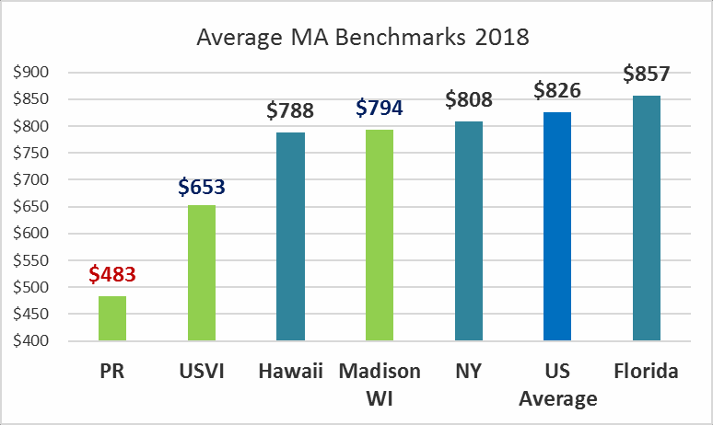

We examined the potential costs of using the MA benchmarks of the USVI in Puerto Rico, combined with the savings of the avoidance of migration resulting from the program enhancements on the island. Given recent trends, and the accelerated migration due to the hurricanes, we prepared a scenario assuming there would be 100,000 more beneficiaries from Puerto Rico in the states without meaningful change like the MA proxy. To estimate the cost of beneficiaries in Florida and New York, we divided the populations between dual and non-dual to apply dual specific cost data obtained from CMS and MedPac (***See Appendix 3***).

# Estimated Cost-Savings if 100,000 Medicare beneficiaries are impacted

**Puerto Rico MA Benchmark Use of USVI as Proxy**

**2018 Benchmark Valuation**

|  |  |  |  |  |  |  |
| --- | --- | --- | --- | --- | --- | --- |
| **Beneficiaries** | | **MA PMPM** | | **Gross Annual Expense** | | **Net Difference** |
| **Puerto Rico** | **USVI Proxy** | **Puerto Rico** | **USVI Proxy** |
| FFS | 63,000 | $433 | $433 | $ 327,668,335 | $ 327,668,335 | $ - |
| Non-Dual | 277,200 | $598 | $787 | $ 1,989,601,966 | $ 2,619,118,656 | $ 629,516,690 |
| Dual | 289,800 | $950 | $1,251 | $ 3,303,720,000 | $ 4,349,028,013 | $ 1,045,308,013 |
| Totals | 630,000 | $778 | $1,024 | $ 5,620,990,302 | **$ 7,295,815,004** | **$ 1,674,824,703** |
| Annual Savings Assuming Avoidance of Migration of 100,000 lives to FLA/NY (50/50) | | | | | | **$ (2,803,885,968)** |
| **Net Annualized Savings** | | | | | | **$ (1,129,061,265)** |

See prior table for annualized migration savings and source of PMPMs PMPM Totals for MA only (i.e. excludes FFS)

# Potential Smaller Technical Fixes

## *Although insufficient to break the spiral to the bottom, important technical fixes remain* on the table to address specific anomalies.

* 1. **Establish a Puerto Rico-Specific Minimum ESRD Medicare Advantage Minimum Benchmark to Break Self-Perpetuating Cycle of Reductions**

The situation of poor reimbursement for dialysis patients and access to care continues to deteriorate in Puerto Rico. The ESRD MA benchmark for Puerto Rico has fallen by more than 40% since 2012. The Puerto Rico MA benchmark for ESRD is $4,352 in 2018, while the national average is $6,702, and benchmark in the next closest jurisdiction, USVI is $6,038. The Puerto Rico ESRD benchmark is 28% below the USVI and this creates a fundamental issue of providing even the core, basic health care services such as dialysis required for these patients.

This is largely a result of a unique self-generating cost-payment cycle in which ever diminishing FFS ESRD payments perpetuates an unrealistic compensation level in traditional Medicare, causing undue reductions in the resources for 3,500 ESRD patients in MA. CMS has recognized critical disadvantages of the FFS payments for dialysis in Puerto Rico and their impact on MA.19

The Medicare FFS ESRD costs and payments for Puerto Rico are impacted by significant changes in FFS pricing for Part A, Part B and dialysis payment anomalies identified in recent years by CMS, and documented in FFS regulation. However, the 2018 MA did not reflect any updates in methodology or policy to address these core factors within ESRD rates. Specifically, the data CMS is using for the ESRD MA Benchmark is missing input based on claims paid by the local Medicaid plans. This is caused by the fact that Puerto Rico has different administration of a 90 day coordination with Medicaid as compared to the 30 month period CMS typically uses. This causes data that is paid on the Medicaid program that would typically flow through the CMS Fee to be missing from the rate making process.

Furthermore, as validated by CMS staff, CMS does not apply current Medicare FFS fee schedules to the ESRD MA benchmark experience data. Therefore, the GPCI update for Puerto Rico that the 2018 Rates implemented will be factored into the pricing on the general Puerto Rico MA benchmark will not be included for the ESRD benchmark. Accordingly, the significant changes in Part A pricing due to the new uncompensated care formula is also not being reflected in the ESRD MA benchmark calculation. These two pricing adjustments are critical in the case of Puerto Rico, and not doing them is contrary to CMS policy in terms of reflecting the latest pricing information known.

These multiple deficiencies contribute to diminishing ESRD MA benchmarks which do not reflect the cost of providing care. The simplest means for CMS to resolve the Puerto Rico ESRD

19 See 81 Fed. Reg. 42,817 (June 30, 2017), “We believe that this information provides evidence that in furnishing renal dialysis services, Puerto Rico could potentially have an economic disadvantage that the rest of the country may not be experiencing.”

MA benchmark would be to use the USVI ESRD MA benchmark until such time as actuarial methodologies can be revised to account for the missing data.

# Transitional Relief through Other Administrative Adjustments that Impact Medicare Advantage

* + 1. Part B Premium Support as Core Benefit for Duals

In line with the policy to define Part A and B deductibles and cost-sharing as part of the A/B Bid, CMS should consider Part B member premium reductions for full benefit duals as part of the core A/B benefit in Puerto Rico. Medicare Savings Programs (MSPs) and Part B Buy-in programs are not available given the history of the statutorily fragmented and capped Medicaid program funding in Puerto Rico. Similarly situated beneficiaries residing in states get the Part B premium paid under Part B Buy-in programs and this helps to alleviate the benefit differential.

* + 1. Star Rating Program Methodologies

As acknowledged in the 2018 Rate Announcement, all future MA Rates should maintain the current Stars methodology adjustments for Puerto Rico considering the statutory exclusion of Part D LIS benefits (as long as this exclusion exists). Even though MA plans and community pharmacies in the island have implemented joint strategies to address issues with access to medication adherence, there are still outstanding and unresolved financial constraints that hinder the quality of care. Therefore, the proposed adjustment is still needed. In addition, CMS should propose additional adjustments related to the uniqueness of the system (Getting Appointments Quickly), and the high proportion of dual eligible beneficiaries (Members Choosing to Leave the Plan). In particular, we propose that the CAHPS question related to the 15-minute wait in a physician office be waived temporarily from the scoring calculations for Puerto Rico.

Finally, the effects of Hurricanes Irma and Maria on STARs measures is multiple and complex. For said reason, we are requesting CMS to hold harmless the MA plans of Puerto Rico by using the 2018 STARs rating for any plan which scores fall below their current rating in the 2019 calculation because of the effects of the emergency in 2017.

# Conclusion

The MA benchmarks for Puerto Rico are wrong. The current MA benchmark process cannot reliably predict what would be the costs of a Medicare FFS program in Puerto Rico. Based on unreliable data currently used to compute the MA benchmark, a proxy methodology should be used for Puerto Rico’s ratemaking computation. Moreover, within the existing context, the use of an MA benchmark proxy will improve the health care system immediately thought a proven programmatic structure based on private sector productivity and competition.

The benchmark reform proposals herein are all vital for a real and meaningful impact for the 580,000 MA beneficiaries living in Puerto Rico in 2019 and beyond. We are committed to the continued improvement in the quality of the Medicare programs in Puerto Rico, demonstrated by the progress made through critical times in recent years. With these adjustments, we are confident we can break the downward spiral of the MA program in Puerto Rico. **Furthermore, expected**

**impact to projected migration reveals that this will be the most cost-effective policy for the Federal government regarding the overall effects to Medicare and Medicaid expenses for the Medicare beneficiary population.** We look forward to continuing the analysis and discussions with the HHS and CMS leadership as we develop a more permanent solution for the worsening disparities.

In defining the policy solution to be included in the 2019 Advance Notice, CMS should consider:

1. The MA program has become the backbone of the system in Puerto Rico, supported by beneficiary choice, a functioning competitive market, and formal administrative and FWA structures.
2. The MA plans in Puerto Rico have done more with less, with 97% of the members being served by 4 STARs plans.
3. Time matters, this is a unique opportunity to address historic anomalies, and the devastating impacts of the ACA one-size fits all formula, exacerbated by the recent natural disaster.
4. This is beyond policy or technical, it is about Medicate Tax-paying citizens in Puerto Rico that have fallen into a never-ending spiral to the bottom unintended by the law.
5. Anomalies created by higher MA penetration can be addressed in Puerto Rico, as a test of what may happen in other areas in the near future.

Lastly, the Federal government will inevitably spend more if members are treated in the states compared to a fixed MA program in Puerto Rico. A very conservative estimated migration of 100,000 Medicare beneficiaries to the mainland US will cost the Federal Government approximately

**$2.8** billion a year in excess of current run rates for these members now served in Puerto Rico; should Puerto Rico receive a proxy based on the USVI benchmark rates, this amount will still be a **$1.1** billion savings to the United States. An MA proxy is the most cost-effective solution to the Puerto health care crisis.

Please save Puerto Rico in Puerto Rico with administrative solutions in the 2019 Call Letter. Through this relief, Puerto Rico can rebuild its health care system better than it has ever been before, retain its doctors, its membership – their families and caretakers – and provide the solid infrastructure necessary to support the continued economic recovery of Puerto Rico. Barring this immediate solution, Puerto Rico’s health care delivery system cannot recover to the extent necessary to support economic recovery and growth. Please help.

We stand ready to meet on these matters at your request. Thank you.

Sincerely,



|  |  |
| --- | --- |
| Dr. Richard Shinto  President of the Medicaid and Medicare Advantage Products Association of PR CEO, Medicare y Mucho Mas  Roberto García  MMAPA Former President & Board Member CEO of Triple S Management, Corp | James P. O’Drobinak  MMAPA Former President & Board Member CEO, MCS Advantage, Inc.    Earl Harper  MMAPA Board Member President, Humana Puerto Rico |
|  |  |
| Carlos A. Carrero MMAPA Board Member Plan President  Molina Healthcare of Puerto Rico, Inc | Juan Dominguez MMAPA Board Member Vice-President  First Medical Health Plan, Inc. |

Cc: Carla DiBlasio, Senior Advisor to the Administrator for Medicare Cheri Rice, Acting Deputy Director, Center for Medicare

Jennifer Harlow, Acting Director, Medicare Plan Payment Group, Center for Medicare Jane Norton, Director, HHS Intergovernmental and External Affairs