

March 5, 2018 [http://www.regulations.gov](http://www.regulations.gov/)

Centers for Medicare & Medicaid Services

Department of Health and Human Services

**RE: *CMS-2017-0163: Advance Notice of Methodological Changes for Calendar Year (CY) 2019 for Medicare Advantage (MA) Capitation Rates, Part C and Part D Payment Policies and 2019 draft Call Letter***

# -on Behalf of-

**InnovaCare, Inc. / MMM Healthcare, LLC (Contracts H4003, H4004, H7522)**

Dear Ladies and Gentlemen:

The undersigned, the Chief Compliance Officer of MMM Healthcare, LLC (the “Plan”), is hereby submitting the comments below to CMS with respect to the proposed rule CMS-2017- 0163***:*** *Advance Notice of Methodological Changes for Calendar Year (CY) 2019 for Medicare Advantage (MA) Capitation Rates, Part C and Part D Payment Policies and 2019 draft Call Letter.* As indicated in our ongoing communications with CMS, we have serious concerns about the sustainability of the Medicare Advantage program in Puerto Rico deriving from the adverse impact experienced in the island upon implementation of ACA. As a result, we recognize, and are grateful for, the attention and focus CMS has placed within the 2019 Advance Notice on the unique challenges faced in Puerto Rico. We appreciate the opportunity to comment on the proposals and issues discussed and to present our recommendations which we believe would help make the MA program more sustainable in Puerto Rico.

At the outset, we note our appreciation that CMS is maintaining the key adjustments implemented in CY2017 to address the unique circumstances in Puerto Rico. We also appreciate the disaster considerations given to Puerto Rico in the 2018 measurement year as we continue to work through the devastating effects of Hurricanes Irma and Maria.

# Attachment II – Section B1 – AGA Methodology for 2019 (p.15)

We recommend establishment of a floor for the AGA factor used in MA benchmark rate development. The MA benchmark rates are developed in a way that has consistently impacted Puerto Rico much differently than the MA program as a whole. In light of these data anomalies caused by the abnormally high MA penetration rate and abnormally low FFS enrollment, we urge CMS to take corrective action to address Puerto Rico underfunding and prevent further



deterioration of the Puerto Rico health care infrastructure. Specifically, we urge CMS to implement a nationwide floor on the AGA factor of 0.7 to address the continuing outliers of the benchmarking rate methodology. Absent year-to-year methodology adjustments, Puerto Rico’s benchmark rate growth consistently lags behind the national average. Over 500,000 Medicare Advantage beneficiaries in Puerto Rico reside in counties with an AGA below 0.6. These members are extreme outliers in a program where benchmark rates center around a mean (when excluding Puerto Rico). The number of MA beneficiaries in counties with an AGA higher than

* 1. is strikingly lower, below 1,500.

Furthermore, there is a strong correlation between geography-specific FFS GPCI factors used to determine provider payment rates and MA benchmark rates. Puerto Rico is an extreme outlier in this measure as well. While the weighted GPCI factor for Puerto Rico is near the national average, the benchmark rate is 43% below the national average.

A nationwide floor would mitigate the impact of the Puerto Rico data anomalies in the FFS program, and would help slow the massive provider migration from Puerto Rico stemming from provider underfunding that is causing greater and greater access issues for beneficiaries.

In absence of the AGA floor or another major correction to the data anomalies, we suggest CMS implement a hold harmless for Puerto Rico benchmark rates prior to any other adjustments.

We also urge CMS to continue measuring and incorporating the impact of zero claimants at the same rate as currently done on the derived Puerto Rico AGA.

# Attachment II – Section D – ESRD Rates (p.22)

We note the on-going issue of the overwhelming cuts since 2012 in the level of reimbursement for End-Stage Renal Disease (ESRD) in the MA program in Puerto Rico. The MA ESRD Benchmark has been reduced during that time period by nearly 40% from $7,000 to $4,300, while the national average is $7,500 and the U.S. Virgin Islands (USVI) rate is $6,000. This level of funding for Puerto Rico is inadequate to serve this population. CMS does not mention the particular situation of Puerto Rico or propose any changes that may avoid additional cuts in the ESRD rates for dialysis patients in PR. While the proposed national updates to the ESRD methodology may help alleviate the issues with the benchmark rate, we believe an MA ESRD proxy at the level of the USVI rate or something similar to an AGA floor is appropriate until a long-term solution is reached.



# Attachment IV – Section 1 – Enhancements to the 2019 Star Ratings and Future Measurement Concepts

**New Measures for 2019 Stars Ratings (p. 107):**

We would like to start by expressing our appreciation for CMS’s acknowledgement of the difficulties and operational barriers that MCOs such as our Plan are facing in the aftermath of Hurricanes Irma and Maria, as well as other natural disasters throughout the country. In particular, we recognize your sensitivity to the fact that 100% of Puerto Rico’s counties were declared disaster areas and, while we have been using our best efforts to provide access and care during trying times, even today some of our clinical care practices around the island are struggling to operate at full capacity, especially in the island’s geographic center. As anticipated in our response last October about the assessment of the impact of Hurricanes Irma and María, the time period in which we have (and will) face challenges in maintaining high compliance with star measures remains in the time frame of between three to six months. As a result, these challenges have interfered with care activities during the last four months of CY2017 and the first quarter of CY2018, directly impacting measures for RY2019 and some of RY2020 as well. In general, the impact has been felt for shorter periods in metropolitan areas and longer periods in rural areas, and we are pleased to observe that our infrastructure recovery processes have moved at a faster pace over the past several past weeks. Nonetheless, the devastation resulting from Hurricanes Irma and Maria cannot be minimized and their impact during the last few months of measurement year 2017 is simply not reversible.

We strongly support your recommendation to allow for the CAHPS, HOS, and HEDIS processes to be optional for Puerto Rico and in the event the Plan chooses to report these measures, use the highest rating per measure (RY2018 vs RY2019) for the RY2019 Stars Rating calculation. However, this proposal does not address certain measures, as follows:

# Statin Use in Persons with Diabetes (SUPD) (p.107)

**Statin Therapy for Patients with Cardiovascular Disease (SPC) (p.107)**

The measures for Statin Use in Persons with Diabetes (SUPD) as well as Statin Therapy for Patients with Cardiovascular Disease (SPC), both constitute new measures for RY2019. As a result, our Plan does not have an option to revert to an earlier year’s result to calculate their Stars Rating. As stated in our impact assessment for Hurricanes Irma and Maria, many pharmacies were closed for a considerable period and in some cases have not yet reopened. This, coupled with transportation issues for many of our members, has had a direct impact on access to medications. In addition, patients in Puerto Rico historically have demonstrated outlier behavior of aversion to the use of statins. This has been mostly related to the side effects associated with their use. In the post-hurricane scenario of complicated living conditions, with the resulting need to engage in more physically-demanding activities, patients may feel even more inclined to avoid or abandon statin therapy. Finally, many physician offices were closed because of no running water or power, thus creating a challenge to obtaining new prescriptions. Because of this last issue and other obstacles to access to care, private companies, charities and governmental agencies were providing free prescription drugs without processing them through MA plans. All

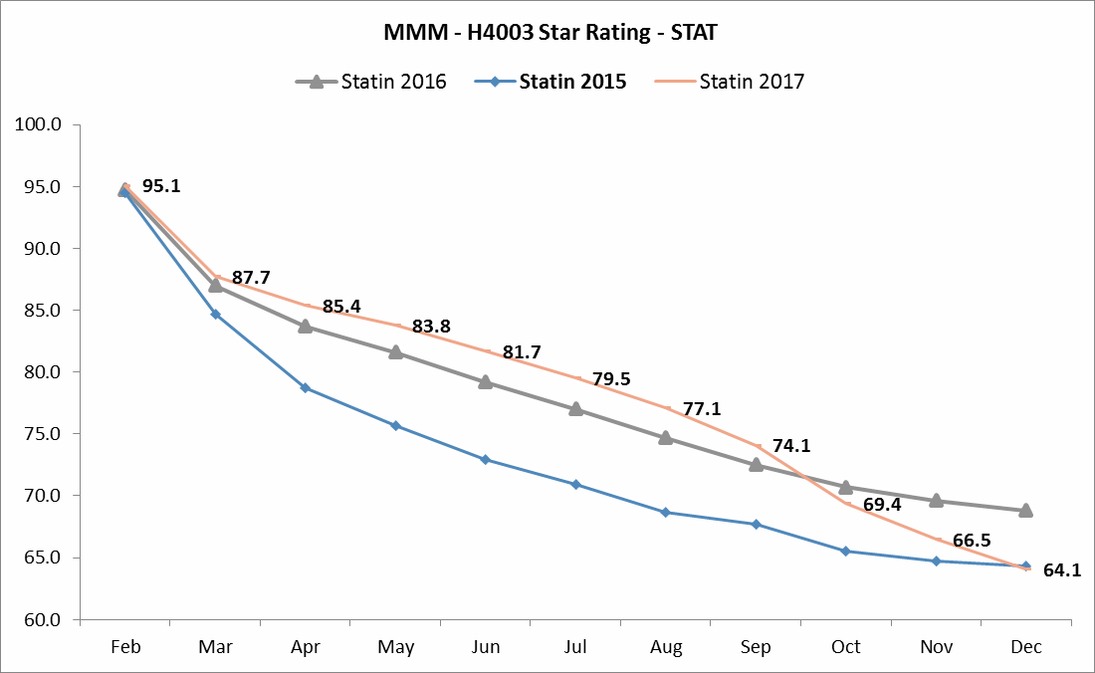

of these elements combined to create challenges for patients to receive treatment, and even when treatment was obtained, there were limited opportunities for the Plan to monitor execution.

As can be observed from the table below, the performance observed for contract H4003 (the Plan’s contract with the highest enrollment) for the Adherence to Statins measure has shown consistent year over year improvement, with performance for Q1-Q3 of 2017 showing even better performance than that of 2016, until Hurricanes Irma and Maria hit when the adherence line drops noticeably.

At the same time, the SPC and SUPD measures were recently introduced as display measures for RY2017. In fact, SPC is a very recent HEDIS measure first introduced in 2016 and still undergoing changes by NCQA. As a result, there is no cut points history for any of these measures to enable plans who are eligible to do so to decide to report or not report the measures. We believe there is a need to correct what would otherwise be an unfair result for plans in regions adversely impacted by natural disasters, and see several possible ways to manage the impact of these measures:

* + 1. Allow measures to remain on display for one more year for all contracts.
    2. Based upon criteria applying exceptions for the adherence measures, allow for these measures to bare a weight of 0 for contracts in Puerto Rico (and other contracts that



comply with the minimum threshold of 25% of beneficiaries in a FEMA-designated area)

* + 1. Based upon final cut points determination, for eligible plans with the minimum threshold described in point 2 above, allow for the use of the measure if the impact on the overall rating is null or beneficial.

# Other Star Ratings Measure Adjustments (p.139)

The Draft Call Letter proposes that all other measures for contracts meeting the minimum threshold described above would be based on the higher of the contract’s RY2018 and RY2019 Star Ratings (and corresponding measure rating), with the exception of Foreign Language Interpreter and TTY Availability and appeals related measures. These measures were excluded based on the belief that they are “completely in the plan’s control… and therefore that there should be no impact from the declaration of a disaster.” We differ with this conclusion because, although business continuity plans we had in place allowed us to be up and running relatively soon after the disaster, and despite some waivers put in place that were intended to open access, we still had some dependency on external parties that may have an impact on results, once fully evaluated. Even today, the island is still experiencing some issues with externally provided communications services, including our Foreign Language translating company. While it is still too early to assess any detrimental impact on these measures, we recommend that these measures be treated the same as the other measures, based on the higher of RY2018 and RY2019 Star Ratings.

The Draft Call Letter also makes reference about the Improvement Measures, and the exclusion from these calculations of measures that revert back to the 2018 Star Rating. In summary, if the plan cannot meet the usual rule where to receive a Star Rating in the improvement measures a contract must have measure scores for both years in at least half of the required measures used to calculate the Part C or Part D improvement measures, the contract will be evaluated without improvement. While this determination seems fair on its face, it can have a punitive impact on contracts like ours that have invested significant efforts to improve on their measures over time. As an example, the adherence measure above has a weight of 0 for the Rating calculation, but holds its entire weight and behavior for the improvement calculation. Yet it is evident that had it not been for the impact of Hurricane Maria 2017 would have ended at a rate even higher than that seen in prior years. We believe it does no harm to calculate the improvement based upon actual RY2019 scores and revert back to RY2018 Improvement Rates if it is higher. Most importantly, we strongly urge that Overall and Summary Ratings should be no less than the result for the most recently evaluated Rating, in this case, RY2018.

# Attachment II – Section A3 - Contract Consolidations and QBP (p. 12)

We disagree with the proposal to assign Star Ratings based on the enrollment–weighted mean of the measure scores of the surviving and consumed contract(s) so that the ratings reflect the performance of all contracts involved in a consolidation. The Star Ratings for a contract are based upon its performance over a period of time and are intended to reflect how well a contract manages its enrollees over that particular period of time, which does not include services or care



coordination on behalf of the beneficiaries of the incorporated contract. There is a time lag between plan performance and rating, so assigning an enrollment weighted mean as a rating can be a penalty to the higher rating surviving entity that has demonstrated better care management and will probably improve the experience and outcomes of the consumed contract members. In addition, the proposed mechanics for the determination of first year ratings and second year ratings as well as for the purposes of QBP determinations will add complexities and burden to the calculation system.

The recommendation would be to keep the current methodology. CMS should use its discretion and power to monitor consolidation practices, which represent less than 4% of the total contracts, and further evaluate contracts’ performance in the event of noticeable wrongful consolidation practices. This evaluation should include whether or not upon consolidation into new contracts, performance of future measurement periods for the surviving contract is maintained or improved, versus that of the consumed contract.

# Other Comments

In addition to the very important recommendations provided above, we have the following additional comments and questions:

# Attachment II – Section G – MA Employer Group Waiver Plans (p.25)

We support the CMS recommendation to continue the waiver of the Bid Pricing Tool bidding requirements for EGWPs in 2019.

We would like to take this opportunity to provide feedback on the MA EGWP payment rate for 2019. Our primary concern is limiting large swings in revenue from methodology changes. As such, we recommend maintaining limiting the impact from the blend of individual market bids and EGWP bids in developing EGWP bid-to-benchmark ratio for 2019 on a county level. We believe this will minimize large swings in premiums for the employer groups.

# Attachment II – Section G – Encounter Data as Diagnosis Source for 2019 (p.42)

In general, we are satisfied with the guidance in keeping the 25% EDS 75% RAPS split in PY2019 and supplementing the EDS with RAPS inpatient data. We request CMS provide more information on whether the RAPS inpatient data will be a permanent addition to the EDS risk score, or whether CMS intends to revert to EDS inpatient data in the future.

# Attachment III – Section C - Part D Risk Sharing (p.49)

We continue to support CMS application of the Part D risk corridor as outlined in the Advance Notice.

# Attachment II – Section A4 – Qualifying County Bonus Payment (p. 13)

We appreciate CMS’s interpretation of the Qualifying County Bonus Payment requirements set forth in Sections 1853(o)(3)(B) and 1853(c)(1)(B) of the Social Security Act as not excluding counties for which the MA capitation rate is subject to a cap, which impacted two-thirds of



Puerto Rico’s municipalities. Given the unique circumstances of Puerto Rico, we believe CMS should review the remaining 26 municipalities that did not qualify in 2018.

We believe the county specific qualification for the 2004 Urban Floor criteria in Puerto Rico should be based on the population of the entire territory rather than MSA for the following reasons:

* A majority of MA products in Puerto Rico are marketed and administered to the entire territory
* The geographic area of Puerto Rico in its entirety is similar to many MSAs

As additional support, we note that OMB Bulletin 13-01 from February 28, 2013 states that the MSA designation is “intended to provide nationally consistent delineations for collecting, tabulating, and publishing Federal statistics for a set of geographic areas” and that “an agency using the statistical delineations in a nonstatistical program may modify the delineations, but only for the purposes of that program.”

# Attachment VI - Section III – Part D

**Improving Drug Utilization Review Controls in Medicare Part D (p. 202)**

In response to your invitation for feedback on the important topic of opioid overutilization, we recommend that additional potentiator drugs that should be considered are: orphenadine citrate, cyclobenzaprine, diazepam, barbiturates, diphenhydramine, brompheniramine combined with phenylephrine and chlorpheniramine. We also recommend including an edit to the following interacting drugs in concurrent use with opioids: Serotonin-Norepinephrine Reuptake Inhibitors (SNRIs) and Selective Serotonin Reuptake Inhibitors (SSRIs). Regarding the MME edits, we support hard edits at 90mg MME due to safety concerns presented by high doses. However, we also believe consideration must be given for cases of limited access to diagnosis data like cancer, to avoid a hard reject at point of sale on members in need of the drug who should not be restricted. Additionally, although there are concerns with certain PBMs implementing an edit concomitant to a 7-day supply, we as a Part D sponsor support this. Finally, we recommend for our population flagging therapies involving either of the following combinations (a)(a) two long- acting opioids or (b) opioid and benzodiazepine.

# Using the Best Available Information when making B vs D Coverage Determinations for Immunosuppressants and Inhalation Durable Medical Equipment (DME) Supply Drugs (page 218)

For immunosuppressants proposed changes, we request that you elaborate on this indicator in MARx and how it is expected to be implemented. We welcome more detailed guidance to understand full scope and next steps.

We very much appreciate the opportunity to comment on the Advance Notice and to present the recommendations we believe will help the beneficiaries enrolled in the MA program. We trust



that these comments will be taken into consideration and incorporated in the Final Announcement and Call Letter.

Very truly yours,

Myra Plumey

Chief Compliance Office MMM HEALTHCARE, LLC