-------

# ----





---



L

I

..,. -

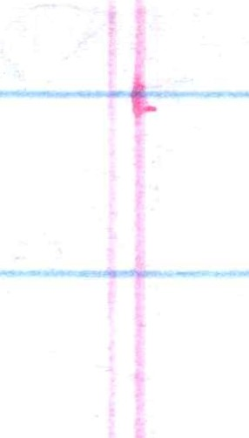'

**H-**

# - -1!. - -

**'i** -

---

--------

*oS Q --- -* -

*J --'<'tl' i,; ro, /µr _L_-"7 _L, ­*

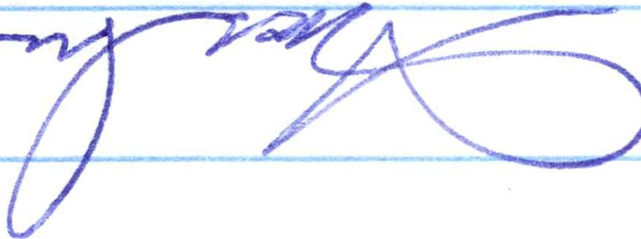

*..).l-ieyt;]Kr;Mc>!? JP i7' tYr y ---=;;;,-,;:-;-:-r-c-l--=---,----,--=- -*

*;-/7J-. ,;7_4?(7 .::r 7 y!7tz?* /..- *rv:-* -vu/ *z~~;~~*

*- -t:,_/ :97[!' YI(-{;? ·_JS'-//??cl'* --

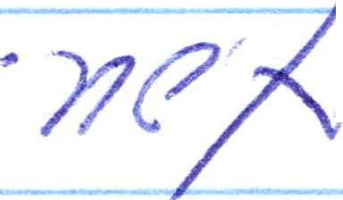

- *, · p;_u // -zYo<-r t:; t/c?tYP7(77* - d *1L-* - - -

*e* ***v, u*** *(>7Jtf{/P:/t7Q -VC?Y//(7 ,,-7// _.!- ---:;-;0'?*

-- *J-::7P11j·P:1Yl e>S' ?'7('1 St?-;nt/ fl 17 a l/ J:L )!_&J?;J- / ef ·- -*

- *'{Jf7IW r' 1 s-f'n? r /t?r( S'JYP! r-1 / ? YJs;--* w· *T* -

- I I ; / • ' ---- _*) ';:..:-- I* 1..-.-'

--- - - - / *""?/_:_,t,{('i_) ;µ.(('17*

*Pa'I fip_ ;;,flY,_* ***;;,:::,ti//!*** *.f:'fU- #, 1:7 [-l* -*_d'CT* • *u-v,;, :;,.y* <:;;-

***--7f'Yl#'.?<?****IJ -L* ***'..\'-<?7*** ' "***f***' ***_L]/1?,#_L/ r,1 2/C7' tl/ -Yl <PJ* ;t:,s--i - - - -**

- - - *".W--"'W (';'-fr'r}?/?f'I;;,,(/,7*

*_L_,(?1/ fg-.f..l_JYJ* r D *.( -2.. ,) ( ._LOV* j *-:. ir f<- ?C d"*;.;,*>rr*

*(/lYtp -F pr'°(7 0,'1e,rrreL7'<l{/"* J2 ;/*! 2p' _J_ n-p7e:J )/,:_Ls;:> -L._'1r*

*-L_74Y,J f?#P7 x ..,,i,)(lv 1 >rw r;- '0/#'rj11..L/c:1 -;y·Q-r S_L,:X/ --v 1...*

0 . *{ I*

*./;:p ;(;Ye> ~~tt:J~~-* -- ---

*-;;>,Vy {t{? L.Y/ <-1.P?J Q_L J. rr·,1 @*

*?>rs ? e(!? .L_(? '?.) t7?J-,f/' rv../--#TI (7'7 (I* ;;*s*, *(Y_* / J? *ii>!*

-L..-' *CA;,/! <'"'¥ Gt)- -L.Yff"_J.2t1p* ..,s. *ff"* _l\ 7_:,*17/' -l -*--

·*3 - / ? c? a:'r/p 1, fY/q? _::? L J /o!?Yo k -P-* ----

- *-L._Yi'!? ?0* _,*t, c:_L Rlilj-V- ./fi"Prr:{j'/c7Jf/!AI >/117(* _J , / ;-:, *n'?*J /-;;,J:'.-- -- -

*27(_ y_ j?' ]'71:> ;;,.-l/*

f _:::;,r '/7/WJZ/

*1._g- "'I/ .>.fS* - - - -- -

*".:::'.' ?' ,: ,,,t?iYj',_5* -'>i0"Cf*S?'--=3::t' ;:I'?S' ;,,3L'( -* - - --

- / - - - - *(Yj7'-P,/vo* / _z- *(?yr;* :-?- ·-- -

*c- :/· y;/ (l*