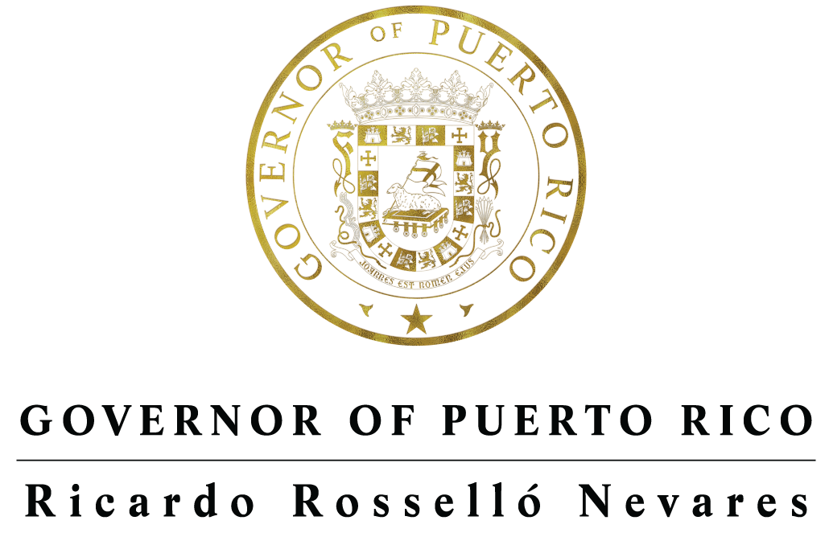

March 5, 2018

The Honorable Alex Azar Secretary

United States Department of Health and Human Services (HHS) 200 Independence Avenue SW

Washington, D.C. 20201 Dear Secretary Azar,

I greatly appreciate you taking the time to meet with me during the recent National Governors Association Winter Meeting. I was very encouraged by your knowledge about Puerto Rico and your interest in working with me to address the unique challenges our health care sector has as well as to maximize the opportunities that are currently before us. As my administration works to navigate through Puerto Rico’s economic challenges and recover from last year’s natural disasters, it has become clear that fixing our health care system and its funding structures is critical for our island to be able to achieve sustainable socio-economic revival. To accomplish this, Puerto Rico must work in close partnership with federal authorities in both the executive and legislative branch, therefore, I want to take this opportunity to highlight some immediate steps we can take together to advance this process.

The emergency supplemental funding that became law last February (Public Law 115-123, Bipartisan Budget Act of 2018) will help provide critical relief for us to meet the healthcare needs of more than 600,000 of the most vulnerable residents of Puerto Rico. While the new funds stabilize Puerto Rico’s Medicaid program through 2020, the program’s federal funding cliff remains as a very real threat. That is why I ask to work closely with your Department in the coming months to identify a long-term solution to Puerto Rico’s Medicaid funding structure that we can present to lawmakers in the next session of Congress before we get close to the next Medicaid cliff deadline.

In the past year Puerto Rico Department of Health and our State Health Insurance Administration (ASES) have made significant advances in the development and implementation of the Puerto Rico Medicaid Management Information Systems (PRMMIS), which will support development and implementation of an Medicaid Fraud Control Unit (MFCU) in Puerto Rico. I also look forward to demonstrating to your satisfaction that we are implementing methods for the collection and reporting of reliable data to the Transformed Medicaid Statistical Information System and to demonstrate our progress in establishing a Puerto Rico MFCU as required by P.L 115-123.

Beyond this, my administration has outlined additional reforms we intend to carry out as part of our Fiscal Plan to transform Puerto Rico’s healthcare model. These sweeping reforms to our healthcare system will lead to a better delivery of care, increase accountability, reduce costs, and reduce fraud, waste and abuse. I ask for the help of HHS to work with us through the review, approval and implementation of these local policy changes.

As we discussed, Medicare Advantage (MA) is one of the three pillars that sustains Puerto Rico’s healthcare industry along with Medicaid and the private health insurance sector. Unfortunately, Puerto Rico’s MA program has suffered from disproportionate Obamacare-related reductions in recent years and is subject to a significant funding gap compared to other states and territories. The MA rates for Puerto Rico counties averaged 24% less than the National average in 2011, but after the Obamacare cuts they are 43% lower (2018). Moreover, they are 39% lower than the state with the lowest MA rates, and 26% lower than the U.S. Virgin Islands. The impact of these disparities cannot be overstated since Puerto Rico has the highest MA beneficiary penetration in the nation (~75%), MA serves 97% (275,000) of all the dual eligible beneficiaries with Medicare Parts A & B on the island through an integrated Dual-Special Needs Program (D-SNP), only possible through the MA platform, and in 2018 over 95% of members are in 4 STAR plans. Therefore, we request your support for the inclusion of policy and MA rate adjustments in the in the *2019 Final Announcement and Call Letter* that can meaningfully mitigate the harmful funding gap for MA in Puerto Rico.

There is precedent for HHS giving guidance to CMS to make policy adjustments for MA rates. For the 2017 rates, the HHS Secretary instructed CMS to make an adjustment in the MA rate setting formula with the purpose of mitigating the continuing increase in the anomalous funding gap for the MA program affecting beneficiaries in Puerto Rico. Still, as evidenced by the simple benchmark numbers, these adjustments are far from enough. My administration and the community of stakeholders in Puerto Rico have analyzed the issue and developed policy alternatives that are meaningful and executable as part of the *2019 Final Announcement and Call Letter* for MA. I urge you to use the full scope and flexibility of HHS and CMS administrative authority to define a new path forward for MA in Puerto Rico, as follows:

* **Methodological Changes for Calculation of MA Benchmarks or a National Floor:** CMS and HHS can establish additional methodological changes that may be appropriate for the calculation of the 2019 MA benchmarks or define a National floor of 0.70 in the average geographic adjustment (AGA) applied to all counties in the nation. Through the later, the policy would protect any county at the National level from falling to abnormally low AGA factors resulting from unexplained variabilities or deficiencies in data, especially as MA penetration continues to increase in many US markets.
* **Additional Monitoring and Reporting Tools for MA in Puerto Rico:** To ensure the new policy supports program objectives, CMS can define additional monitoring and reporting tools with MA plans in Puerto Rico, including a multi-year implementation period of a new MA rate methodology adjustment. I am convinced that measuring effects of the new policy will reveal lessons from the Puerto Rico scenario valuable nationally, especially in relation to value-based services, and social determinants of health.
* **Meaningful Reduction in the ESRD MA Rate Gap for Puerto Rico:** A meaningful step can also be achieved if the regular and End-Stage Renal Disease (ESRD) MA rates for Puerto Rico can be brought to a level that meaningfully reduces the gap, in a similar position as the current payment levels in MA for counties with similar costs of living nationwide or at least to the current level of MA payment rates for the neighbor territory of U.S. Virgin Islands.

Finally, I propose we re-establish the *Puerto Rico – HHS Technical Joint Work Group* to generate a process that can actively address the federal healthcare policy anomalies and propose actionable policy solutions. This is an initiative that has been implemented directly by your office in the past would periodically bring together top HHS officials with a small group of Puerto Rico public officials and key private sector subject matter experts, to discuss issues critical to the island.

We have a unique window of opportunity this year to improve public policies that can set a new healthcare foundation for Puerto Rico’s future. For all the pain and misery that Hurricane Maria brought to the U.S. citizens of Puerto Rico, it has also granted us a chance to rebuild our society on the island. For Puerto Rico to fully recover and rebuild, a strong, reliable and resilient healthcare system must be part of the equation. I look forward to working with you and your team at HSS toward that goal.

Sincerely,

Ricardo Rosselló Governor