Pride Mobility appreciates the opportunity to submit comments on the “2019 Medicare Advantage and Part D Notice Part II and Draft Call Letter” section that proposes “Expanding Health Related Supplemental Benefits.”

Pride Mobility Products Corp. is the world's leader in the design, development and manufacture of mobility products - power wheelchairs, lift chairs, scooters, and vehicle lifts/ramps - for people with disabilities and mobility impairments. Our company is committed to working with the Centers for Medicare and Medicaid Services (CMS) to expand health related supplemental benefits.

Currently the Durable Medical Equipment Prosthetics, Orthotics and Supplies (DMEPOS) benefit does not cover or provide reimbursement for a seat elevation feature when it is provided on a power wheelchair (PWC) on the grounds that it does not fit within the DME benefit category. The CMS has stated, “a power seat elevation feature (E2300) is non-covered because it is not primarily medical in nature”[1] per Medicare coverage criteria. As a result, Medicare beneficiaries with permanent disabilities who are also unable to stand up from their complex rehab technology (CRT) power wheelchair do not have access to this critical, enabling technology.

We request that CMS expand the definition of health-related supplemental benefits to include this technology, which under the current definition is excluded due to CMS’ position that this technology does not serve a medical purpose, even though it does compensate for physical impairments, diminish the impact of health conditions, and/or reduce avoidable emergency room utilization through prevention of falls and over use injury.

According to the National Coverage Determination for Mobility Assistive Equipment (MAE), “Medicare beneficiaries who depend upon mobility assistance are found in varied living situations. Some may live alone and independently while others may live with a caregiver or in a custodial care facility. The beneficiary's environment is relevant to the determination of the appropriate form of mobility assistance that should be used. For many patients, a device of some sort is compensation for the mobility deficit.”[2]

“Effective May 5, 2005, CMS finds that the evidence is adequate to determine that MAE is reasonable and necessary for beneficiaries who have a personal mobility deficit sufficient to impair their participation in mobility-related activities of daily living (MRADLs) such as toileting, feeding, dressing, grooming, and bathing in customary locations within the home.”[3]

Power wheelchair utilization for 2015, obtained through the Freedom of Information Act and the Medicare Part B National Summary Data File, reveals that 43,366 Medicare beneficiaries either rented or purchased a power wheelchair (K0814 – K0864)[4] in the first month it was deemed medically necessary to ameliorate their mobility limitation(s) and allow them to perform or participate in their MRADLs. While a power wheelchair provides the user with 360⁰ of movement in a two-dimensional plane we live in a three-dimensional world. As such, access to the vertical environment is often precluded for individuals with a permanent disability who meet the coverage criteria for, and use a Group 3 power wheelchair – which is less than 35% of the power wheelchair (PWC) utilization. This negatively impacts their ability to perform or participate in their MRADLs independently, safely, and in a timely manner often resulting in the unnecessary expense of personal care assistance (PCA) or a preventable adverse occurrence.

In 2016 Georgia Tech conducted a survey of power wheelchair users who have a power adjustable seat height (PASH) system on their current wheelchair to solicit information as to when, where and why this feature is used. 78% of the 156 respondents were experienced wheelchair users who had used a seat elevator for over a year. When asked to estimate the relative frequency of using the seat elevation feature in the locations listed 93.6% indicated that they use it in the home often or sometimes.

|  |  |  |  |  |  |  |  |  |
| --- | --- | --- | --- | --- | --- | --- | --- | --- |
|  | Often | # | Sometimes | # | Rarely | # | Never | # |
| At Home | 78.9% | 86 | 14.7% | 16 | 4.6% | 5 | 1.8% | 2 |
| At work or school | 45.3% | 43 | 23.2% | 22 | 10.5% | 10 | 21.1% | 20 |
| In the community | 56.5% | 61 | 37% | 40 | 5.6% | 6 | 0.9% | 1 |
| Outdoors | 38.5% | 42 | 32.1% | 35 | 24.8% | 27 | 4.6% | 5 |

One half of the respondents reported using the seat elevating feature more than once per hour and when asked to report on the activities for which elevation was used they responded:

|  |  |  |  |  |  |  |  |  |
| --- | --- | --- | --- | --- | --- | --- | --- | --- |
|  | Often | # | Sometimes | # | Rarely | # | Never | # |
| During transfers to or from the wheelchair | 63.8% | 67 | 16.2% | 17 | 7.6% | 8 | 12.4% | 13 |
| To help reach things | 81.9% | 86 | 13.3% | 14 | 3.8% | 4 | 1% | 1 |
| Improve gaze or line of sight | 55.2% | 58 | 29.5% | 31 | 11.4% | 12 | 3.8% | 4 |
| While dressing | 16.3% | 17 | 26% | 27 | 17.3% | 18 | 40.4% | 42 |
| While grooming (brushing teeth, combing hair, etc.) | 39.4% | 41 | 23.1% | 24 | 16.3% | 17 | 21.2% | 22 |
| While eating or preparing a meal | 59.2% | 61 | 24.3% | 25 | 6.8% | 7 | 9.7% | 10 |
| During toileting activities | 27.2% | 28 | 17.5% | 18 | 22.3% | 23 | 33% | 34 |
| During bathing activities | 21% | 22 | 10.5% | 11 | 17.1% | 18 | 51.4% | 54 |

The mobility related activities of daily living identified by these wheelchair users are in alignment with the research and case studies cited as part of the Rehab Engineering Society of North America (RESNA) Position on the Application of Seat-Elevating Devices for Wheelchair Users, published in 2009, which states, “A common intervention that provides vertical mobility within a wheelchair is a seat-elevating device.”[5]

The National Coverage Determination for Mobility Assistive Equipment asks if “other limitations exist; can they be ameliorated or compensated sufficiently such that the additional provision of MAE will be reasonably expected to significantly improve the beneficiary’s ability to perform or obtain assistance to participate in MRADLs in the home?”[6]

According to more than 200 experts in the field of seating and wheeled mobility (Physical Therapists – PTs, Occupational Therapists – OTs and RESNA Certified Assistive Technology Professionals – ATPs) who participated in a survey conducted by Quantum Rehab in 2016 the answer is YES., other limitations individuals with permanent disabilities who experience a loss of function, and use CRT power wheelchairs can be ameliorated or compensated for with the addition of a medically necessary power elevating seat.

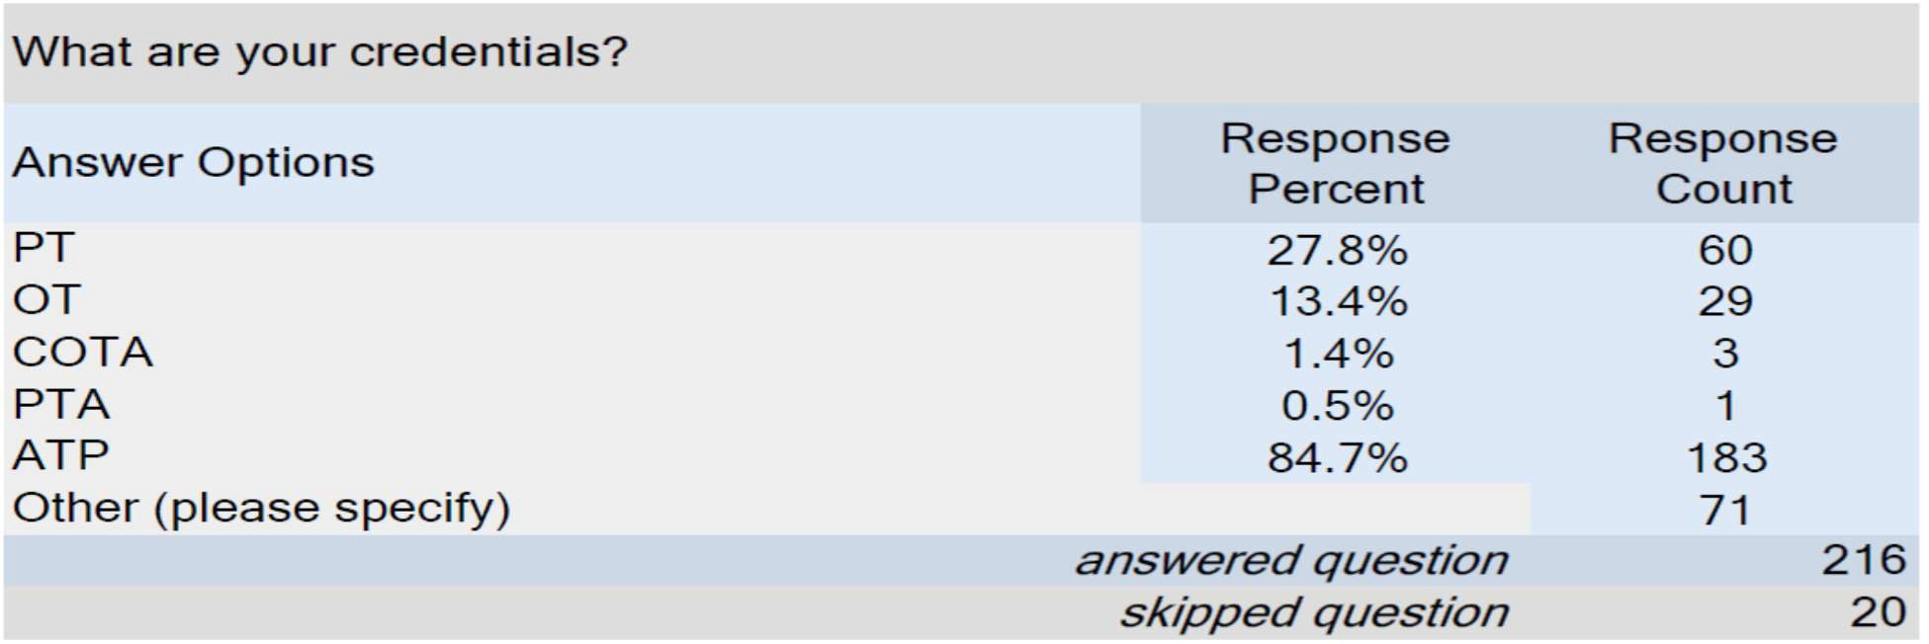

These experts disagree with CMS’s longstanding contention that a seat elevation feature is similar to lifting or elevating equipment, such as bathtub lifts, bed lifters or elevators and stairway elevators as. A power adjustable seat height system is a power seat option that is independently operated by the wheelchair user to replace a loss of function. While the experts would agree that the feature may be used for non-medical purposes the primary use of the feature is necessary to allow the individual to perform or participate in the MRADLs.

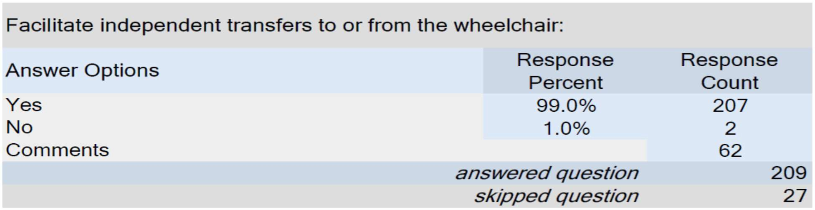

Transferring from a wheelchair to other surfaces such as a bed, toilet, or other surface is a necessary part of the daily routine. Transferring is a means to accomplish MRADLs (Mobility Related Activities of Daily Living). PASH is necessary to:

1. Enable transfers across unequal surface heights
   1. Adjust seat height above the surface to be transferred to/below surface to be transferred from, or
   2. Adjust the seat height equal to the surface to be transferred to/from in order to:
      1. Compensate for Lower Extremity (LE) weakness
      2. Compensate for Upper Extremity (UE) weakness and/or limited range of motion
      3. Compensate for joint or muscle pain in the neck, back, UEs or LEs
      4. Minimize the resistance of gravity when attempting to transfer uphill
      5. Compensate for balance challenges at rest or when moving

“A wheelchair user is more readily able to transfer in a downhill direction using a sliding board versus uphill or to a level surface. In the downhill direction gravity assists as opposed to providing additional resistance and difficulty, as in the uphill direction. Transferring in a downward direction requires less upper extremity strain.”[7]

To independently transfer from the power wheelchair to her bed at 23” high with her sliding board Madonna adjusts the wheelchair seat height to 24” from its static, low height of 21”. When she transfers from her bed she adjusts the wheelchair seat height to 22”. This allows her to utilize gravity effectively to assist with the transfer without putting her at heightened risk for an adverse occurrence, such as a fall. Without this feature, individuals with a permanent disability, such as amyotrophic lateral sclerosis, muscular dystrophy, a spinal cord injury, or multiple sclerosis, who use this feature to replace the loss of function in their lower extremities, are often rendered dependent on a personal care attendant (PCA) to transfer to/from their chair.

A wheelchair user may adjust the wheelchair seat to several different heights throughout the day depending on whether s/he is transferring to or from the bed, toilet or in/out of a shower commode chair for bathing.

Without this capability the wheelchair user is at heightened risk for injury from a preventable fall during the transfer, especially towards the end of the day when fatigue is heightened.

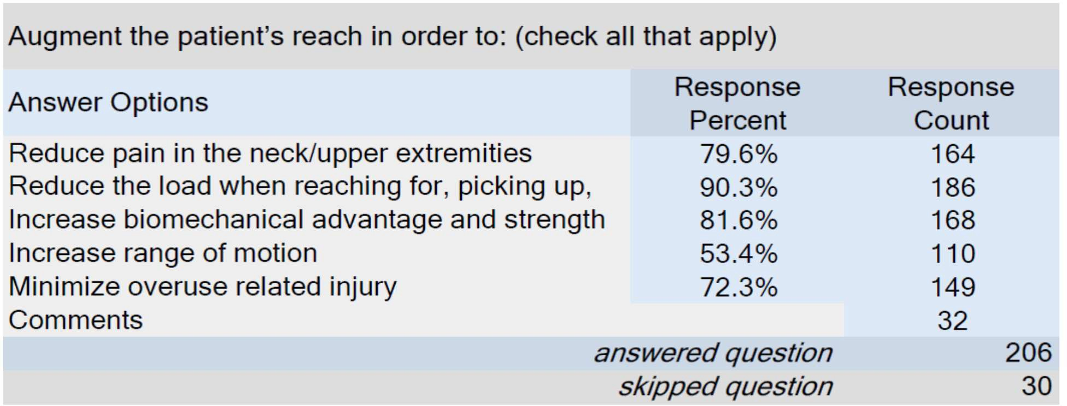

“Seat elevators may also help reduce upper extremity pain and help delay secondary complications to the shoulders. Studies have found an association between overhead activity and the development of shoulder pain and shown that the degree of upper arm elevation is one of the most important parameters influencing shoulder muscle load. When reaching from an elevated position, these loads are reduced, which is significant for individuals with already compromised upper extremity strength and range of motion.”[8]

A study comparing the frequency and duration of overhead arm activity between wheelchair users and occupationally matched non- wheelchair users during an 8-hour workday found that wheelchair users performed an average of 297 episodes of overhead arm activity, while controls performed an average of 53 episodes.[9] According to a number of studies, surgical treatment for rotator cuff tears can cost between $300 and $15,000 (hospital cost), and approximately $250 to $5,000 for surgeon fees. For Madonna use of a power wheelchair with a PASH system is essential to replace the loss of function she has experienced with her disability and to preserve her upper limb function, safety and continued independence.

“The upper limb and neck are common sites for the development of repetitive strain injuries (RSI), a constellation of musculoskeletal injuries caused by repetitive movements, awkward postures and sustained force. Problems typically begin with mild symptoms of pain, fatigue, numbness, tingling, and stiffness that rise and dissipate depending on activity demands. These initially minor symptoms have the potential to develop into debilitating disorders such as shoulder impingement syndrome, frozen shoulder, shoulder tendinitis, thoracic outlet syndrome, and tension neck syndrome.”[10]

“For individuals with limited reaching abilities, a seat elevating device may be necessary for access to objects and surfaces within their home...improving their independence and decreasing their dependence on others.”[11]

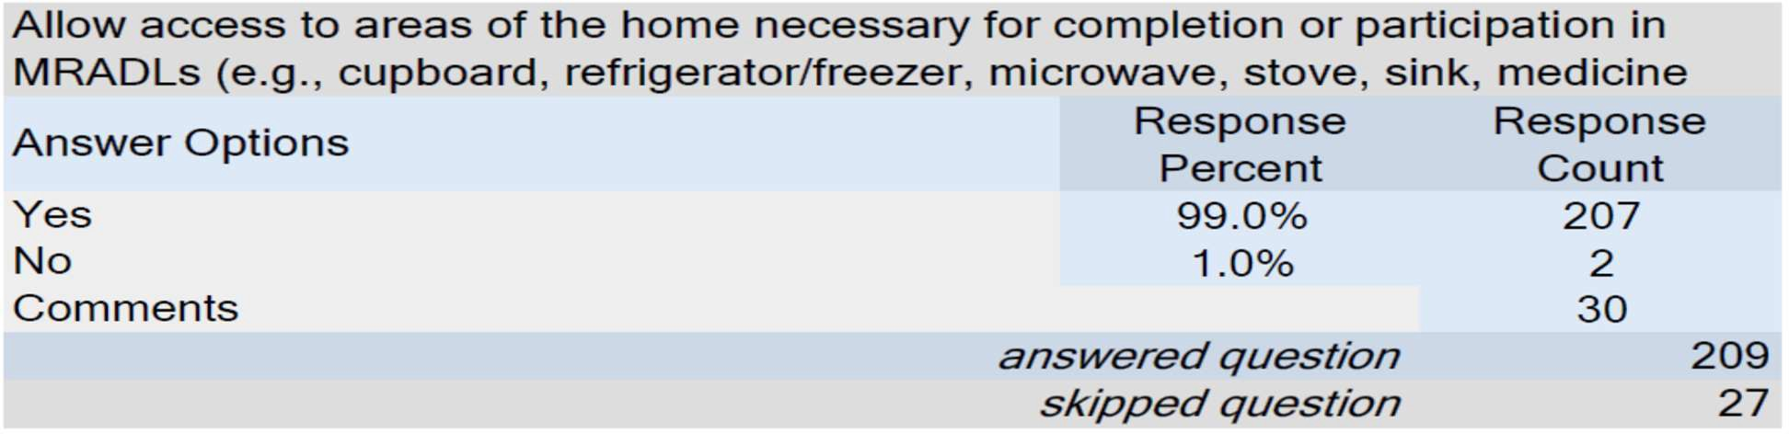

For individuals with a permanent disability a power adjustable seat height is medically necessary to:

1. Enable performance/participation in Mobility Related Activities of Daily Living (MRADLs) such as bathing, dressing, feeding, grooming and toileting in the customary locations of the home.
   1. Adjust the vertical position of the seat to facilitate reach and:
      1. Compensate for UE weakness and/or limited range of motion
      2. Compensate for pain in the neck, back or UEs
      3. Compensate for balance challenges at rest or while moving
      4. Compensate for the inability to stand

“Feeding” as a MRADL comprises all aspects of meal preparation including, but not limited to shopping for groceries, putting them away, cooking the meal, eating and cleaning up afterwards. Stephanie is fully independent and safe in performing each step of the essential, life sustaining activity of obtaining nutrition and hydration as she has full access to the vertical environment with the use of a power adjustable seat height system.

The inability to reach and function safely in the kitchen, or lack of adequate access to food and water puts Stephanie at heightened risk for preventable and costly secondary medical complications.

Without this power seat option, Medicare beneficiaries with permanent disabilities may be rendered dependent on an unnecessary personal care attendant for at least 3 hours per day as their only other way to compensate for the loss of function brought about by their condition. At a median salary of $10/hour[12] this equates to a cost of $10,950 for PCA services annually, or $54,750 over the 5-year reasonable useful lifetime of the equipment.

The MRADL of “grooming” may include, but is not limited to brushing/styling one’s hair, putting on make-up or shaving in the customary location of the home – the bathroom. The medically necessary power wheelchair will allow the individual with a permanent disability to get to the bathroom, but the PASH is an essential component to their success in performing or participating in these activities at the highest level of independence possible.

**Conclusion:**

**Pride Mobility requests that CMS expand the definition of health-related supplemental benefits to include this power adjustable seat height technology, which CMS currently excludes from coverage due to their position that this technology does not serve a medical purpose, even though it does compensate for physical impairments, diminish the impact of health conditions, and/or reduce avoidable emergency room utilization through prevention of falls and over use injury.**

**Thank you again for the opportunity to provide comments on the 2019 Medicare Advantage proposal to expand health related supplemental benefits. Please contact Seth Johnson, VP of Government Relations at 1-800-800-8586 x1480 if you have any questions regarding these comments or would like to discuss in more detail.**

1. 1. Noridian Healhcare Solutions, LLC (2016). LCD for Wheelchair Options/Accessories, Effective 01/01/16, Retrieved on 01/09/17 from https://med.noridianmedicare.com/documents/2230715/2240923/Wheelchair+Options+Accessories.pdf/e43667cc-121f- 42dd-99fb-b4b0372e522e
   2. CMS, (2005). 280.3 Mobility Assistive Equipment (MAE), (Effective May 5, 2005), Medicare National Coverage Determinations Manual Chapter 1, Part 4 (Sections 200 – 310.1) Coverage Determinations, Retrieved on 01/09/17 from https://[www.cms.gov/medicare-](http://www.cms.gov/medicare-) coverage-database/details/ncd-details.aspx?NCDId=219&ncdver=2&bc=AAAAgAAAAAAAAA%3d%3d&

  
2.
3. 1. CMS, (2005). 280.3 Mobility Assistive Equipment (MAE), (Effective May 5, 2005), Medicare National Coverage Determinations Manual Chapter 1, Part 4 (Sections 200 – 310.1) Coverage Determinations, Retrieved on 01/09/17 from https://[www.cms.gov/medicare-](http://www.cms.gov/medicare-) coverage-database/details/ncd-details.aspx?NCDId=219&ncdver=2&bc=AAAAgAAAAAAAAA%3d%3d&

  
4. 1. Part B National Summary Data File Retrieved on 01/09/17 from https://[www.cms.gov/Research-Statistics-Data-and-](http://www.cms.gov/Research-Statistics-Data-and-) Systems/Downloadable-Public-Use-Files/Part-B-National-Summary-Data File/Overview.html

  
5. 1. Arva, J. et al, (2009). RESNA Position on the Application of Seat-Elevating Devices for Wheelchair Users. Assistive Technology, 21(2), 69-72. http://doi:-10.1080/10400430902945587.

  
6. 1. CMS, (2005). 280.3 Mobility Assistive Equipment (MAE), (Effective May 5, 2005), Medicare National Coverage Determinations Manual Chapter 1, Part 4 (Sections 200 – 310.1) Coverage Determinations, Retrieved on 01/09/17 from https://[www.cms.gov/medicare-](http://www.cms.gov/medicare-) coverage-database/details/ncd-details.aspx?NCDId=219&ncdver=2&bc=AAAAgAAAAAAAAA%3d%3d&

  
7. 1. Arva, J. et al, (2009). RESNA Position on the Application of Seat-Elevating Devices for Wheelchair Users. Assistive Technology, 21(2), 69-72. http://doi:-10.1080/10400430902945587.

  
8. 1. Arva, J. et al, (2009). RESNA Position on the Application of Seat-Elevating Devices for Wheelchair Users. Assistive Technology, 21(2), 69-72. http://doi:-10.1080/10400430902945587

  
9. 9,10. Sabari, J., Shea, M., Chen, L., Laurenceau, A., Leung, E, (2016). Impact of Wheelchair Seat Height on Neck and Shoulder Range of Motion During Functional Task Performance. Assistive Technology, 28(3), 183-189. http://doi:10.1080/10400435.2016.1140692
10.
11. Arva, J. et al, (2009). RESNA Position on the Application of Seat-Elevating Devices for Wheelchair Users. Assistive Technology, 21(2), 69-72. http://doi:-10.1080/10400430902945587.
12. http://www.payscale.com/research/US/Job=Personal_Care_Attendant_(PCA)/Hourly_Ra