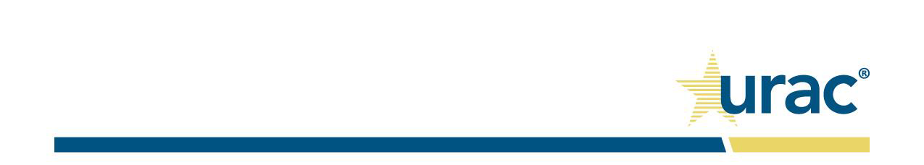

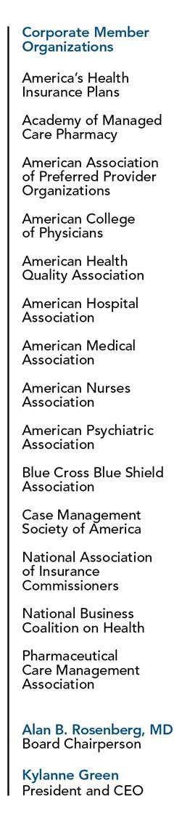January 12, 2018 Seema Verma

Administrator, Centers for Medicare and Medicaid Services

U.S. Department of Health and Human Services 200 Independence Avenue, SW

Washington, DC 20201 RE: CMS-4182-P

Dear Administrator Verma,

On behalf of URAC I respectfully offer our comments in response to the proposed policy changes for Medicare Advantage and the Prescription Drug Benefit Program for contract year 2019.

URAC is the premier accreditor of pharmacies and pharmacy benefit management organizations. Industry leading organizations and Part D sponsors hold URAC accreditation including CVS Caremark, Express Scripts, OptumRx, Aetna, Humana, and Cigna. URAC accredits more than 300 licensed pharmacies as specialty pharmacies located across the country. Many of the pharmacies that have achieved URAC Specialty Pharmacy Accreditation are small, community, and regional pharmacies.

The debate regarding appropriate access to pharmaceuticals and pharmacies is not limited to Medicare. In fact, commercial insurers, pharmacy benefit managers (PBMs), physicians, pharmacies, and accreditors have been at the forefront. As patients have relied on an increasing number of specialty drugs for their care, payers, employers, and their contracted PBMs have focused on the elevated risks associated with these increasingly complex medications and disease states. While the short-term impact of these management efforts on access must be monitored, the importance of quality management as it relates to patient safety and outcomes must not be overlooked.

As detailed in our comments included with this letter, we urge CMS to take an active role in this debate as we fear Medicare is at risk of falling behind nationally accepted principles of pharmacy management. While we understand CMS’s decision not to define a “specialty pharmacy” for fear of an undue influence on the market, we would note that there are broadly accepted, established principles of quality upon which CMS can engage to ensure Medicare enrollees are afforded the same level of quality care as commercially insured patients.

URAC supports CMS’s efforts to ensure Medicare enrollees continue to enjoy access to pharmaceuticals and pharmacies in their communities. Our position has provided URAC with unique insight into the rapidly evolving environment in which patients receive care via increasingly complex and potentially harmful pharmaceuticals. As CMS explores the role of quality management in Part D, URAC stands ready to support CMS’s efforts wherever possible. Please do not hesitate to call on URAC as a resource at any time.

Sincerely,

Kylanne Green

Kylanne Green President and CEO

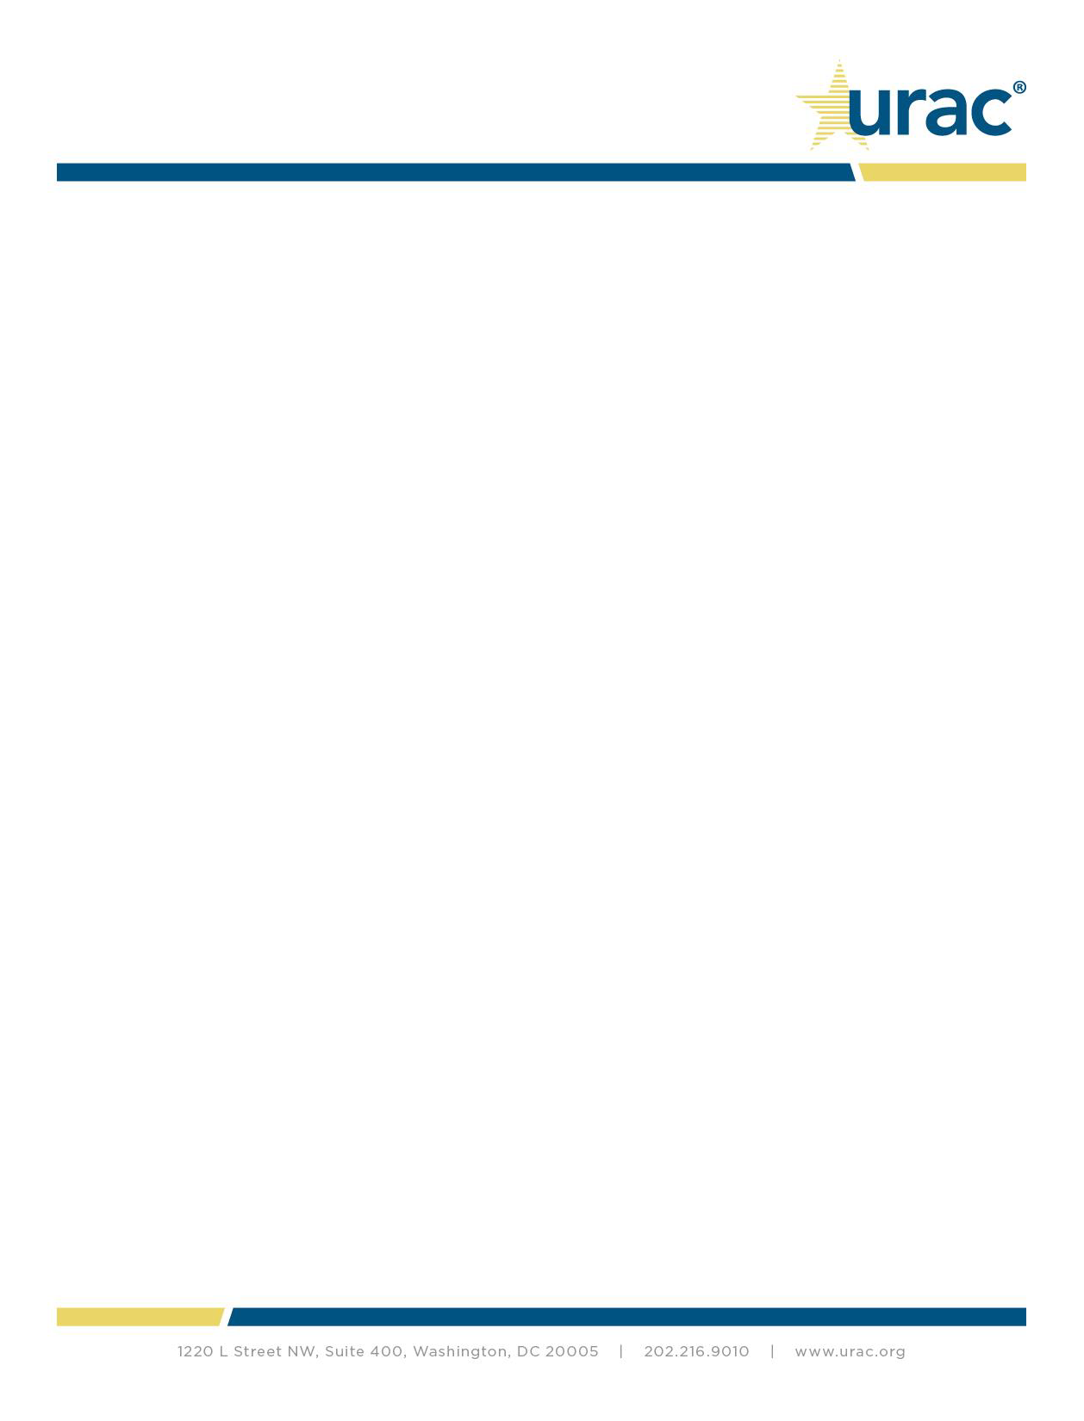

Role of Accreditation in Pharmacy Quality

URAC appreciates CMS’s continued recognition of the role for accreditation in the Part D program. While the question of the appropriateness of accreditation in Part D sponsor contracts is worthy of discussion, it is important to first recognize the central role pharmacy accreditation, specifically specialty pharmacy accreditation, is playing in the broader delivery system.

Given the complexity of specialty medication and the potential for serious side effects, pharmacies must deploy specific competencies in a reliable manner to promote and document positive clinical outcomes. URAC’s Specialty Pharmacy Accreditation is structured around the idea that all pharmacies dispensing specialty drugs must do more than focus on the right patient, the right drug, at the right time. URAC believes the pharmacy should be focused on delivering the right result for patients. Those pharmacies that have achieved URAC Specialty Pharmacy Accreditation have demonstrated their ability to safely dispense and effectively manage the care of patients who require increasingly complex medications.

Commercial payers and their pharmacy benefit managers (PBMs) often seek to ensure that pharmacies within their networks are meeting industry standards by requiring accreditation. For example, specialty pharmacies manage and deliver pharmaceuticals that may require special handling, patient education, and clinical monitoring. A failure on the part of the specialty pharmacy to appropriately perform any aspect of the storage, delivery, education, or monitoring of a specialty drug might lead to patient safety issues as well as the inability of patients to receive a life-saving therapy.

Therefore, commercial payers are focused on the quality of services delivered within their networks in order to protect patients and reduce the human and financial costs associated with poor quality. Organizations that fail to achieve accreditation have a greater potential to deliver care that results in real harm to patients as they have failed to demonstrate their ability and capacity to care for complex patients receiving complex drugs. As a tool of quality assurance, PBMs look for an independent validation of excellence to ensure that their network has the capacity to fully provide these highly specialized services.

URAC prides itself on designing accreditation programs that are accessible to all organizations who wish to demonstrate their commitment to quality regardless of size or business model. URAC’s process for accreditation and pricing takes into account the varying business models that may be addressed by an accreditation program. Our quarter of a century experience evaluating the quality of healthcare organizations has taught us that neither size nor business model is a predictor of quality. This has been true with our experience accrediting specialty pharmacies across the country. To date, more than 300 pharmacies including many small, community pharmacies have pursued and achieved URAC Specialty Pharmacy Accreditation.

Defining Specialty Pharmacy

As CMS correctly notes, Medicare Part D enrollees will continue to need routine access to specialty drugs. However, CMS’s decision to not define specialty pharmacy and defer to later years the discussion of this topic due to the “rapidly changing” environment may be short-sighted. Despite CMS’s intention to not disrupt the market, any decision by CMS, including deferred action, on this issue will directly impact the market as past deferments have shaped today’s environment. CMS’s failure to acknowledge the role that specialty pharmacies play in the management of specialty drugs fails to acknowledge the basic quality principles that have developed in response to the quality and cost pressures associated with specialty drugs.

We encourage CMS to take a more active role in this debate as we fear Medicare may fall behind nationally accepted principles of pharmacy management that commercial insurers have deployed to eliminate fragmentation in the delivery system and protect patients from harm. While we understand CMS’s decision not to define a specialty pharmacy, we would note that there are broadly accepted, established principles of quality upon which CMS can engage. This engagement may not be focused on a definition but more broadly focused on a review of the quality principles associated



with pharmacy management. This effort could then inform and guide Part D sponsors as they set standard contracting provisions for their pharmacy networks. This approach has the benefit of allowing the current Part D program’s any willing pharmacy (AWP) regulations to be met while ensuring CMS allows broadly accepted quality principles to be applied and afford Medicare enrollees the same assurance of quality that is expected in commercial insurance. URAC is happy to support CMS’s efforts in this regard with data and knowledge gathered in our review of the nation’s leading pharmacy organizations.

Accreditation as a Quality Tool in Part D

As highlighted, specialty pharmacy accreditation plays an important role in validating the abilities of pharmacies to effectively manage patients receiving specialty medications. Regardless of how Part D sponsors build their networks, the value of accreditation does not change in that it is always a validator of quality uniquely focused on the skills and services required to appropriately care for patients. We reject any suggestions that the value or impact of accreditation in promoting quality assurance is mitigated by the manner of a network agreement deployed by a Part D sponsor.

Further, we acknowledge that the practice of “specialty pharmacy” is not limited to URAC accredited organizations nor is it defined exclusively by URAC or other accreditors. However, given the unique nature of specialty drugs and the potential impact on the life of a patient, we feel strongly that pharmacies that have validated their capabilities via accreditation are the most appropriate and best positioned to manage patients receiving treatment via specialty medications. This applies to any pharmacy regardless of business model. As evidenced by the various types of pharmacies that have achieved accreditation, any organization regardless of size or practice model that is committed to quality has the opportunity to demonstrate that commitment and achieve accreditation.

Accreditation is a rigorous process that requires a resource investment on the part of pharmacies. As such, we do not support redundant requirements that increase the administrative burden pharmacies encounter. URAC does not support the use of audits or additional credentialing criteria conducted by a Part D sponsor that is redundant to the accreditation achieved by the pharmacies. We believe that this function is best performed by an independent, third-party accreditor.

URAC makes the information required to verify the accreditation status of an organization publicly available via the searchable directory on our website.

Multiple Accreditation Requirements by Part D Sponsors

CMS indicates that it has received complaints from pharmacies that Part D sponsors have begun to require accreditation by multiple accrediting organizations. URAC firmly believes that accreditation is an important independent validator of an organization’s quality, however, we do not support redundant requirements that increase the administrative burden pharmacies face. We believe, where there is substantial similarity among accreditors, one accreditation is sufficient to demonstrate an organization’s quality.

While several organizations offer a specialty pharmacy accreditation, URAC’s Specialty Pharmacy Accreditation is the industry’s premier standard due to the high-level of rigor associated with both the standards as well as the accreditation process. In this regard, there is no substantially similar accreditation program to URAC’s Specialty Pharmacy Accreditation. Having reviewed the standards and processes of other accreditors, we are confident that the rigor of URAC’s standards and processes are unmatched. Therefore, we view any requirement for URAC Specialty Pharmacy Accreditation coupled with an additional accreditation from another entity to be an unnecessary and redundant burden on pharmacies.

URAC is happy to provide as much information as possible to CMS so that you may better assess similarities among accreditors.



Pharmacy Practice Standards and REMS

We agree with CMS’s continued policy to leave the establishment of pharmacy practice standards to the states. However, it is important to recognize the distinct difference between established practice standards as they relate to licensure and accreditation.

URAC standards utilize state practice standards as a foundational principle of our Specialty Pharmacy Accreditation. Where URAC accreditation is a comprehensive review validating the operations of pharmacies based on quality standards defined by national best practices, a state Board of Pharmacy review is often specifically focused on licensure and the environment in which drugs are dispensed. For example, URAC requires a pharmacy to ensure that its pharmacists are in fact duly licensed by the Board of Pharmacy and that all pharmacy personnel function within the legal limitations of scope of practice. In addition, URAC accreditation requires that pharmacies utilize metrics to track the quality of the work performed within the pharmacy environment. Accreditation goes beyond physical requirements for providing pharmacy services to require the operations meet a certain quality threshold. This example encapsulates an important distinction between state oversight and accreditation.

While accreditation builds on the oversight work done by states, it is wrong to assume that this is sufficient to determine capabilities that are variable among providers holding the same license. Specialty drugs by their very nature are in fact “special” and require a different approach than what is required for traditional dispensing. Logic follows that what constitutes quality for specialty drugs is different than what constitutes quality for traditional drugs. This is recognized in commercial markets and accreditation has served as a validator of the critical capabilities a pharmacy must have to deliver quality care to patients receiving specialty drugs. While the Risk Evaluation and Mitigation Strategies (REMS) presents an elevated performance threshold, this applies to such a small proportion of drugs that it is insufficient as a quality standard for the growing number of enrollees treated by a specialty drug.

We encourage CMS to refrain from unnecessarily restricting Part D sponsors’ ability to ensure Medicare beneficiaries receive access to the same level of quality of care that is delivered to those enrolled in commercial plans. Specialty pharmacy accreditation is widely used today to ensure the quality of pharmacy services as they relate to specialty medications. Broad limits on accreditation would remove a valuable resource that is proven to improve the quality of care patients receive. Often the patients who are served by a specialty pharmacy represent those who are the most vulnerable in our healthcare system.