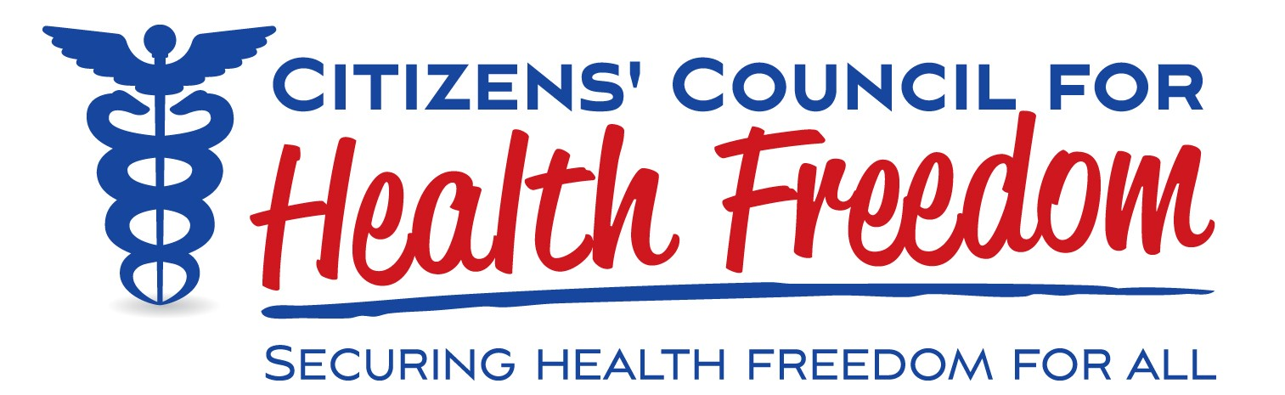

January 15, 2018

Administrator Seema Verma

Centers for Medicare & Medicaid Services Department of Health and Human Services

Attention: CMS-4182-P

RE: Public Comment on “Medicare Program: Contract Year 2019 Policy and Technical Changes to the Medicare Advantage, Medicare Cost Plan, Medicare Fee-for-Service, the Medicare Prescription Drug Benefit Programs, and the PACE Program;” Proposed Rule

Citizens’ Council for Health Freedom (CCHF) is a national health policy organization whose mission is to protect health care choices, individualized patient care and medical and genetic privacy. CCHF is commenting primarily on the proposed option called “Any Willing Pharmacy,” which is number 12 under “Supporting Innovative Approaches to Improving Quality, Accessibility and Affordability,” (page 5).

However, we include a recommendation regarding PBMs and pharmacy payment adjustments, as discussed starting on page 329.

Note: page numbers refer to the pre-published 713-page draft of the proposed rule.

**We support the CMS Medicare proposal to restore the freedom of senior citizens to access medication at the pharmacy of their choice.**

Today, the choice of pharmacy for many senior citizens is limited. Many are forced to go to pharmacies that are approved by Pharmacy Benefit Managers (PBMs) under contract with Medicare Part D sponsors. Family owned or independent pharmacies are often excluded from these “preferred” pharmacies and patients can be forced to change pharmacies as a result. In lower population areas, patients may need to travel increasingly long distances to reach a pharmacy classified as “preferred” by the PBMs. Patients should have the choice to access medication at any pharmacy that accepts their payment regardless of coverage.

Opening up this market to any willing pharmacy also increases competition among pharmacies nationwide, which always benefits consumers. The “Any Willing Pharmacy” policy will greatly encourage price competition and lead to lower costs in the Medicare Part D program. Kickbacks to and between the PBMs and large pharmaceutical companies only add to the costs of the current system while doing nothing to help the patient.

According to the National Community Pharmacists Association, five studies in a one- year period show that PBM-preferred pharmacies and mail order are frequently **more expensive** than non-preferred pharmacies.

In that realm, CMS’s commentary on PBM pricing strategies starting on page 329 is instructive:

“In recent years, a growing proportion of Part D sponsors and their contracted PBMs have entered into payment arrangements with Part D network pharmacies in which a pharmacy’s reimbursement for a covered Part D drug is adjusted after the point of sale based on the pharmacy’s performance on various measures defined by the sponsor or its PBM. Furthermore, we understand that the share of pharmacies’ reimbursements that is contingent upon their performance under such arrangements has also grown steadily each year. As a result, sponsors and PBMs have been recouping increasing sums *from* network pharmacies after the point of sale (*pharmacy price concessions*) for “poor performance” relative to standards defined by the sponsor of PBM. These sums are far greater than those paid *to* network pharmacies after the point of sale (*pharmacy incentive payments*) for “high performance.” We refer to pharmacy price concessions and incentive payments collectively as pharmacy payment adjustments.”

These tactics, CMS notes, create a lack of transparency and a potential shifting of the costs onto Medicare recipients and taxpayers. We agree that “requiring all pharmacy price concessions that sponsors and PBMs receive be used to lower the price at the point of sale” is a good idea. However, we also note our opposition to PBM “performance measures,” which are extraordinarily subjective, may actually be compliance measures, can be used to avoid proper payment for care, and can be used to restrict access to needed care. **We encourage CMS to forbid payments based on performance measures.**

In conclusion, Medicare must not be a source of soaring profits for government contractors (corporate sponsors and their PBMs), and the government should not prefer one pharmacy over another for the many citizens near and far who rely on access to medication for the length and quality of their lives.

Citizens’ Council for Health Freedom supports this proposal to restore patient freedom to obtain medications at whatever pharmacy they choose. Patient choices should not be limited by the choices of the federal government, a health plan, or a private company under contract with either. True insurance does not limit choices.

Thank you for this proposal. It is a significant step toward restoring patient freedom and market competition in health care.



Twila Brase, RN, PHN President and Cofounder