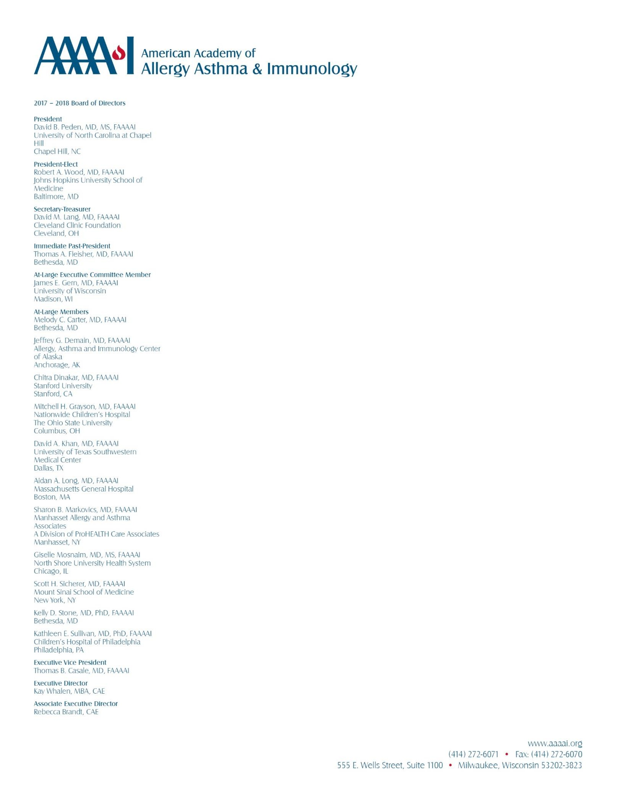

January 16, 2018

Ms. Seema Verma, Administrator

Centers for Medicare & Medicaid Services Department of Health and Human Services Room 445-G, Hubert H. Humphrey Building 200 Independence Avenue, SW Washington, DC 20201

*Submitted electronically via Regulations.gov*

## Re: Medicare Program; Contract Year 2019 Policy and Technical Changes to the Medicare Advantage, Medicare Cost Plan, Medicare Fee-for-Service, the Medicare Prescription Drug Benefit Program, and the PACE Program

Dear Administrator Verma,

Established in 1943, the AAAAI is a professional organization with more than 7,000 members in the United States, Canada and 72 other countries. This membership includes allergist/immunologists (A/I), other medical specialists, allied health and related healthcare professionals—all with a special interest in the research and treatment of patients with allergic and immunologic diseases.

We appreciate the opportunity to provide feedback on proposals for Medicare Advantage (MA) and Part D Prescription Drug Programs in Contract Year 2019.

# Quality Rating System

CMS explains that it is considering the development of a survey that would capture physicians’ experiences with MA plans, and including that in the Quality Rating System. A/I professionals face a number of challenges with MA plans, with the majority being administrative burdens – such as complex prior authorizations, step-therapy requirements, and non-medical switching of medications – that distract busy practices from delivering high-quality care and place inappropriate barriers between the enrollee and medically necessary care and treatment. Attempting to work with the MA plan to address these challenges through the appeals processes is cumbersome and time consuming. Practices spend many hours drafting countless letters and waiting on hold to speak with “peer” reviewers to secure enrollee access to important therapies.

We believe MA plans should be accountable to the physicians treating their enrolled beneficiaries. A survey of physicians that rates plans on the aforementioned issues, and that is tied to their quality bonus payment, would incentivize necessary improvements. To that end, ***we urge CMS to establish a stars measure, weighted no less than 3.0, that is based on a survey of physicians’ experiences with MA plans. We urge CMS to work with the***

***physician community, including A/I professionals, on the development of the survey tool to ensure key questions are addressed.***

# Request for Information Regarding the Application of Manufacturer Rebates and Pharmacy Price Concessions to Drug Prices at the Point of Sale

We welcome the opportunity to provide feedback in response to CMS’ request for information related to manufacturer rebates and pharmacy price concessions to drug prices at the point of sale. A/I practices routinely hear from patients about the challenges they face in obtaining prescription medicines due to their costs. While some patients ration their medications, taking less than prescribed to lengthen the time between fills, others simply do not fill their prescriptions, allowing their condition to worsen. For patients with certain A/I conditions, this is dangerous and may have serious consequences.

***We have reviewed CMS’ policy considerations and urge the agency to move forward with a mandatory pass-through of 100% of price concessions at the point of sale.*** We understand that a pass-through policy would have a slight impact on premiums; however, that increase would be offset by significant savings at the point of sale. And, in our experience, what hinders patient access to their medicines the most is the price they pay at the pharmacy counter.

# “Preclusion List”

While CMS seeks to reduce administrative burden by replacing its current Medicare enrollment requirement with a new “preclusion list,” some of the criteria the agency proposes to use to make such determinations lack objectivity. For example, CMS states it will consider “*the seriousness of the conduct underlying the prescriber’s revocation [from Medicare]*”; “*the degree to which the [physician’s] conduct could affect the integrity of the [Part D/MA] program*”; and, “*any other evidence that CMS deems relevant to its determination,*” in determining whether a physician should be included on the “preclusion list.”

Not only does this hurt the program by potentially limiting the pool of available clinicians for Medicare beneficiaries, it also puts the professional reputation of the physician in jeopardy. We do not believe CMS’ proposed appeals process is enough to address this concern. Once a clinician has been placed on the list, there will be professional consequences. ***We urge CMS to revise its preclusion list criteria, removing criteria that are subjective in nature, in the final rule.***

*****

We appreciate the opportunity to offer these comments, and we look forward to working with you as you implement changes to MA and Part D for 2019. If you have any questions, please contact Sheila Heitzig, Director of Practice and Policy, at [sheitzig@aaaai.org](mailto:sheitzig@aaaai.org) or (414) 272-6071.

Sincerely,



## David B. Peden, MD MS FAAAAI President

2