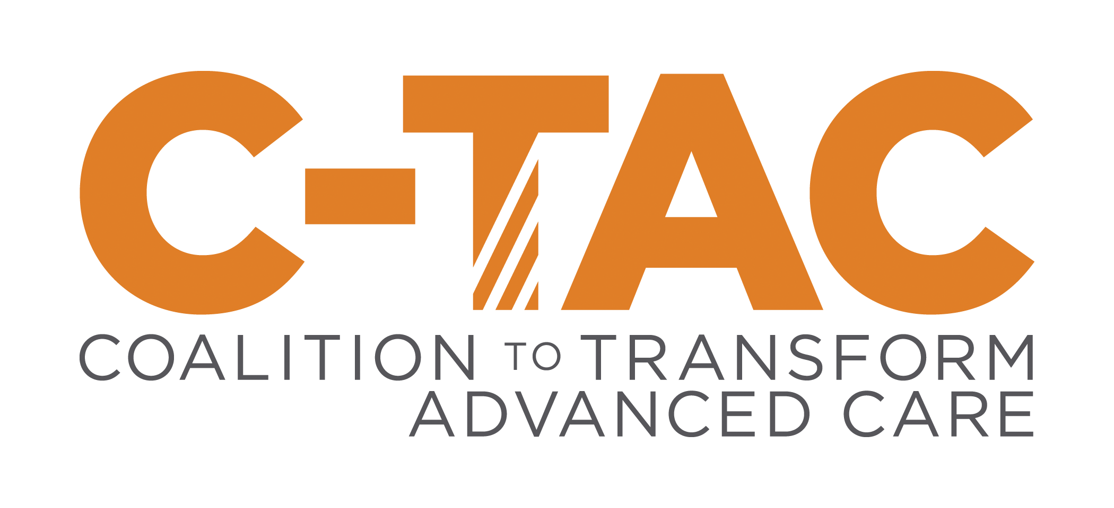

January 16, 2018 Ms. Seema Verma

Administrator, Centers for Medicare and Medicaid Services Room 445-G, Hubert H. Humphrey Building

200 Independence Avenue, SW Washington, DC 20201

1299 Pennsylvania Avenue NW

Suite 1175

Washington, DC 20004

# Re: CMS-4182-P, RIN 0938-AT08, Medicare Program; Contract Year 2019 Policy and Technical Changes to the Medicare Advantage, Medicare Cost Plan, Medicare Fee-for- Service, the Medicare Prescription Drug Benefit Programs, and the PACE Program

Dear Ms. Verma,

On behalf of the Coalition to Transform Advanced Care (C-TAC), we appreciate the opportunity to provide comments on this proposed rule with respect to those areas that would affect people living with advanced illness.

C-TAC is a national non-partisan, not-for-profit organization dedicated to ensuring that all those living with advanced illness, especially the sickest and most vulnerable, receive comprehensive, high- quality, person- and family-centered care that is consistent with their goals and values and honors their dignity. C-TAC is made up of over 140 national and regional organizations including patient and consumer advocacy groups, providers, health plans, faith-based and community organizations, and others who share a common vision of improving advanced illness care in the U.S.

C-TAC’s definition of advanced illness is when one or more conditions becomes serious enough that general health and functioning begin to decline, treatment may no longer lead to preferred outcomes, and care oriented toward comfort may take precedence over attempts to cure – a process that extends to the end of life and that for some individuals and their families may lead to transition to hospice.

Medicare Advantage (MA) enrollment has been steadily growing and so this proposed rule has the potential to impact an increasing proportion of Medicare beneficiaries. Overall, we are supportive of this proposed rule and have comments on the following areas:

**Implementing the Comprehensive Addiction and Recovery Act’s (CARA) provisions** We recognize that this section reflects the required CARA provisions and feel they are a sensible approach to the current opioid abuse crisis. However, people with advanced illness other than cancer may often be taking opioids appropriately, even if at seemingly high doses. We therefore are concerned that any effort to minimize opioid abuse not inadvertently minimize access to these medications for those who justifiably need them.

Here are our responses to the requests for comment in this section:

Frequently abused drug class- We support limiting the class of frequently abused drugs to just opioids for the reasons provided in the proposed rule and also as some medications in the other potentially addictive categories are valuable for patients when properly prescribed and administered.

Guidelines- We support the dosing and prescribing guidelines given the combination of high doses and multiple providers/pharmacies needed to prompt a concern for possible opioid abuse. However, we would note that high daily doses, those above the 90-morphine milligram equivalent (MME) limit, are not impossible for some with advanced illnesses beyond cancer or for those who are receiving palliative care. We also want to recommend that CMS focus on educating providers on the MME concept, as our experience suggests this is not widely known or employed in most clinical settings.

Exempted populations- The proposed rule exempts those with cancer or who are enrolled in hospice from the CARA provisions and we support this as they are clearly among the groups of patients for whom these medications were intended and for which they are appropriate and effective when properly administered. We do want to note, however, that people with advanced illness beyond cancer, and those getting palliative care but not yet hospice, should also be exempted, although we acknowledging that doing so, as the proposed rule notes, is not currently easy to identify or track. However, we urge CMS to find ways to identify and possibly exempt other appropriate patient populations in future rule making.

Actions- We support the proposed actions to follow up with a beneficiary identified as being at risk for opioid abuse as they seem thorough and appropriate. In particular, involving a case manager is a good early step in the outlined process and could potentially confirm that someone taking high doses of opioids due to a non-cancer advanced illness, or as part of receiving palliative care, for example, is taking them appropriately and does not need be monitored more closely.

# Flexibility in uniformity requirements

CMS has determined that it has the authority to permit MA organizations to 1) reduce cost sharing for certain covered benefits; 2) offer specific tailored supplemental benefits; and 3) offer lower deductibles for enrollees that meet specific medical criteria, provided that similarly situated enrollees, that is, all enrollees who meet the identified criteria, are treated the same. We think this is potentially a good development, as those with advanced illness often have needs that go beyond those of people with less advanced conditions. Such needs also span the medical and social spheres and can include assistance with food, housing, and other social supports, all of which can make an important impact on health.

However, there are currently no metrics in place to provide an objective measure of outcomes from broadening such offerings. We, therefore, recommend that CMS develop such measure on a plan, not contract, level for the advanced illness population and on transition to hospice, as included in the Patient Choice and Quality Care Act legislation.

# MA/Part D Quality rating system

We support the proposed change to the previous requirement that all future measures be National Quality Foundation (NQF) validated. This opens this door to new measures that may be less expensive and lengthy to develop and confirm, which is of particular interest to the advanced illness field, as we have lacked the resources and evidence base to develop measures on the previous NQF-only track.

Regardless of whether new measures are validated by the NQF or not, however, we repeat what we have said in past, which is that we need both new measures for the advanced illness population and for this population to be *excluded* from preventive and Health Outcomes Survey measures that can often be counterproductive. We also need more measures focused on outcomes and the member’s experience of care and, ideally, ones that track whether the care delivered was aligned with that member’s goals and values.

# Removal of Quality Improvement Project (QIP) for MA Organizations

CMS believes the removal of the QIP and the continued CMS direction of populations for required CCIPs would allow MA organizations to focus on one project that supports improving the management of chronic conditions. We support this development if this is to be one of the outcomes and encourage CMS to continue focusing on improving care for those with both chronic and advanced conditions going forward.

Thank you for the opportunity to comment on the draft of this Strategic Plan. We believe with the suggestions above it could improve and incentivize better care for all those living with advanced illness.

If you have any questions, please contact Marian Grant, Senior Regulatory Advisor, C-TAC, at 443-742-8872 or [mgrant@thectac.org.](mailto:mgrant@thectac.org)

Sincerely,

*Marian Grant*

Marian Grant, DNP, CRNP, ACHPN, FPCN

Senior Regulatory Advisor

Coalition to Transform Advanced Care (C-TAC) 1299 Pennsylvania Ave, Suite 1175

Washington, DC, 20008