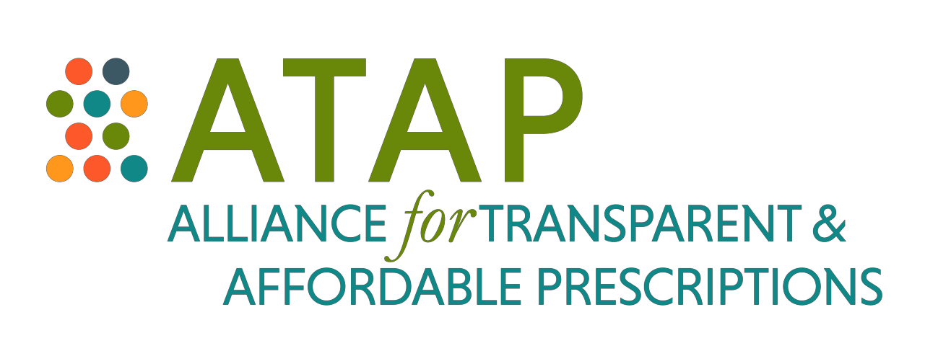

January 16, 2018

Ms. Seema Verma, Administrator

Centers for Medicare & Medicaid Services Department of Health and Human Services Room 445-G, Hubert H. Humphrey Building 200 Independence Avenue, SW Washington, DC 20201

*Submitted electronically via Regulations.gov*

**Re: Medicare Program; Contract Year 2019 Policy and Technical Changes to the Medicare Advantage, Medicare Cost Plan, Medicare Fee-for-Service, the Medicare Prescription Drug Benefit Program, and the PACE Program**

Administrator Verma:

The Alliance for Transparent and Affordable Prescriptions (ATAP) consists of seventeen patient and provider groups who are concerned about the role pharmacy benefit managers (PBMs) play in the rising cost of drugs and reduced patient access. PBMs are third-party entities that manage and administer prescription drug plans for payers, including Medicare Parts C and D. Among other functions, PBMs negotiate rebates with pharmaceutical manufacturers and manage drug utilization by beneficiaries. Unfortunately, there are currently no requirements for PBMs to pass negotiated savings onto payers or patients.

In November, the Centers for Medicare and Medicaid Services (CMS) released its proposed rule entitled “Medicare Program; Contract Year 2019 Policy and Technical Changes to the Medicare Advantage, Medicare Cost Plan, Medicare Fee-for-Service, the Medicare Prescription Drug Benefit Programs, and the PACE Program” (“Part D rule”). In the Part D rule, CMS includes a section entitled “Request for Information Regarding the Application of Manufacturer Rebates

and Pharmacy Price Concessions to Drug Prices at the Point of Sale” (“RFI”). In the RFI, CMS notes that, when the Part D program was established, the agency believed that “market competition would encourage Part D sponsors to pass through to beneficiaries at the point of sale a high percentage of the manufacturer rebates and other price concessions they received, and that establishing a minimum threshold for the rebates to be applied at the point of sale would only serve to undercut these market forces.” However, the agency goes on to state that “actual Part D program experience has not matched expectations in this regard. In recent years, only a handful of plans have passed through a small share of price concessions to beneficiaries at the point of sale.” CMS adds that “sponsors may have distorted incentives as compared to what we intended in 2005.” As such, in the RFI, CMS discusses solicits comments on requiring sponsors to include at least a minimum percentage of manufacturer rebates and all pharmacy price concessions received for a covered Part D drug in the drug’s negotiated price at the point of sale. ***We strongly support a mandatory pass-through policy***, for the reasons outlined below.

# A MANDATORY PASS-THROUGH WOULD REDUCE THE FINANCIAL BURDEN ON PATIENTS WHILE SAVING MEDICARE MONEY.

When manufacturer rebates and pharmacy price concessions are not reflected in the price of a drug at the point of sale, beneficiaries do not see any reduction in their cost-sharing obligations as a result of PBM negotiations. But the lack of pass-through of price concessions does not just increase costs for beneficiaries; it also increases costs for the Medicare program. This is because the calculation of when beneficiaries move through the four phases of the benefit is based on the negotiated prices reported at the point of sale. In other words: beneficiaries move through the benefit into catastrophic coverage more quickly when price concessions are not passed on to them. This shifts more of the total drug spend onto Medicare, as Medicare liability is highest in the catastrophic phase, and plan liability is lowest. The claim by PBMs that they save costs seems ironic in light of these facts. While the PBMs’ ability to obtain price concessions is beyond dispute, very little of these price concessions ever translate to reduced cost-sharing for patients, or to savings for the Medicare program. Instead, the price concessions are simply absorbed by the middleman. A mandatory pass-through would help alleviate this problem.

The impact estimates provided by CMS are very promising. CMS provides ten-year impact estimates of a forced pass-through of 33%, 66%, 90%, and 100% of manufacturer rebates at the point of sale: at the lowest point of that range (33%), beneficiaries would save $19.6 billion dollars in their out-of-pocket costs. While a pass-through policy would increase premiums, that increase is more than offset by the deep reductions in cost-sharing at every level of pass- through. With a 100% pass-through, beneficiaries would save a whopping $56.9 billion overall. Similarly, the per-member-per-month savings estimates provide by CMS tell us that, at a 33%

pass-through, beneficiaries would save $30.33 per month, while, at a 100% pass-through, beneficiaries would save $88.13 per month. ***We support a 100% pass-through.*** Not only does that provide the biggest savings for beneficiaries, it also, as explained below, prevents gaming that could occur with any partial pass-through.

Any argument that the policy would increase premiums is disingenuous as it does not factor in the offsetting impact of the large reductions in cost-sharing: the overall savings numbers calculated by CMS are the result of slight increases in premiums that are more than offset by large reductions in cost-sharing. With regard to requiring that all pharmacy price concessions be used to lower the price at the point of sale, CMS notes that such a policy “would affect beneficiary, government, and manufacturer costs largely in the same manner as discussed previously in regards to moving manufacturer rebates to the point of sale.”

# A PASS-THROUGH POLICY APPLYING TO 100% OF ALL PRICE CONCESSIONS WOULD PREVENT GAMING AND INCREASE TRANSPARENCY.

As CMS notes, price concessions not included in the negotiated price at the point of sale put downward pressure on plan premiums, to the extent that plan bids reflect accurate direct and indirect remuneration (DIR) estimates. However, any DIR received that is above the projected amount factored into a plan’s bid contributes primarily to plan profits, not lower premiums.

CMS analysis indicates that in recent years, the DIR amounts that Part D sponsors and their PBMs actually received have consistently exceeded bid-projected amounts. Moreover, to capture the premium advantage that results from applying price concessions as DIR, sponsors sometimes opt for higher negotiated prices in exchange for higher DIR and, in some cases, even prefer a higher net cost drug over a cheaper alternative. This is a twofold blow to patients: not only are they pushed to a higher cost drug, but they then receive no cost-sharing reduction from the very price concession structure that led the plan to prefer the higher cost drug in the first place. This unconscionable behavior cannot be cured by claims of modest premium decreases.

Additionally, the current leeway given to PBMs on how to classify price concessions negatively affects the competitive balance in Part D. Some sponsors include price concessions in negotiated prices while others include them in DIR. When negotiated prices do not have a consistent meaning across the Part D program, beneficiaries cannot make educated choices when selecting a plan. The decision of how to treat price concessions may also provide a competitive advantage based on no substantive benefit to beneficiaries. For example, if Plan A applies price concessions as DIR at the end of the coverage year rather than using them to reduce the price at the point of sale, Plan A may be able to provide a lower premium than Plan B, which applies price concessions at the point of sale. This could allow Plan A to capture

additional market share by making its plan look more attractive to beneficiaries. However, that competitive advantage in the form of lower premiums results only from the technical difference in how Plan A treats its price concessions compared to Plan B – not from any actual efficiencies in Plan A. In other words, allowing PBMs the choice of how to treat their price concessions results in bids that are not actually comparable. And, while the beneficiary may be attracted by the lower premium cost in his or her plan selection, he or she may ultimately be worse off financially, due to much higher out-of-pocket costs for prescription drugs.

Unfortunately, the definitional gaming does not apply solely to how price concessions are factored into plan bids to CMS. There are currently no industry standards for key terms used in PBM contracts with manufacturers, plan sponsors, and pharmacies, allowing each PBM to advantageously define those terms on an ad hoc basis. For example, PBMs are not required to follow Food and Drug Administration (FDA) definitions for what is and is not a “generic” drug. This allows the PBM to define as “generics” products that were not approved pursuant to Abbreviated New Drug Applications (ANDAs) by FDA, which is the generally understood definition of the term “generic.” Conversely, it allows the PBM to define as “brands” products that *were* approved pursuant to ANDAs when that is financially beneficial. This lack of definitional agreement enables sleights of hands such as the PBM treating single-source generic drugs as brand products when financially beneficial or inflating generic substitution rates for products that were invoiced as brands.1

Definitional agreement and consistency are the foundation to most other policy solutions. Any requirement for PBMs to pass through to plans and patients a portion of rebates and other price concessions depends on a common definition of “rebate,” discount,” “fee,” and any other term the PBM may use. In the example noted above, the solution seems simple: ***require PBMs to classify a product as a generic or a brand according to how the product was approved by the FDA, consistently across the product life.*** Similarly, ***requiring the PBM to apply all price concessions at the point of sale would be more straightforward and less subject to gaming than only requiring a percentage of rebates to be passed through.*** A 100% pass-through obligation of all price concessions can help avoid having to rely on the PBM to report its rebate numbers based on a definition of its own choosing. Without a 100% pass-through requirement, PBMs would be able to easily circumvent the pass-through obligation by reclassifying money: in fact, there are reports of PBMs already using such reclassifications to avoid pass-through obligations under their contracts with plan sponsors.2

1. “When is a brand a generic? In a contract with a PBM.” Linda Cahn, *Managed Care* (Sept. 2010), available: [https://www.managedcaremag.com/archives/2010/9/when-brand-generic-contract-pbm.](https://www.managedcaremag.com/archives/2010/9/when-brand-generic-contract-pbm)
2. “Comparing Pharmacy Benefit Managers: Moving Well Beyond the Simple Spreadsheet Analysis” by David Calabrese, RPh, MHP, Am. Health Drug Benefits, 2008 Jun; 1(5): 9-19.

The status quo is harming patients. We see firsthand how out-of-pocket costs cause patients to ration their drugs, or even stop filling their needed prescriptions altogether. The concepts advanced by CMS in its RFI provide a way to save Medicare beneficiaries money on their prescriptions by allowing them the benefit of price concessions that currently disappear into a morass of middlemen and intermediaries. Moreover, the proposal would provide savings to beneficiaries without compromising their access to the medications they need – all while reducing costs for the government. It is imperative that CMS work toward addressing the misaligned and perverse incentives inherent in the current structure. We thank CMS for this critical first step and urge the agency to adopt a policy requiring sponsors to include all price concessions at the point of sale for Medicare beneficiaries.

Sincerely,

American Association of Clinical Urologists American Bone Health

American College of Rheumatology Association of Women in Rheumatology American Psychiatric Association California Rheumatology Alliance

Coalition of State Rheumatology Organizations Florida Society of Rheumatology

Global Healthy Living Foundation

Lupus and Allied Diseases Association, Inc. National Organization of Rheumatology Managers New York State Rheumatology Society

North Carolina Rheumatology Association Rheumatology Alliance of Louisiana Rheumatology Nurses Society

Tennessee Rheumatology Society

U.S. Pain Foundation