**Intervention/Driver Performance**

**Progress Report**

*Arizona Contract Deliverable C.3#3.2*

*Effectiveness of Pharmacist- and Nurse-Managed Interprofessional, Post-Hospital Discharge Transition of Care Program at Preventing Readmissions and Reducing Costs*

*Authors:*

*Ettie Lande, RN, MS, ACM-RN, Associate Director, HSAG, Amber Saldivar, MHSM, Director, Analytics, HSAG Cindy Strickland, JD, Senior Researcher, HSAG*

*Co-Authors/Consultants: Jenny Bingham, PharmD, UA Medication Management Center Kate Johnson, BSN, RN, UA Medication Management Center*

*Sandra Leal, PharmD, MPH, SinfoníaRx Patrick Campbell, PharmD, UA College of Pharmacy*

*Funding: QIN-QIO activities in this report are funded by the Centers for Medicare & Medicaid Services. Contract Number: HHSM-500-2014-QIN008I*

# TITLE and ABSTRACT

## Title

**Effectiveness of Pharmacist- and Nurse-Managed Interprofessional, Post-Hospital Discharge Transition of Care Program at Preventing Readmissions and Reducing Costs**

1. **Abstract**

### Background

Pharmacists provide valuable expertise to the multi-disciplinary teams that coordinate transitions of care before and after hospital discharge. This study investigated the effectiveness of a pharmacist-and nurse-managed interprofessional, post-hospital discharge transition of care program, the Discharge Companion Program (DCP). The purpose of this study was to determine whether patients who received the DCP intervention experienced reduced hospital readmissions rates or Medicare expenditures.

### Intervention

The DCP was a systematic, team-based, 30-day approach, with direct pharmacist-to-patient or -caregiver contact in the first and third weeks after discharge. A second, and no less critical, element of the DCP was a Transitional Care Nurse (TC-RN) who managed information, acted as a communications hub, and coordinated with the patient and the patient’s extended care team, while maintaining documentation in the hospital’s electronic health record (EHR) during the 30 days after discharge.

The study population included 225 Medicare fee-for-service (FFS) beneficiaries discharged from Tucson Medical Center between August 2015 and July 2016.1 The intervention group was comprised of a total of 175 beneficiaries who agreed to participate in the DCP, and received at least one pharmacist consultation in the week following discharge. The remaining 50 beneficiaries either declined to participate in the DCP or could not be reached, and were treated as a comparison group. They received the hospital’s usual care coordination after discharge.

### Results

The DCP led to significant reductions in hospital readmission at 30, 60, and 90 day post-discharge. At 30 days after discharge, the readmission rate for the comparison group was 28 percent, while that of the group that received the intervention was 12.6 percent (Odds Ratio 0.370 [95% CI 0.173-0.782] (*p* = 0.0105). At 60 days after discharge, the comparison group’s readmission rate was 42 percent, while the intervention group had a readmission rate of 20 percent (OR 0.345 [95% CI 0.176-0.677]) (*p* = 0.0019). At 90 days after discharge, 52 percent of the comparison group had been readmitted, and only 27.4 percent of the intervention group had been readmitted (OR 0.349 [95% CI 0.183-0.666]) (*p* = 0.0014).

The DCP led to a significant reduction in the time-to-readmission at 90 days post-discharge. At the 90-day mark, approximately half (52 percent) of the comparison group had been readmitted, while only a little more than one quarter (27 percent) of the intervention group had been readmitted. (Log-rank *p* = 0.0003).

Despite a numerical reduction of $4,000 in average Medicare expenditure per beneficiary at 30-days post- discharge, no statistically significant difference in average Medicare expenditures between the two groups was

1 The study was restricted to Medicare fee-for-service beneficiaries because it was conducted pursuant to the Quality Innovation Network-Quality Improvement Organization (QIN-QIO) 11th SOW, which coordinates quality improvement activities for Medicare FFS beneficiaries.

observed. A trend towards significant differences was observed with p-values decreasing from 30 days (*p =*

0.1936) to 90 days (*p* = 0.0548).

### Conclusion

Participation in the DCP program was associated with significantly lower readmissions at 30, 60, and 90 days after discharge. Time to readmission was also longer for the intervention group throughout the 90 days after the discharge. No difference in average Medicare expenditures per beneficiary was observed between the two groups.

# INTRODUCTION

## Problem Description

Transitions of care between healthcare settings present difficult challenges to patients, whether they are discharged from hospital to home or to an alternative level of care, such as a skilled nursing facility (SNF). These problems are compounded by the multiple transitions created by avoidable readmissions. With each transition between settings, there is an increased potential for patient confusion, for loss of information, and for errors in communication. As a result, quality improvement initiatives have focused on finding ways to improve communication across multiple healthcare settings, and to integrate the skills of interdisciplinary teams to improve patient experience and outcomes.

Since the inception of the Affordable Care Act (ACA) in 2010, a core goal of federal health care policy has been the reduction of avoidable hospitalizations. At that time, one in five Medicare patients (19.6 percent) discharged from an acute care hospital were readmitted within 30 days; one in three (34 percent) were readmitted within 90 days.2

TMC is a non-profit, acute care community hospital with more than 600 beds located in Tucson, Arizona. The hospital has engaged with its Quality Innovation Network-Quality Improvement Organization (QIN-QIO) in a statewide initiative to reduce unnecessary readmissions. TMC’s 30-day hospital-wide all-cause unplanned readmission rate from July 1, 2014 through June 30, 2015 was 14.8 percent (95 percent CI 13.9–15.8 percent), not significantly different from the national average of 15.6 percent.3 TMC decided to use lessons learned from the professional literature and quality improvement experience to improve its processes for transitioning vulnerable patients from the hospital to home or another facility.

The hospital hypothesized that integration of pharmacists with registered nurses (RNs) to provide support after discharge would improve medication outcomes, and looked for a partner with experience providing medication therapy management services during the critical post-discharge, 30-day period. TMC queried community providers to find interest and engagement in this effort, and found a partner in SinfoníaRx. SinfoníaRx is an innovative healthcare company focused on optimizing pharmacist expertise in an interdisciplinary team to serve patients with multiple chronic conditions and complex illnesses. Established in 2006, SinfoníaRx has worked with the University of Arizona College of Pharmacy pioneering Medication Therapy Management (MTM) services.

## Available Knowledge

TMC investigated the root causes of its patients’ readmissions, and identified common patterns related to medication issues, and adverse drug events. A number of readmissions were prompted by incidents of bleeding among patients on multiple therapies such as antiplatelet or antithrombin medications, especially among patients

2 Jencks SF, Williams MV, Coleman E. Rehospitalizations among patients in the Medicare fee-for-service Program. NEJM 2009; 360(14):1418-1428.

3 Medicare Hospital Compare, https:/[/www.](http://www.medicare.gov/hospitalcompare/search.html)m[edicare.gov/hospitalcompare/search.html.](http://www.medicare.gov/hospitalcompare/search.html)

aged 80 or older, or with impaired kidney function. Another common trigger for a patient’s return to the hospital was shortness of breath, and the hospital recognized this might be ameliorated by ensuring that chronic obstructive pulmonary disease and asthma patients were discharged with medication therapy consistent with evidence-based national guidelines, such as having a bronchodilator delivered to bedside prior to discharge.

The hospital found that changes to a patient’s medication regimen were often made without consideration for financial consequences such as higher copays. In addition, differences in the drug formularies of different payers added to confusion and frustration during transitions of care. Patients often encountered multiple medication changes over the course of treatment that were due solely to changes in formularies as they transitioned from home into the hospital, and then out of the hospital back home or to another post-acute care facility. These changes could create frustrating barriers to accessing medications requiring the patient to make repeated trips to the pharmacy, or to wait for authorizations for non-formulary medications or multiple calls between doctors and pharmacies and payers.

TMC recognized that pharmacists were in a unique position among clinical staff to address all of these issues, from educating patients regarding their medications’ purposes and potential side effects, to evaluating potential drug-drug interactions, to identifying medication-related problems that might be encountered by aging patients, to addressing concerns about navigating formulary changes to find the best treatment options at the lowest cost. The hospital noticed that most of its readmissions occurred in the first or third week after discharge, and decided to focus on those time periods for maximal impact.

This experience was consistent with the professional literature, which indicates that Medicare beneficiaries at high risk for readmissions due to multiple chronic conditions, polypharmacy, or lack of needed social support, benefit from improvements in the quality of transitions of care to and from hospitals.4 Studies have shown that problems that give rise to avoidable rehospitalizations include inadequate or inappropriate care, sub-optimal patient adherence to their medication and self-care regimens, and lack of clear communication between patients and providers and among providers.5

Pharmacist involvement in the discharge planning process can further reduce preventable readmissions.6 Intensive pharmacist involvement during admission and continuing for 30 days after discharge has been associated with a significant reduction in 30-day readmissions for high risk patients.7 Effective medication reconciliation required more than simple comparison of lists of medications. For the best effect, the process required direct engagement with the patient and active collaboration between pharmacists and physicians in

4 Brock J, Mitchell J, Irby K, et al. Association between Quality Improvement for Care Transitions in Communities and Rehospitalizations Among Medicare Beneficiaries. JAMA 2013;309(4):381-391.

5 Brown RS, Peikes D, Peterson G, et al. Six Features of Medicare Coordinated Care Demonstration Programs that Cut Hospital Admissions of High-Risk Patients. Health Aff 2012;31(6):1156-1166.

6 Phatak, Impact of Pharmacist Involvement in the Transitional Care of High-Risk Patients Through Medication Reconciliation, Medication Education, and Post Discharge Call-Backs (IPITCH Study). J Hosp Med 2016;11(1):39-44. Polinski JM, Moore JM, Kyrychenko P, et al. An Insurer's Care Transition Program Emphasizes Medication Reconciliation, Reduces Readmissions And Costs. Health Aff 2016;35(7):1222-29; Ensing HT, Stuijt CM, van den Bemt BJF et al. Identifying the Optimal Role for Pharmacists in Care Transitions: A Systematic Review. JMCP 2015;21(8):614-38.

7 Phatak, Impact of Pharmacist Involvement in the Transitional Care of High-Risk Patients Through Medication Reconciliation, Medication Education, and Post Discharge Call-Backs (IPITCH Study). J Hosp Med 2016;11(1):39-44.

personalized clinical medication review, with access to patient’s clinical notes aimed at optimization of pharmacotherapy.8

However, pharmacist involvement alone, even at relatively intensive levels, did not necessarily improve patient outcomes.9 The combination of pharmacist involvement with patient-centered, individualized care planning, and the support of a team dedicated to the facilitation of communication and collaboration between pharmacists, primary care providers, and other providers, was more likely to have a positive impact, and was more cost effective.10

A wide variety of strategies to improve care coordination have been tried. Programs that have been successful tend to have several qualities in common:

* Comprehensive transitional care after discharge
* Care coordinators who act as a communications hub for the extended care team
* Strong medication management
* Evidence-based patient education
* Telephone contact after discharge

## Rationale

TMC and SinfoníaRx expected that the DCP intervention would be effective in reducing readmissions and overall costs because it made use of proven best practices to provide solutions closely tailored to the issues identified by the hospital’s root cause analysis of local problems.

The hospital hypothesized that it could leverage its EHR to provide timely information about the patient’s medical history and the recent hospitalization that could be shared with the DCP team of pharmacists and nurses.

Permitting the DCP pharmacist to add progress notes including pharmacology recommendations and/or safety concerns to the hospital’s EHR not only made the information accessible to other health care providers, it preserved the benefit of the consult for any later hospitalizations. This approach maximized the interprofessional team’s knowledge about the hospitalization and identified necessary follow-up that could be facilitated for the patient. The DCP also improved the quality of post-discharge communications, by empowering the nurse to serve as the hub of communications, initiating systematic contact with the primary care provider, with specialists to whom the patient was referred for follow-up, with the patient’s preferred community pharmacy, as well as with the patient and their caregivers. The partners believed that these improvements in coordinating transitions of care would prevent or ameliorate problems that had triggered many of the hospital’s readmissions.

## Specific Aims

The goal of the DCP was to provide cost effective post-hospital medication therapy management services to patients at high risk of readmission. It sought to combine direct telephonic pharmacist-to-patient consultations with a nurse-managed chronic disease coordination team to initiate the exchange of information among the patient

8 Ensing HT, Stuijt CM, van den Bemt BJF et al. Identifying the Optimal Role for Pharmacists in Care Transitions: A Systematic Review. JMCP 2015; 21(8):614-38.

9 Li H, Guffey W, Honeycutt L, et al. Incorporating a Pharmacist Into the Discharge Process: A Unit-Based Transitions of Care Pilot. Hosp Pharm 2016;51(9):744-751.

10 Phatak, Impact of Pharmacist Involvement in the Transitional Care of High-Risk Patients Through Medication Reconciliation, Medication Education, and Post Discharge Call-Backs (IPITCH Study). J Hosp Med 2016;11(1):39-44.

and their multiple healthcare providers in a coordinated, comprehensive, and highly effective manner. The program was designed to integrate patient (or caregiver) participation in the team.

The specific aims of this study were to be measured at 30, 60, and 90 days after discharge, and were to:

* Reduce readmissions for patients in the DCP intervention group relative to patients in the comparison group.
* Reduce average Medicare expenditures for patients in the DCP intervention group relative to patients in the comparison group.

# METHODS

## Context

The hospital used the following primary conditions as inclusion criteria, offering the DCP to adults at high risk for readmission due to one or more of the conditions at the time they were assessed for discharge planning and care coordination: asthma, chronic obstructive pulmonary disease, diabetes mellitus, heart or kidney failure, hip or knee replacement, myocardial infarction, pneumonia,

and/or status post-coronary artery bypass graft **Figure 1—Study Population**

surgery.

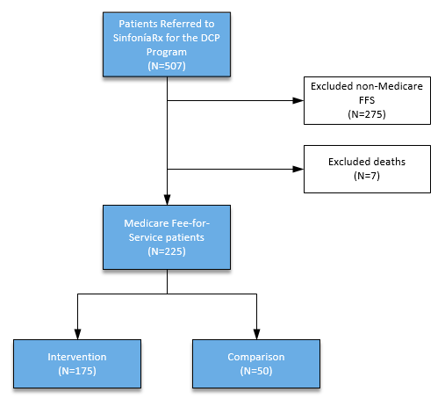TMC identified a total of 507 patients who were eligible for the program. Of those, 225 were Medicare FFS beneficiaries, as shown in Figure 1. Seven patients died within 90 days of discharge, and were excluded from the study population.

Patients discharged from TMC with the primary conditions between August 2015 and July 2016 were referred for voluntary enrollment in the DCP. Patients who agreed to participate were placed in the intervention group; those who declined or could not be reached after discharge constituted the comparison group. Patients in the intervention group were followed for 30 days post-discharge by the DCP team, which performed the interventions and collected data between August 31, 2015 and July 28, 2016. Patients were defined as having had the intervention upon completion of the first pharmacist consultation call in week one after discharge.

Patients in the comparison group were discharged

from TMC with the hospital’s usual care during the same time period.

Primary data were collected during the DCP and provided to Health Services Advisory Group, Inc. (HSAG). Medicare health insurance claim numbers (HICNs) were extracted from the TMC data and matched with an internal tracking log maintained during the DCP program to obtain the discharge dates and information regarding whether the beneficiaries were in the intervention or comparison group. Medicare FFS Parts A and B claims obtained from the Centers for Medicare & Medicaid Services (CMS), were used to identify readmissions and Medicare expenditures for each of the beneficiaries in each group.

## Interventions

* 1. **Description of the interventions in sufficient detail that others could reproduce them**
     1. Identification of patients for participation in the DCP study

TMC’s Transitional Care Nurse (TC-RN) screened patients for the primary discharge conditions, taking into account any increased risk of readmission due to advanced age (greater than 80 years), polypharmacy, patient health care literacy and physician referrals.11 If the patient wanted to participate, the TC-RN used a template to collect standardized demographic and disease information from the patient, their representative, and the hospital EHR for forwarding to SinfoníaRx through an encrypted server. A copy of the template is provided in Appendix A.

The patient’s preferences for contact for the consultation were noted. If the patient had been admitted from, or was being discharged to a nursing home or rehabilitation facility, the TMC TC-RN notified the case manager at the facility of their enrollment in the program and requested the facility fax its Medication Administration Record (MAR) to SinfoníaRx.

Those patients who could not be reached after two telephone call attempts post-discharge by the DCP pharmacist were assigned to the comparison group, and were provided with the hospital’s usual care which included at least one telephone call attempt within 24-72 hours after discharge by the hospital’s care coordination nurse. If the patient could be engaged (contacted by telephone), they were asked whether they were able to fill and refill prescriptions and whether they understood the purpose of their prescription medications. If problems or issues were identified, additional calls were made and actions taken to resolve the issues.

* + 1. DCP: Week One Consult

For patients in the intervention group, the TC-RN from TMC reviewed the hospital record and summarized the recent hospitalization, noting information such as test results, abnormal lab values, issues with adherence, or other items that might require further follow up post-discharge. This summary provided a convenient shortcut to the critical information dispersed throughout the hospital EHR, for use by the pharmacist and others on the DCP care team. The general program plan is set out in Figure 2.

11 TMC’s Transitional Care team educated community cardiologists, hospitalists, and Accountable Care Organizations regarding the program, and provided procedures for referring appropriate patients.

### Figure 2—Overview of DCP Plan

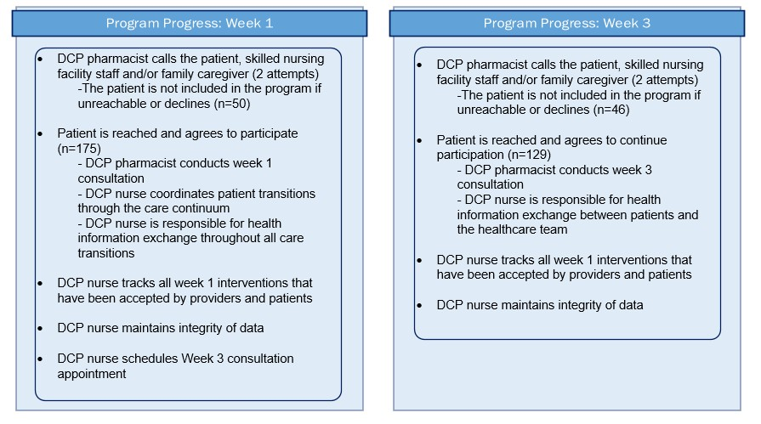

Source: Harrington AR, Nelson ML, Bingham J, Johnson K, Leal S. Pharmacist- and Nurse- Managed, Interprofessional, Post-Hospital Discharge Transition of Care Program, poster presented to Academy of Managed Care & Specialty Pharmacy Annual Meeting, San Francisco, CA, April

19-22, 2016.

Upon receiving the referral, SinfoníaRx took over the care coordination services with the aid of clinical pharmacist providers located at the University of Arizona Medication Management Center. The DCP pharmacist (a Doctor of Pharmacy, PharmD) initiated the first patient consultation within one week after discharge. The intervention focused on immediately pressing issues, and was tailored to the specific disease state of the patient, as summarized in Figure 3.

### Figure 3—Week 1 Care Coordination Activities

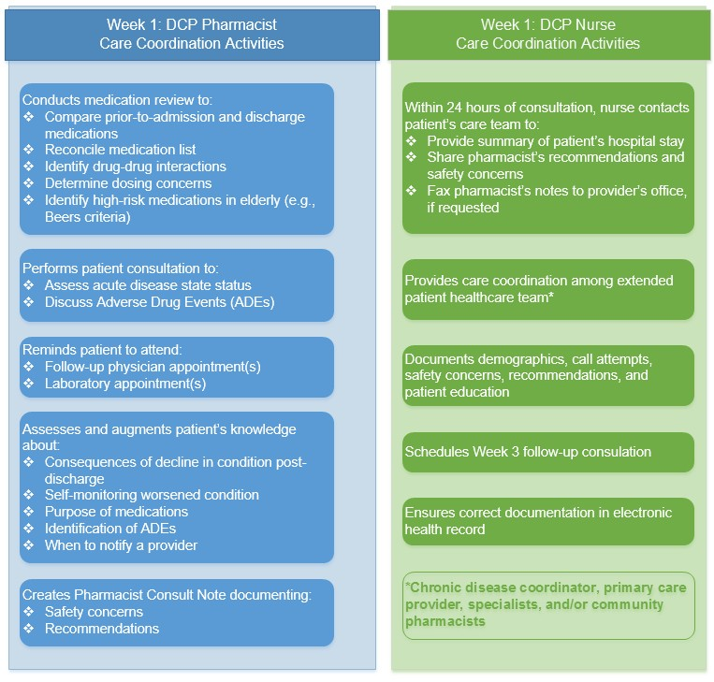

Source: Harrington AR, Nelson ML, Bingham J, Johnson K, Leal S. Pharmacist- and Nurse- Managed, Interprofessional, Post-Hospital Discharge Transition of Care Program, poster presented to Academy of Managed Care & Specialty Pharmacy Annual Meeting, San Francisco, CA, April 19-22, 2016.

The pharmacist performed a comprehensive medication review in order to identify therapeutic duplications, drug- drug interactions, drug-disease interactions, possible side effects, presence of medications potentially inappropriate for older adults (High-Risk Medication in the Elderly), medication adherence, financial or cost concerns, adherence to national guidelines, and dosing concerns.

A standard call script was used to promote consistency and data integrity. The script was customized prior to the call with the specific patient’s test results and lab values according to their disease condition. Pertinent values from the EHR including weight, serum creatinine, creatinine clearance, digoxin level, and ejection fraction were pulled into the template prior to the consult. Follow-up lab work and appointments were also noted, so that the pharmacist could provide individualized support and reinforcement to the patient.

The pharmacist counseled the patient regarding how to identify symptoms that should be immediately reported to a provider, when to call 911, or how to recognize complications. The pharmacist emphasized the importance and purposes of newly prescribed medications, and when to report side effects. The telephone encounters averaged 30

minutes in length, and made use of the teach-back method to validate patients’ comprehension. The pharmacist entered a Pharmacist Consult Note and recommendations in TMC’s EHR. The DCP nurse ensured the completeness and accuracy of the electronic record, and faxed copies of the note and recommendations to other providers such as the primary care physician and any rehabilitation or care facility involved.

* + 1. DCP: Week Three Consult

A second consultation was conducted in the third week after discharge by the DCP pharmacist, and raised long- term issues relevant to the patient’s medical condition(s) in addition to issues related to the acute problem that led to the hospitalization. The pharmacist followed up on issues identified in the initial call, inquired about follow-up provider appointments, reviewed medication changes, and encouraged the participant to obtain appropriate vaccinations. The Care Coordination Activities for Week 3 are listed in Figure 4.

### Figure 4—Week 3 Care Coordination Activities

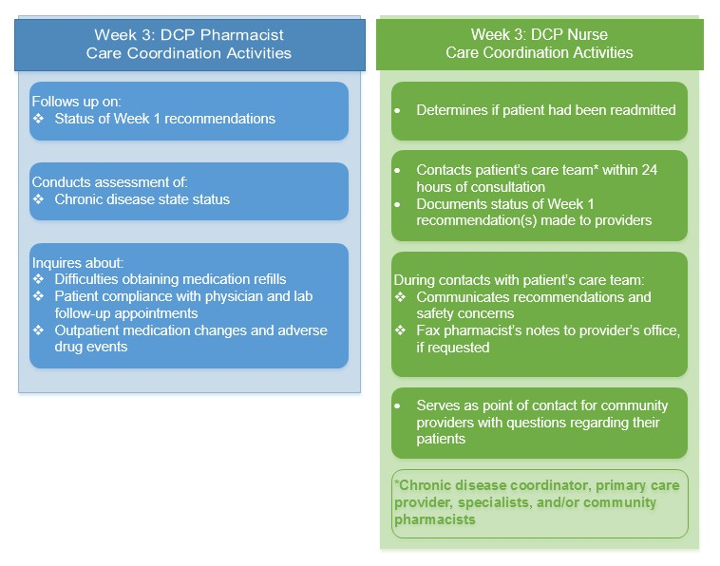

Source: Harrington AR, Nelson ML, Bingham J, Johnson K, Leal S. Pharmacist- and Nurse- Managed, Interprofessional, Post-Hospital Discharge Transition of Care Program, poster presented to Academy of Managed Care & Specialty Pharmacy Annual Meeting, San Francisco, CA, April 19-22, 2016.

* + 1. Care Coordination and Data Collection

The DCP nurse collected data prospectively during the 30 days after discharge, maintaining program records for all patients in an internal tracking log, tracking dates of contact, as well as some information related to cost and efficiency (e.g., time spent reviewing the EHR records, time spent on each call with the first 100 patients). The nurse recorded the date the first and third week consultation were completed, or the reason if not completed (i.e.,

deceased, readmitted, declined to participate, unable to reach). The DCP nurse logged the recommendations or concerns of the DCP pharmacists and any problems raised by the patients or other providers. The DCP nurse tracked the discharge location (i.e., whether a patient was discharged home alone, home with home health care, or to a skilled nursing facility), and noted the person to be contacted for the DCP pharmacist consultation (i.e., the patient, a caregiver, or a facility staff member).

## Specifics of the team involved in the work

The staffing for the DCP included team members at both TMC and SinfoníaRx, and their responsibilities are listed in Table 1. In addition to the clinical and administrative roles of the team members described elsewhere in this paper, a pharmacist coordinator position was created to maintain the integrity and completeness of the data. The pharmacist coordinator provided weekly feedback to both SinfoníaRx and TMC teams, managed problems and clinical feedback logs, managed workflow and training materials, managed maintenance of a competency check list for users, and managed templates in the EHR.

### Table 1—Discharge Companion Program Team Members and Functions

|  |  |  |
| --- | --- | --- |
| **Role** | **Entity** | **Function** |
| Transitional Care Nurse (TC-RN) | TMC | * Identified the patients eligible for the DCP program. * Conducted initial telephone call to explain the program, and   o if patient chose to receive services, notified the patient of upcoming contact from a DCP pharmacist  o If patient declined or could not be reached, continued with usual care   * Summarized the recent hospitalization, and populated template for referral to DCP * Forwarded to DCP |
| Pharmacist Coordinator | SinfoníaRx | * Performed consultations * Relayed intervention information to nurse coordinator to inform providers/pharmacy * Logged success stories * Provided weekly feedback to both SinfoníaRx and TMC teams * Managed problem log * Managed clinical feedback log * Managed workflow and training materials * Managed competency check list for users * Managed templates in EHR |
| Nurse Coordinator | SinfoníaRx | * Contacted pharmacies * Contacted providers/specialists * Scheduled appointments * Tracked outcomes |
| Pharmacist | SinfoníaRx | * Performed consultations * Relayed intervention information to nurse coordinator to relay to provider/pharmacy |
| Pharmacist Preceptors | SinfoníaRx | * Supervised pharmacy residents |
| Pharmacy Residents | SinfoníaRx | * Performed consultations |

1. **Measures**

The following measures were chosen to evaluate the intervention:

* Inpatient Readmissions Rate
  + **Numerator**: Number of Medicare fee-for-service beneficiaries aged 18 and older in the study population who were readmitted as an inpatient to any hospital within 30, 60, and 90 days of the index discharge, stratified by:
    - Comparison Group—No DCP intervention
    - Intervention Group—DCP intervention
  + **Denominator**: Number of discharges of Medicare fee-for-service beneficiaries aged 18 and older in the study population.
  + **Rationale**: This measure will help indicate whether the improved coordination of care provided by the DCP was associated with a reduction in the rate of inpatient readmissions at 30, 60, and 90 days post-discharge.
* Time to Readmission
  + **The number of days until readmission** or the end of the 90 days following the date of discharge.
  + **Rationale**: This survival analysis will help determine whether the DCP intervention improved the odds of remaining free of readmission for a longer period after discharge. This is a separate benefit from reducing the rate of readmissions, focusing on the patient’s ability to remain in their homes longer.
* Medicare Expenditures Per Beneficiary
  + **Sum** of all Medicare claims paid for each patient in the study population from 3 days prior to the index admission through 30, 60, and 90 days post-discharge, stratified by:
    - Comparison Group—No DCP intervention
    - Intervention Group—DCP intervention
  + **Rationale**: One of the hypotheses of the DCP was that improved care coordination would ultimately result in a decrease in overall Medicare spending as costs are shifted from inpatient hospitalizations to less costly outpatient services. However, it was expected that some post- discharge expenses would increase if the DCP succeeded in improving patient follow-up with their care team. This measure will investigate if and how the DCP impacted Medicare expenditures at 30, 60, and 90 days after discharge.

### Analysis

* 1. **Qualitative and quantitative methods used to draw inferences from the data**

The approach used to assess the impact of the intervention was a comparison of the readmissions rates between discharged beneficiaries who received the intervention and those who received usual care. For each discharge of a beneficiary in each of the groups, readmissions that occurred during the 90 days after the index discharge were counted.

The population covariates of age, gender, race, and ethnicity were examined in order to evaluate the similarity of the populations between the intervention and comparison groups. The outcome of this comparison is shown below in the results section.

Further analysis of whether the intervention’s impact differed according to the underlying disease conditions was explored, but was not informative due to small population sizes when the population was allocated among ten different primary disease conditions.

### Methods for understanding variation within the data, including the effects of time as variable

Differences in the demographic characteristics of the intervention and comparison groups were analyzed utilizing a chi-square test. The intervention outcomes were assessed by comparing comparison-group data to intervention- group data. Logistic regression was used to estimate the effects of the intervention on readmission rates at 30, 60, and 90 days after discharge. A Kaplan Meier estimate evaluated differences in the odds of readmission over time for 90 days after discharge for the two groups. The difference between the mean and median Medicare expenditures per person for the two groups was compared using a *t*-test and a Wilcoxon signed-rank test respectively.

### Limitations

Self-selection bias. The design of the study was not randomized; all patients assessed by the TMC TC-RN who met the criteria of the program were given the option of receiving DCP services. The use of the selection criteria of patients’ preference and the ability to reach them telephonically post-discharge may have resulted in selection bias, although it is not clear which way that bias may have shifted results—the refusal to participate might have been because a patient’s condition was less complex, so the patient did not perceive the need for the program or because the patient was too sick to participate. Alternatively, a patient might refuse because of their individual privacy concerns or level of health care engagement, unrelated to the quality of the intervention. Decisions made by family members or nursing facilities on whether to accept additional support might differ from those made by patients themselves for a wide range of reasons.

Confounding causes. A number of different healthcare settings within the region (hospitals, nursing homes, home health agencies, etc.) have implemented strategies to improve readmissions rates which undoubtedly have impacted those residing in the Tucson area. These efforts may have also contributed to the lowering of readmissions rates for the intervention group. These include known effects such as the impact of home health agencies (HHAs) or skilled nursing facilities (SNFs) to which some patients were discharged, as well as at least one group of primary care physicians who was conducting a study of an intervention of its own, and requested that their patients be excluded from the DCP. Clearly, reducing readmissions and improving coordination across transitions of care are the subjects of extensive safety and quality improvement activities, both formal and informal.

Lack of centralized data regarding expenditure for medications. Especially since this project directly involved the use of medications, the inability to include reliable data regarding expenditures for prescription medications after discharge was a limitation. The evaluation of patient adherence and persistence to a medication regimen is complex and beyond the scope of this report.

## Ethical Considerations

A primary ethical issue for the investigators was maintaining the privacy of patient-specific data. Protected health information (PHI) was used with appropriate protections to obtain Medicare claims data for the study population in order to evaluate the impact of this improvement activity. Only aggregated data and non-identifiable health information were disclosed in this report.

This quality improvement activity did not present any additional risk to members of either the intervention or comparison group, so individual patient consent beyond that necessary to receive treatment was not considered necessary.12

Acknowledgements: The authors would like to acknowledge the cooperation of the care coordination staff at TMC, SinfoníaRx, and the University of Arizona in the study not only in sharing data, but in sharing their processes.

Competing Interests: SinfoníaRx provided funding for this pilot program at no charge to TMC. After the pilot, the partners entered an agreement for SinfoníaRx to provide medication therapy management services to patients referred by TMC at an agreed-upon rate per patient.

# Results

## Results

* 1. **Initial steps of the intervention(s) and their evolution over time (e.g. time-line diagram, flow chart or table) including modifications made to the intervention during the project**

The DCP intervention was a comprehensive approach to the complex issues presented during the transition of care out of the hospital. The intervention was designed through a lengthy process of formal preparation, and the partners did not make significant changes in the DCP’s intervention over the course of the study. However, lessons were learned during the intervention that might be valuable for others intending to try similar interventions.

As they worked with the hospital’s EHR, the DCP team was able to improve the usability of the data in the hospital medical record. Communication templates were improved to provide a single location for collecting key information from throughout the EHR on clinical signs, symptoms, and test results that were particularly important for patients because of their disease conditions.

The team encountered some difficulties in convincing SNFs to cooperate with requests for information after discharge. They learned that a direct phone call from the pharmacist was effective in gaining the cooperation of SNFs who did not provide the patient's Medication Administration Record (MAR) in response to the initial fax request.

The team found that noting the reasoning behind the DCP pharmacist’s specific disease state interventions in the DCP internal tracking log saved time by providing the DCP nurse with all the information needed to answer questions from the patient’s extended health care team as they came up, without having to continually check with the pharmacist.

## Contextual elements that interacted with the interventions

*Sample Description*

Of 225 Medicare FFS beneficiaries given the option of the DCP, a majority (77.78 percent) chose to participate. Patient characteristics are presented in Table 2. The patient population as a whole was predominantly white (94-

12 Lynn J, Baily MA, Bottrell M, Jennings B, Levine RJ, Davidoff F, et al. The Ethics of Using Quality Improvement Methods in Health Care. Ann Intern Med. 2007;146:666-673. doi: 10.7326/0003-4819-146-9-200705010-00155. Available at <http://annals.org/aim/article/734470/ethics-using-> quality-improvement-methods-health-care. Accessed on April 11, 2017.

96 percent) and non-Hispanic (88-92 percent), and all participants were 65 years or older. The differences between the two populations were not significant.

The frequencies of discharge location by type (home, skilled nursing facility, or other rehabilitation facility) did not differ significantly between the two groups, although members of the intervention group were significantly more likely to be discharged home with home health agency follow-up than without it, as shown in Table 2.

### Table 2—Patient Characteristics and Discharge Locations

|  |  |  |  |
| --- | --- | --- | --- |
| **Characteristic** | **Comparison n=50 (%)** | **Intervention n=175 (%)** | ***p*-value** |
| Age |  |  |  |
| 65-75 years | 29 (58) | 71 (41) | 0.03 |
| 76-85 years | 16 (32) | 77 (44) | 0.13 |
| 86+ years | 5 (10) | 27 (15) | 0.33 |
| Sex |  |  |  |
| Male | 32 (64) | 107 (61) | 0.71 |
| Female | 18 (36) | 68 (39) | 0.71 |
| Race |  |  |  |
| White | 47 (94) | 165 (96) | 0.56 |
| Other | 3 (6) | 13 (7) | 0.56 |
| Ethnicity |  |  |  |
| Hispanic | 6 (12) | 13 (8) | 0.32 |
| Non-Hispanic | 44 (88) | 160 (92) | 0.32 |
| Discharge Location |  |  |  |
| Home | 27 (54) | 83 (47) | 0.41 |
| Home with HH | 6 (12) | 48 (27) | 0.02* |
| SNF | 8 (16) | 24 (14) | 0.68 |
| Other | 3 (6) | 7 (4) | 0.56 |
| *Statistically significant differences between comparison group and intervention group based on chi square test. Although the p-value for the cohort Age 65-75 years was less than 0.5, that was not significant after Bonfiorri correction using alpha = 0.05. HH = Home Health care, SNF = Skilled Nursing Facility, Other = other rehabilitation facility. | | | |

*Contact Designated for Pharmacist Consultation*

Members of the intervention group identified the point of contact for the pharmacist consult. The largest group of contacts were with the patient themselves (41 percent) or together with a caregiver (4 percent), although this did not constitute a majority. Overall, slightly more than half of the pharmacist consultations were conducted without direct patient involvement (30 percent with caregiver alone, 25 percent with facility staff) as depicted in Figure 5. This finding underscored the importance of enhanced care coordination for beneficiaries who are frequently unable to raise their own concerns or provide their histories directly.

### Figure 5—Contact for Pharmacist Consultation

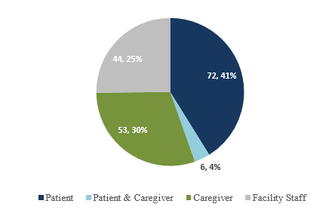

Given the length of the 30-day formal follow-up period with discreet pharmacist consults at weeks one and three, the data were explored for evidence that exposure to “more” of the intervention resulted in a greater benefit.

Among the 175 discharges in the intervention group, the majority, 129 (74 percent) received both of the planned consults. However, although 46 discharges only received the first consult, some of these patients restarted the DCP after a readmission, and received more than one first week consultation. Due to this overlap in populations, further study of differences in outcome related to the “dose” of the intervention received were not undertaken.

## Observed associations between outcomes, interventions, and relevant contextual elements

* + 1. *Participation in the DCP intervention was associated with a significant reduction in readmission rates*

Medicare claims data were used to identify inpatient readmissions to any hospital in the 90 days after discharge from TMC for the study population. A logistic regression was used to compare the readmission rates of the intervention and comparison groups at 30, 60, and 90 days after discharge. The results are displayed in Table 3**.**

### Table 3—Readmissions at 30, 60, and 90 Days

|  |  |  |  |  |  |
| --- | --- | --- | --- | --- | --- |
| **Mea sur e** | **Follow-up Period** | **Co mp aris on Gro up**  **n = 50 (%)** | **Inte rve ntio n Gro up**  **n = 175 (%)** |  | **Odds Ratio (95% CI)** |
| Ave rag e Rea dmi ssio ns Rat e | 30 days | 14  (28.  0) | 22  (12.  6) | 0.01  05 | 0.370 (0.173-0.792) |
| 60 days | 21  (42.  0) | 35  (20.  0) | 0.00  19 | 0.345 (0.176-0.677) |
| 90 days | 26  (52.  0) | 48  (27.  4) | 0.00  14 | 0.349 (0.183-0.666) |

The DCP was associated with significantly lower readmissions rates at all three time points. Compared to the odds of readmission for patients receiving usual care, the odds of readmission for DCP patients decreased from

0.370 at 30 days to 0.345 at 60 days, and slightly increased at 90 days to 0.349. The odds ratio at 90 days indicates that those who participated in the DCP had a 65 percent lower odds of being re-hospitalized as compared to those who received usual care.

* + 1. *Participation in the DCP intervention was associated with longer times to readmission*

A Kaplan Meier estimate was performed to determine whether participation in the DCP was associated with longer time to readmission (time free of return to the hospital). The event history data set was constructed from the Medicare Part A claims data linked to each member of the study population, and included the date of the index discharge and the first inpatient readmission that occurred within the 90 days following discharge. The event was defined as the day of the first readmission after each index discharge and was assigned a continuous time variable (number of days free of readmission from 1-90). The data were right-censored at 90 days after discharge.

Throughout the 90-day time period examined, participation in the DCP intervention was associated with higher proportional odds of remaining free of readmission, as shown in Figure 6. By the 90th day after the index discharge, the odds of remaining free from readmission were roughly 73 percent for a patient who received the DCP, compared with 48 percent for a patient who received usual care after discharge.

These findings demonstrate a significant protective effect against inpatient readmission to the hospital for DCP participants compared to those receiving usual care. An odds ratio of 0.370, as observed at 30 days post- discharge, indicates that DCP participants were 63 percent less likely to be readmitted at 30 days than those in usual care.

The protective effect of the DCP was observed at all three time points and demonstrated an increase in the treatment effect size over time. The log-rank *p*-value of 0.0003 is statistically significant, and strongly supports rejecting the null hypothesis that the groups had similar risks of rehospitalization over time. In other words, there is only a 0.0003 percent probability that the observed difference would happen by chance if there were no real difference between the intervention and comparison groups.

### Figure 6—Comparison of Time to Readmission

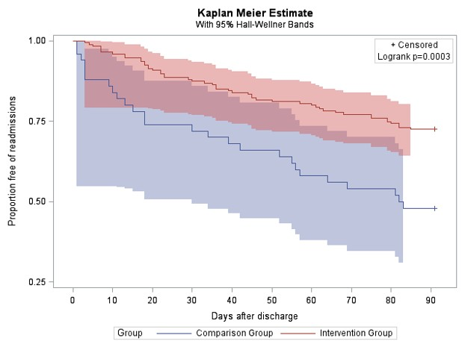

Source: HSAG analysis of Medicare Claims data.

Note: The shaded areas in the figure, the Hall-Wellner bands, represent the 95 percent confidence interval for each population.

* + 1. *Significant reductions in average Medicare expenditures were not observed*

DCP participants had lower numerical mean Medicare expenditures than those in the comparison group. At 30 days post-discharge the mean numerical difference was $4,218 and increased to $75,42 at 90 days post-discharge. The differences in the average Medicare expenditures between groups were compared using a *t*-test at 30, 60 and 90 days post discharge, yielding *p*-values greater than 0.05, as shown in Table 4. A Wilcoxon Rank Sum analysis of median Medicare expenditures was also performed, with similar results which are not shown.

### Table 4—Variance in Average Medicare Expenditures per Beneficiary

|  |  |  |  |  |
| --- | --- | --- | --- | --- |
| **Meas ure** | **Follo w-up Perio d** | **Comp ariso n Grou p (n = 50)** | **Intervention Group (n = 175)** | **value** |
| Avera ge Medic are Expen diture s Per Benefi ciary | 30  days | $30,8 78 | $26,660 | 0.193  6 |
| 60  days | $35,2 77 | $28,667 | 0.059  6 |
| 90  days | $39,2 28 | $31,686 | 0.054  8 |

Spending was also examined by the type of service, whether inpatient, outpatient, home health, or SNF. No significant differences between the intervention and comparison groups were observed when examined by claim type. The average expenditures are depicted in Figure 7 and Figure 8.

### Figure 7—Average Medicare Spending per Beneficiary on Home Health and Outpatient Services by Intervention Group and Comparison Group

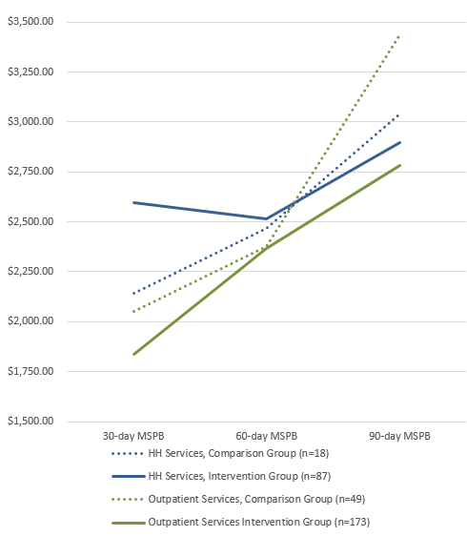

**Figure 8—Average Medicare Spending per Beneficiary on Inpatient Hospital and SNF Services by Intervention Group and Comparison Group**

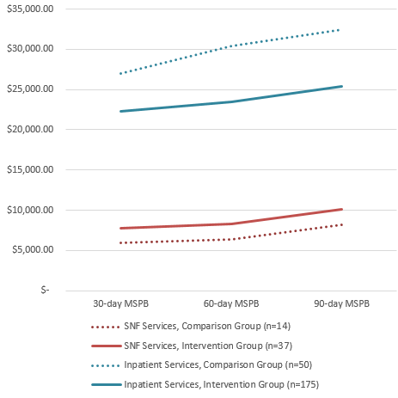

* 1. **Unintended consequences such as unexpected benefits, problems, failure, or costs associated with the intervention(s)**

No unintended consequences were identified in this study.

## Details about missing data

The study was limited to those patients for whom complete data were compiled, including a HICN, demographic information, and a discharge date matched between the DCP internal tracking log and the Medicare claims data.

# Discussion

## Summary

1. **Key findings, including relevance to the rationale and specific aims**

Patients discharged from TMC who received the DCP intervention experienced significantly lower rates of readmission to the hospital at 30, 60, and 90 days after discharge. The readmission rates ranged from 14.8 percentage points lower for the intervention group at 30 days, to 23.8 percentage points lower at 90 days.

The time to readmission was significantly lengthened for members of the intervention group. Nearly three quarters (72.6 percent) of the members of the intervention group had not been readmitted by the end of the 90-day period studied, compared to only approximately half (48 percent) of the members of the comparison group.

These findings are consistent with the DCP’s having performed as expected and met the aims of improving coordination of care and reducing readmissions after discharge.

## Particular strengths of the project

The continued decline in readmissions at 90 days after discharge was a particularly interesting finding, since many studies have shown that readmission rates are increasing at this time compared to rates at 30 days post- discharge.13 This demonstrated the strength of the results attained.

Other strengths of the project were related to the project’s design. The DCP included elements not widely reported in the literature. First, it expanded the hospital’s EHR to accommodate data entry and information sharing between care providers outside the hospital after discharge. The fragmentary nature of the medical records of patients with multiple chronic diseases and hospitalizations, such as those in this study population, is a major contributor to the lack of coordination in transitions of care. This strategy lessened that fragmentation by providing meaningful exchange of electronic information between providers.

A second strength of this program design was its systematic methodology for ensuring that the most recent national care guidelines for medication management, were taken into account following discharge. The incorporation of checklists and scripting customized for each disease state coupled with relevant lab values or test results provided a reliable method for ensuring that best practices specific to the patient were identified and followed. These administrative measures reduced variation in the process regardless of which DCP pharmacist performed the functions and ensured a high degree of quality. At the same time, the program provided a strategy for communicating recommendations and concerns and their underlying reasoning to subsequent providers and community pharmacies.

Finally, the DCP was operationalized with a documented structure for maintaining program integrity and data quality, as summarized in Table 1. The partners’ willingness to share this detailed framework will enhance their ability to spread the intervention to other providers.

## Interpretation

1. **Nature of the association between the intervention(s) and the outcomes**

The associations between the DCP intervention and the reductions in readmissions and increased time to readmissions for 90 days after discharge were strong, statistically significant, and in the direction that would be expected if the intervention improved coordination of care after discharge. The results are plausible, and in agreement with currently accepted scientific understanding of the processes that improve coordination of care transitions after discharge from the hospital. Although the limitations to the study were not trivial, the evidence suggests that the DCP improved patient outcomes.

## Comparison of results with findings from other publications

The results were consistent with findings in the literature, some of which have reported reductions in readmissions from 8 to 50 percent, depending on the study and the population.14,15,16

13 Jencks SF, Williams MV, Coleman E. Rehospitalizations among patients in the Medicare fee-for-service Program. NEJM 2009; 360(14):1418-1428.

14 Brown RS, Peikes D, Peterson G et al. Six Features of Medicare Coordinated Care Demonstration Programs that Cut

Hospital Admissions of High-Risk Patients. Health Aff 2012;31(6):1156-1166.

15 Phatak A, Prusi R, Ward B. et al. Impact of Pharmacist Involvement in the Transitional Care of High-Risk Patients Through Medication Reconciliation, Medication Education, and Post discharge Call-Backs (IPITCH Study). J Hosp Med 2016;11(1):39-44.

16 Polinski JM, Moore JM, Kyrychenko P, et al. An Insurer's Care Transition Program Emphasizes Medication Reconciliation, Reduces Readmissions And Costs. Health Aff 2016;35(7):1222-9.

The lack of significant savings in Medicare expenditures for the intervention group is also consistent with the literature, as many studies have been unable to identify significant evidence of cost savings. This study may provide important insight on the issue, with its identification of the significantly higher proportion of patients in the intervention group who received home health care support after discharge. Only 12 percent of the comparison group were discharged home with home health care, compared to 27 percent of the intervention group. This additional investment in care may help explain the lack of cost savings over the 90-day period investigated, but may also be implicated in the longer time to readmission for patients in the intervention group.

## Impact of the project on people and systems

The DCP intervention appears to have had an immediate impact on the readmission rates and time to readmission for patients who received the intervention. SinfoníaRx recorded numerous clinical interventions recommended by their pharmacists to improve safety, reduce costs, improve compliance with national consensus treatment guidelines, improve medication adherence, and improve vaccine guideline adherence. SinfoníaRx’s analysis of its internal data, together with its estimate of an impressive return on investment will be submitted in a separate publication.

Anecdotal evidence collected by TMC and SinfoníaRx supported the positive impact of the DCP. Feedback from patients and providers indicated that patients were actively engaged in their care post discharge, and felt their concerns about medications were addressed. Providers appreciated being informed of patient hospitalizations and medication changes, as well as the additional pharmacist input regarding patient medication regimens.

Community pharmacies were recognized as an important part of the overall success of the program, and were responsive in deactivating prescriptions for medications that were discontinued during the patient’s hospital stay. The hospital’s disease coordination staff also reported benefitting from increased communication and continuity of care with the outside providers.

Due to their positive experience and the impact of the program, TMC has extended the DCP beyond its initial course into 2019.

## Costs and strategic trade-offs, including opportunity costs

The DCP made conscious trade-offs to integrate the unique expertise of a pharmacist in evaluating medications and communicating with patients, with the skills of a strong care coordination nurse familiar with the clinical needs of complex high risk patients, with the hospital EHR, and with normal flows of information within the hospital and after discharge. The DCP developed a framework for providing the right team resources at the right time to respond to the information needs of a complex constellation of stakeholders, from patients and families, to SNFs, to primary care physicians, and to community pharmacies. It is presumed that costs to a hospital for similar outsourced medication therapy management services would vary, but might be expected to be less than staffing a program like the DCP with internal full time pharmacists and additional care coordination nurses.

The success of the program was also dependent on a highly functional EHR to maintain the complex and intricate communications between the team members. DCP’s mechanism for sharing information from the hospital’s EHR such as the pharmacist’s progress note with external providers underscores the importance of two-way communication after discharge to coordinate care to prevent readmissions.

## Limitations

**a. Limits to the generalizability of the work**

The DCP team had access to the hospital’s Electronic Health Record (EHR), for viewing the clinical record and for adding Pharmacist Progress Notes. Although use of EHRs has become widespread, a program such as DCP

would probably work best in an environment where hospital leadership and the EHR vendor are committed members of the development team. Settings with hybrid EHRs that are not fully integrated or automated might be unable to achieve similar timeliness in record review or standardization of interventions without incurring additional design costs.

Another factor in the DCP’s success that may differ across hospitals is the extensive language support system available at TMC. The DCP pharmacist and nurse had access to translation in more than 80 languages, permitting the pharmacist consultations to be conducted in real time with a translator present on the telephone along with the patient.

## Conclusions

* 1. **Usefulness of the work**

Both industry trends and CMS policy decisions indicate that improvements to medication therapy management over transitions of care will continue to play a critical role in improving health care while controlling costs. This work should prove useful to hospitals and health systems that lack the time and resources to create an effective medication therapy management program internally.

CMS has shown a commitment to developing innovative models for optimizing medication use, improving care coordination, and strengthening system linkages through a variety of programs. The Enhanced Medication Therapy Management (MTM) Model for Prescription Drug Plans, the Hospital Value-Based Purchasing (VBP) Program, the Hospital Readmission Reduction Program (HRRP), the Meaningful Use Program, the Merit-based Incentive Payment System (MIPS) Quality Payment Program, and the Advanced Alternative Payment Models (APMs) all share these aims.

Coordinating with effective programs like DCP will also be useful for Medicare Advantage Prescription Drug Plans and standalone Part D Prescription Drug Plans seeking to perform well on quality measures as CMS rolls out its plan to add numerous medication-related Star Ratings measures to the information it publishes on health insurance plans. The health plans must ensure high quality care is delivered across all clinical settings and throughout their provider network, which will require communication and coordination across extended care teams, including primary care physicians, specialists, pharmacies, inpatient/outpatient facilities, and emergency rooms/urgent care settings.

The DCP targets many of the specific mechanisms by which these programs are expected to generate cost savings and improve patient outcomes, by:

* + 1. Improving medication adherence to avoid medical complications
    2. Ensuring that medications are taken properly and ADEs are avoided, resulting in improved care for patients and reduced need for hospitalizations and emergency department visits
    3. Improving the accuracy of administration of medications to improve outcomes and reduce waste, for example from having to repeat courses of therapy
    4. Improving appropriateness of prescription of evidence-based therapies appropriate to the beneficiary in order to reduce complications and save unnecessary medical costs
    5. Helping identify and eliminate duplicative medications.17

17 Participants Selected for Part D Enhanced Medication Therapy Management Model, https:/[/www.](http://www.cms.gov/Newsroom/MediaReleaseDatabase/Fact-sheets/2016-Fact-sheets-items/2016-10-03.html)c[ms.gov/Newsroom/MediaReleaseDatabase/Fact-sheets/2016-Fact-sheets-items/2016-10-03.html.](http://www.cms.gov/Newsroom/MediaReleaseDatabase/Fact-sheets/2016-Fact-sheets-items/2016-10-03.html)

The DCP program is ahead of the curve, and provides a specific and detailed methodology for developing and operationalizing this type of innovative solution.

## Sustainability

The DCP partners have shared a robust methodology for a program that is self-sustaining through standardized checklists and templates. The intervention also provides a mechanism for regular review and timely updates to clinical practice guidelines. The approach makes maximum use of an interdisciplinary team to provide excellent and cost effective care.

The results of this study underscore the importance of patient-centered, integrated, interprofessional models of care across transitions. Although its precise methodology for calculating return on investment (ROI) was proprietary, SinfoníaRx has calculated a per-patient ROI for hospitals that exceeds the cost of providing MTM services in this program. That estimate does not take into account savings to patients who are steered toward less expensive or more effective medications, or to potential impacts of continued changes in payment incentives for care coordination.

The DCP intervention provides a good prototype for an efficient and cost effective division of the many tasks necessary to improve coordination of care among the healthcare professionals with the appropriate expertise fitted to the task. It also provides insight on the importance of matching information to the time and place of need.

Programs like DCP are currently reliant on like-minded innovative hospitals, health systems and payers to provide reimbursement for this MTM model. As CMS payment models move to episodic payment rather than FFS, providers will presumably have financial incentives to coordinate care to prevent readmissions, whether or not they are directly reimbursed by Medicare for the service.

## Potential for spread to other contexts

TMC and SinfoniaRx have generously shared the DCP, providing a quality MTM model that has been tested and proven to have significant positive impact in this study’s intervention group with reductions seen in the 30, 60 and 90 day hospital readmission rates. The partners have disclosed a great deal of detail about their operations to enable others to replicate their work and are committed to spread of the DCP methodology.

This study supports the trend toward integrating pharmacists with interdisciplinary teams of professionals in post- discharge care.

## Suggested next steps

Further study among larger subpopulations, and a randomized controlled trial would be logical next steps to test the value of the DCP approach. More detailed analysis of Medicare spending by disease condition as well as additional information about prescription drug spending would provide a better picture of the intervention’s impact on costs.

On a larger scale, the findings in this study support loosening the criteria a patient must meet to qualify for MTM services. CMS has suggested that MTM services currently offered by Part D plans may fall short of their potential to improve quality and reduce unnecessary medical expenditures, due to misaligned financial incentives and regulatory constraints. Part of the agency’s rationale for its latest round of improvement activities is its realization that current Medicare Part D statutory and regulatory MTM provisions, which require standardized offerings of uniform services to enrollees who meet strict program criteria, may work counter to CMS’ long-term aims.

Eligibility based on strict criteria regarding a beneficiary’s number of medications or chronic conditions, or on a benchmark for expected annual prescription drug costs, may not lead to providing the best care at the best time to

the people who need it most. Instead, Part D MTM programs as originally designed may not have included the level of resources or the type of activities that could have the greatest positive effect on beneficiary outcomes.

Patients with chronic illness face a number of challenges managing their day-to-day and long term health, in part because medications are complex, confusing, costly and potentially dangerous. Reducing the current statutory and regulatory eligibility requirements would give MTM providers the latitude to customize their approach based on individual patient needs to identify those most at risk for services timed when they need it most. The results of this study indicate that a far more patient-centric, individualized approach to post-discharge medication therapy management may provide much better results, at least in terms of reduced and delayed readmissions to the hospital.