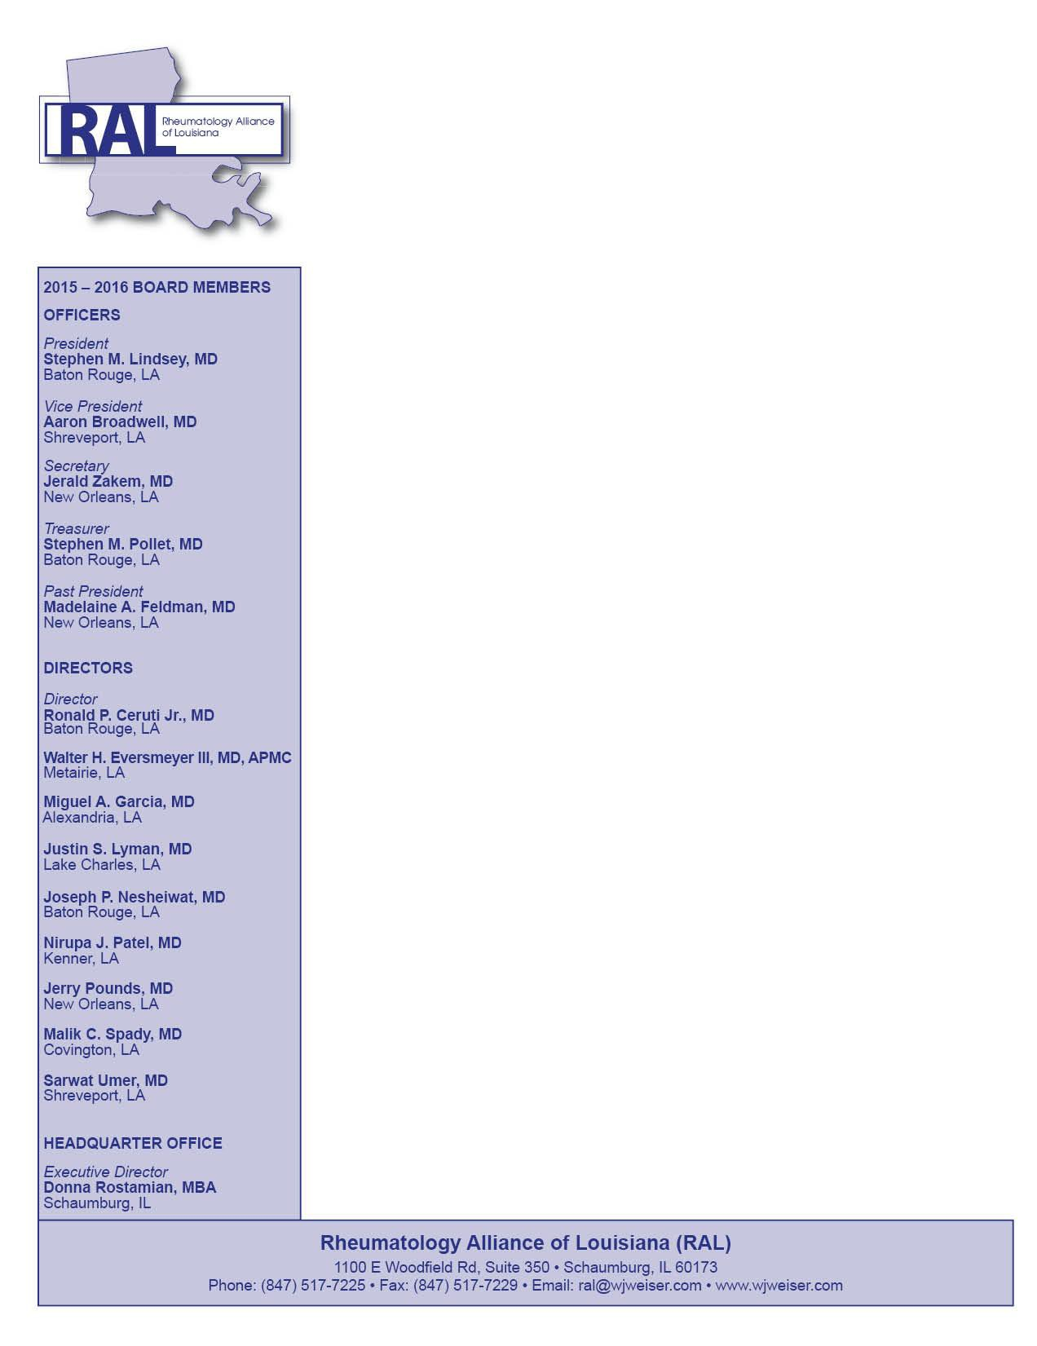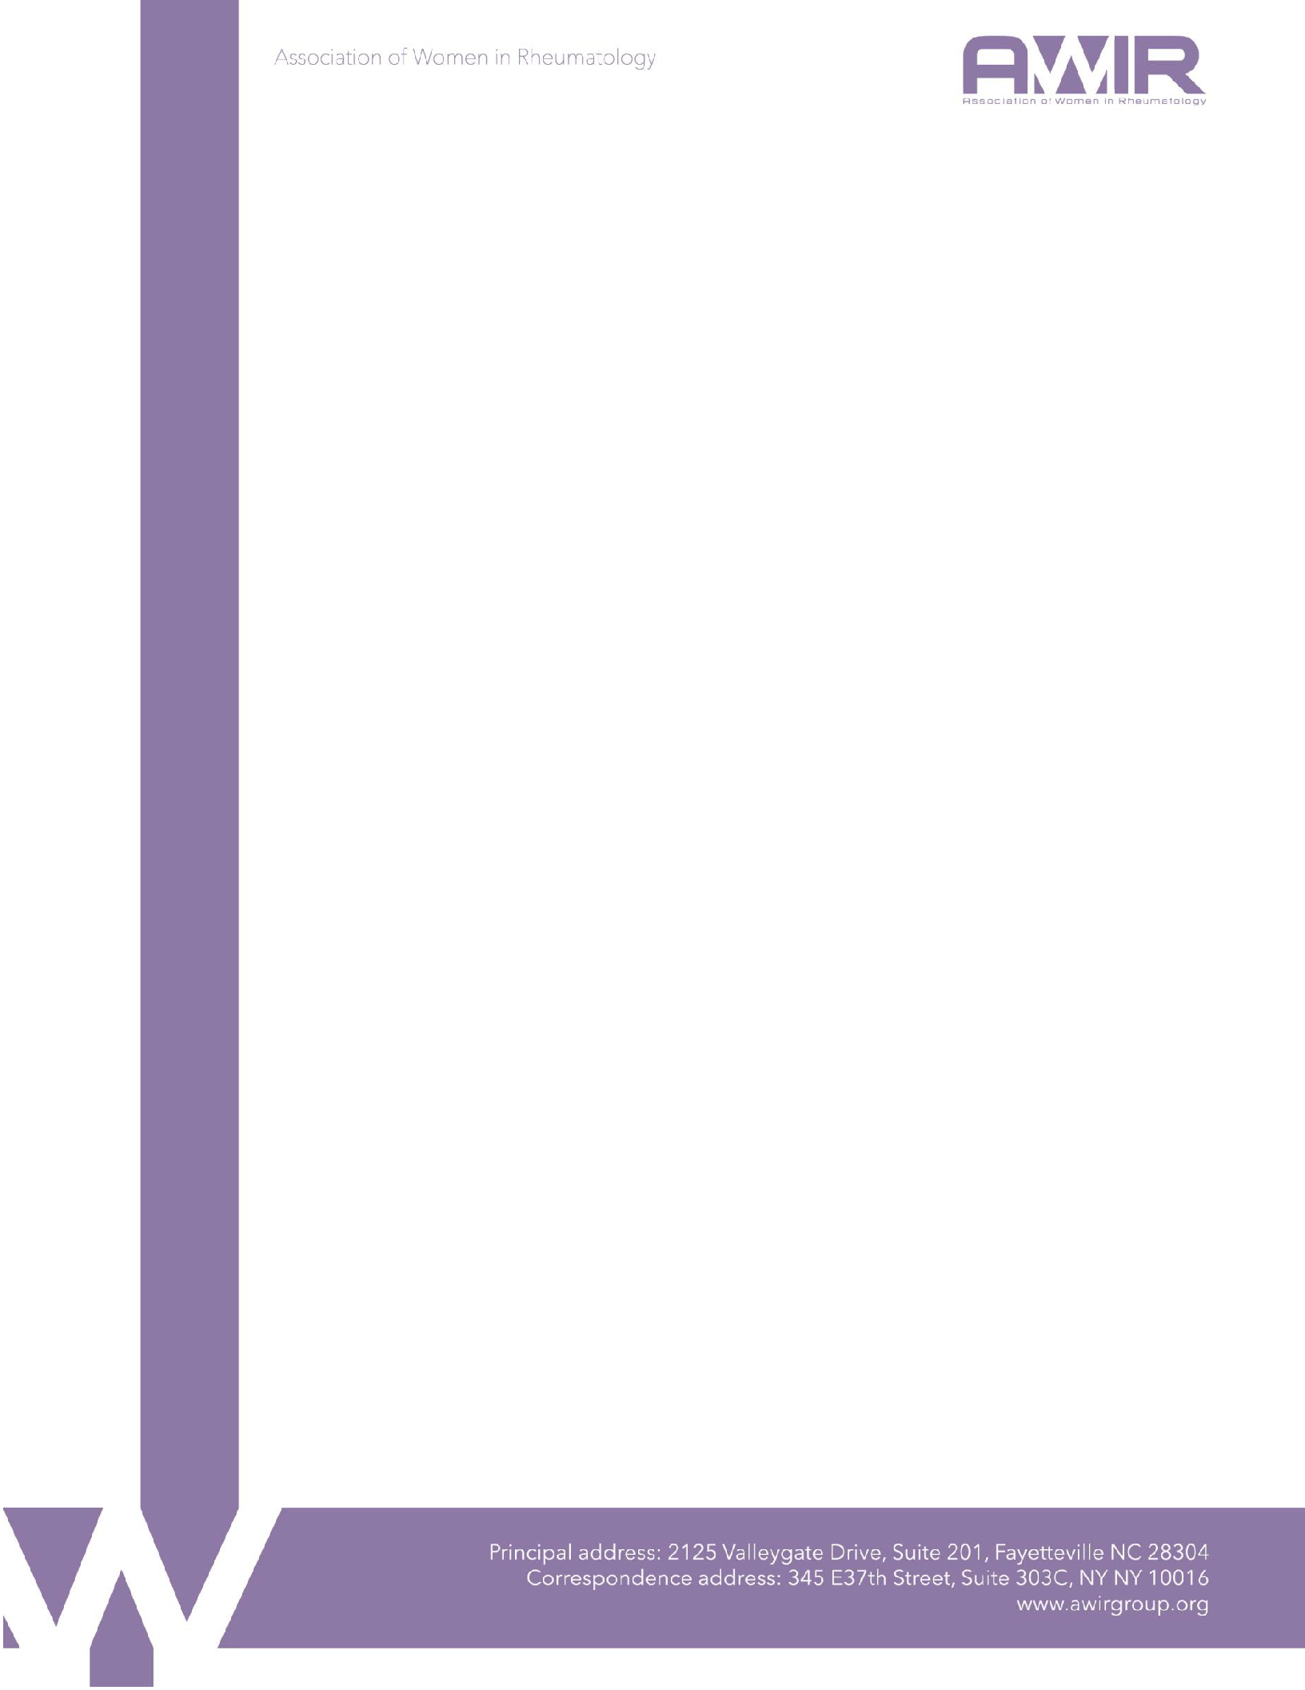

January 16, 2018

Ms. Seema Verma, Administrator

Centers for Medicare & Medicaid Services Department of Health and Human Services Room 445-G, Hubert H. Humphrey Building 200 Independence Avenue, SW

Washington, DC 20201

**RE: CMS-4182-P, Medicare Program; Contract Year 2019 Policy and Technical Changes to the Medicare Advantage, Medicare Cost Plan, Medicare Fee-for-Service, the Medicare Prescription Drug Benefit Programs, and the PACE Program**

*Submitted electronically v*[*ia http://www.regulations.gov*](http://www.regulations.gov/)

Dear Administrator Verma:

The Association of Women in Rheumatology (AWIR) respectfully submits these comments to the Centers for Medicare & Medicaid Services (CMS) on the proposed rule on Medicare Managed Care (Part C) and Prescription Drug Plans (Part D) (CMS-4182-P).

AWIR is dedicated to promoting the science and practice of Rheumatology, fostering the advancement and education of women in Rheumatology, and advocating access to the highest quality health care, and management of patients with Rheumatic diseases. Rheumatologists across the country, including our members, are dedicated to the successful implementation of MACRA, and the AWIR appreciates the opportunity to provide comment on “Medicare Program; Contract Year 2019 Policy and Technical Changes to the Medicare Advantage, Medicare Cost Plan, Medicare Fee-for-Service, the Medicare Prescription Drug Benefit Programs, and the PACE Program” (hereinafter “proposed rule”).

# Request for Information Regarding the Application of Manufacturer Rebates and Pharmacy Price Concessions to Drug Prices at the Point of Sale

The proposed rule includes a section entitled “Request for Information Regarding the Application of Manufacturer Rebates and Pharmacy Price Concessions to Drug Prices at the Point of Sale.” In this section, CMS puts forth a detailed request for information (hereinafter “RFI”) regarding a requirement that plan sponsors “include at least a minimum percentage of manufacturer rebates and all pharmacy price concessions received for a covered Part D drug in the drug’s negotiated price at the point of sale.”

In considering such a requirement, the RFI specifically notes that when the Part D program was established, CMS believed “that market competition would encourage Part D sponsors to pass through to beneficiaries at the point of sale a high percentage of the manufacturer rebates and other price concessions they received, and that establishing a minimum threshold for the rebates to be applied at the point of sale would only serve to undercut these market forces. *However, actual Part D program experience has not matched expectations in this regard”* (emphasis added). Instead, the RFI explains that “only a handful of plans have passed through a small share of price concessions to beneficiaries at the point of sale” and that “sponsors may have distorted incentives as compared to what we intended in 2005.”

AWIR appreciates the opportunity to respond to this RFI, specifically with respect to mandatory pass-through requirements for manufacturer rebates. AWIR is among those patient and provider groups that has become increasingly concerned with the negative impact of PBMs and the rebate system on drug costs and patient access to affordable treatment. In short, we believe that PBMs exploit their control over formularies and the lack of transparency in the rebate system in order to negotiate higher rebates and keep a large portion as profit instead of passing them onto plans and patients, which not only drives up lists prices for drugs, but also hinders our patients’ ability to obtain the medications they need in a timely and affordable manner. As such, AWIR strongly supports a mandatory pass-through policy that requires sponsors to apply a minimum percentage of manufacturer rebates to the negotiated price of Part D drugs at the point of sale.

We believe that such a policy will not only substantially reduce the cost burden on Medicare patients, but it also will generate overall savings for the Medicare program as a whole. In theory, the rebate system, whereby PBMs negotiate and receive retroactive discounts from drug manufacturers in exchange for preferred placement on the PBM’s tiered formulary, is supposed to lower drug costs, but this is far from reality. Instead, it creates perverse financial incentives for PBMs to develop their formularies based on rebates, not patient safety and efficacy.

Moreover, it puts pressure on the manufacturers to give a rebate amount that is substantial enough to garner favorable placement on the formulary, or in some cases, to get on it at all. In this way, the ability to leverage rebates to ensure formulary placements is a significant market influence that manufacturers must take into account when setting list prices, which ultimately results in higher list prices.

To be sure, the list price of a drug is technically just an abstract amount that is supposed to be a starting point for cost-related negotiations throughout the system. However, because the price used to calculate patient cost sharing typically does not take into account rebates and discounts, the “abstract” list price is unfortunately all too real for patients. As the RFI notes, “When manufacturer rebates and other price concessions are not reflected in the negotiated price at the point of sale (that is, applied instead as DIR at the end of the coverage year), beneficiary cost- sharing, which is generally calculated as a percentage of the negotiated price, becomes larger, covering a larger share of the actual cost of a drug.” This means, as the RFI further explains, that for “many Part D beneficiaries who utilize drugs and thus incur cost-sharing expenses, this means, on average, higher overall out-of-pocket costs, even after accounting for the premium savings tied to higher DIR.”

A clear example of this increased cost burden to patients and the government can be found in the gap coverage phase of Part D, commonly known as the donut hole. In this phase, Medicare patients are required to pay 40% of the plan’s cost for covered brand-name drugs, where the plan cost equates to the list price. As such, the patient has to pay 40% of the list price for the brand- name drug, which has been unreasonably driven up by the rebate system. The other 60% is paid by the manufacturing industry and the plan: the manufacturer pays a 50% discount payment, and

the remaining 10% is covered by the plan, or in other word the government. But all of this is based on the negotiated price,1 which very rarely (if ever) takes into account rebates and other price concessions. It is not hard to see that if the negotiated price of a drug at the point of sale is lower, not only would the patient pay less out-of-pocket, but the government would end up spending less as well.

In seeking feedback on determining the specific minimum percentage of manufacturer rebates that must be passed through at the point of sale, CMS emphasizes that it is not considering requiring that 100 percent of rebates be applied at the point of sale. According to CMS, while a 100% pass-through policy would result in lower out-of-pocket costs for many beneficiaries, larger cost-sharing savings for many beneficiaries, it “would also result in larger premium increases for all beneficiaries and lower flexibility for Part D sponsors in regards to the treatment of manufacturer rebates, and thus, for some sponsors, weaker incentives to participate in the Part D program.” Putting aside the fact that this argument is somewhat undercut by CMS’ own ten- year impact estimates of a forced pass-through, we are not entirely convinced that any increase to premiums as a result of a 100% pass-through policy would not be more than offset by the large reductions in patient cost-sharing.

That being said, however, AWIR strongly supports a mandatory pass-through policy that establishes a minimum percentage of manufacturer rebates that must be applied at the point of sale, even if that minimum percentage is less than 100%. We urge CMS to implement a mandatory pass-through policy that sets the minimum percentage around 90%, as we believe that the potential increase in premiums is overstated, especially given that PBMs are already able to subvert passing rebates onto plans and patients due to the lack of transparency surrounding PBM contractual negotiations.

# Treatment of Follow-On Biological Products as Generics for Non-LIS Catastrophic and LIS Cost Sharing

As specialty physicians who regularly treat patients with biologics, we are intimately aware of the importance of biosimilars and interchangeable biologics, which can provide our patients with less costly alternatives to the increasingly expensive innovator biologics. AWIR therefore supports CMS’ proposal to revise the definition of generic drugs to include follow-on biologics only for the purposes of LIS cost-sharing and for non-LIS catastrophic coverage. We agree with CMS that applying the same levels of cost-sharing to biosimilars as applicable to generic drugs

1 The RFI defines negotiated price as “the price paid to the network pharmacy or other network dispensing provider for a covered Part D drug dispensed to a plan enrollee that is reported to CMS at the point of sale by the Part D sponsor. . . . More broadly, the negotiated price is the primary basis by which the Part D benefit is adjudicated, and is used to determine plan, beneficiary, manufacturer (in the coverage gap), and government liability during the course of the payment year, subject to final reconciliation following the end of the coverage year.”

for non-LIS catastrophic and LIS cost sharing will provide enrollees with lower cost alternatives that “will improve enrollee incentives to choose follow-on biological products over more expensive reference biological products, and will reduce costs to both Part D enrollees and the Part D program.”

# Expedited Substitutions of Certain Generics and Other Midyear Formulary Changes

In an effort to provide Part D sponsors with more flexibility to implement generic substitutions, CMS further proposes allowing sponsors to immediately remove, or change the tiering of, brand name drugs, when those drugs can be replaced with therapeutically equivalent newly approved generics. Certain requirements would apply including generally advising enrollees beforehand that such changes can occur without a specific advance notice and later providing information to affected enrollees about any specific generic substitutions that occur. CMS also proposes to also allow sponsors to make those specified generic substitutions at any time of the year rather than waiting for them to take effect two months after the start of the plan year. Finally, CMS further clarifies that this provision would not apply to biosimilars that are not considered interchangeable by the FDA.

AWIR is generally concerned that PBMs exercise far too much control over formularies, especially given that formularies are seemingly constructed based on the PBMs bottom line, and not efficacy, safety, and cost to the patient. While we acknowledge the importance of generic substitutions and appreciate CMS’ intent in trying to provide sponsors with more flexibility to implement generic substitutions, we are deeply concerned that this gives PBMs and sponsors too much leeway in formulary construction and could ultimately undermine efforts to minimize formulary changes that impede our patients ability to obtain their prescribed medications and that interfere with our physicians’ ability to provide the best possible care to their patients.

To its credit, CMS does try to restrict permissible formulary changes under the proposed rule by limiting them to only therapeutically equivalent generic drugs and prohibiting removal or change in tiering of a brand name drug the generic equivalent could have been included with the sponsor’s initial formulary submission or during a later update window. While this proposed provision, as contemplated by CMS, is admittedly narrow, it fails to take into account a few key considerations regarding formularies and their construction.

First, although the proposed provision is limited to generics and does not apply to follow-on biologics, as more biosimilars enter the market, the relaxed requirements as proposed for formulary changes seemingly pave the way for expansion into follow-on biological products, especially those that are deemed interchangeable. The problem, however, is that even those biologic products that are determined to be interchangeable are still not therapeutically equivalent, given the complex molecular nature of biologics. Allowing a PBM or sponsor to immediately remove or change the tiering of brand name drugs and substitute or add newly approved biosimilars, even those that are deemed interchangeable, will inevitably result in patients being switched off their stable medications by a third party who is not their physician.

Second, with respect to the proposed notice requirements, CMS explains that under the proposed provision, “enrollees would receive the same information they receive under the current regulation—the only difference being that the notice could be provided after the effective date of the generic substitution. . . . Part D sponsors seeking to make immediate substitutions would be newly required to have previously provided general notice in beneficiary communication materials such as formularies and EOCs that certain generic substitutions could take place without additional advance notice.” Given the increasingly complex and confusing nature of plan benefit designs and the difficulties of merely locating, much less understanding, drug formularies, a general notice in an EOC does virtually nothing to make up for the notification of a change in coverage after the fact.

Third, while the proposed provision attempts to allow for generic substitutions while still protecting beneficiaries, the underlying fundamental issue with respect to formulary changes still remains: as described above, the rebate system causes PBMs to make formulary decisions based on rebates and their potential profit, not on what is best for the patient in terms of efficacy, safety, and cost to beneficiaries. Allowing PBMs and sponsors to make mid-year changes to formularies, even if limited as described in the proposed provision, not only gives them more control over formularies, but it also at best overlooks—and at worst reinforces—the perverse formulary decisions they make at the detriment to patients.

# Part D Tiering Exceptions

Recognizing that that most formularies now include several expanded tiers that in some cases mix brands and generics, CMS proposes to change the tiering exceptions process to make it more in line with the increasing complexity of tiered formularies. More specifically, CMS proposes to base eligibility for tiering exceptions on the tier that contains the preferred alternative drug to the higher-cost requested drug, rather than based on tier labels established by the plan. This would remove an existing loophole whereby plans could exclude generic tiers, including non-preferred generic tiers, from the tiering exception system.

Specialty tiers, however, will still be excluded from tiering exceptions under the proposed rule, as CMS asserts that beneficiary access to drugs on specialty tiers is already protected by the 25% coinsurance limit, rendering tiering exceptions largely unnecessary.

AWIR commends CMS’ effort to clarify the tiering exceptions process and to expand access to these exceptions, and is generally supportive of the proposed tiering exceptions provision to the extent that, under the current Part D formulary paradigm, it increases patient access to effective and affordable treatment. That being said, however, we feel it is important to once again note that the underlying problems with current formularies as constructed by PBMs still remain. So while the proposed tiering exceptions provisions does help to ensure patients have access to the medications they need at the most favorable cost-sharing terms available, it does not make formularies less complex or easier for patients to navigate, and it certainly does not address the fact that PBM formularies are designed to enhance PBM profit margins, not the quality of patient care. As such, AWIR urges CMS to examine and consider provisions that would require PBMs and sponsors to establish and maintain evidence-based formularies that aim to provide beneficiaries with the most appropriate medication based on efficacy, safety, and cost to patients.

In conclusion, on behalf of AWIR, we appreciate the opportunity to provide comments on the outlined issues and their impact on rheumatology, and look forward to working with the agency on this and other Medicare proposals in the future. Should you have any questions, please direct them to Ally Lopshire, JD a[t ally@wjweiser.com.](mailto:ally@wjweiser.com)

Sincerely,

Grace C. Wright, MD, PhD, FACR President, AWIR



Gwenesta B. Melton, MD Advocacy Co-Chair, AWIR

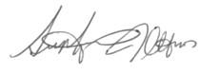

Stephanie Ott, MD Advocacy Co-Chair, AWIR