January 16, 2018

Seema Verma

Administrator, Centers for Medicare and Medicaid Services

Department of Health and Human Services

200 Independence Ave SW

Washington, DC 20201

Re: CMS-4182-P

Dear Ms. Verma:

# I am writing on behalf of the National Association of Health Underwriters (NAHU), a professional association representing more than 100,000 licensed health insurance agents, brokers, general agents, consultants and employee benefit specialists. We are pleased to have the opportunity to provide comments to the proposed rule titled “Medicare Program; Contract Year 2019 Policy and Technical Changes to the Medicare Advantage, Medicare Cost Plan, Medicare Fee-for-Service, the Medicare Prescription Drug Benefit Programs, and the PACE Program.”

Thousands of NAHU members specialize in the sale of private Medicare products to senior and disabled clients. As such, we have a critical interest in proposed changes to traditional Medicare, as well as the Medicare Advantage program and Prescription Drug Benefit program for the 2019 plan year and the proposed rule’s goals of improving program quality, accessibility and affordability. Members of NAHU who work every day with Medicare beneficiaries on their health insurance needs provided direct insight into our comments on the proposed rule, which we have broken down by topic and ordered as they appear in the proposed rule. We appreciate the Centers for Medicare and Medicaid Services’ consideration of our point of view.

**Implementation of the Comprehensive Addiction and Recovery Act of 2016 (CARA)**

NAHU supports the framework proposed by CMS to allow Medicare Part D plan sponsors to establish a coordinated program to manage beneficiaries at risk for prescription drug abuse. Specifically we support he proposal to, if necessary, limit access to controlled substances that are frequently abused except for through selected providers and pharmacies. In addition, we agree with the proposal to codify the current Part D Opioid Drug Utilization Review (DUR) Policy and Overutilization Monitoring System (OMS) by integrating this current policy with the new prescription drug management system. NAHU believes that Medicare beneficiaries and the American society as a whole will benefit from the care-management elements being introduced into the Part D program to limit over-prescribing of opioids and other prescription drugs that are frequently abused.

**E-Prescribing**

NAHU supports the proposed regulatory updates to 42 CFR §423.16 and related sections that will facilitate greater electronic transmission of prescriptions and prescription-related information for Medicare beneficiaries between their prescribers, dispensers, intermediaries and Medicare prescription drug plans, effective January 1, 2019. NAHU believes that these updates will make the prescribing system more efficient for providers, plans and beneficiaries, and will lead to fewer errors and other related cost savings.

**Electronic Delivery of Documents**

NAHU strongly supports the changes in the proposed rule for both Medicare Advantage and Part D plan sponsors that will allow health insurers to deliver more documents to plan participants electronically rather than in hard copy. We also agree with the proposed change to the delivery date of the evidence-of-coverage statement to the first day of the Annual Election Period (AEP), rather than 15 days prior to that date. These changes will reduce costs and improve administrative efficiencies for plans and for many beneficiaries.

However, we note that the Medicare population is one of the least likely groups to uniformly have access to the Internet. Even if access is available, many Medicare beneficiaries struggle to use it reliably. This population also frequently relies on the assistance of designated representatives, such as children or other caregivers or advisors, for the management of both their healthcare coverage services and their important paperwork. As such, we believe it is extremely important that Medicare beneficiaries always have the option to request to receive copies of all documents in hard copy rather than electronically, and that they always have the option to designate one or more authorized representatives to receive copies of electronically delivered documents or hard copies of the same.

**Changes to Medicare Advantage Plan Uniformity Requirements**

CMS has proposed making changes to the Medicare Advantage plan uniformity requirements to allow more flexibility and health plan modifications of benefits and cost sharing for members based on their health status and specific medical histories. This would include allowing plans to offer specific tailored supplementary benefits to people with certain health conditions, and offer reduced cost sharing and deductibles for people who meet specific medical criteria. The proposed rule specifies that plans that take advantage of this flexibility must not violate § 18529(B) of the Medicare Modernization Act (MMA), which prohibits plans from denying, limiting or conditioning coverage or services based on health status-related factors. It also states that CMS is considering issuing guidance clarifying the flexibility MA plans have to offer targeted supplemental benefits for their most medically vulnerable enrollees and requests comments from stakeholders about the implementation of this flexibility.

NAHU members very much appreciate the concepts of greater plan design flexibility and targeted benefits aimed at improving the value and quality of care provided to specific beneficiaries outlined in this section of the proposed rule. However, we have questions about how these proposed changes would interface not only with the nondiscrimination provisions outlined in the MMA, but also with Section 1557 of the Affordable Care Act, the Americans with Disabilities Act, the Genetic Information Nondiscrimination Act and other civil-rights protections in federal law. We request that CMS provide clarification on these topics in the final rule and in any sub-regulatory guidance issued relative to this section of the regulation. NAHU also believes that it would be very wise for CMS to issue extensive sub-regulatory guidance concerning the proposed plan uniformity flexibility with many detailed examples for permissible and impermissible actions. Such guidance is necessary so that health plans and licensed health insurance agents and brokers clearly understand how these provisions might be implemented and marketed without violating discrimination protections and increasing adverse selection.

**Plan Segment Benefits Flexibility**

NAHU supports the proposed changes to 42 CFR § 422.262 that would allow plans to vary supplemental benefits made available to beneficiaries by plan segment, just as they are currently allowed to vary premiums and cost-sharing requirements.

**Maximum Out-of-Pocket Limit for Medicare Parts A and B Services**

NAHU supports the changes proposed to the methodology used for the establishment of the maximum out-of-pocket limits (MOOP) for Medicare Part A and Part B services when enrolled in a Medicare Advantage plan. However, our members would like to note that, in some markets, there are Medicare Advantage plans being marketed that do not have a MOOP for out-of-network services. NAHU members believe that the MOOP is a hallmark of Medicare Advantage plan offerings and feel that it should always be preserved for both in-network and out-of-network benefits.

**Changes to Meaningful-Difference Requirements**

NAHU members believe that the proposed changes that relax “meaningful difference” requirements for plans in §§ 422.254 and 422.256 as well as §423.265 will result in more competition and increase the number of Medicare Advantage and Part D plan choices for consumers in many markets. Given the amount of health-plan consolidation, our membership suggests that the meaningful-difference rules also be relaxed in the case of acquisitions/mergers so that multiple plan options can exist between the two merged entities for multiple years.

NAHU also supports CMS’s statement of commitment to plan choice and price transparency, as well as the promise to implement more sophisticated approaches to consumer engagement and provide consumers with better decision-making tools to compare plan options. NAHU agrees that this effort will help beneficiaries, caregivers and family members make more informed plan choices, and better tools will help health insurance agents and brokers serve this unique population.

**Coordination of Enrollment and Disenrollment through MA Organizations and Effective Dates of Coverage and Change of Coverage and Establishing Limitations for the Part D Special Election Period for Dually Eligible Beneficiaries**

NAHU appreciates that seamless conversions are being eliminated for almost all Medicare beneficiaries and believes that automatic enrollment should also be discontinued for the dual-eligible population. Our membership feels that each Medicare beneficiary, regardless of their coverage status and income level, should have the opportunity to review their coverage each year and make sure that it still fits their needs, budget and lifestyle. Even individuals whose plans are cancelled or are in an inappropriate care situation should be allowed the option to review their health coverage situation and making an active decision to reenroll in the same type of coverage. If an individual isn’t capable of acting on his or her own behalf, then an authorized representative should be consulted. NAHU suggests that the practice of passive reenrollment be discontinued for dual-eligible people in all circumstances as well as other Medicare beneficiaries. In addition, our membership is concerned that the proposal to limit enrollment for dual-eligible beneficiaries to one change outside of the annual election period is confusing and will be difficult for this under-served market.

**Effective Dates of Coverage and Change of Coverage**

NAHU supports the proposed changes §422.68 regarding the effective date of coverage when a person in their Initial Coverage Election Period (ICEP) enrolls. NAHU has long advocated for the coverage of a person enrolling during or after the month of entitlement to Part A and Part B to be effective the first day of the calendar month following the month an ICEP election is made. This ICEP change will also make the effective date for individuals turning 65 consistent with current effective date rules for enrollment of under-65 individuals. We appreciate CMS making this adjustment, which will be a significant help to beneficiaries and an administrative improvement.

**Restoration of the Medicare Advantage Open Enrollment Period and Prohibition of Marketing During the Open Enrollment Period**

NAHU appreciates and supports the codification of the updated Medicare open enrollment period, which our membership has long believed should be restored in a modernized format.

NAHU members know that the new OEP will help ensure that all Medicare beneficiaries are enrolled in a plan that best suits their needs and budgets. It will also help licensed health insurance agents and brokers more effectively serve their clients.

As for the related provision that establishes a “knowing” standard with regard to enforcement of the unsolicited marketing requirement for individuals during the OEP, NAHU members are in full support of the provision prohibiting marketing during the OEP. Health insurance agents and brokers appreciate the opportunity to provide input to CMS about how to ensure that this regulation works most effectively, and we can understand why the “knowing” standard was proposed. Our membership feels that if this standard is used, it will also be crucial for CMS to accompany it with education about this prohibition to be targeted to all related industries and interest groups so that all entities that may target this vulnerable population will understand the law and the consequences for knowing violations.

**Reducing the Burden of the Compliance Program Training Requirements**

NAHU requests clarification from CMS that the proposed changes that will eliminate the CMS specific training requirement, as well as the requirement that first-tier downstream risk (FDR) complete annual compliance training, will apply to licensed independent health insurance agents and brokers who market and assist beneficiaries with their year-round coverage needs with Medicare Advantage and Part D plans. Our membership would also like to know if this proposed rule would eliminate their need to receive annual certification both through the Association of Health Insurance Plans (AHIP) and also through each carrier whose products they represent.

NAHU members note that the current certification program requirements for experienced independent agents are burdensome, costly and repetitive. However, licensed and professional health insurance agents and brokers take their education requirements seriously and believe that it is critical that new entrants to serving the coverage needs of Medicare beneficiaries receive professional training. If the new changes to compliance requirements do indeed apply to independent health insurance agents and brokers and others that help Medicare beneficiaries with enrollment and plan services, NAHU requests clarification as to how CMS and health plans will have to ensure that less-experienced individuals have a clear understanding of all of the complex rules CMS has in place to protect this vulnerable population.

**Revisions to Communication/Marketing Materials and Activities**

NAHU supports CMS’s proposal to develop a broad definition of “communication materials” used by plans and their downstream service providers, like independent agents and brokers, to provide information to enrollees and prospective beneficiaries, as well as a more specific subset definition of “marketing materials.” Further, we support the proposed change that would limit the materials that need to be reviewed and approved by CMS in advance of their use to merely “marketing materials,” but still require that “communication materials” follow specified standards determined by CMS. Finally, we agree that “marketing materials” and their related requirements should focus on materials and activities that aim to influence enrollment decisions rather than those materials and activities geared at providing information to the Medicare population and related caregivers and family members. Providing this greater degree of specificity in protections will help beneficiaries and will allow plans and their service providers to improve the content of their materials and ensure that they meet the highest quality standards.

**Reducing the Medicare Advantage and Part D Medical Loss Ratio Requirements**

NAHU supports the proposed changes to the medical loss ratio (MLR) calculation for Medicare Advantage and Part D plans to make it easier for plans to claim and report expenses for fraud prevention and recovery by treating these expenses as plan quality improvements. This change will allow plans to devote greater resources to fraud protection, which is particularly important in this age of cyber fraud crimes. Increased fraud prevention not only helps protect consumers and their personal data, but it will also reduce premium costs to the benefit of all consumers. Similarly, NAHU members support the proposed changes to simplify the MLR reporting requirements for Medicare Advantage and Part D carriers in 42 CFR §§ 422.2480 and 423.2480. As part of this proposal, in the final rule NAHU suggests that CMS reduce the related record-retention burden for Medicare Advantage and Part D plans and their downstream entities, such as licensed agents and brokers, down from currently excessive 10 years of record storage. Instead, NAHU suggests that Medicare Advantage and Part D plans and their downstream entities be required to keep records for three years for MLR review purposes, as within the industry three years considered a sufficient period of data for a valid review.

NAHU sincerely appreciates the opportunity to provide comments on this proposed rule and we look forward to working with you in the year ahead on private-market improvements to the Medicare Advantage and Part D programs. If you have any questions or need additional information, please do not hesitate to contact me at either (202) 595-0787 or [jtrautwein@nahu.org](mailto:jtrautwein@nahu.org).

Sincerely,

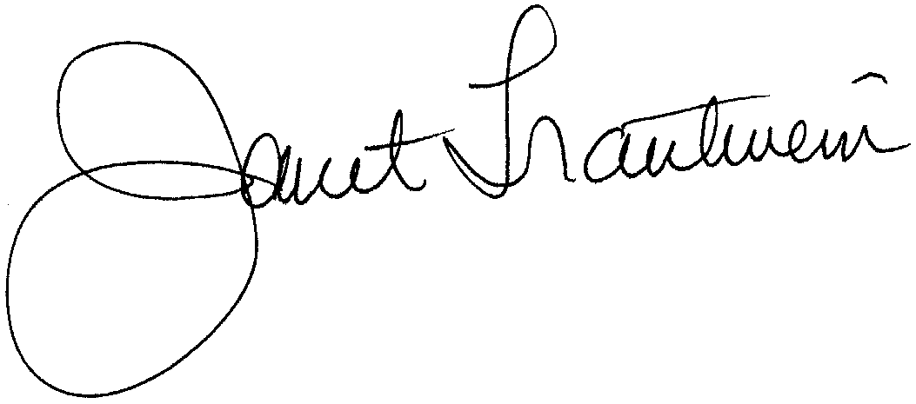

Janet Stokes Trautwein

Executive Vice President and CEO

National Association of Health Underwriters