January 16, 2018

Seema Verma, Administrator

Centers for Medicare & Medicaid Services Department of Health and Human Services 200 Independence Avenue, SW Washington, DC 20201

# Re: Medicare Program; Contract Year 2019 Policy and Technical Changes to the Medicare Advantage, Medicare Cost Plan, Medicare Fee-for-Service, the Medicare Prescription Drug Benefit Programs, and the PACE Program [CMS-4182-P]

Dear Administrator Verma:

RxAnte, Inc, a predictive analytics and clinical services company focused on improving prescription drug use, appreciates the opportunity to provide comments to the Centers for Medicare & Medicaid Services (CMS) on the proposed rule, Medicare Program; Contract Year 2019 Policy and Technical Changes to the Medicare Advantage, Medicare Cost Plan, Medicare Fee-for-Service, the Medicare Prescription Drug Benefit Programs, and the PACE Program [CMS-4182-P], released on November 16, 2017. Specifically, RxAnte offers comments on the section of the proposed rule focused on the Medicare Advantage (MA) and Part D Quality Ratings System.

RxAnte was founded in 2011 to provide health plans and providers with new tools for managing their growing accountability for prescription drug use and outcomes. We quickly found a market for our predictive analytics, targeted clinical interventions, and strategic advisory services among Medicare Advantage and Part D plans. Today, our technology platforms and services are used by national and regional plan sponsors to manage the quality of medication use for 8.5 million Medicare and Medicaid members. Our comments on the proposed rule are informed by six years of experience measuring and forecasting Part D and HEDIS quality ratings, identifying and targeting interventions to members at-risk of poor performance on medication-related quality measures, and supporting daily drug therapy management workflows for pharmacies, care managers and community-based providers. This experience has given us the opportunity to observe the effects of the Quality Ratings System on the behavior of plan sponsors, and we provide these comments with the goal of informing continued improvements in the program—and ultimately in the outcomes the program delivers for beneficiaries.

The Quality Ratings System, or Star Rating measures, serves to measure how well Medicare Advantage and Medicare prescription drug (Part D) plans perform. Medicare scores how well plans did in several categories, including quality of care and customer

service. Ratings range from 1 to 5 stars, with 5 being the highest and 1 being the lowest score. The overall Star Rating score provides a way to compare performance among several plans. Through this proposed rule, CMS proposes to codify the existing Star Rating System with some changes.

The current Part C and Part D Star Ratings System has been implemented and modified each year via the annual advance notice and rate announcement (“Call Letter”) process. RxAnte is pleased that CMS is using this opportunity to codify the methodology. RxAnte agrees that because the system has been in place for some time and is mature, there is less need for extensive changes each year, and we believe that greater transparency and predictability will enable plan sponsors to make longer-term commitments to specific improvement strategies.

As general comments to CMS, RxAnte believes that CMS should continue to heavily emphasize improving prescription medication use through the Star Ratings System. New studies regularly highlight the health and financial tolls of under-, over-, and mis-use of prescription drugs, particularly in the vulnerable Medicare and Medicaid populations.

Moreover, appropriate use of medications by beneficiaries directly leads directly to improvement in other health priorities, making appropriate prescribing and adherence ideal intermediate outcome measures. In our experience, another advantage of these measures is that because they are calculated from prescription drug event (PDE) data, they can be monitored by every Medicare Advantage plan and Part D plan (PDP) in near real-time, and monitored for every member.

The importance of continued focus on medication adherence measures is illustrated in the figure below, which describes our analysis of publicly available CMS data for MA and PDP plans through 2017. This figure demonstrates that the incentives to improve adherence in these categories are working and that the improvement trend has not flattened yet. We believe that this analysis highlights the importance of CMS continuing to focus on and grow its pool of medication-related measures and to support efforts of the Pharmacy Quality Alliance (PQA) and others to develop evidence-based quality measures with a focus on medication-use.

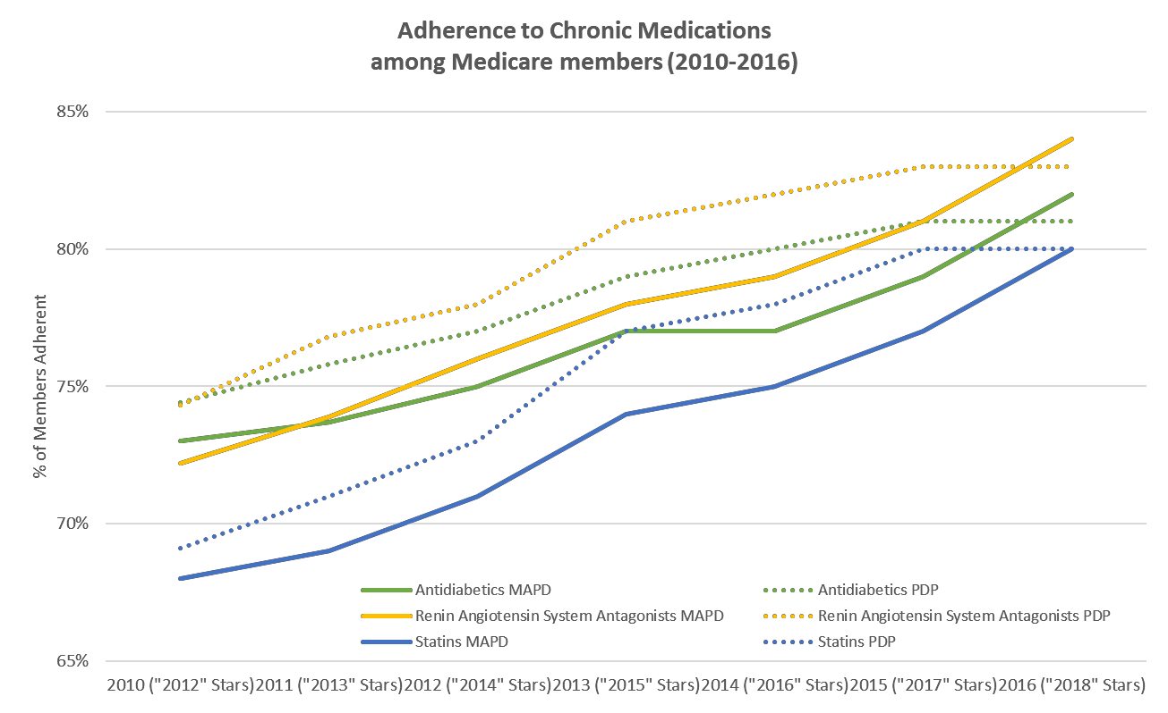

In addition to our general comments, RxAnte offers comments on two specific provisions in the proposed rule: (1) Contract consolidation, and (2) Measure-level Star Ratings.

# Contract Consolidation

CMS proposes a significant change in how contract-level Star Ratings are assigned when there is a contract consolidation. CMS indicates that this is to address the increasing number of beneficiaries being moved from lower-rated to higher-rated contracts as part of consolidations. CMS proposes that, instead of assigning the surviving contract the Star Rating that it would have earned without regard to the consolidation, CMS would assign Star Ratings based on the enrollment-weighted mean of the measure scores of the surviving and the consumed contract for the first two years after consolidation.

RxAnte supports the CMS proposed change in how contract-level Star Ratings are assigned when there is a contract consolidation. This change in how Star Ratings are assigned will require that plans that anticipate or are in the process of being “consumed” continue to dedicate effort and an investment to improve performance on quality measures. RxAnte has seen plans discontinue or deprioritize quality improvement investments for contracts and beneficiaries being consolidated into a different contract in a subsequent year. We believe that the proposed change will provide an effective incentive to focus on health outcomes and quality ratings associated with beneficiaries in consolidating plans.

# Measure-level Star Ratings

For the majority of Star Rating measures, CMS proposes to determine the “cut points” using a clustering methodology. RxAnte reviewed the cut point clustering methodology used by CMS in the past and noted that there is no minimum number of enrollees for a plan to be included as cut points are calculated. This methodology makes it possible for a few plans to disproportionately impact the 5-Star threshold. While the disproportionate impact of small plans may not be seen every year, CMS should carefully monitor its clustering methodology to identify cut points that best reflect industry performance.

RxAnte is most concerned about the timing of the release of the cut points. RxAnte asks that CMS make adjustments to the timing of the release of the cut points via the final regulation and ongoing improvements to how the Quality Rating System is operationalized. RxAnte is supportive of the CMS previous practice of publishing pre- determined 4-star thresholds for certain measures, because we observed plan sponsors investing more in quality improvement programs when the cutpoints were known before the end of the performance year. We recommend using such predetermined 4-star thresholds going forward. A pre-specified cut point provides a concrete goal toward which plans can work and makes it possible for pharmacy and quality improvement departments to advocate internally for the needed allocation of resources. Medicare Advantage plans and PDPs have a limit in what they can invest in quality improvement; knowing where they need to improve and by how much allows them to direct resources most appropriately. Pre-specifying the 4-star cut point still allows CMS to determine the 3-star and 5-star cut points once plan data is received, but it does allow plan sponsors to know what goal they need to reach to get a Quality Bonus Payment (QBP).

CMS also indicates that it is considering methodologies that would minimize year-to-year changes in the cut points by setting the cut points so they are a moving average of the cut points from the two or three most recent years or setting caps on the degree to which a measure cut point could change from one year to the next. RxAnte supports the use of such methodologies and is in favor of the stability that this change would bring to the Star Rating measures.

# Conclusion

RxAnte appreciates the CMS efforts to improve on the MA and PDP Quality Rating System as provided in this proposed rule and the efforts to increase transparency. Part D measures are very important and lead to improvements in all health outcomes. As CMS considers input for additional Star Rating measures to be proposed in the future, RxAnte encourages CMS to continue to grow the Part D measures, and specifically medication adherence and appropriate medication use measures, and to weight them more heavily.

Thank you for the opportunity to provide comments on the proposed rule. If we can provide additional input or use our prescription drug data files and expertise to assist CMS in modeling changes to Part D quality measures, please let me know. I can be reached at [jbenner@rxante.com](mailto:jbenner@rxante.com).

Sincerely,

Joshua S. Benner, PharmD, ScD President and CEO