**Comments for Part D proposed rule from Peter B. Bach, MD from Memorial Sloan Kettering Cancer Center, Stacie B. Dusetzina, Ph.D. from Vanderbilt University Medical Center, Rena Conti, Ph.D. from the University of Chicago**

We appreciate the opportunity to comment on Medicare’s proposed Part D rule (CMS-4182-P). Our comments focus exclusively on the Request for Information regarding the possibility of implementing point-of-sale rebates within the benefit.

**Overview of our work on point-of-sale rebates for Medicare Part D**

As a point of reference, we published an article in JAMA Internal Medicine[1] in 2017 detailing some important consequences for Medicare beneficiaries on high cost medications that resulted from a steadily widening gap between drug’s ‘list’ prices and ‘net’ prices. We noted that one way to ameliorate the consequences was to institute ‘point of sale’ rebates in Part D.

In our study we highlighted two important consequences for beneficiaries enrolled in Part D plans. First, for drugs requiring beneficiaries to pay deductibles or co-insurance, a drug with a higher list price (and larger rebate) under the standard benefit structure would have higher out of pocket costs for the beneficiary than the drug with the lower list price (and smaller rebate), even when net prices received by manufacturers are the same. Second, due to the fact that beneficiaries move through the Part D benefit structure based on their own out of pocket spending, setting their out of pocket costs based on inflated list prices rather than net prices increases the number of patients reaching the catastrophic coverage / reinsurance phase of the benefit. In addition, since plans are able to retain some rebates under the current benefit design, this may induce them to select more expensive products for Part D formularies.

On the first consequence of current plan benefit design, we provided an example of two competitive drugs for the treatment of Hepatitis C Viral infection - Gilead’s Harvoni (ledipasvir/sofosbuvir) and Merck’s Zepatier (elbasvir/grazoprevir)- in our paper. Under current benefit design and using Medicare’s own Part D planfinder for 2016 we showed that a full treatment course with Harvoni would cost a beneficiary nearly $2,000 more out of pocket than a similar treatment course with Merck’s Zepatier, despite having similar net prices.

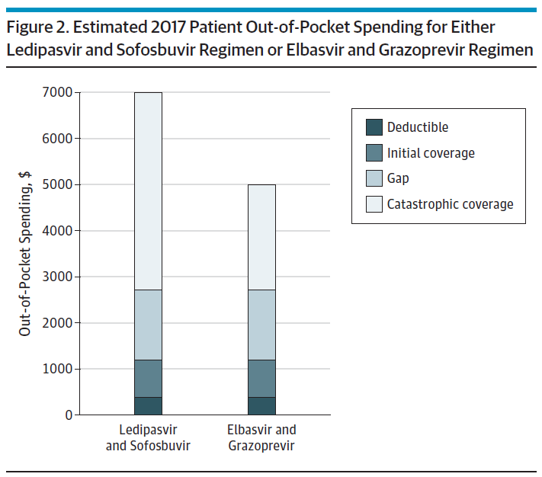

Source: JAMA Internal Medicine, 2017

We also showed how plans may be benefitting as both the list prices (and the rebate amounts) of drugs covered under their formulary increase. To illustrate these consequences we posted an interactive tool so policymakers could see the impact of list to net price differentials for beneficiary, plan, pharmaceutical company and Medicare [https://drugpricinglab.org/our-work/rebates-medicare-part-d/]

Finally, a longer term benefit of instituting point-of-sale rebates in Medicare Part D is that it would protect beneficiaries from the immediate consequence of list price increases that are increasingly common for specialty drugs, even when net price increases are smaller in magnitude. The difference between these two phenomena are explained by the trend toward widening rebate margins that beneficiaries today only indirectly benefit from through premiums.

**Policy Tradeoffs: plan retained rebates compared to point-of-sale rebates**

*Effect of point of sale rebates on the distribution of costs in Part D:*

The tradeoff between instituting point of sale rebates or alternatively maintaining the status quo of rebates being retained by the Part D plans is made clear in the CMS actuary analysis. Instituting point-of-sale rebates lowers the out of pocket costs for medicines among those beneficiaries who take them. This means the policy change would potentially provide substantial financial relief for those beneficiaries who take expensive medications. In exchange there would be a small rise in premiums, a tradeoff that would raise costs for all beneficiaries (likely by a small amount) and for Medicare (which pays the majority of premiums).

This relative shift caused by point of sale rebates points to an important policy question: to what extent should CMS structure the benefit to leave the burden of high cost drugs on those who take them, or alternatively seek to spread those costs as much as possible across all beneficiaries and the program itself? We would urge CMS to favor the latter policy stance, as in our view the merit of the program is found most in the financial protection it provides to those who need high cost medicines.

*Choice between ‘fixed’ rebates per therapeutic category and ‘actual’ rebates per plan:*

In the proposed approach, CMS would apply fixed levels of rebates per therapeutic category across plans and beneficiaries. While this would achieve the objective of reducing prices at the point of sale, we would encourage CMS to contemplate incorporating the actual rebates achieved by each plan for each drug at the NDC level. As of 2015 CMS requires reporting of the rebates, and while some rebate levels may not be known until end of year, plans are already estimating them in the context of generating their bids. We would encourage CMS towards a policy that at the point of sale each plan should incorporate the rebates they achieve through their negotiations. While this may involve some unmasking of the rebates, the benefit of doing so is that some plans will not end up unduly capturing benefits from not passing along the entire rebate, and avoid other plans from being ‘under water’ from passing on more than they actually collect.

**Actuary calculation included in the Proposed Rule:**

The CMS actuary incorporated estimates in the proposed rule that highlight the potential tradeoff introduced through point of sale rebates. While we appreciate the actuary’s work on this question, we propose some assumptions should be further specified to determine their impact as CMS considers the broader policy tradeoff.

**How big is the rebate applied when determining the drug price for purposes of calculating beneficiary share?**

As we understand it, the CMS actuary applied a fixed rebate across all categories of drugs and across all plans in the benefit to assess point of sale rebates, we believe that the CMS actuary has plan and drug level data that would allow for more detailed modeling of point-of-sale rebates. We are not sure the impact of applying these rebates in such a specific manner, but it is possible it could change some of the projections given that some specialty drugs have large rebate levels while others do not.

We also appreciate the static nature of the actuary’s projections, but think there may be merit in projecting forward 5 or 10 years to assess the aggregate impact of point-of-sale rebates in light of strong ongoing trends toward both higher list prices and widening gross-to-net differences.

We also propose a variation on the actuary model, where the progression through the benefit is different for the beneficiary than it is for the pharmaceutical company, as follows:

1. the beneficiary transitions to different stages of the Part D benefit based on the point-of-sale rebated price
2. the pharmaceutical company discount provided in the coverage gap would be based on the list price (technically the WAC) of the dispensed drugs

Under this alternative scenario the pharmaceutical sponsor rebate would be triggered when list price based progression reached the coverage gap, and the rebate level during that subsequent period would be based on 50% of list price (technically the WAC) for those drugs for which rebates are required. The rebate would terminate when the list price based progression reached the catastrophic phase.

This modification would leave the pharmaceutical contribution consistent irrespective of the rebate level that CMS applies to the point of sale, and also increase their contribution in the current actuary models – a contribution that would reduce Medicare and beneficiary costs in the projections. The WAC is also entirely under the control of the pharmaceutical company irrespective of rebate level, so pharmaceutical company decisions to raise WAC for instance would translate directly into larger rebates paid in the coverage gap.

1. Dusetzina SB, Conti RM, Yu NL, Bach PB. Association of Prescription Drug Price Rebates in Medicare Part D With Patient Out-of-Pocket and Federal Spending. JAMA Intern Med. 2017;177(8)1185-1188.