**C!tongres.s of tqe lltniteik §fates**

**llllta.s!Jington, mar 20515**

January 16, 2018

Ms. Seema Verma Administrator

Centers for Medicare & Medicaid Services 200 Independence Avenue, S.W. Washington, D.C. 20201

Dear Adminish·ator Verma:

We write to express our appreciation and suppoti for a proposal included as part of the Centers for Medicare and Medicaid Services' (CMS) proposed rule for the 2019 Medicare Part D plan year. This proposal would increase transparency and accuracy in Medicare Pati D prescription drug spending and reporting.

In June 2016, a bipartisan group of 30 members of the House of Representatives raised concerns with pharmacy price concessions in Part D and the problems that they posed for beneficiary cost sharing, as well as federal reinsurance and low income cost-sharing subsidies paid by CMS to Pati D plan sponsors.

We applaud the agency for listening to our concerns and for its proposal that would effectively prohibit retroactive pharmacy Direct and Indirect Remuneration (DIR) fees, which are clawed back by Part D plan sponsors, or their Pharmacy Benefit Manager (PBM) intermediaries, as much as 6 months after a prescription has been filled. We have heard from countless pharmacists in the.communities we represent about how these DIR fees threaten their businesses as they do not know when these fees will be collected, how large they may be, and whether the final reimbursement total will even cover the cost of the drug dispensed.

While the agency' s proposal would provide some certainty and predictability for community pharmacists on reimbursement rates, CMS also noted that this proposal would reduce net beneficiary costs by $10.4 billion. Senior citizens should not be forced to pay cost sharing on artificially inflated drug prices at the pharmacy counter that quickly force them into the coverage gap, therefore this proposal is vital in reducing costs for our vulnerable seniors and ensuring they have access to the medications they need.

We thank you for listening to and addressing concerns in regard to the negative impact of retroactive pharmacy DIR fees and urge the Administration to immediately finalize this proposal in the 2019 final Pati D rule, rather than continuing to collect fmiher information.

Sincerely,

PRINTED ON RECYCLED PAPER

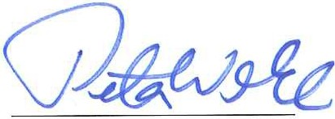

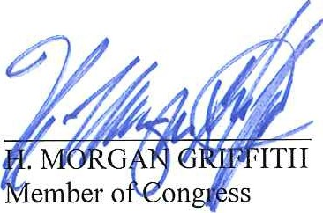 *d*

AUSTIN SCOTT

Member of Congress

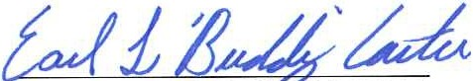

Member of Congress·

Member of Congress

PETER WELCH

Member of Congress

DAVE LOEBSACK

Member of Congress

**- AJ·**

. ADERHOLT

Member of Congress

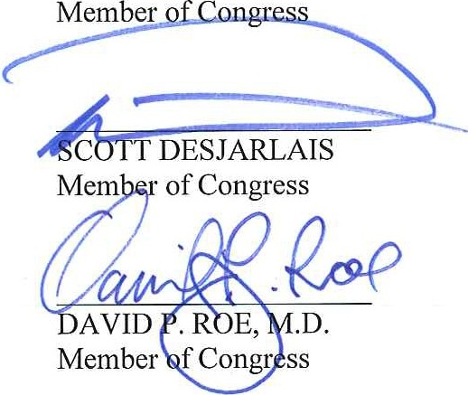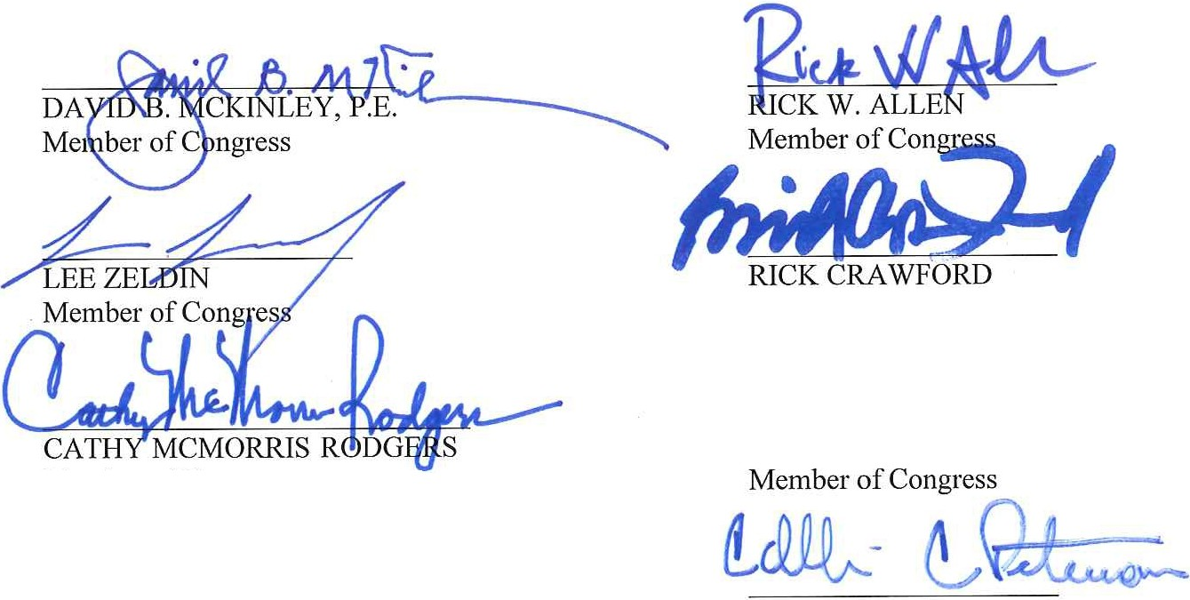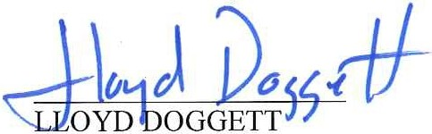

h

## STEVE KING

M r of Congress

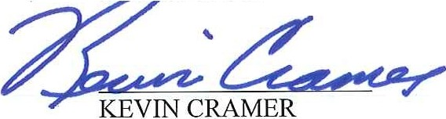

Mem er of Congress

Member of Congress

*,'( ·* G&,J-

TULSI GABBARD

COLLIN C. PETERSON

Member of Congress

# ..

**CLAYHIG**

**S**

M=:;:gress

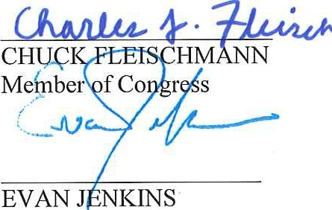-

Member of Congress



CHRIS STEWART

Member of Congress

# ESCOMER

Member of Congress

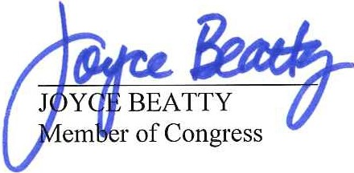

IMEHE TLER

Member of Congress

*I*

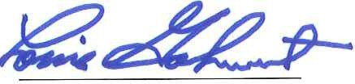LOUIE GOHMERT

Member of Congress

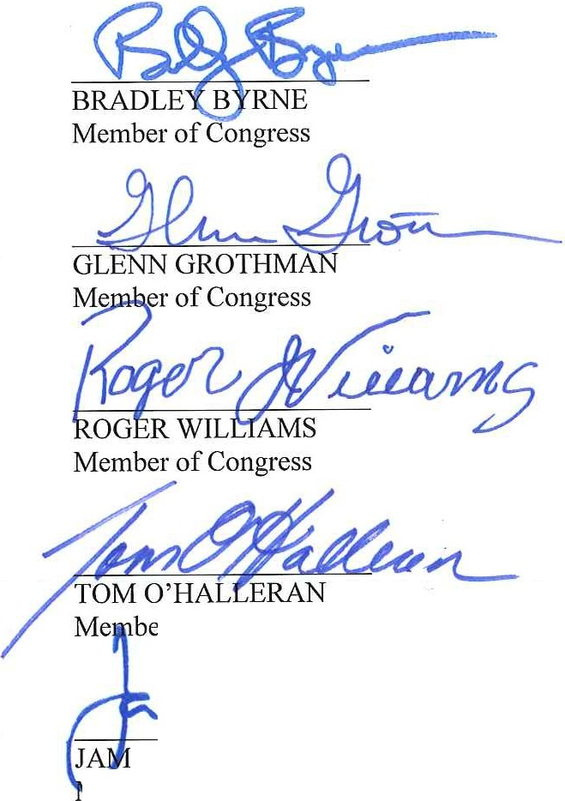

ber of Cong·

m

IE RASKIN

/ c:.JYL

/

*ff, h*

A. DREW FERGUSON IV, D.M.D

Member of Congress

*J\fo·/2*

WILLIAM R. KEATING

Member of Congress

*d?.Q4*

SEAN DUFFY

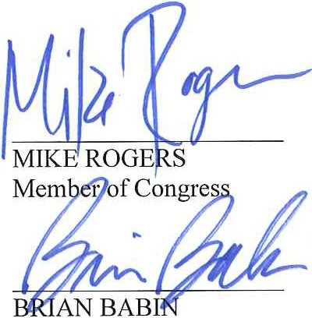,D.D.S.

Member of Congress

*o?ttvll*

LOU BARLETTA

Member of Congress

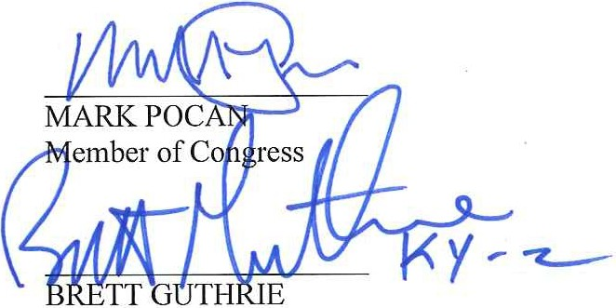

Member of Congress

MIKE GALLAGHER

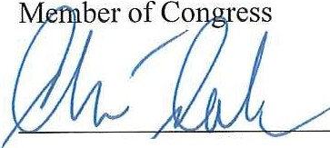

*!J*C*b*HR*;*IS*:*C*!*L*i*LIN*&*S *f*

*k,,.s* -

DAVEBRAT

Member of Congress

-

Member of Congress

*c 4*

Member of Congress

*01 1*

FRENCH HILL

Member of Congress

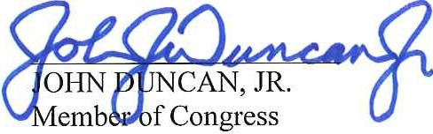*A,,iQ..q.- (, lf).1_y '-*

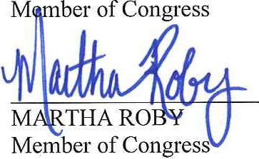

*i*

*ts*

GRE¢i6, ARPER

Member of Congress

/J;,1~~...,~~

..

TT

Member of Congress





i3LAKEFARENTHOLD

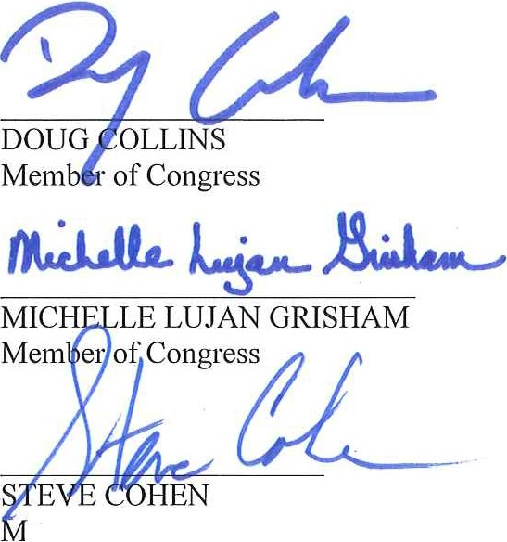

ember of Congress

Member of Congress

*J*NIEL WEBSTER

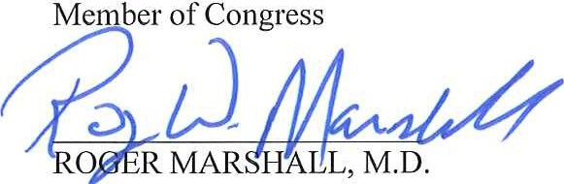

T

Member of Congress

*!fJtw*

Member of Congress

Member of Congress

*ef /JYI*

VICENTE GONZALEZ

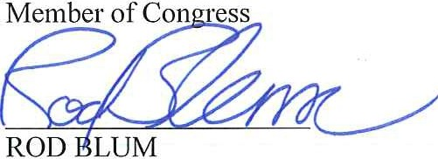

Member of Congress

J ULBERSON

*7nJ?)CJI*

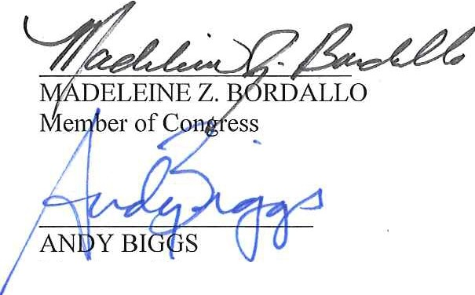

&

-

Member of Congress

***l&e o d:_***

Member of Congress

SALUD 0. CARBAJAL

Member of Congress

*r11o1J*

*e*MO *;*BRO*1*OKS

TED S. YOHO, D.V.M.

Member of Congress

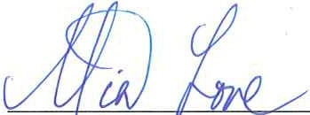

Member of Congress

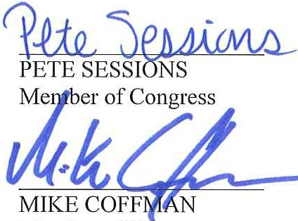

**ES**

Member of Congress

Member of Congress

Member of Congress

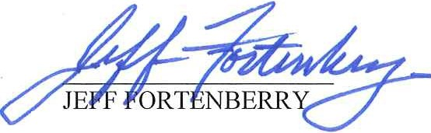

## M

EDDIE BERNICE JOHNSON

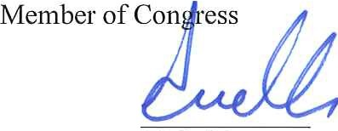

**UELLAR**

Member of Congress