**oton9re1n1 of fire Nnifeil fates**

**1ll!Iusl1in9ton, 1)(1! 20515**

January 12, 2018

The Honorable Eric D. Hargan Acting Secretary

U.S. Department of Health and Human Services Hubert H. Humphrey Building

200 Independence Avenue, SW Washington, D.C. 20201

Dear Acting Secretary Hargan,

Thank you for the work the Department of Health and Human Services (DHHS) is doing to reduce unnecessary rules and regulations. As you know, excessive government regulations not only add to the cost and complexity of running medical practices, but can also adversely impact the delivery of patient care.

We specifically appreciate your attention and consideration to two regulations that have adversely affected dentists and their patients that were appropriately addressed in the DHHS November 28 proposed rule1 to maintain program integrity while removing unnecessary

requirements for providers. Few dentists are emolled in Medicare because routine dental services are not covered by Part B. However, dentists do provide essential care for many Medicare beneficiaries under Part C through Medicare Advantage (MA) plans.

By creating the "preclusion lists" that will be used by the MA plans to verify the eligibility of a provider to participate in those plans and rescinding the regulation2 that would require dentists who only provide MA covered services to emoll in Medicare, more dentists will be able to .. participate in Part C plans and Medicare beneficiaries will receive timely oral health care.

1 42 CFRParts 405,417,422,423, and 498 [CMS-4 182 - P] RJN 0938-ATOS

Medicare Program; Contract Year 2019 Policy and Technica l Changes to the Medicare Advantage, Medicare Cost Plan, Medicare Fee-for-Service, the Medicare Prescription Drug Benefit Programs, and the PACE Program

2 42 CFR Parts 405, 410, 411, 414, 417, 422 , 423 , 424, 425 , and 460 [CMS- 1654- F] RIN 0938-AS81

Medicare Program; Revisions to Payment Policies Under the Physician Fee Schedule and Other Revisions to Part B for CY 2017; Medicare Advantage Bid Pricing Data Release; Medicare Advantage and Part D Medical Loss Ratio Data Release; Medicare Advantage Provider Network Requirements; Expansion of Medicare Diabetes Prevention Program Model; Medicare Shared Savings Program Requirements. Final Rule

DATES: These regulations are effective on January 1, 2017.

PRINTED ON RECYCLED PAPER

Similarly, the use of these same preclusion lists will allow Medicare Part D3 plan sponsors and pharmacy benefit managers to confom only eligible dentists and other health care professionals prescribe medications to Medicare beneficiaries emolled in the Medicare Part D plans. This will eliminate the additional burden on providers to emoll in Medicare and ensure beneficiaries will receive their prescribed medications without undue delay.

By addressing these unnecessary administrative burdens, dentists will be able to focus on improving access to oral health care and delivering care to patients who need it most. We support your action on these regulations and look forward to your issuance of the final rule.

Sincerely,

3 RIN 0938-AR37- 42- CFR Parts 409,417, 422, et al. Medicare Program; Contract Year 2015 Policy and Technical Changes to the Medicare Advantage and the Medicare Prescription Drug Benefit Programs; Proposed Rule - Federal Register/ Vol. 79, No. 7 / Friday, January 10, 2014

Federal Register / Volume 79, Number 100, Friday, May 23, 2014 - 42 CFR Parts 417,422,423, et al. Medicare Program;

Contract Year 2015 Policy and Technical Changes to the Medicare Advantage and the Medicare Prescription Drug Benefit Programs; Final Rule

\

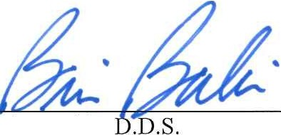Brian Babin,

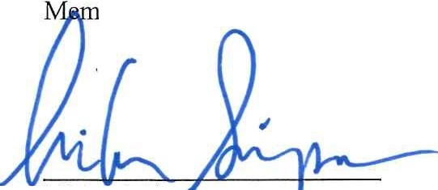ber of Congress

Michael Sim son Member of Congress

1. Drew Ferguson IV, DMD Member of Congress

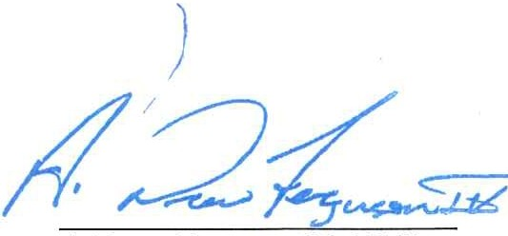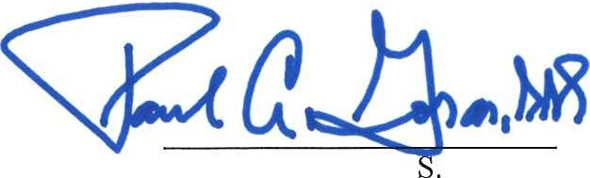Paul A. Gosar, D.D. Member of Congress

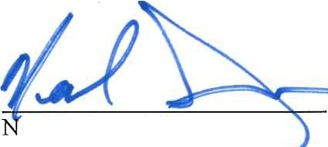

ea! P.

' M.D.

# Member oTf

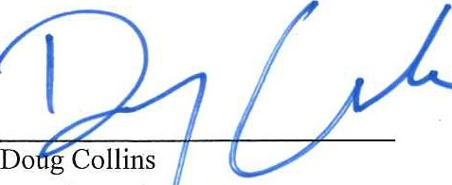

ngress

MemberoT"eorrgr= - - -

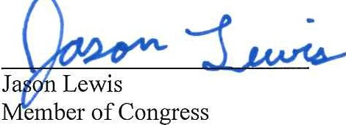*11 -1) k*

--=

Roger Marshall, M.D. Member of Congress

Ralph Norman

Member of Congress