SWIFT Server Upgrade

SYSTEM DESIGN DOCUMENT

Exec

Version 1.0

Revision History

|  |  |  |
| --- | --- | --- |
| Date | Version | Remarks |
| 02/12/2019 | 0.5 | Revised template based on more recent information |
|  |  |  |
|  |  |  |
|  |  |  |
|  |  |  |
|  |  |  |

Table of Contents

1. Purpose 1

2. Design Overview 2

2.1. General System Overview 2

2.1.1. Goals 2

2.1.2. Design Decisions 2

2.2. Assumptions/Constraints/Risks 3

2.2.1. Assumptions 3

2.2.2. Constraints 4

2.2.3. Risks 4

2.3. Guidelines 4

2.4. Methods 4

2.5. Standardization 4

2.6. Performance Engineering 5

3. System Architecture 6

3.1. Hardware Architecture 7

3.2. Software Architecture 10

3.3. Security Architecture 11

4. System Information Design 12

4.1. Database Design 12

4.2. System Inputs 13

4.3. System Outputs 13

4.4. Section 508 Compliance 13

4.5. Data Conversion 13

5. External Interfaces 14

APPENDIX A DESIGN SPECIFICATION APPROVAL 15

APPENDIX B REFERENCES 16

APPENDIX C KEY TERMS 17

Table of Figures

[Figure 1 - Annual SWIFT Tech Refresh Cycle 4](https://solesolutionsinc.sharepoint.com/Shared%20Documents/ACF/FY19/Server%20Upgrade/Stage%20Gates/RAR_PDR_CDR/Ready%20To%20Be%20Sent%20to%20ACF/SWIFT%20Server%20Upgrade%20Design%20Doc.docx#_Toc13203664)

Figure 2: Performance Architecture 5

Figure 3: System Architecture 6

Figure 4: Architecture of PSC Data Center 7

Figure 5: SWIFT Physical Architecture 8

Figure 6: Table of New SWIFT Servers 8

Figure 7: Table of Storage Configuration 9

Figure 8: SWIFT Technology Stack 10

Figure 9: SWIFT Security Architecture 11

Figure 10: Table of Database Version 12

Figure 11: SWIFT Business Data Model 12

# Purpose

The SWIFT application used to manage executive correspondence for the Administration for Children and Families (ACF) and other tenant agencies is hosted on three servers in the MAHC Datacenter in Reston, VA maintained by Sev1Tech. These servers are currently configured with Windows Server 2008, and Microsoft will no longer support the operating system after January of 2020. The SWIFT servers need to be upgraded to Windows Server 2016 and SQL Server Enterprise 2016.

The Contractor will reinstall SWIFT on servers that have been provisioned with Windows Server 2016. SWIFT will be thoroughly tested by the Contractor after the installation to ensure proper functioning.

All necessary hardware and Windows Server 2016 and SQL Server licenses will be provided by the Government.

# Design Overview

## General System Overview

At ACF approximately 9,000 cases are managed each year in the SWIFT system. These cases are primarily executive correspondence letters that are signed by the Secretary or the Administrator. ACF partners with other mid-size OpDivs and some StaffDivs to share costs by utilizing a single installation of SWIFT located in a PSC data center in Reston.

Across HHS the SWIFT case management system manages nearly 100,000 cases per year. By the end of 2020, the number of cases managed annually will increase to over 1 million.

SWIFT scales to the enterprise with no per-seat licensing. Work assignments are easily shared with all coordinators, executives & subject matter experts across the organization. A recent initiative to integrate with SharePoint (not yet available at ACF) permits collaboration within the workflows, improving quality and reducing duplicative work that impacts timeliness.

A data warehouse enables agencies to manage workloads with scheduled reports and to analyzed performance of all components of a workflow.

SWIFT was developed using Microsoft technologies such as .Net and SQL Server and integrates with Salesforce in the Office of the Secretary to seamlessly transfer cases between the Secretary and the ACF.

### Goals

The scope of this project is limited to an upgrade of operating system of three SWIFT servers in the PSC Reston data center managed by Sev1Tech. An upgrade of Microsoft Internet Information Server (IIS) and SQL Server database is included in this effort. No change to the SWIFT code base is included in the scope of this project. The diagrams included in this document have been updated to reflect the new servers and upgraded versions of the operating system, IIS and SQL Server.

### Design Decisions

The following design considerations apply to this project:

* Windows Server 2008 will not be supported after January of 2020
* Three new servers have been acquired for SWIFT in the Reston PSC datacenter
* Sev1Tech will configure the servers, software prerequisites and firewalls
* SSI will build and install the SWIFT Application
* SSI will migrate data/documents from the current environment to the new environment
* No change to the SWIFT application code base is within the scope of this project
* No change to the SWIFT baseline configuration is necessary, except:
  + Configuration updated for new machine names
  + Legacy printable data sheets will no longer be supported – ACF & OASH will be configured for new printable data sheets already in use at SAMHSA, ASPE & ASPR
  + SWIFT will be installed using new “single click” installation procedure
  + SQL SSIS packages will be installed in the encrypted SSISDB catalog.

## Assumptions/Constraints/Risks

### Assumptions

* Integration with existing Government systems (other than the Secretary’s Policy System (SPS)) is not included in this project.
* Any activities requiring the participation of ACF personnel will be conducted at ACF.
* This project does not include travel to any Government office outside the Washington, DC metro area.
* ITIO will provide network engineering support necessary to address issues related to the SWIFT system interaction with the existing network environment.
* Due to the limited scope of this effort, stage gate reviews will be consolidated where possible, to conserve project resources.
* Significant system modification, installation or configuration due to changes in the hardware or network platform is beyond the scope of this project.
* Significant system modification, installation or configuration due to hardware or network equipment failures is beyond the scope of this project.
* Significant system modification, installation or configuration due to changes of Government business policies or reorganization is beyond the scope of this project.
* Hardware for the server upgrade will be acquired by the Government.
* All software licenses necessary for the server upgrade, including SQL Server Enterprise, will be provided by the Government.
* SQL Server licenses will be provided by the Government.
* SSI will not be responsible for the installation of the server operating system.
* This project does not include relocating the servers to a new datacenter or any new firewall or access management changes.
* Any change to network infrastructure or IT policies that reduces access or changes the way SSI accesses the SWIFT system or servers from their corporate facility in Front Royal, may affect the cost of services provided by SSI.

### Constraints

* The ACF instance of SWIFT is hosted in a PSC data center. The infrastructure is managed by Sev1Tech. The application is managed by SSI.
* The SWIFT environment consists of one production web server, one database server and one middle tier asynchronous background task server. No test environment has been allocated for SWIFT in the HHS environment. The application contractor maintains SWIFT development, test and QA test environments at its own facility.

### Risks

Refer to the project risk register for a list of risks associated with this project.

## Guidelines

The upgrade effort will follow established ACF guidelines for IT change management, including participation in stage gate reviews, creation of all applicable supporting artifacts, and participation in security testing/ATO renew.

## Methods

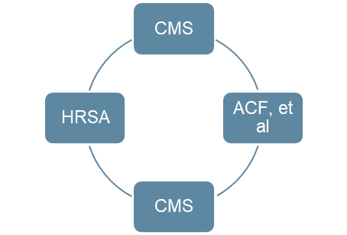SWIFT is used across HHS and developed collaboratively by all participating OpDivs/StaffDivs, but primarily by CMS. The system is refreshed at least annually with the latest codebase containing the latest features, security patches and remediated defects.

Figure 1 - Annual SWIFT Tech Refresh Cycle

Three installations of SWIFT exist at HHS:

* Baltimore - CMS
* Rockville - HRSA
* Reston - ACF, SAMHSA, ASPE, ASPR, OASH

This collaborative approach to system maintenance and enhancement provides a significant cost savings to the Government.

## Standardization

SWIFT is Government Off-the-Shelf (GOTS), a method to enable reuse of software across multiple projects. The Centers for Medicare & Medicaid Services (CMS) has been the primary sponsor the SWIFT platform since 2008 and directly responsible for a significant majority of upgrades and enhancements in that time. CMS is the primary custodian of the software source code and has prerogative over other Government users of SWIFT to define the software architecture, establish development standards and select restricted software components for integration.

In all other areas, ACF and HHS standards apply.

## Performance Engineering

No change to system design with regard to enhancing performance is within the scope of this project. Only a minor increase in hardware specifications (i.e. CPU and memory) have been defined for this project due to Government cost constraints.

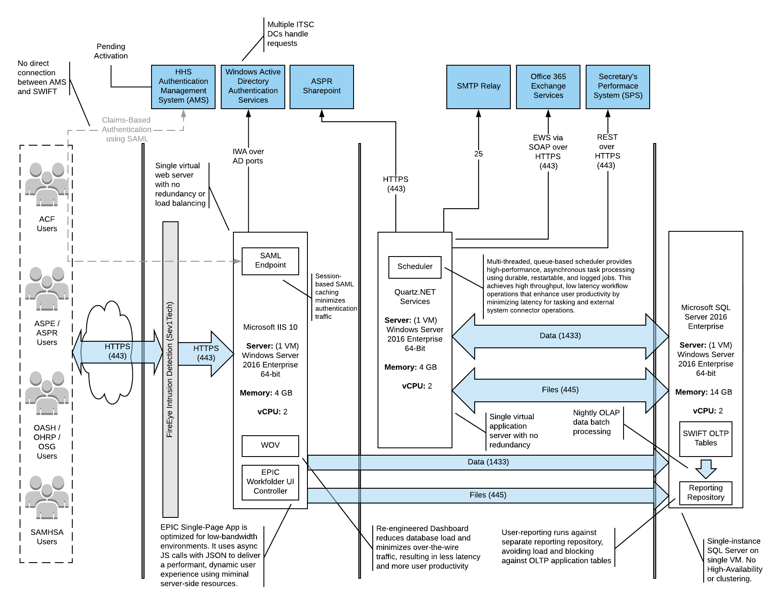

Figure 2: Performance Architecture

# System Architecture

No change to the System Architecture is in the scope of this project.

SWIFT is a .NET application that utilizes a SQL server database. Asynchronous operations are managed using a Quartz scheduler. Files are stored on the file system and streamed securely to authorized users using the SWIFT Filegate service. Customizable templates and XML business rule configuration files provide the ability to customize SWIFT for a business need or user group.

A configuration change will be implemented to switch ACF and OASH from legacy WDS cover sheets to the newer set of templates used by SAMHSA, ASPE and ASPR.

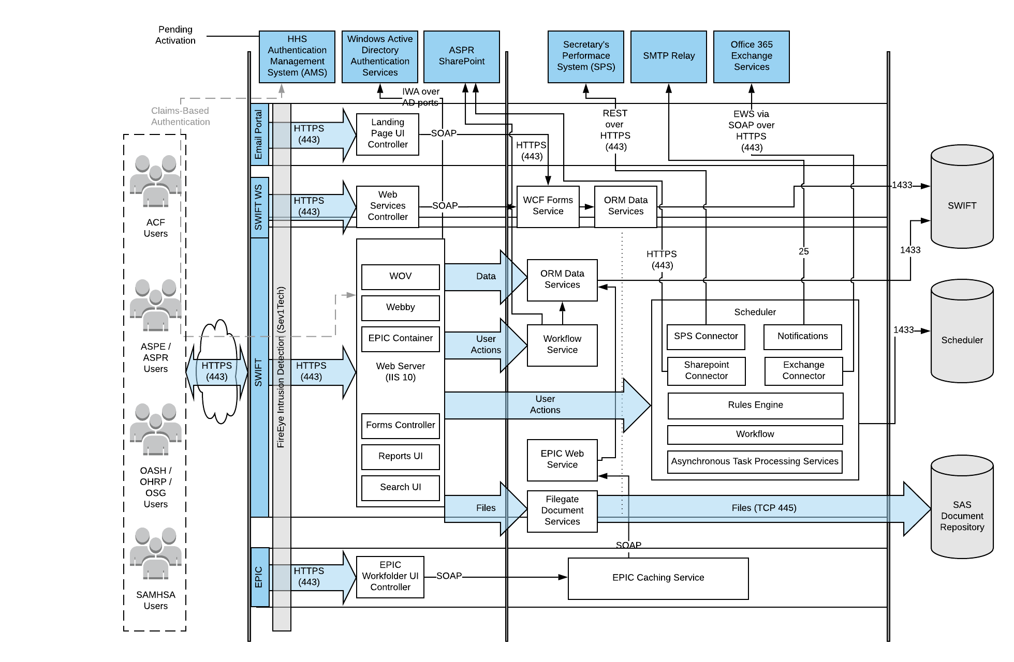

Figure 3: System Architecture

## Hardware Architecture

The new SWIFT servers will be located in the same PSC Reston data center as the current servers. The Sev1Tech contractor manages the data center and will provision the hardware and submit it for scanning by ITIO.

The upgrade of the SWIFT production environment (three servers) is the focus of this project. The development and test environments are managed by the SSI contractor in their Front Royal facility.

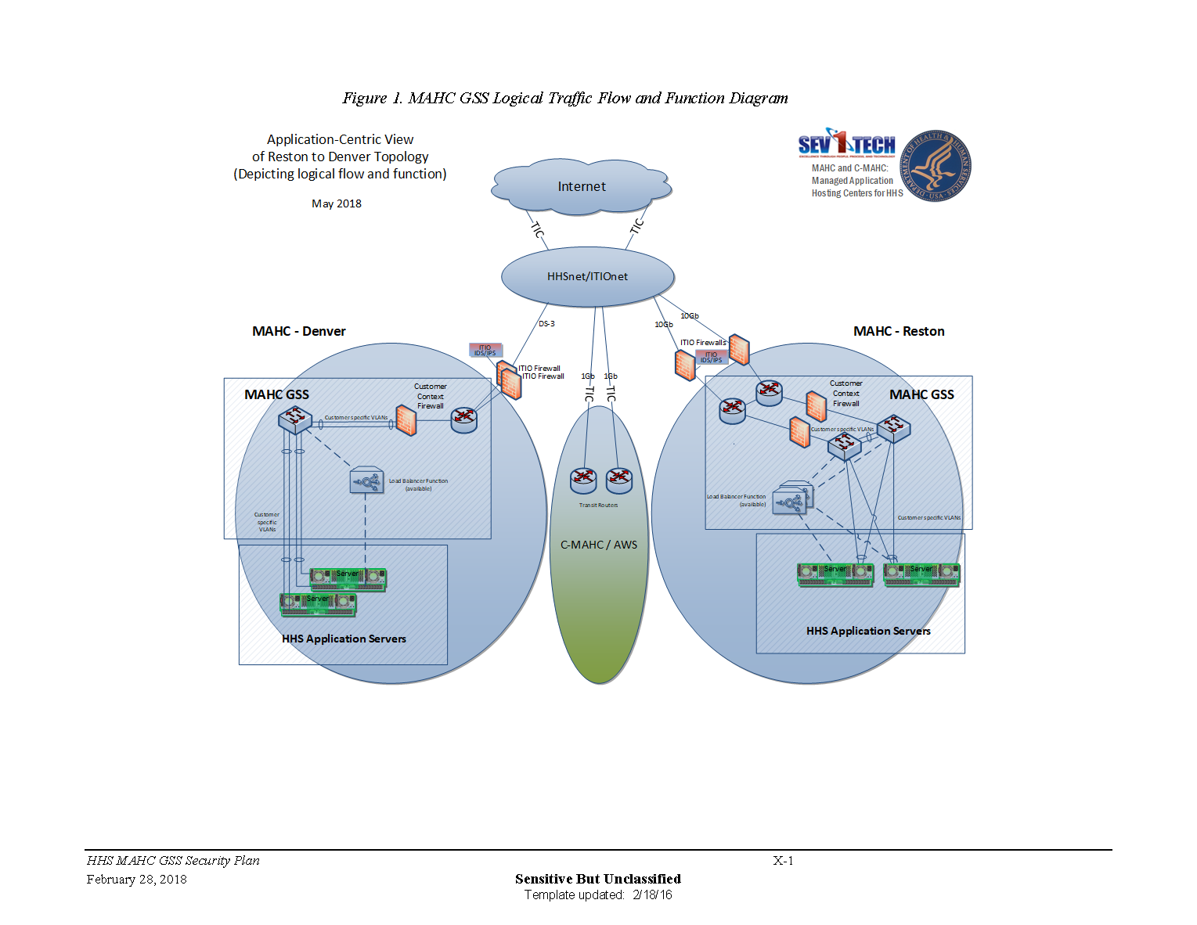

Figure 4: Architecture of PSC Data Center

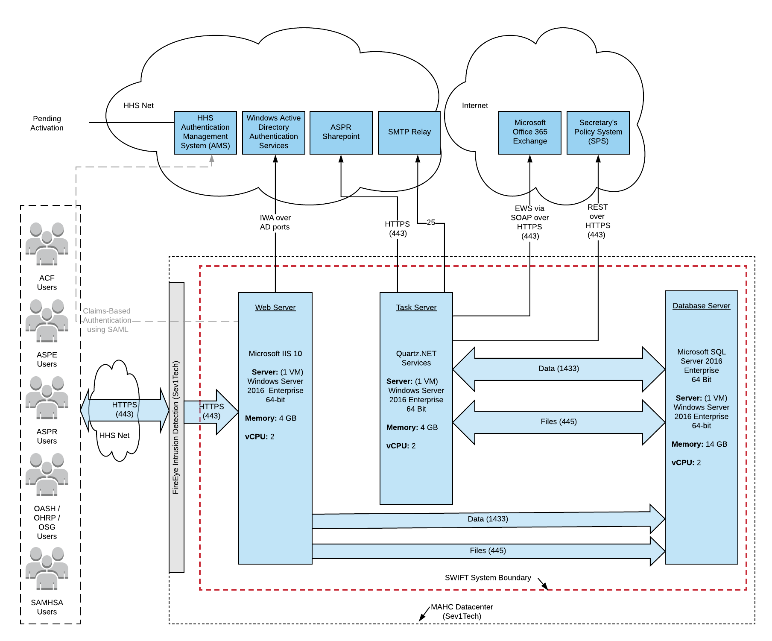

Figure 5: SWIFT Physical Architecture

An upgrade of the servers is the primary objective of this project. Only a production environment exists in the Reston data center. The Development and Test environments are located in the SSI contractor’s facility in Front Royal, Virginia. The new production servers will meet the following specifications:

|  |  |  |  |  |  |
| --- | --- | --- | --- | --- | --- |
| Server Name | Type | # IP Addr | OS | NumCPUs | TotalMemory |
| M1CMV410 | Web | 1 | Windows Server 2016 | 2 | 4 |
| M1CMV411 | DB | 1 | Windows Server 2016 | 2 | 14 |
| M1CMV412 | App | 1 | Windows Server 2016 | 2 | 4 |

Figure 6: Table of New SWIFT Servers

Storage for the new servers will be allocated as defined below:

|  |  |  |
| --- | --- | --- |
| Server | Volume/Mount Point | Size (GB) |
| M1CMV410 | OS | 60 |
| Data | 421 |
| Data | 79 |
| M1CMV411 | OS | 60 |
| Data | 200 |
| Data | 800 |
| Data | 200 |
| M1CMV412 | OS | 60 |
| Data | 60 |
|  |  | 1940 |

Figure 7: Table of Storage Configuration

Several firewalls and policies must be configured for the new servers. These rules are consistent with the current environment.

* Administrator privileges are required for the SSI team on all three servers for the DevOpps model of application operations and support
* Direct, SSL-encrypted application access on port 443 from the SSI corporate network to the web server for the SWIFT site to permit operation of the offsite SWIFT support center.
* Firewall and routing must be configured for the following connectivity:
  + The IOS SPS application running in the Salesforce cloud
  + Microsoft’s O365 cloud
  + ASPR SharePoint
* Intra-application connections for SWIFT
  + Outbound from the M1CMV412 to ports 80 and 443 on M1CMV410
  + Outbound from the M1CMV412 and M1CMV410 to port 1433 on M1CMV411
  + Outbound from the M1CMV412 and M1CMV410 to Windows file sharing ports on M1CMV411
* Session lengths on the new servers that are not shorter than the current servers.
* Application service accounts with elevated privileges.
* File share on the M1CMV411.

## Software Architecture

No change to the technology stack is in the scope of this project.

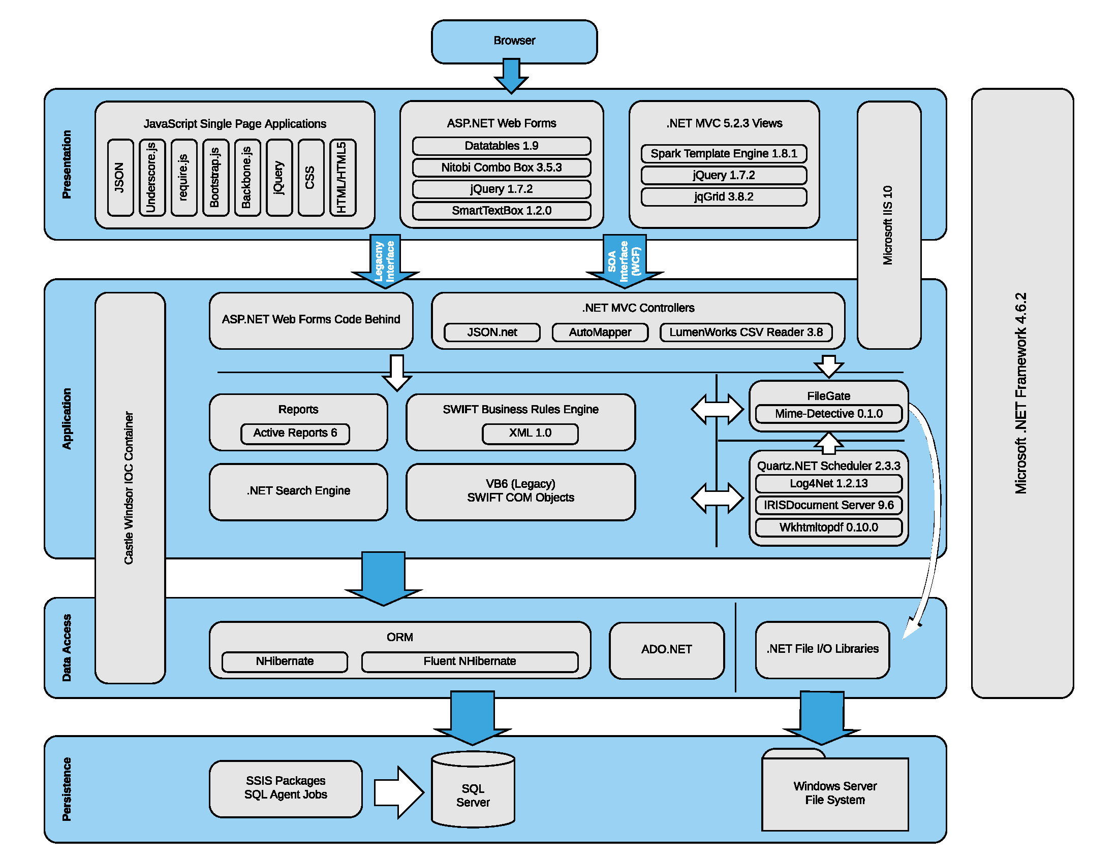

Figure 8: SWIFT Technology Stack

## Security Architecture

No change to the security architecture is in the scope of this project.

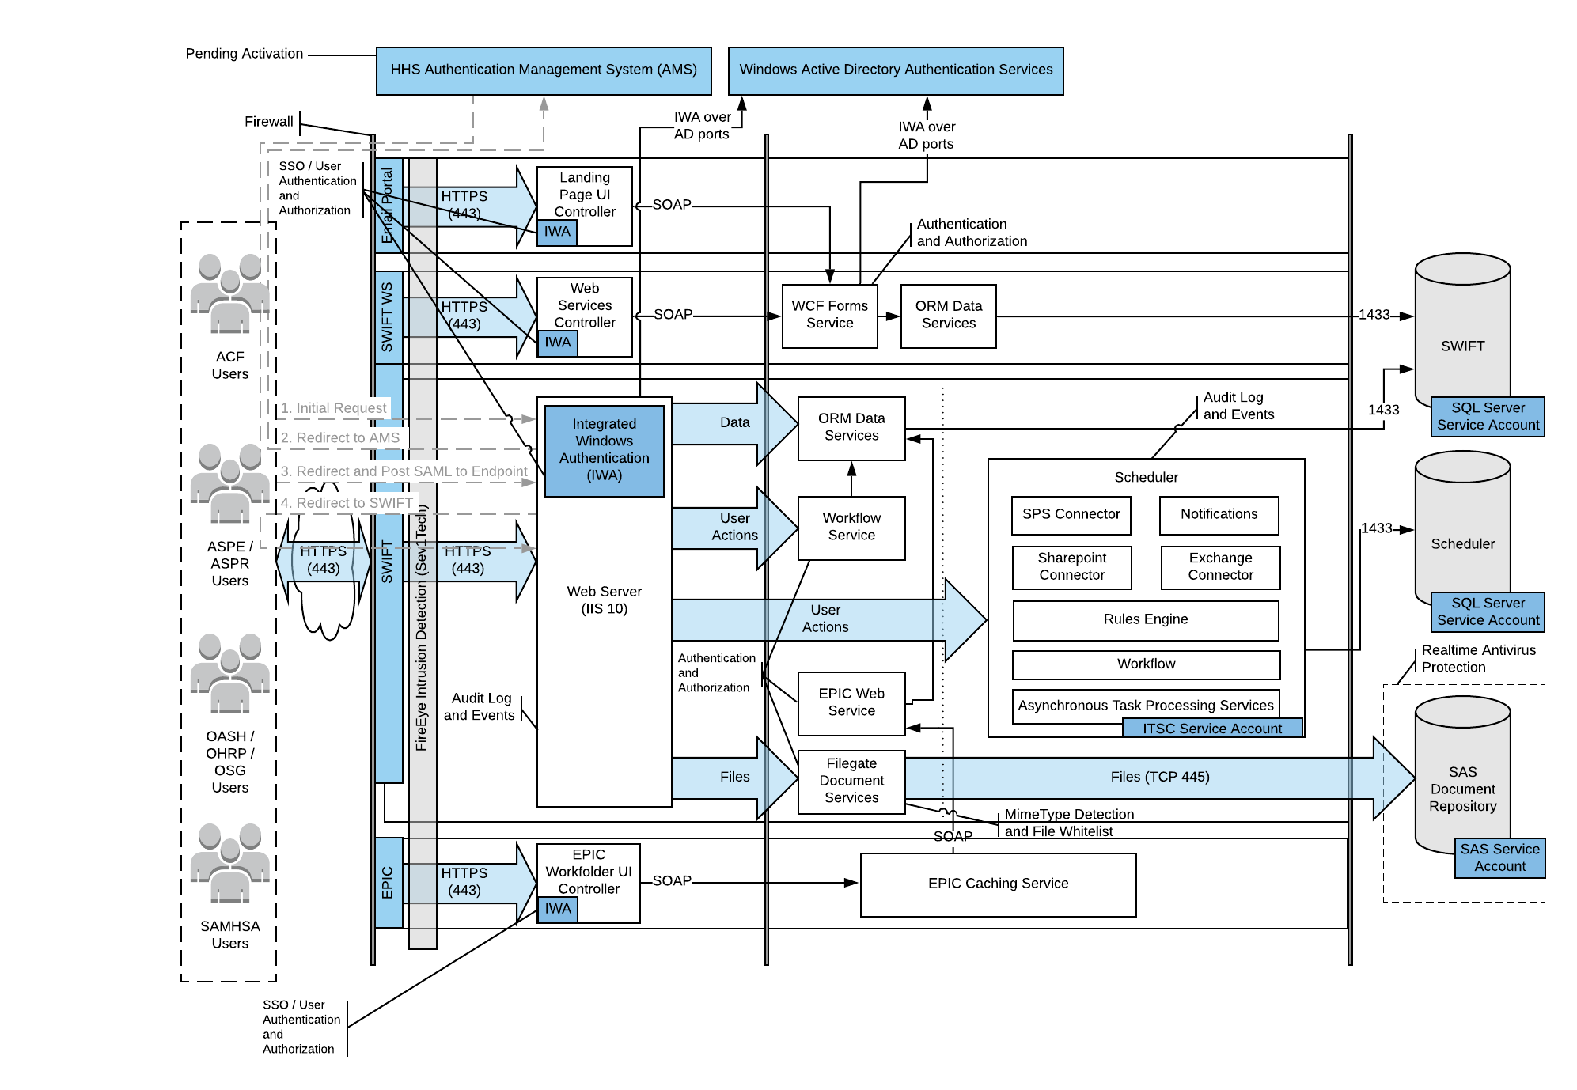

Figure 9: SWIFT Security Architecture

# System Information Design

## Database Design

SQL Server will be upgrade from version 2008 to version 2016 with this effort.

|  |  |
| --- | --- |
| Server | RDBMS w/version |
| M1CMV411 | SQL Server 2016 Enterprise |

Figure 10: Table of Database Version

There is no change to the data design with this project. Below is an overview of the existing business data structures.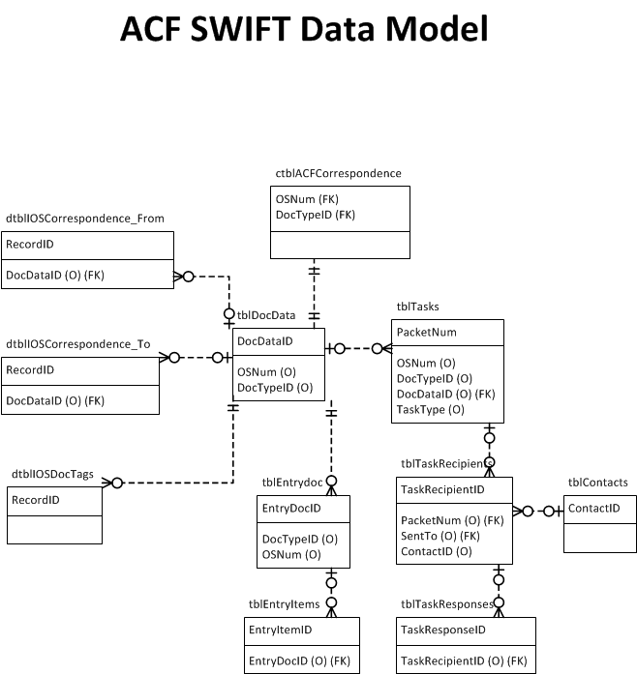

Figure 11: SWIFT Business Data Model

## System Inputs

There are no new system inputs with this project. Refer to figure…

## System Outputs

There are no new system outputs with this project. Refer to figure…

## Section 508 Compliance

There are no new user interfaces defined for this project.

SWIFT received a passing score of 76.7% when tested by CMS for 508 compliance. Retest of remaining issues passed in January 2018.

The SWIFT Electronic Signature application received a passing score of 100% when tested by CMS for 508 compliance.

## Data Conversion

There is no data conversion necessary with this project.

SWIFT data files will be migrated with no conversion to the new server within the PSC data center using Windows file sharing protocols temporarily established between the old and new environment.

# External Interfaces

There is no change to external interfaces with this project.

SWIFT interfaces with the following external systems:

* IOS SPS system (Salesforce)
* ASPR-managed SharePoint 2013 in AWS
* HHS cloud-based Exchange environment via EWS
* HHS SMTP
* HHS ITSC Domain Controllers

###### DESIGN SPECIFICATION APPROVAL

The undersigned acknowledge that they have reviewed the ________________ System Design Document and agree with the information presented within this document. Changes to this document will be coordinated with, and approved by, the undersigned, or their designated representatives.

|  |  |  |  |
| --- | --- | --- | --- |
| Signature: |  | Date: |  |
| Print Name: |  |  |  |
| Title: |  |  |  |
| Role: |  |  |  |

|  |  |  |  |
| --- | --- | --- | --- |
| Signature: |  | Date: |  |
| Print Name: |  |  |  |
| Title: |  |  |  |
| Role: |  |  |  |

|  |  |  |  |
| --- | --- | --- | --- |
| Signature: |  | Date: |  |
| Print Name: |  |  |  |
| Title: |  |  |  |
| Role: |  |  |  |

###### REFERENCES

The following table summarizes the documents referenced in this artifact.

|  |  |  |
| --- | --- | --- |
| Document Name | Description | Location |
|  |  |  |
|  |  |  |
|  |  |  |

###### KEY TERMS

The following table provides definitions and explanations for terms and acronyms relevant to the content presented within this document.

|  |  |
| --- | --- |
| Term | Definition |
|  |  |
|  |  |
|  |  |