FINAL PROJECT GUIDELINES

- Full Master Model -

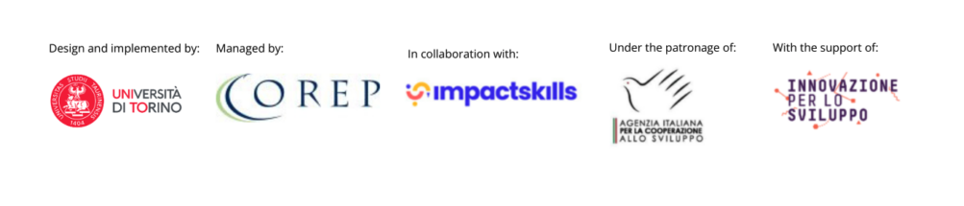
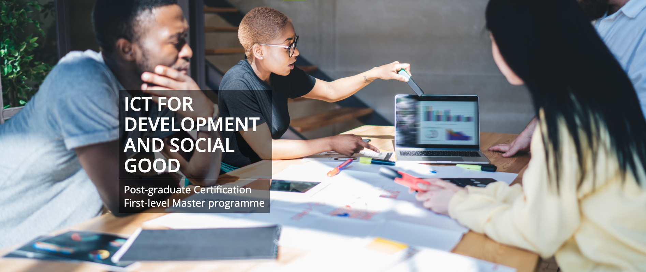

- INTRODUCTION
Below you will find the guidelines that will facilitate your work towards the conclusion of the first level Master programme, that is, the development and delivery of the Final Project. All students that attend Full Master Model are required to complete the Final Project and present it in an online-based concluding event that will take place in December 2026.
The following guidelines have been developed in collaboration with the Scientific Committee of the Master programme, as well as reviewed by some of the lecturers of the Master programme. Ultimately, these guidelines have been approved by the Scientific Committee.

- AIM & OBJECTIVES
The first-level Master programme “ICT for Development and Social Good” aim to support the theoretical and practical development of students in the field of Information and Communications Technologies for Development, as well as support their critical thinking towards existing initiatives, methods and tools; and enhance their ability to develop, adopt and reappropriate various technologies and social innovation methodologies for local, national or international development.
The objectives of the Final Projects are as follows:
- To enable students to practice and apply the theoretical and practical skills and knowledge in real-life projects/cases;
- To test students’ ability to integrate the ICTs tools and platforms and the theoretical knowledge, in international cooperation projects and/or contexts;
- To equip various non-governmental organizations that were involved in the course through Internship partnerships with concrete ideas and practical skills that help strengthen their work through ICTs;
- To provide an opportunity for students to present their Final Projects to a wider public through an online Public Barcamp.

- WE ENCOURAGE YOU TO:
- Closely connect your Final Projects with the Internship. It is expected that your Final Project is a conclusion of your Internship and Master’s journey. So, it is fundamental that you use the Internship as a moment of research, inquiry, practice, and experimentation to apply the skills, competencies, and knowledge gained during the Master programme. Don’t forget: failures are good lessons too!
- Work individually, however, we also recommend peer support when asked or needed. You come from different backgrounds and have different skill-sets, hence, use each other’s expertise and skills.
- Align your Final Projects with the thematics of the Master programme and have a ‘social good’ approach. Further, it is key that your Final Project should be seen from the lenses of the Master programme’s content.
- To use, adopt and/or re-appropriate one or more ICT tools, apps or platforms that have been tackled during the Master’s lectures.
- To use, adopt and/or re-appropriate one or more ICT theoretical concepts, methods/methodologies, principles and/or frameworks that have been tackled during the Master’s lectures.

- WHAT YOU NEED TO ACCOMPLISH?
- Final Projects, preferably, should have two components:
a) the first includes the development of the theoretical concept which describes (and backs-up) your research/inquiry/pilot… name it as you wish.
b) the second includes the practical component where you should produce a tangible ‘product’, for example: a technological prototype, a methodological framework, a (re)appropriation of a technology in development context, or other type of artefact. While this is not obligatory, we highly recommend it as an added value to the overall experience.
c) and lastly, you need to prepare a 5-minute presentation with slides to discuss your Final Project.
- The template for the theoretical concept can be found HERE (or see attached in the email).
- Whereas, for the practical component you are requested to submit the original work/prototype through a third-party tool/platform by inserting the url links in the theoretical concept template.

- PLEASE AVOID:
- Providing a descriptive work of your Internship in the Final Project. We are more interested to read how the learnings of your Master have been integrated in the Internship and then reflected in the Final Project.
- Using first-person language “I did…”, “We worked…”, etc., instead give priority to third-person language. Be careful also in using gender-neutral language.
- Providing false information, data, as well as plagiarism as information of your own. Always cite the sources using the following format: surname and name of the author, title of publication, year of publication, printing house (e.g. Smith J., ICT for Development, 2017, University of Turin). All content submitted undergoes different checks to ensure that the project does not contain plagiarized content, including the unethical use of generative AI tools such as ChatGPT. Whenever generative AI tools are used, it should be mentioned in the thesis project as a disclaimer, and ideally, provide all exchanges with the LLM in a separate annex.

- WHAT SUPPORT CAN YOU RECEIVE?
- Don’t be afraid to ask for help! If you are facing any challenge related to the development of the Final Project, you should get in touch with the Master’s Tutor who is responsible to provide support to everyone.
- Mentorship! The Master’s organizers (University of Turin, Corep and Impactskills) have access to a wide range of experts and professionals (including the lecturers of the course) who may support your work. However, they also have limited time. Therefore, if you need mentorship, you should contact the Master’s Tutor, explain what mentorship/advice you need, what is the purpose and then the Master’s Tutor will propose the way forward.
- Resources and materials! If you need to have access to all the lectures (video-recording), materials and slides, you can access them at any time in the Moodle. In case you need any specific material, resource, etc. - you can try to ask a Master's Tutor who may point you out to a specific expert or online resource. Remember that you should have access to a wide range of online bibliographies with your Unito account!
- Meetings! The Master’s Co-ordinator will be available to meet with you in case support or discussion is needed. The schedule includes the working hours between Monday to Friday. It may happen that the Master’s Tutor may invite you in a meeting to check-in the progress of work.

- PRESENTATION OF FINAL PROJECTS
- Presentation of Final Projects will take place online, in front of the expert’s commission and it will be open to the public.
- The precise schedule of the presentations will be provided to you later on.
- Your Final Projects, along with other additional documents, will be submitted to the Commission and to the Director of the Master before the online event, in order for them to read and review.

- TIMELINE
Please note: the timeline below should be considered as a draft timeline and may be subject of change. However, it does provide an approximate idea of how the overall flow of the Master’s conclusion will take place.
- 15 November 2026: All Internships are completed and therefore terminated. All students should provide the necessary documents of internships’ conclusions to Dott.sa Valentina Gelato at: valentina.gelato@unito.it (Please read and follow instructions in Internship Guidelines document)
- 13 November 2026 (17:00 CET): Students should provide the first draft of their Final Projects to the Reviewer who will give feedback on the draft.
- 20 November 2026: Students receive the Reviewer’s feedback.
- 30 November 2026 (23:59 CET): After receiving the Reviewer’s feedback, students should provide the final draft of their Final Projects.
- 10-11 December 2026: Thesis Graduation (online event) - presentation and discussion of the Final Projects in front of the Master’s Commission. (Note: more detailed information about the thesis graduation event will be provided to you in November).

