FINAL PROJECT

THEORETICAL CONCEPT


- Full Master Model -
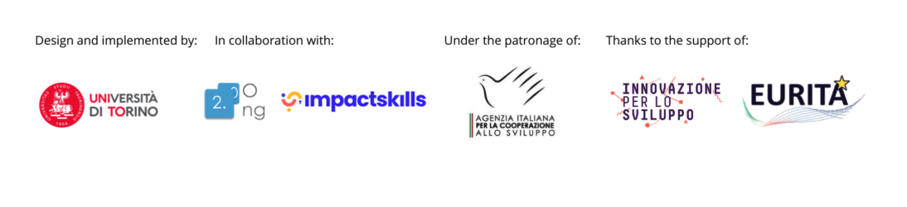

1. TITLE: Search And Rescue Monitoring

2. FIELD: Data for Migrants and Refugees

3. FULL NAME: Abdelrahman Gadalla, Italy

4. INTERNSHIP
Add details about your Internship program, such as: name of entity, country, brief description of entity, etc.. 150 words maximum
During my internship with UNHCR Malta in the Information Management unit, I focused on enhancing Search and Rescue (SAR) operations through effective data management and visualization. My role involved liaising with government entities to streamline data exchange processes, ensuring accurate and timely sharing of critical information to support life-saving operations. I contributed to capacity-building initiatives by training stakeholders on data management best practices and the use of tools to process information efficiently.
A key aspect of my work was developing automated dashboards and GIS-based solutions to provide actionable insights into SAR activities. These tools enabled real-time monitoring of boats in distress, improved decision-making, and reinforced the ability of teams to respond swiftly to emergencies. By integrating technology and fostering collaborative relationships, my internship contributed to reinforcing operational efficiency, supporting UNHCR's mission to protect and assist vulnerable individuals in the Mediterranean.

5. ABSTRACT
It should state the topic of the thesis, describe the methods used, and give the main results or conclusions. 150 words maximum.

This project addresses the ongoing Mediterranean migration crisis by designing ICT-based solutions to enhance SAR operations. Using an action research methodology, the project identifies key challenges like communication barriers, resource limitations, and operational inefficiencies. The proposed solutions integrate real-time communication, GIS mapping, and predictive tools to optimize SAR efforts. Stakeholder feedback and justice considerations have been considered to ensure ethical design and equitable resource distribution. Key findings reveal significant improvements in coordination, reduced fatalities, and strengthened public awareness.
This project underscores the importance of innovative, socially responsible ICT solutions in addressing complex humanitarian challenges.

6. INTRODUCTION AND MAIN QUESTIONS
This section summarizes the context and issues at stake, and should typically answer (a subset of) the following questions:

What is the topic of the Final Project?
ICT solutions enhance decision-making in SAR operations by addressing critical operational challenges and enabling efficient, data-driven responses:
Real-Time Communication:
- ICT solutions facilitate seamless information exchange between stakeholders, including NGOs, governments, and SAR teams.
- Features like live updates and instant alerts improve coordination during rescue missions.
Data Integration and Analysis:
- ICT systems compile and analyze diverse datasets, including weather patterns, migration routes, and distress signals.
- Predictive modeling, such as GIS-based tools, identifies high-risk areas, enabling proactive resource deployment ”Subject to GOV Authorizations”.
Resource Optimization:
- By visualizing data in real time, ICT tools help allocate resources like rescue vessels, medical supplies, and personnel more effectively.
Monitoring and Accountability:
- ICT tools offer transparency, allowing stakeholders to track and evaluate SAR efforts, fostering trust and operational accountability.
Public Engagement:
- Solutions can provide accessible visualizations and updates to inform and engage the public, garnering support for SAR activities.

What Are the Ethical Considerations in Implementing Data-Sharing Systems?
Implementing data-sharing systems in SAR operations requires careful attention to ethical concerns to avoid unintended harm:
Data Privacy and Security:
- Personal information of rescued individuals must be anonymized to protect their identities and safety.
- Secure data storage and transfer mechanisms are crucial to prevent unauthorized access or misuse.
Bias Prevention:
- Data must be collected and processed in a way that avoids reinforcing biases or discrimination based on nationality, status, or other factors.
Informed Consent:
- Stakeholders, including migrants, must be informed about how their data will be used and provide consent where applicable.
Transparency:
- The purpose, scope, and limitations of the data-sharing system should be clearly communicated to all stakeholders.
Ethical Design:
- ICT solutions should prioritize human dignity, ensuring that tools do not dehumanize or stigmatize individuals.

How is the topic of the Final Project significant in terms of current questions on cooperation, social good and/or international development?
Shared Solutions:
- Create ICT solutions accessible to NGOs, governments, and communities, promoting transparency and unified efforts.
Collaborative Frameworks:
- Facilitate regular workshops and meetings where stakeholders can share insights, align objectives, and develop joint strategies.
Role Clarification:
- Clearly define the roles and responsibilities of each stakeholder to minimize conflicts and redundancies.
Equitable Voice:
- Ensure all parties, particularly NGOs and marginalized communities, have an equal say in decision-making processes.
Community Engagement:
- Include local communities in SAR strategies to leverage their knowledge of geographic and cultural contexts.
Technology Accessibility:
- Train stakeholders on how to use the ICT tools, ensuring equitable access regardless of resources or technical expertise.

What is the overall structure of the Final Project?
Lastly, you should also list the main questions that you investigate in your Final Project. 300 words maximum.

The overall structure of the Final Project is organized into a series of interconnected sections, each contributing to a comprehensive understanding of the issue at hand and the proposed solutions. The project begins with a Title that encapsulates the focus of the work. The Field section identifies the broader domain, in this case, humanitarian assistance and human rights, within which the project is situated.
The Internship section provides contextual background, highlighting the professional setting and practical experiences that informed the project. This is followed by the Abstract, which offers a concise summary of the problem, methodology, and key findings, setting the tone for the deeper exploration in subsequent sections.
The Introduction and Main Questions outline the context of the Mediterranean migration crisis, presenting the primary challenges and questions the project seeks to address. This flows naturally into the Objectives, clearly defining the goals, such as improving SAR operations and fostering collaboration among stakeholders.
The Methodology and Research Methods section elaborates on the action research approach, detailing stakeholder engagement, data analysis, and ethical considerations. This methodological foundation supports the Discussion of the Implication of the Master Programme, connecting the project to the theoretical frameworks, tools, and principles learned during the course of study.
The heart of the project lies in the Discussion of the Final Results/Product/Findings and Analysis, where the outcomes, advantages, and critiques of the ICT solution are examined in detail. The project concludes with a Conclusions section, summarizing the key insights and their implications.

7. OBJECTIVES
Explain what are the main objectives of the Final Project?

The Final Project is guided by a set of clearly defined objectives aimed at addressing the operational, ethical, and humanitarian challenges associated with Search and Rescue (SAR) operations in the Mediterranean. These objectives ensure a focused and impactful approach to leveraging Information and Communication Technology (ICT) solutions in this complex environment.
Enhance Coordination Among Stakeholders: The project aims to design an ICT solution that bridges communication gaps between key stakeholders, including NGOs, governmental bodies, and SAR teams. By enabling seamless real-time communication, the solutions will foster greater collaboration and reduce redundancies during rescue operations.
Optimize Resource Allocation and Decision-Making: The use of GIS-based mapping and predictive modelling is a cornerstone of this objective. These tools help identify high-risk zones, prioritize resource deployment, and streamline operations. The solutions aims to reduce delays in response times, ensuring that resources are directed where they are most needed, potentially saving lives.
Uphold Human Rights and Justice Principles: The project emphasizes ethical and justice-oriented design in its ICT solutions. This includes safeguarding the dignity and rights of individuals rescued, ensuring data privacy, and avoiding biases in data interpretation. The system aims to support equitable treatment of all individuals in distress, regardless of their nationality or status.
Increase Public Awareness and Engagement: By creating accessible data visualizations and open-access solution, the project seeks to inform and involve the public in SAR efforts. The goal is to foster greater societal support and advocacy for the humanitarian principles underlying SAR operations, while countering misinformation and stigmatization of migrants.
Promote Socially Responsible Innovation: The project integrates feedback from diverse stakeholders, including migrants, to ensure the ICT solution is practical, inclusive, and adaptable to evolving challenges. This objective highlights the importance of responsible research and innovation (RRI) in the context of humanitarian crises.
Through these objectives, the project aspires to create a holistic, impactful solution that enhances SAR effectiveness, promotes justice, and upholds humanitarian values.

8. METHODOLOGY AND RESEARCH METHODS
This section will describe the methodological approach, including a brief discussion on this method’s potential strengths and limitations. For example, did you run any interviews with the organization? Did you run any research? It will present and discuss the ‘data’: e.g. spatial, social, economic, institutional, political, historical elements considered; sources; general indicators; units of analysis; sampling, etc. If relevant, the data generated through interviews, questionnaires, field research, etc., will also be presented and discussed. Maximum 500 words

The methodology chosen for this project combines Action Research to ensure a practical, iterative approach to developing an impactful ICT solution that aligns with the needs of all stakeholders involved in SAR operations.
By Solving real-world problems through continuous cycles of planning, acting, observing, and reflecting. This will prioritize collaboration and feedback from stakeholders at each stage, which is essential for addressing the complex and dynamic environment of SAR operations.
Identifying key challenges in current SAR operations, such as communication barriers, resource constraints, and political obstacles.
Integrating justice considerations, especially in the ethical design and presentation of information to prevent bias or misuse of data.
This approach ensures that the final product is not only a functional tool for SAR operations but also a socially responsible innovation that aligns with the humanitarian values of dignity, justice, and equity in crisis response.
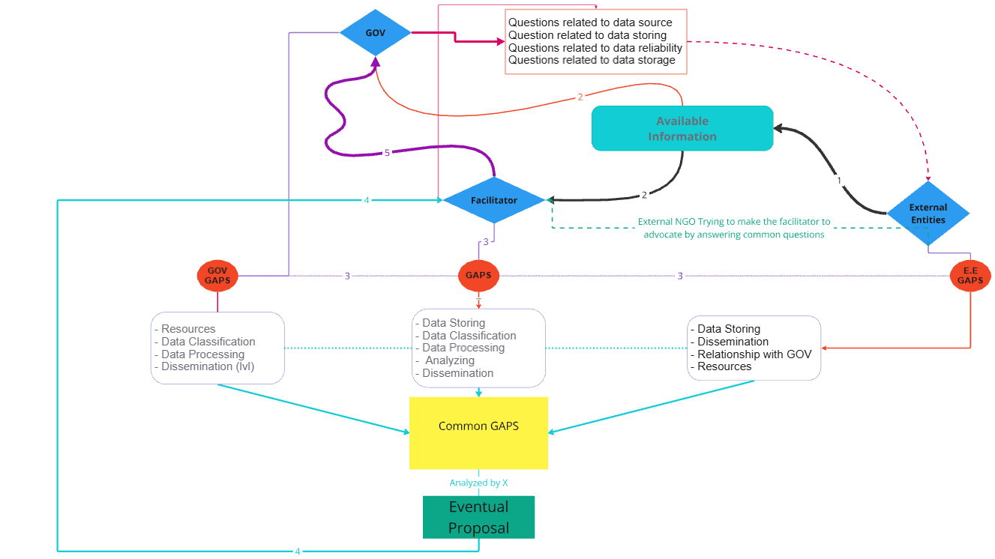

Social justice in SAR ICT use requires that data interpretation and visualizations are unbiased and that the technology accounts for all people in distress equally, regardless of nationality or status. Inclusive data visualizations can also support advocacy for equitable SAR policies by showing the full scope of the crisis.
e.g. GIS visualizations that highlight underserved or high-risk routes, using data to advocate for equitable SAR resources across all areas, and creating tools that highlight the number of lives saved and lost to promote more just and inclusive policies.
acknowledging and valuing this knowledge. This may include:
- Listening to Survivors’ Experiences: Conducting interviews or discussions with migrants and refugees who have crossed the Mediterranean can provide invaluable insights into the challenges they faced and their expectations from SAR operations.
- Understanding Motivations and Risk Perceptions: Recognizing the diverse factors that drive migration and the ways migrants perceive risks can inform more responsive SAR strategies that align with their perspectives and respect them.
This approach will:
Improve Operational Effectiveness: By incorporating SAR operators’ field insights, the system can reflect on-the-ground realities, including logistical challenges, risk areas, and response timing.
Enhance System Usability: Designing an ICT system with input from these users ensures the tools are accessible, intuitive, and relevant, maximizing their potential to improve SAR outcomes.
Addressing Power Imbalances between Government and NGOs
The SAR landscape in the Mediterranean is marked by a significant power imbalance, with governmental authorities often having the final say in regulations, access, and resource allocation. This disparity can lead to the marginalization of NGO perspectives and expertise. Can be addressed via:
- Promoting Equal Voice for NGOs: Ensuring that NGOs, who frequently conduct rescue operations and directly engage with migrant populations, have an equal say in the development and operationalization of SAR policies and tools.
- Facilitating Cross-Sector Collaboration: Building a collaborative approach that respects both governmental regulations and NGO expertise, encouraging an environment where both sides can share insights and influence decision-making equitably.
- Data Sharing and Trust-Building: Transparent sharing of data and visualizations among stakeholders is key to trust-building. When stakeholders see that SAR operations are driven by accurate, real-time data, they are more likely to endorse and support the operations, trusting that SAR teams are working efficiently and ethically.
Transparency and Data Access for Fair Knowledge Distribution: creating solutions for collaborative use of ICT and GIS tools, SAR operations can unify diverse stakeholders. Shared data visualizations and tracking technologies make it easier for stakeholders to coordinate efforts, reducing redundancies and increasing overall SAR effectiveness.
Training and Knowledge Building among Stakeholders
- Capacity-Building: Providing accessible information and education about SAR operations and rights can empower migrants and their communities, helping them understand the resources and support systems available.
Ensuring that SAR operators, including those from smaller NGOs or under-resourced teams, receive training to use the ICT tools effectively.
- Ethical Data Presentation: Ethical Use of Data to Prevent Misrepresentation Ensuring that data about migration flows and SAR efforts is presented in a way that respects the dignity of migrants, avoiding dehumanizing language or imagery.
- Avoiding Stigmatization: Countering narratives that portray migrants as mere data points or as burdens by framing data within the humanitarian context of rights and protection.
Data collected from SAR operations, when misrepresented, can lead to stigmatization of migrants, or reinforce negative stereotypes.

9. DISCUSSION OF THE IMPLICATION OF THE MASTER PROGRAMME
Please explain in this section how you connected the learnings of the Master program within your Final Project. For example: which ICT’s apps, tools, theoretical method, concepts or frameworks, principles have you used, as well as provide (if possible) evidence-based reasoning. Maximum 500 words.

The Master Programme in ICT for Development and Social Good played a pivotal role in shaping the Final Project, offering theoretical insights, practical tools, and a collaborative learning environment essential for its success. Through the programme's comprehensive curriculum, I gained the knowledge and skills required to conceptualize and implement an innovative ICT solution to enhance Search and Rescue (SAR) operations in the Mediterranean.
The program emphasized critical analysis of ICT initiatives, equipping me with frameworks to assess their societal impact and potential failures. Drawing on principles such as Responsible Research and Innovation (RRI), the project integrates societal engagement, ethical considerations, and justice dimensions into its design. The emphasis on social good, equity, and human rights provided a foundation for embedding justice-oriented features into the ICT solutions, ensuring it serves all stakeholders equitably.

Practical Tools and Technologies
The programme introduced cutting-edge tools and solutions that were directly applied in the project:
GIS Mapping: Utilized to identify high-risk migration routes and optimize resource allocation during SAR operations.
Data Visualization: Leveraged to create accessible, transparent representations of SAR data collected via Activity INFO solutions, fostering stakeholder engagement.
These tools were essential for building a robust ICT system using ArcGIS and Power Bi that enhances real-time decision-making and stakeholder collaboration in SAR missions.

Methodologies
The programme’s focus on action research aligned with the project’s iterative approach, enabling real-world problem-solving through cycles of planning, acting, observing, and refining. Skills in stakeholder engagement, learned during the Master, were critical for conducting workshops and interviews with NGOs, governments.
Principles of Social Innovation
The curriculum emphasized the importance of co-creation and involving diverse stakeholders in the design process. This influenced the project's inclusive approach, ensuring that the voices of marginalized groups, such as migrants and under-resourced NGOs, were incorporated into the solutions’ development.

Evidence-Based Reasoning
Key lessons from the Master’s case studies and fieldwork helped ground the project in evidence-based practices. For instance, studying successful ICT interventions highlighted the importance of user-centered design and data privacy protocols. These insights were implemented to create a solution/protype that is ethical, user-friendly, and effective in addressing SAR challenges.

Community Building and Collaboration
The programme fostered a community of practitioners, providing opportunities to network and collaborate with peers and experts. This network was invaluable for refining the project through peer feedback and expert guidance, enhancing its overall impact and viability.

Final Impact
By connecting the learnings from the Master programme with the project's objectives, I was able to design a solution that not only addresses operational inefficiencies but also aligns with the humanitarian principles of dignity, equity, and justice. The programme’s integration of theoretical and practical learning ensured that the ICT solutions were both innovative and socially responsible, contributing meaningfully to SAR operations and broader development goals.

10. DISCUSSION OF THE FINAL RESULT/PRODUCT/FINDINGS AND ANALYSIS
This section should include findings based on the primary sources gathered during fieldwork, or provide analysis of the final product in case something has been produced. Further, in this section you should discuss the advantages and the critique of your final results/product/findings. 800 words maximum.

The final product of this project is a prototype of ICT solutions designed to improve the efficiency and ethical standards of Search and Rescue (SAR) operations in the Mediterranean. The solutions integrate three key components:
Real-Time Communication Tools: These enable seamless coordination among NGOs, governmental bodies, and SAR teams.
GIS Mapping and Predictive Analytics: These features identify high-risk migration routes, optimize resource allocation, and support proactive interventions.
Data Visualization Dashboards: These provide accessible, anonymized data visualizations to enhance decision-making and public awareness.
Findings from Fieldwork and Stakeholder Engagement
The primary data was gathered through stakeholder workshops, interviews with SAR operators, and consultations with NGOs and local communities. Key findings include:
Operational Challenges: Communication barriers, resource constraints, and inconsistent data-sharing practices hinder the effectiveness of SAR missions.
Stakeholder Needs: NGOs and governmental agencies expressed a need for a unified solutions that integrates data and supports real-time collaboration.
Ethical Concerns: Stakeholders highlighted the importance of safeguarding the dignity and privacy of individuals rescued.
Public Awareness Gaps: A lack of accessible, transparent data limits public engagement and support for SAR operations.
These findings informed the design of the solutions, ensuring it addresses the specific challenges and needs identified during fieldwork.
Advantages of the Final Product
Improved Coordination:
The solutions enable real-time communication between stakeholders, reducing redundancies and improving response times.
GIS mapping provides a shared view of high-risk zones, facilitating better alignment of resources.
Enhanced Decision-Making:
Predictive analytics support proactive planning, enabling stakeholders to allocate resources effectively before crises escalate.
Data visualizations offer a clear, actionable view of migration patterns and SAR operations, aiding decision-makers.
Ethical and Justice-Oriented Design:
Anonymized data safeguards the privacy of individuals, addressing concerns about data misuse.
Justice dimensions, such as distributive and procedural fairness, are integrated into resource allocation and stakeholder participation.
Public Engagement and Advocacy:
Accessible dashboards and visualizations foster public awareness of SAR efforts and migration challenges, countering misinformation and stigmatization.
The solutions support advocacy for equitable policies by highlighting underserved areas and disparities in resource allocation.
Critique of the Final Results/Product
Technical Limitations:
The solutions’ reliance on internet connectivity and advanced infrastructure may limit its usability in remote or resource-constrained areas.
The initial prototype lacks advanced features such as machine learning for more sophisticated predictive analytics.
Dependency on Stakeholder Participation:
The success of the solutions depends on consistent participation and data-sharing from diverse stakeholders, which may be hindered by political or organizational barriers.
Scalability and Cost:
High initial development and implementation costs pose challenges for scaling the solutions across different regions.
Smaller NGOs may lack the resources to adopt the solutions fully, necessitating additional funding or subsidies.
Political and Regulatory Challenges:
Navigating the complex political landscape of SAR operations, including conflicting interests among stakeholders, could limit the solutions’ effectiveness.
Data-sharing agreements may face resistance due to concerns about sovereignty and control.
Analysis of Findings
The findings demonstrate the potential of ICT to transform SAR operations, particularly in improving coordination, decision-making, and public engagement. However, the critiques underscore the need for ongoing refinement and adaptation to address technical, financial, and political barriers.
Evidence-Based Recommendations
Enhancing Technical Features:
Future iterations of the solutions should incorporate advanced analytics, such as machine learning, to improve predictive capabilities.
Offline functionality could enhance usability in regions with limited connectivity.
Building Stakeholder Trust:
Transparent governance structures and data-sharing agreements are essential for fostering trust among stakeholders.
Training programs should be implemented to build the capacity of NGOs and SAR teams to use the solutions effectively.
Securing Funding and Partnerships:
Collaboration with international organizations, such as the UNHCR, could provide financial and logistical support.
Open-source development models could reduce costs and encourage broader adoption.
Advocacy for Policy Reforms:
Data visualizations should be used to highlight systemic inequalities, advocating for more equitable resource distribution and policy changes.
Stakeholder engagement efforts should include local communities and migrants to ensure inclusive, justice-oriented solutions.

11. CONCLUSIONS
The conclusions drawn should be substantiated from the body of the Final Project. Maximum 300 words.

The final product, an ICT solution for enhancing SAR operations, represents a significant step toward addressing the Mediterranean migration crisis. By leveraging real-time communication, GIS mapping, and data visualization, the solutions improve coordination, decision-making, and public awareness. While technical and political challenges remain, the project underscores the transformative potential of ICT when designed with ethical and justice-oriented principles. Future iterations should focus on scalability, advanced features, and stronger stakeholder engagement to maximize the solutions’ impact.

12. APPENDIX: MATERIALS & PROTOTYPES
Please insert below any other information, document, prototype, url link, that you think would be important for the Commission to read or have a look at, such as: survey data, data visualization, technological prototype, mockup, etc.. You may consider submitting them also as Appendix.

