



**(DEPI)**



***Managing Procurement, Inventory & Sales of Construction & Building Materials to Individuals and Businesses***

**Ahmed Mohamed Wael**

**Mohamed Essam Eldin Salah Eldin**

**Hazem Hamdy Rabie**

**توجيه الشكر**

نود أن نعبر عن خالص امتناننا **لوزارة الاتصالات وتكنولوجيا المعلومات (MCIT) ومبادرة رواد مصر الرقمية (DEPI)** لتوفير هذه الفرصة القيمة للتعلم واكتساب الخبرة في بيئة أوراكل. وقد أسهمت هذه المبادرة بشكل كبير في تعزيز قدراتنا الفنية ومكنتنا من اكتساب مهارات تمنحنا ميزة تنافسية في المجال المهني.

كما نتوجه بجزيل الشكر **للسيد مصطفى عبد النعيم** على تفانيه اللامحدود ونصائحه القيمة ودعمه المستمر طوال رحلة التدريب. لقد كان لجهوده دور محوري في إثراء تجربتنا التعليمية وتطويرنا المهني.

خالص تقديرنا

**Acknowledgment**

We would like to extend our sincere gratitude to the **Ministry of Communications and Information Technology (MCIT)** and the **Digital Egypt Pioneers Initiative (DEPI)** for providing us with the valuable opportunity to learn and explore the Oracle environment. This initiative has significantly enhanced our technical capabilities and equipped us with skills that give us a competitive edge in the professional world.

A special thanks to **Mr. Mostafa Abdel Naeem** for his unwavering dedication, mentorship, and continuous guidance throughout the training journey. His support played a crucial role in our learning experience and professional development.

**📍 Introduction**

**BG30** is a specialized Enterprise Resource Planning (ERP) system designed to support companies operating in the **construction and building materials industry**. Whether selling to individual end-users or large business entities, BG30 offers a complete solution for managing sales, purchases, inventory, vendor relations, and operational scheduling.

This user guide provides a detailed walk-through of the system’s key functions and user interfaces, supported by screenshots and explanations to help users navigate and operate the system effectively.

BG30 is ideal for companies that:

* Sell building materials to both individual consumers and commercial clients
* Manage retail and wholesale orders
* Need to track delivery timelines, payment terms, and stock availability
* Require structured supplier and client management

INDEX

Contents

System Architecture: 5

Defining the New User BG.30 in Oracle Applications 6

Define User Form 7

Logging in as BG.30 8

9

Assign General Ledger Responsibility 9

How to Identify Exact Menu Names in Oracle Applications 12

How to Get the Exact Menu Name for Adding/Removing from Responsibility: 13

Location Management 15

Defining an Operating Unit in BG30 16

Organization Setup 17

Replicate Seed Data 18

Profile Options 19

Setting Up Work Calendars 20

Adding Exceptions 21

Final Calendar Setup 22

Calendar Creation Procedure For Operating Unit: [Your OU Name] 23

Workday Calendar (final view) 24

|  |  |  |  |  |  |  |  |  |  |
| --- | --- | --- | --- | --- | --- | --- | --- | --- | --- |
| System Architecture: | | | | | | | | | |
| GL | | | | | | | | | |
|  |  |  |  |  |  |  |  |  |  |
| BG30 (OU) | | | | | | | | | |
| Head Quarters | | | | | | | | | |
|  |  |  |  |  |  |  |  |  |  |
| PROCUREMENT (consignee +owned) | | | | | | | | | |
|  |  |  |  |  |  |  |  |
| INV ORG | | | | | | |  |
|  |  | │ |  | │ |  |  |  |  |  |
|  |  | │ |  | │ |  |  |  |  |  |
|  |  | LOCATOR |  | NON-LOCATOR |  |  |  |

# 

# Defining the New User BG.30 in Oracle Applications

To create a new user in Oracle ERP, follow the steps below. This process is done using the **System Administrator** responsibility.

**The Navigation Path: System administrator→ Security →User→ Define**

**Purpose:**

This function allows administrators to create and manage user accounts, assign responsibilities, and control access to different parts of the system.

**Steps to Define a User:**

1. **Login** to Oracle ERP and select the **System Administrator** responsibility from the home screen.
2. In the **Navigator** window (as shown in the screenshot), expand the following path:
   * Security
     + User
       - Click on **Define**
3. Click the **Open** button to launch the **Define User** form.

# Define User Form

After launching the **Define User** form, you can:

* + Enter the **Username**
  + Set the **Password**
  + Assign **Responsibilities**
  + Define **Effective Dates** (start and end dates of the user’s access)

# Logging in as BG.30

Enter the username and password defined in the process of defining new user (BG.30)

Oracle system will ask you to change the first-time password with a new password

Enter the new password and confirm it again.

The Oracle EBS system is now logged in as BG.30 with the defined responsibility General Ledger Vision Operations USA.

In the next step it will be illustrated how to customize the responsibility assigned to the user BG.30.

# Assign General Ledger Responsibility

1. In the **Responsibilities** region of the form (bottom half):
2. Click into the first empty line under **Responsibility**.
3. Press **F4** or click the list of values (LOV) button.

From the LOV, search and select:  
**"General Ledger Vision Operation (USA)"** (a customized version of the GL responsibility).

Copying a Responsibility in Oracle Applications

1. To copy an existing responsibility (like General Ledger) and assign it to your username, follow these steps:
2. Log in to Oracle Applications with System Administrator responsibility
3. Navigate to Security > Responsibility > Define
4. Query the existing responsibility (General Ledger)
5. Click Copy button
6. In the new form:
7. Enter a new Responsibility Name (e.g., BG30_General_Ledger)
8. Enter a new Responsibility Key (e.g., BG30_General_Ledger)
9. Save the new responsibility

Adding/removing menus from a responsibility:

Understanding Oracle Applications Menu Structure for Responsibility Management

The image of the "View Tree" screen for the GL_SUPERUSER menu in Oracle Applications, showing how to examine the menu assigned to a responsibility.

How to View Menu Trees for a Responsibility

1. Navigation Path:
   * System Administrator Responsibility
   * Application > Menu
   * Query the menu name (e.g., GL_SUPERUSER)
   * Click "View Tree..." button
2. Menu Tree Components Visible in the Image:
   * Menu Header: Shows the menu name (GL_SUPERUSER) and description (General Ledger Superuser)
   * Hierarchical Table: Displays all menu entries in execution order
3. Key Columns in the Menu Tree:
   * Step: Execution sequence number
   * Prompt: What users see in the menu
   * Submenu/Function: The actual program or submenu being called
   * Description: Explains the menu item's purpose

* + Using System Administrator Responsibility, navigate to: **Application Developer > Application > Menu**
  + Query the menu name you know (e.g., GL_SUPERUSER)
  + Select the menu and click "Entries" button
  + Locate the specific entry to see its details
  + **Entry Information Section**:
  + **Sequence**: 1 (order in which it appears)
  + **Prompt**: "Journals" (what users see)
  + **Description**: "Enter, generate, and post actual and encumbrance journals"
  + **Menu Identification Section**:
  + **Menu ID**: 87942 (unique numeric identifier)
  + **Name**: GL_SU_JOURNAL (system name)
  + **Display Name**: GL_SU_JOURNAL

# How to Get the Exact Menu Name for Adding/Removing from Responsibility:

*The exact name appears in the "Name" field (GL_SU_JOURNAL), the Menu ID (67902) is the unique identifier*

* + System Administrator Responsibility
  + Security > Responsibility > Define
  + Query the responsibility you want to modify

1. **Note the Menu field value - this is the exact name of the main menu assigned**

Best Practices:

1. Always verify you have the correct menu by checking both the prompt and description
2. For standard Oracle menus, never modify directly - always create a copy first

Menu before exclusion Exclusion process

Menu after exclusion

Best Practices

1. Always test exclusions in a development environment first
2. Document all exclusions with:
   * Responsibility name
   * Exact menu name excluded
   * Effective dates
   * Business reason
3. Consider creating custom responsibilities rather than heavily modifying standard ones

# Location Management

* This screen defines physical addresses and site information for organizational units.

*Where you tell the system about your actual buildings/offices.*

**Simple steps:**

1. Give it a name (e.g., "Cairo_Headquarters")
2. Paste the full address (include country!)
3. Set the timezone correctly - this affects all time-sensitive reports

**Watch out for:**

* The "Inactive Date" field - only fill this if the location will close someday

# Defining an Operating Unit in BG30

**📝 Description:**

This page demonstrates how to set up an **Operating Unit** within the Oracle ERP environment for the BG30 system, which is used in the retail and wholesale of building materials to both end users and business entities.

* **Name**: The operating unit is named BG30_Operating Unit.
* **Type**: Set as Operating Unit to define its role in the multi-org structure.
* **Dates**: The "From" date indicates the start of activation (01-01-2025). The "To" field is left empty to signify ongoing status.
* **Location**: Linked to BG30_Location, with an address in Smart Village, Giza, Egypt.
* **Internal or External**: Marked as Internal, indicating it is a part of the internal company structure.

# Organization Setup

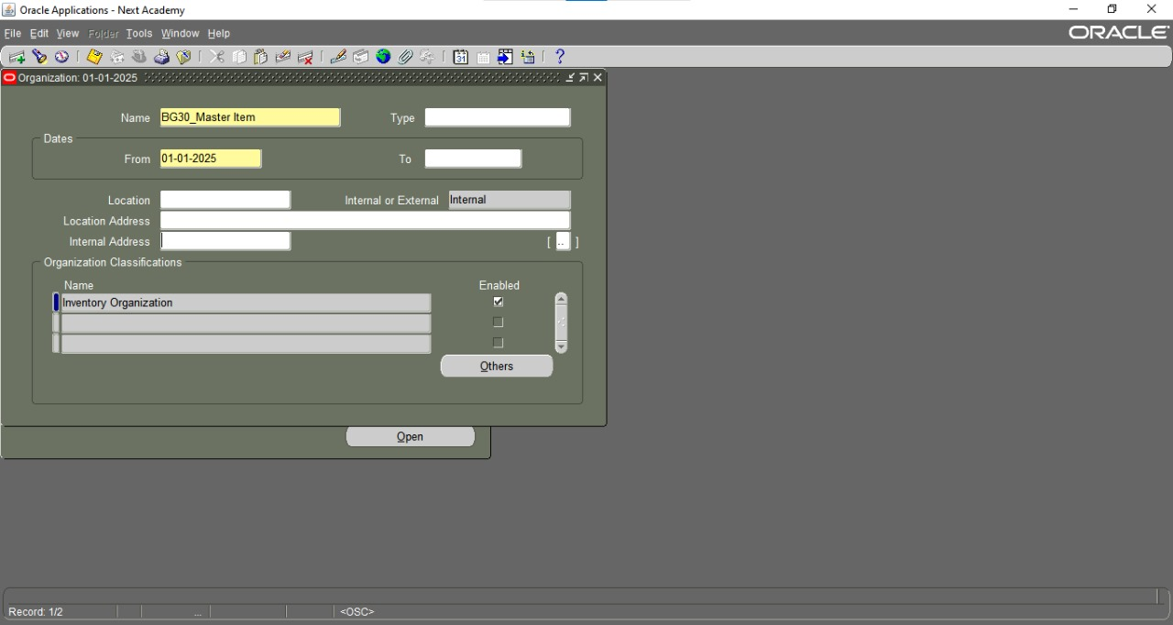

This screen shows the **Organization Definition** form used to define organizational units within BG30. It is critical for setting up inventory locations, warehouses, and other operational hubs.

Key components include:

* **Name**: For example, BG30_Master Item, used to identify the organization.
* **Date Range**: Defines the active period of this organization.
* **Type**: Classification of the organization (not filled in this screenshot).
* **Internal or External**: Indicates if the location is part of the internal structure.
* **Location & Address**: Specifies the physical location and internal address.
* **Organization Classifications**: Defines the purpose, in this case, “Inventory Organization,” which is marked as *Enabled*.
* **Organization Classifications**: Marked as Operating Unit and enabled, confirming that it functions as a separate unit within the organization hierarchy.

This screen is essential for configuring operational entities in Oracle, which allows for the separation of financial transactions, procurement activities, and reporting per unit.

# Replicate Seed Data

**Checking Background Jobs**

*Like looking at your email "Sent" folder to see if things actually processed.*

**What the numbers mean:**

* **Request ID:** Like a receipt number (e.g., 8852694)
* **Completion Text:**
  + Good news: "Normal completion" ✅
  + Bad news: Any other message means something went wrong

# Profile Options

**System Settings (Profile Options)**

*The "control panel" for your whole ERP system.*

**Important ones you'll use:**

* MO: Operating Unit = Your main working area
* HR: Business Group = Which employee group you manage

**Golden rule:**

* Never change these unless you're 100% sure - wrong settings can break things!
* profile options (must be assigned to BG30_INVENTORY [RESPONSIBILITY]):1) GL Ledger Name (Vision Operations)
* 2) HR: Business Group (Vision Corporation)3) HR: Security Profile (Vision Corporation)4) HR: User Type (HR with payroll user)5) MO: Operating Unit (The operating unit)
* 6) MO: Default Operating Unit (The operating unit)
* 7) GL Ledger ID
* Assigned by default
* 8) GL: Data Access Set

# Setting Up Work Calendars

*Where you tell the system about workdays, holidays, and shifts.*

**Basic setup:**

1. Name your calendar (e.g., "Egypt_Work_Calendar")
2. Mark weekends (Saturdays/Sundays)
3. Add national holidays using the exception dates

**Shift example:**

* Shift "03:00_CA1" might mean:

# Adding Exceptions

----------------------------------------------------------------------------------------------------------------------------

*Like marking "Out of Office" days for the whole company.*

**How to add holidays:**

1. Find your calendar template ("BG30_TEMP")
2. Click "Add Date"
3. Enter dates like "07-01-2025" (7th January)

**Why this matters:**

* The system won't schedule work on these days
* Shows correctly on all reports
  + Starts: 9:00 AM
  + Ends: 5:00 AM

# Final Calendar Setup

*The "advanced" calendar screen with all options.*

**Handy features:**

* **Day On/Off switches:** Like a light switch for workdays
* **Exception List:** Your full holiday schedule
* **Shift Times:** Where you define "9-to-5" or night shifts

# Calendar Creation Procedure For Operating Unit: [Your OU Name]

**1. Purpose**

This document provides step-by-step instructions for creating and maintaining work calendars specific to your Operating Unit (OU) within Oracle Applications. Proper calendar configuration ensures accurate scheduling, payroll processing, and operational planning.

**2. Pre-Requisites**

* Navigation access to **Workday Calendar** functions
* Llist of working days and holidays

**3. Calendar Creation Steps**

**3.1 Accessing Calendar Management**

1. Navigate to:  
   **Work Structures > Calendar > Define Calendar**
2. Select your Operating Unit from the dropdown

# Workday Calendar (final view)

*A visual calendar like you'd hang on a wall - but for the ERP.*

***What you can do here:***

* *See all exception dates highlighted*
* *Check which days are workdays*
* *Spot mistakes in your calendar setup*

***Color coding:***

* *Normal days = White*
* *Holidays/Exceptions = Usually colored*