Aerial Drones: Unmanned and Unlicensed

Henry Holben

Comp 11: Rhetorical Composition

April 6, 2016

1. Introduction:

Most everyone wants to fly. Since antiquity humankind has dreamed of going to the clouds and back again. From Daedalus-style tower jumpers, to the genius albeit unfeasible flying machines designed by Leonardo DaVinci, humanity has dreamed and dreamed of joining the birds in powered flight. Since its invention a century and thirteen years ago, heavier-than-air aircraft has progressed from the powered kite that lifted off from Kill Devil Hills to the spacecraft that have landed on the moon, fulfilling our dreams and pushing our expectations a little bit further. Some will give up years of their lives to the dream of piloting an aircraft. But for the rest of us who lack the knowledge and experience to strap into a cockpit and navigate through the clouds, a smaller and cheaper alternative has been dreamed up. Today most anyone who has an infatuation with flying can own a small plastic frame and four motorized rotor blades to take the pilot into the air and wherever he chooses to go. What is more, these toys offer the thrills of flying all from the comforts of home. Drone’s are sparking interest in many, and annoyance in others. However the fact that many flying robots are taking to the skies raises questions for the earthbound observer. ‘Is it safe?’ and ‘Is it watching me?’ come to mind. While anyone wanting to put themselves at the yoke of even small airplane is required to undergo extensive training both on the ground and in the air with an instructor, consumer drone pilots owning drones weighing more than fifty-five hundredths of a pound must merely register their drones with the Federal Aviation Administration, (The FAA) and follow a short amount of guidelines to lawfully fly a hobbyist drone. When privacy and safety are considered drone owners are not held to enough responsibility. Like the first automobile drivers civilian drone owners an alarming amount of freedom. The FAA ought to require all hobbyist drown owners desiring to fly drones off of their property to register for a license.

II. Drone Basics

Because the definition of a drone is disputed, it is worthwhile establishing here. For the purposes of this paper the word “drone” refers to any unmanned aerial vehicle, often referred to as an UAV by the FAA. Drones have been used by the military, by businesses, and as playthings. This paper is only concerned with hobbyist and commercial drones, which are usually quadracopters (having four helicopter-like rotor blades on the ends of four armatures extending from a base at the machine’s center) that can be controlled and navigated by remote control. Consumer drones often employ computers, smartphones, or tablets to allow their users to navigate using a camera that is mounted somewhere on the drone. This feature allows the pilot to navigate their drone from great distances so that, unlike remote control toy aircraft of the past, pilots need not be present near the drone’s location.

FAA Policy Concerning Drones

When considering drone legislation it is important to consider what legislation regarding drones has already been passed. According to the requirements listed on the FAAs website, [FAA.gov](http://FAA.gov), any owner with a drone weighing more than 0.55 pounds is required to register their drone.[1] This registration does not include applying for a license. The registered drone and drone owner are simply known. Licenses are only required of owners who fly their drones as part of a profession. The maximum

While drones of this weight may pose no threat to public safety, they are still equipped, by necessity, with cameras.

III. Safety Concerns

a. Historical Incidents

Writing for the Washington Post, Craig Whitlock published an article concerning drone incidents

“In Washington, a Cessna pilot reported a drone cruising at 1,500 feet in highly restricted airspace over the nation’s capital, forcing the U.S. military to scramble fighter jets as a precaution.”[2]

b. Potential Dangers

Drones are steered from far away. Like many technologies built upon the internet, drones offer their pilots anonymity. Civilian cars have license plates, civilian airplanes and helicopters have ID numbers painted on their sides. Such identifications allow anyone who witnesses those vehicles being used illegally to read the ID number and thus have a lead start to discovering the pilot or driver’s identity. As of yet drones are not required to post a visible identification number of any kind.

Drones are becoming increasingly popular with consumers, thus drones are quickly taking up more and more air space. The following quote, from a speech given by the administrator of the FAA, Michael Huerta, gives some perspective on this increase.

“Indeed, our latest aerospace forecast estimates that there could be as many as seven million drones sold in the United States by 2020. That’s about two and a half times the population of the state of Nevada.”

As the number of drones rises, and as the design of drones improve the dangers and the breaches of privacy can only expect to increase also.

C. Possible Legislative solutions

The Federal Aviation Association has been creating legislation for remote control flying toys long before the creation of the modern drone. Some may argue that drone owners, as property owners, should have the unchecked right to fly their machines without the government scrutinizing their actions. The United States was founded in part, in response to unjust government regulations. This raises the question of whether the United States, as a country fond of the freedoms it guarantees to citizens, should restrict the flight of consumer drones at all. Consider the need for regulation in the past. The first to drive automobiles had no legal need for a driver’s license. The legislation came later, in response to automobile accidents and injuries. In the modern world licensing has become absolutely necessary to keep the roads and highways safe. The law does not need to wait until drone accidents become commonplace, to require a license of all drone flyers.

Drones are compositions of two technologies that have historically been regulated by the law; namely aircraft and radio. If a hobbyist decides to modify even a child’s remote control car, the tinkerer should be aware of the laws surrounding radio transmission regarding the RC car. In the United States there are two frequencies one is aloud to transmit to control things such as toys and garage doors.

V. Conclusion

When the dangers and the risks of privacy invasion are considered, hobbyist drones are becoming a greater and greater concern. Despite this concern, the FAA does not as of yet require hobbyist drone flyers to be tested for a license to fly their machines. The quadrocopters are being sold at an alarming rate, and thus the machines are becoming more commonplace, and thus, more hazardous. In order to better protect the rights of citizens, the FAA ought to require hobbyist drown owners desiring to fly drones off of their property to apply for a license.

End Notes

1. Getting Started. [FAA.Gov](http://FAA.Gov).2017

2. Whitlock, Craig. *FAA records detail hundreds of close calls between airplanes and drones.* The Washington Post. 20 August 2015.

Bibliography

McGriffy, David. "Make:Drones". Maker Media Inc. San Fransisco. 2017

[Perritt, Jr., Henry H](javascript:__doLinkPostBack('','ss~~AR%20%22Perritt%2C%20Jr.%2C%20Henry%20H.%22%7C%7Csl~~rl','');), and [Sprague, Eliot O](javascript:__doLinkPostBack('','ss~~AR%20%22Sprague%2C%20Eliot%20O.%22%7C%7Csl~~rl','');). "Drones". 2015

Huerta, Michael. "Drones: A Story of Revolution and Evolution". Las Vegas, NV. January 6, 2017

Rash, Wayne, "FAA Bans All Drone Operations Over Large Swaths of U.S. Airspace". Business Source Premier. eWeek. 15306283. 12/28/2015

Getting Started. [FAA.Gov](http://FAA.Gov).2017

Whitlock, Craig. *FAA records detail hundreds of close calls between airplanes and drones.* The Washington Post. 20 August 2015.

Outline:

I. Introduction

II. FAA Policy concerning Drones

a. The FAA

b. History of Unmanned Aircraft

c. Current Legislation

III. Safety Concerns

a. Historical Incidents

b. Potential Dangers

C. Possible Legislative solutions

ii. Constitutionality

iii. Legal Precedents

IV. Privacy Concerns

a. Historical Incidents

b. Potential Danger

c. Possible Legislative Solutions

V. Conclusion

I am researching the amount of regulation that has been passed on the ownership of consumer drones in the United States. My interest in this topic stems first from my love for flying, and second from my interest in the security of IoT (Internet of Things) devices. My father, a hobbyist pilot shared his own love for the airplane while I was small and impressionable. Throughout my childhood my dad would make an occasion from time to time of taking me for a ride, usually in one of his flying club’s Cessna 172 Skyhawks. The first of these rides occurred in the club’s most cherished airplane, N74PE, or “Four Papa Echo”. It was in this first terrifying ride, that I became enchanted with the view from a couple thousand feet. Not long after, my dad declared me his “copilot”, and I’ve been hooked ever since. My interest in IoT devices originated with a

I have long been fascinated with flying.

Unmanned robots are filling the skies. Hobbyist quadracopters are becoming more and more commonplace. And with these oddly shaped drones comes several risks and breaches of privacy, as should be expected. It is not difficult to imagine the danger that can be caused by a single drone. And thus is more important than ever that the regulations on remote control hobbyist aircraft be evaluated and scrutinized.

Until 1903 mankind dreamed of springing from the earth and joining the birds in the skies. Even when lighter-than-air hot air balloons already existed, an unsatisfied mankind dreamed of going to the sky with a cumbersome noisy engine dragging him upward. Among the dreamers, two brothers from Ohio resolved to do just that. With several years of researching, tinkering, and testing, Orville and Wilber Wright unveiled the airplane, after millennia of anticipation. But that wasn’t enough. Faster and faster aircraft engines were developed, and the helicopter joined the airplane in sky. Mankind dreamed further, of taking an aircraft out of the atmosphere, to the moon, to other worlds entirely and back again. And we are all still dreaming. What once was nothing more than a dream is today the mundane reality travelers step into after being hassled by metal detecters and luggage searches.

Some will give up years of their lives to the dream of piloting an aircraft. But for the rest of us who lack the knowledge, and experience, to strap into a cockpit and navigate through the clouds, a smaller and cheaper alternative has been dreamed up. Today most anyone who has an infatuation with flying can own a small plastic frame and four motorized rotor blades to take the pilot into the air and wherever he chooses to go. What is more, these toys offer the thrills of flying all from the comforts of home. While anyone wanting to put themselves at the yoke a even small airplane is required to undergo extensive training both on the ground and in the air with an instructor, drone pilots must merely register their drones with the Federal Aviation Administration, (The FAA) and follow a short amount of guidelines to lawfully fly a hobbyist drone.

With the additional risks brought about by hobbyist drones, I propose that research be done into the regulations placed on hobbyist drone owners in the United States so that the effectiveness of drone policy can be better gauged and improved.

**NEWS ANALYSIS: A new interpretation of FAA rules results in a complete ban, at least for now, of even the limited ability to fly drones in large areas of the U.S.**

Drone operations of all types, including unmanned aircraft systems used for commercial, hobby and recreational purposes, have been banned in large areas of the United States under a new interpretation of Federal Aviation Administration rules.

While an Advisory Circular issued by the FAA in September announced the rules, the agency only made clear that no-fly restrictions now applied where the rules previously allowed flights under 400 feet above ground level and more than five miles from airports.

The circular was sent to the Academy of Model Aeronautics, which has had a long-standing agreement with the FAA that allowed it to operate from established flying areas, including some that are well within the five-mile distance from airports, as long as the activities were coordinated with airport operations and with the FAA controllers at the airport. Now those agreements have been put on hold.

Under the new rules, all aircraft regardless of size or type are required to be equipped with a radar transponder and an aircraft radio for communications with air traffic control. Drones and model aircraft don't carry them because the equipment is too large and heavy and requires an electrical system far beyond anything such aircraft could carry.

Previously, operators had to be in contact with air traffic control if they were within five miles of an airport, but that contact didn't need to be via an aircraft radio. Most of the time contact with air traffic control was by phone.

The new rules apply to any unmanned aircraft system (UAS) flown within 30 nautical miles of the VHF Omnidirectional Radio Range (VOR) transmitter located at Washington Reagan National Airport (DCA) in Arlington, Va. The rules also apply to any of the areas of restricted airspace that appear in the list of temporary flight restrictions (TFRs) throughout the United States.

TFRs can appear anywhere for a wide variety of reasons, frequently without advance warning. For example, any time the president flies somewhere, there's a 30-mile region of prohibited airspace around him.

An FAA spokesperson explained how this rule applies to UAS devices. "Unmanned aircraft, including model aircraft, are 'aircraft' and are subject to FAA rules," the spokesperson said in an email to eWEEK.

"No aircraft is allowed to fly inside the Special Flight Rules Area (SFRA) unless it complies with the published airspace security requirements. All aircraft flying in the Washington DC SFRA are required to squawk a discrete beacon code and maintain continuous radio communications with air traffic controllers. Aircraft that cannot meet these requirements are prohibited from operating within the SFRA without specific authorization," the email said.

While the FAA comment was specifically referring to model aircraft, the spokesperson confirmed to eWEEK that the rules apply to all UAS devices, including drones.

Note that the FAA rules do allow operators to apply for a waiver, but a waiver is granted for specific operations in specific areas.

This means that if you're using a drone to inspect cell towers, for example, you would need a waiver for each cell tower and each time you wanted to inspect it. These rules apply to any UAS that weighs less than 55 pounds. Larger devices have a similar set of restrictions.

By now you may recall that the FAA has just created an entire UAS registration system that's supposed to allow drone flights. You'd be right, but those rules aren't as unlimited as they might seem at first. While you can operate a commercial drone if the FAA allows it, that ability goes away any time you're in an area with a TFR, whether it's around Washington or somewhere else, such as Honolulu, where UAS devices are grounded during a TFR established, for example, while the president is on vacation there.

Of course, not all TFRs are set up because the president is traveling by air. Some go into effect because of disasters such as wildfires in California. Others are in place only for the duration of a football game or a concert.

Others exist because Disney or other theme park operators requested them. There are lots of reasons, and if you're operating a drone (or contracting with a drone operator) you need to be on top of those restrictions constantly.

Those limitations and restrictions apply to any drone or other UAS you might be thinking about operating. This includes the drone you got for Christmas even if it's smaller than the 8.8 ounces required for registration. And it applies regardless of whether it's being used for fun or for commercial reasons.

If you think you're going to need to use some kind of UAS for your business, then you would be wise to check for TFRs daily at the Web link above and be prepared to be flexible. Most TFRs really are temporary, and just because they're in place one day, doesn't mean they're going to be in place the next.

You also need to be aware that the president is only one of many prominent people who qualify for their very own flight restrictions. When the pope came to town, he got his own TFR, as do other foreign heads of state when visiting the U.S. But so does the Super Bowl and the World Series. Any of these can cancel the drone flight you need to perform for your business. It's UAS operators' responsibility to be aware of any applicable restrictions.

PHOTO (COLOR)

~~~~~~~~

By Wayne Rash

Copyright of eWeek is the property of QuinStreet, Inc. and its content may not be copied or emailed to multiple sites or posted to a listserv without the copyright holder's express written permission. However, users may print, download, or email articles for individual use.

**Speech – "Drones: A Story of Revolution and Evolution"**

"Drones: A Story of Revolution and Evolution"

Michael Huerta, Las Vegas, NV

January 6, 2017

**Consumer Electronics Show**

Good morning everyone, and thank you for joining us here today.  I hope you had a great holiday, and I want to wish you all a very Happy New Year.

For 50 years, the Consumer Electronics Show has been the place where technology meets everyday life. In the past, that wouldn’t be a place where you’d expect to meet someone from the FAA.

But, with its eager embrace of drone technology, CES has soared into the frontier of aviation. And that means this is *exactly* where we need to be.

We have a whole FAA team staffing a booth down in the drone marketplace. They’re available to answer questions and get any feedback that attendees have to offer. I encourage you all to stop by for a visit.

For me personally, this is my second straight year visiting CES. And I have to tell you, I find the array of products on display to be just as spectacular as I did a year ago. Maybe even more so.

There is cutting-edge innovation all around us: Artificial intelligence. Virtual reality. Wearables. Digital imaging. And, of course, drones.

Since my last visit here, the story of drones has continued to be a story of revolution and evolution.Revolution in the technology and how it’s being used. And evolution in the way we, the FAA, are approaching integrating this new entrant into the National Airspace System.

Our challenge is to find the right balance where safety and innovation co-exist on relatively equal planes. I don’t think it’s an exaggeration to say we have accomplished more toward this goal in the past year than we did in all previous years combined.

We worked with industry to establish the first set of comprehensive rules for flying small unmanned aircraft.

We established a Drone Advisory Committee and held our first annual unmanned aircraft symposium.

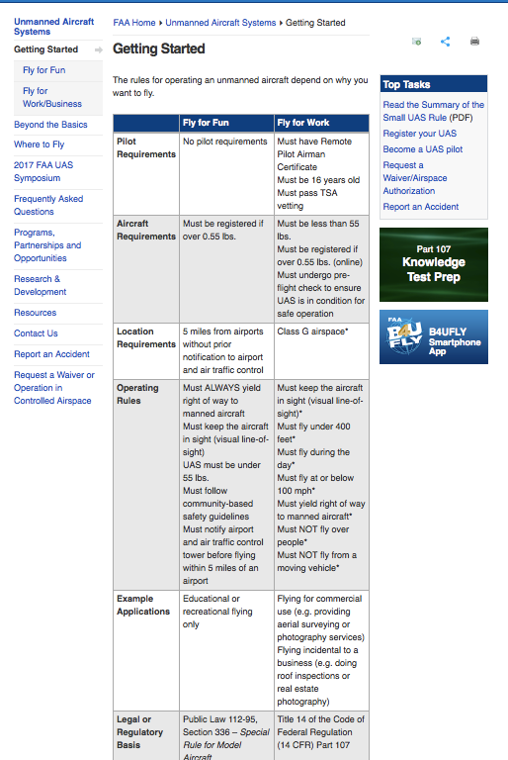

[**National Security**](https://www.washingtonpost.com/world/national-security)

**FAA records detail hundreds of close calls between airplanes and drones**

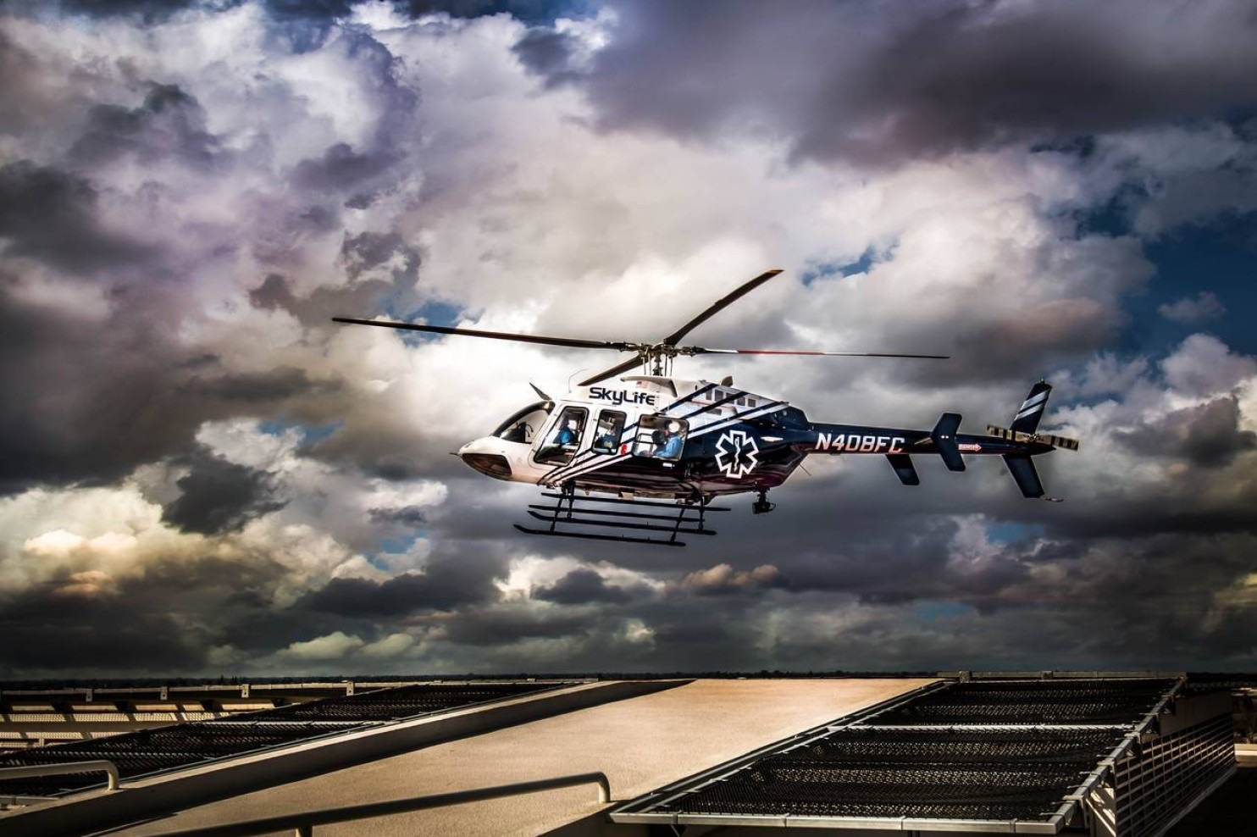

An undated photo of the SkyLife Air Ambulance helicopter that was involved in a near collision with a drone. (Brett Schoenwald/ SkyLife Air Ambulance)

**By** [**Craig Whitlock**](https://www.washingtonpost.com/people/craig-whitlock/) August 20, 2015

On Sunday, a swarm of small rogue drones disrupted air traffic across the country on a scale previously unseen in U.S. skies.

At 8:51 a.m., a white drone startled the pilot of a JetBlue flight, appearing off the aircraft’s left wing moments before the jet landed at Los Angeles International Airport. Five hours later, a quadcopter drone whizzed beneath an Allegiant Air flight as it approached the same runway. Elsewhere in California, pilots of light aircraft reported narrowly dodging drones in San Jose and La Verne.

In Washington, a Cessna pilot reported a drone cruising at 1,500 feet in highly restricted airspace over the nation’s capital, forcing the U.S. military to scramble fighter jets as a precaution.

In Louisville, a silver and white drone almost collided with a training aircraft. In Chicago, United Airlines Flight 970 reported seeing a drone pass by at an altitude of 3,500 feet.

All told, 12 episodes — including other incidents in New Mexico, Texas, Illinois, Florida and North Carolina — were recorded Sunday of small drones interfering with airplanes or coming too close to airports, according to previously undisclosed reports filed with the Federal Aviation Administration.

Before last year, close encounters with rogue drones were unheard of. But as a result of a sales boom, small, largely unregulated remote-control aircraft are clogging U.S. airspace, snarling air traffic and giving the FAA fits.

**More than 70 close calls with small drones since Aug. 1**

Locations are diagrammatic

Drones are

Therefore I propose that commercially available drones

1.
2.