Hunter Howe

**Hemp Pollen Exclusion Analysis**

**Overall Seed vs. Flower Weight**

1. **Pollen Exclusion**:
   * Provides detailed information on various cultivars, including total dry biomass, stalk weight, seed weight, flower weight, and conditions like control or thinning. Additional observations like aphids are also noted.

Fig 1. Seed weight vs. Flower Weight (Pollen Exclusion)

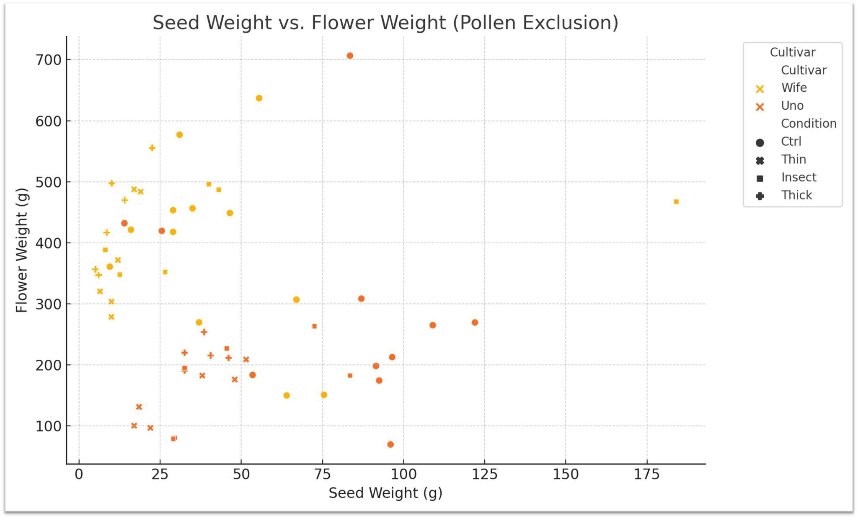

1. **Hail Damage Field**:
   * Similar to the Pollen Exclusion sheet but with additional information related to hail damage and injury events. It includes data on total dry biomass, seed weight, flower weight, conditions, and cultivar types.

Fig 2. Seed Weight vs. Flower Weight (Hail Damage)

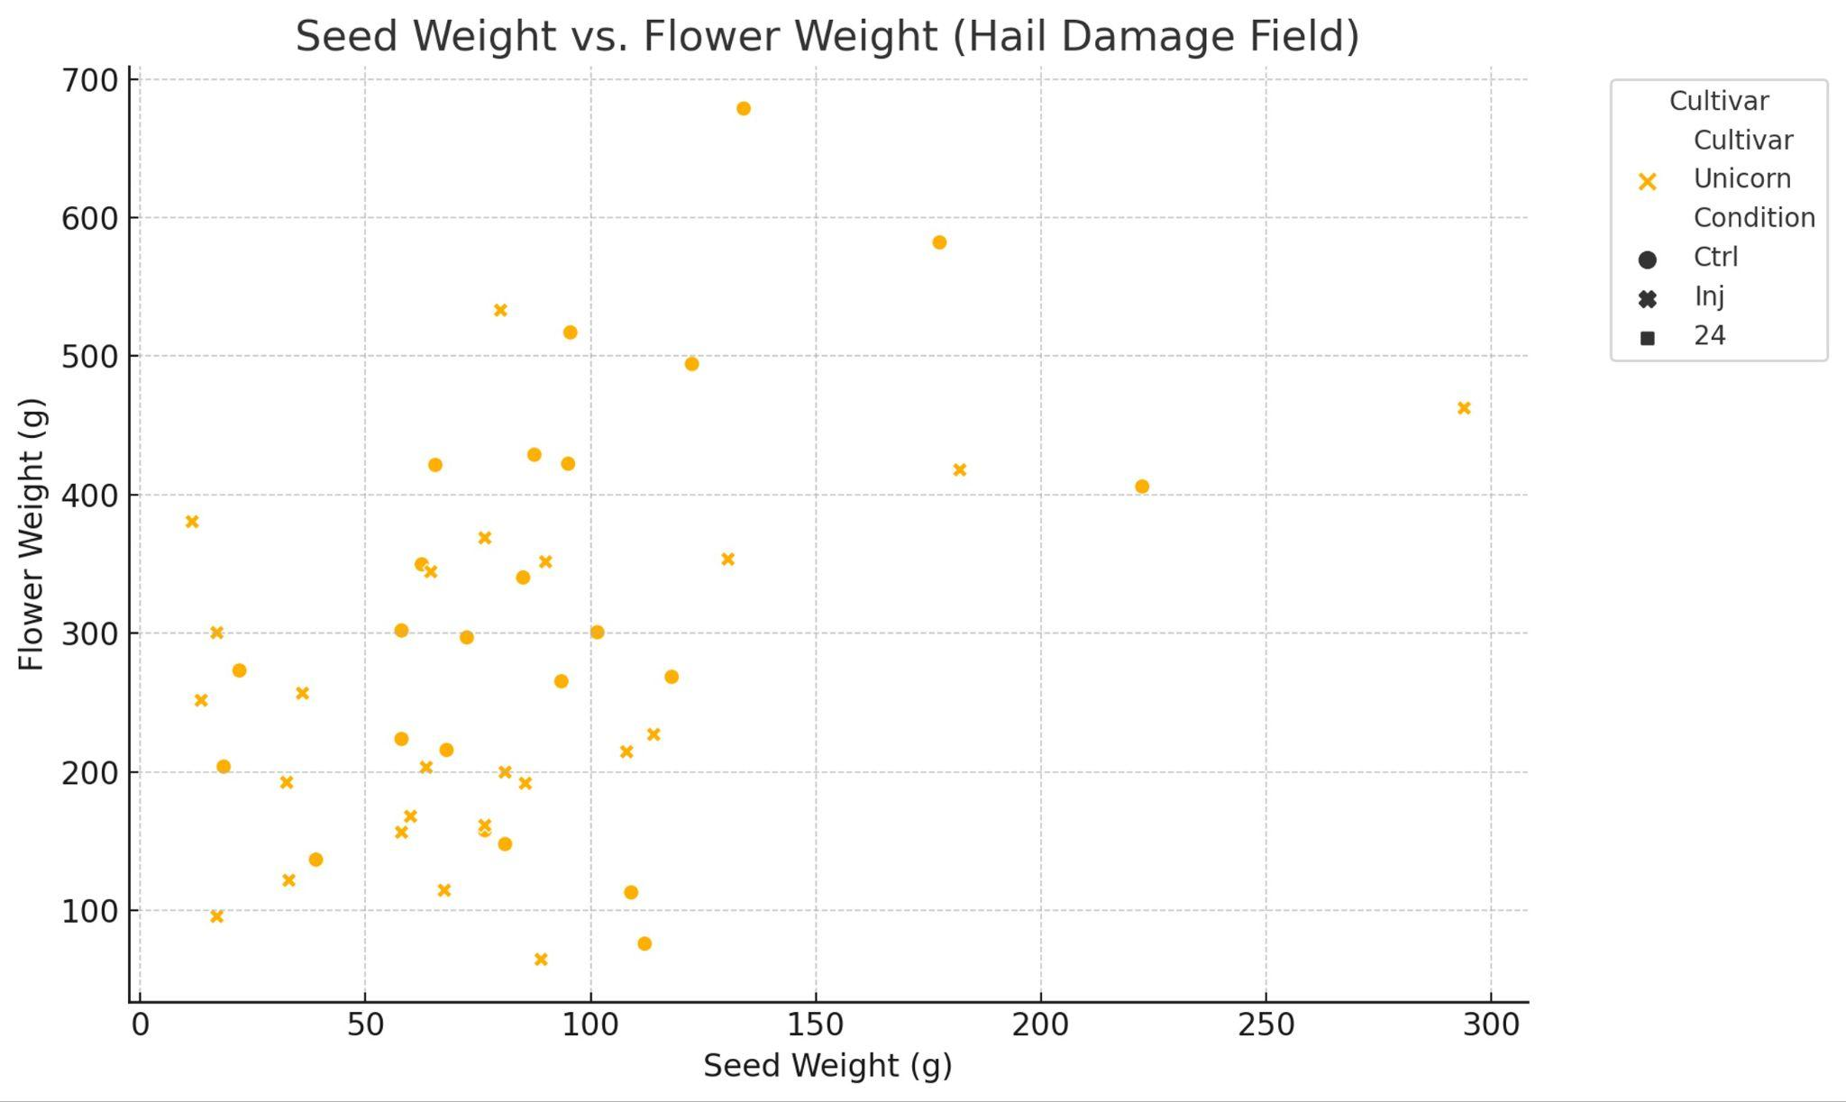

To proceed with visualizations and correlation analysis, we should focus on the relevant columns for the pollination effects, seed weight, flower weight, and cultivar information. Let's start by visualizing the relationships between seed weight and flower weight for different cultivars in the "Pollen Exclusion" and "Hail Damage Field" sheets. Then, we'll perform correlation analysis to find significant correlations. ​​

1. **Pollen Exclusion Sheet**:
   * The plot illustrates the relationship between seed weight and flower weight across different cultivars and conditions (e.g., control, thin).
   * Each point represents a sample, and different colors indicate different cultivars.
2. **Hail Damage Field Sheet**:
   * This plot also shows the relationship between seed weight and flower weight, factoring in the condition of hail damage.
   * Different colors represent different cultivars, and styles indicate the conditions (e.g., control, injured).

Next, let's perform a correlation analysis to determine the statistical relationships between these variables. We will calculate the correlation coefficients for seed weight, flower weight, and other relevant metrics. ​​

Here are the correlation matrices for the relevant variables in the **Pollen Exclusion** and **Hail Damage Field** sheets:

### **Pollen Exclusion Correlations:**

* **Total dry biomass (g) and Flower weight (g)**: Strong positive correlation (0.930.930.93), indicating that as total dry biomass increases, flower weight tends to increase as well.
* **Total dry biomass (g) and Stalk weight (g)**: Positive correlation (0.860.860.86).
* **Seed weight (g) and Flower weight (g)**: Very weak correlation (0.060.060.06), suggesting minimal linear relationship in this context.

### **Hail Damage Field Correlations:**

* **Total dry biomass (g) and Flower weight (g)**: Strong positive correlation (0.950.950.95).
* **Total dry biomass (g) and Seed weight (g)**: Moderate positive correlation (0.740.740.74).
* **Seed weight (g) and Flower weight (g)**: Moderate positive correlation (0.560.560.56).

These correlations suggest that flower weight is strongly associated with the total dry biomass in both datasets, and seed weight shows a stronger relationship with flower weight in the Hail Damage Field data compared to the Pollen Exclusion data.

**Yield Metrics**

The bar charts provide a visual comparison of the average yield metrics for each cultivar in both datasets:

### **Pollen Exclusion Cultivars:**

* **Uno**:
  + Shows a balanced distribution between seed weight and flower weight, with flower weight slightly higher.
  + Total dry biomass is relatively low compared to the **Wife** cultivar.
* **Wife**:
  + Has a significantly higher average flower weight and total dry biomass compared to **Uno**.
  + Seed weight is lower than that of **Uno**, indicating a different focus on yield characteristics.

Fig 3. Average Yield Metrics by Cultivar (Pollen Exclusion)

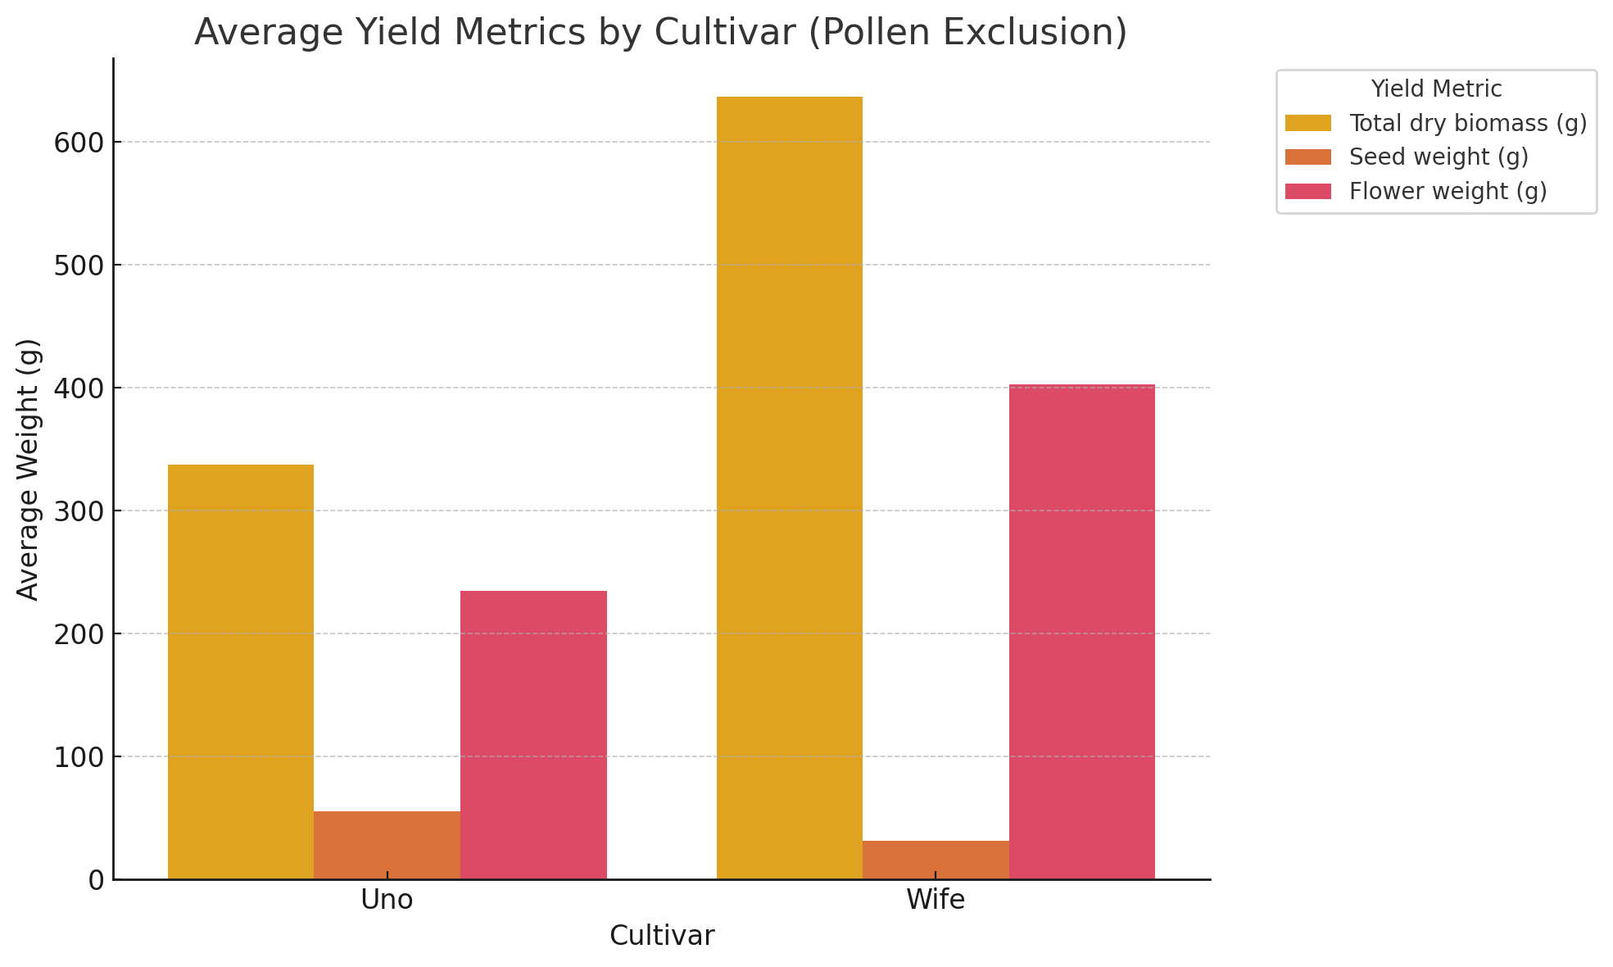

### **Hail Damage Field Cultivar:**

* **Unicorn**:
  + Displays a moderate balance between seed weight and flower weight.
  + Total dry biomass is in between the values seen for **Uno** and **Wife** in the Pollen Exclusion dataset.

Fig 4. Average Yield Metrics (HD)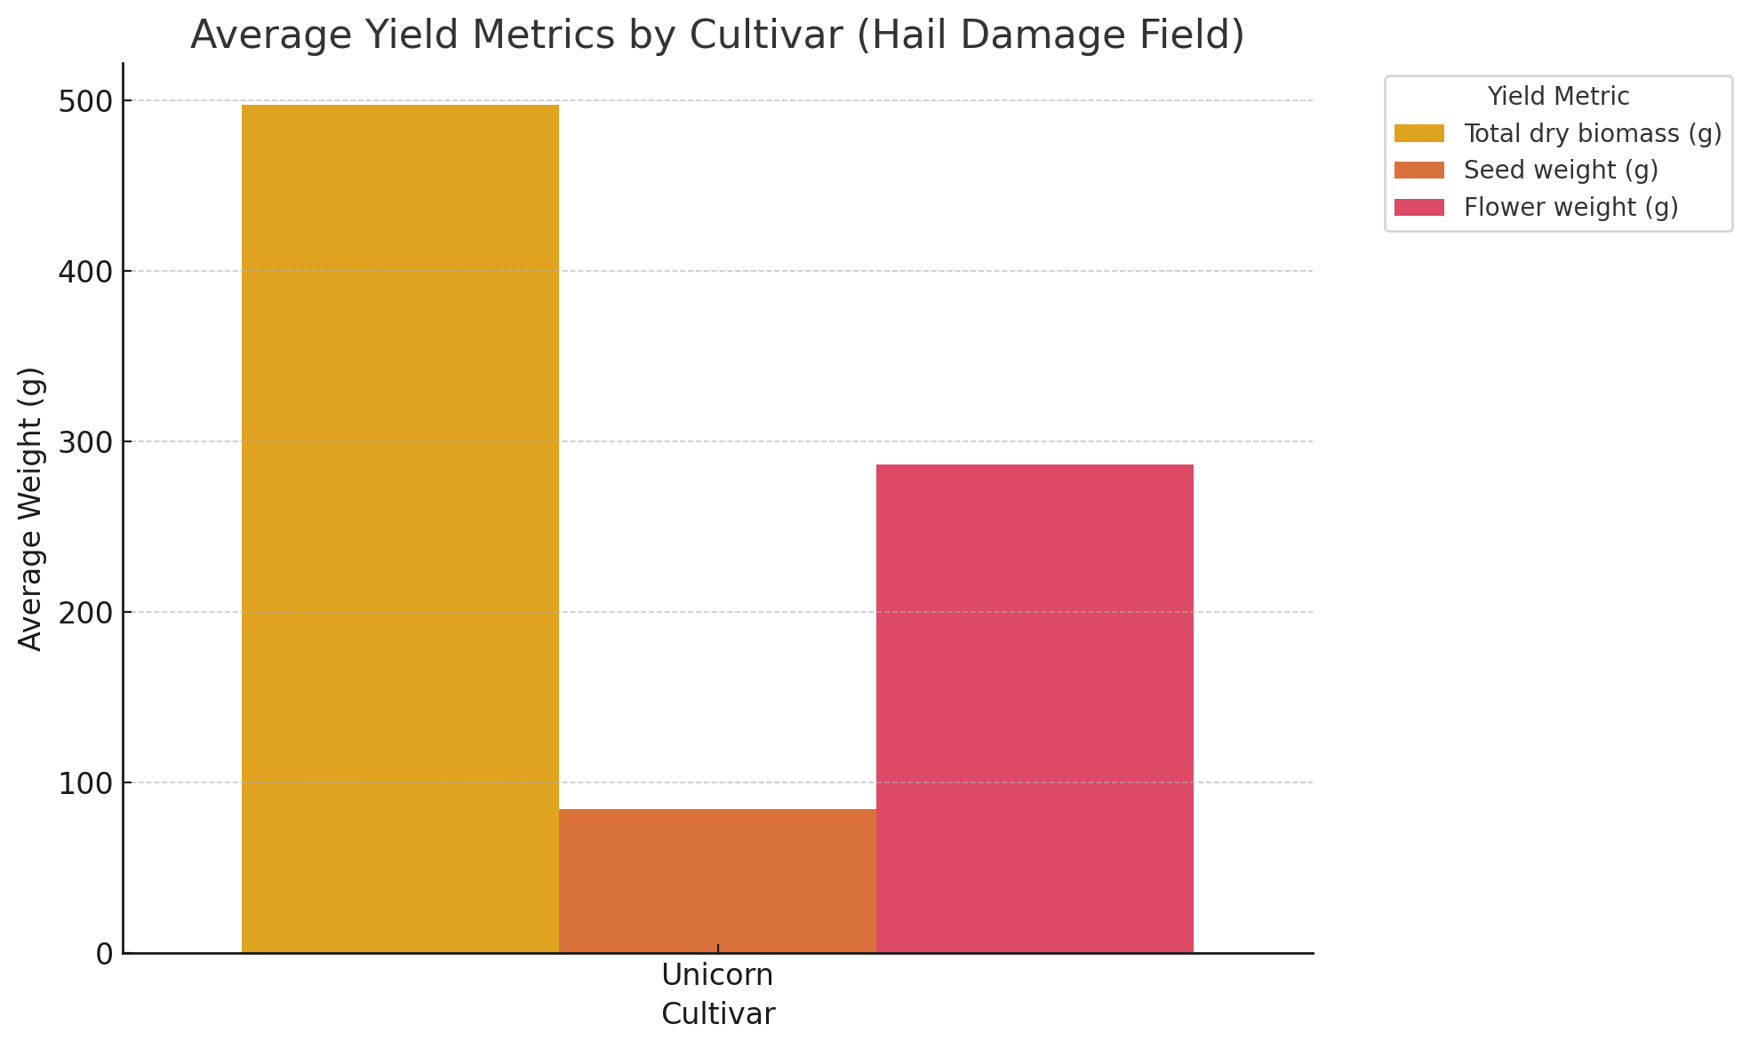

Fig 6. Seed Weight vs. Condition (Hail Damage)

### **Key Insights:**

* **Wife** cultivar excels in flower production, which may be beneficial for biomass-focused goals.
* **Uno** provides a higher seed weight yield relative to its flower weight, potentially advantageous for seed-focused cultivation.
* **Unicorn** offers a balanced yield, potentially resilient under varied conditions, including hail damage.

**Seed & Flower Weight vs. Condition**

### **Pollen Exclusion Dataset:**

* **Flower Weight**:
  + **Wife** cultivar shows higher flower weight under control conditions compared to thin conditions.
  + **Uno** cultivar maintains a consistent flower weight across control and thin conditions, though generally lower than **Wife**.
* **Seed Weight**:
  + **Uno** cultivar has a higher seed weight under control conditions compared to thin conditions.
  + **Wife** cultivar displays lower seed weight across both conditions, with a slight decrease in thin conditions.

Fig 5. Seed Weight vs. Condition (Pollen Exclusion)

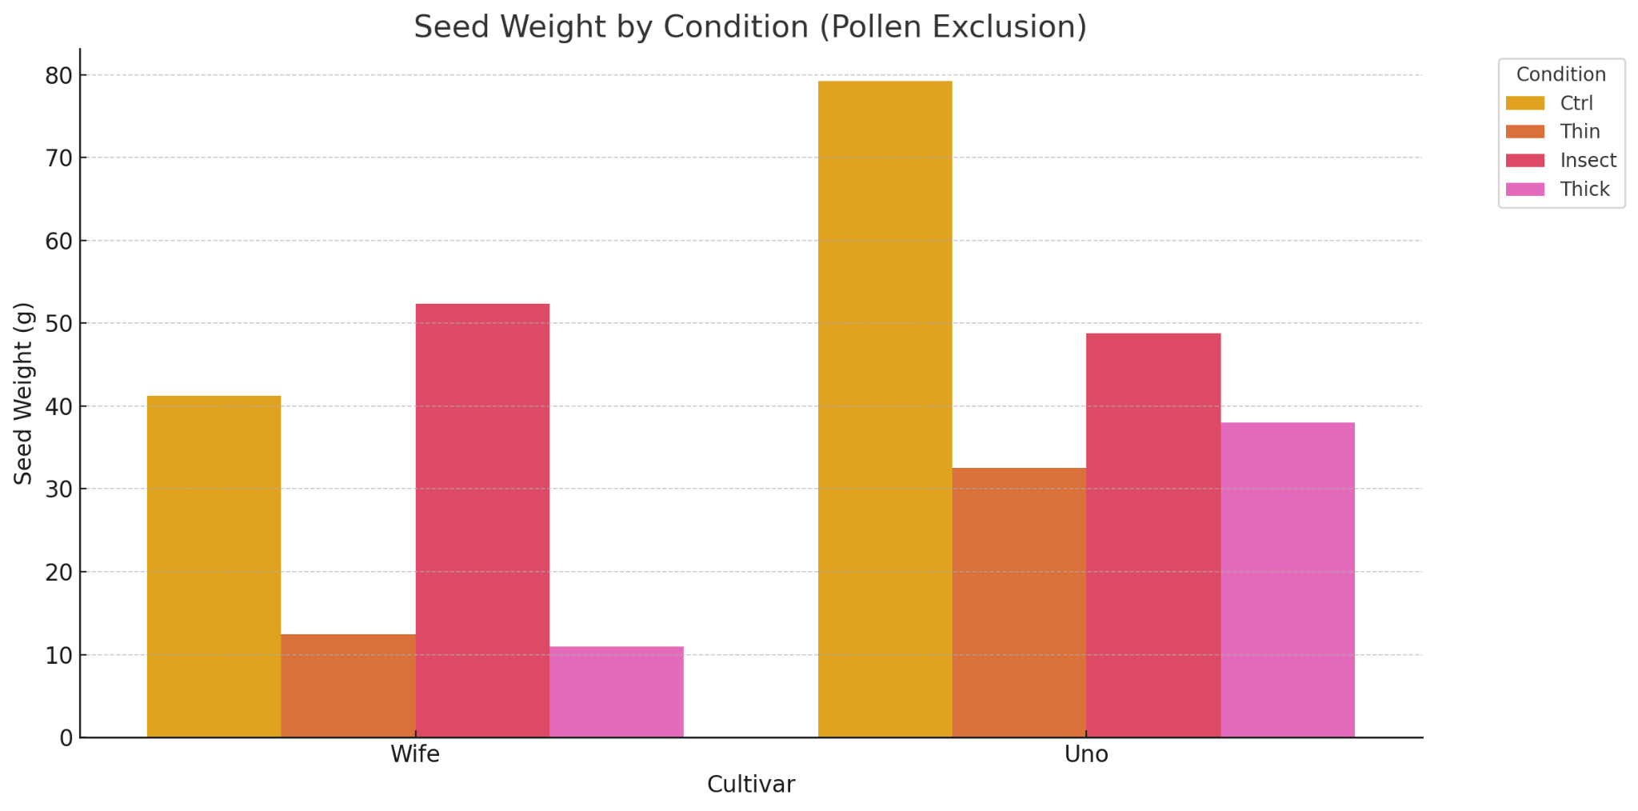

Fig 6. Flower Weight by Condition (Pollen Exclusion)

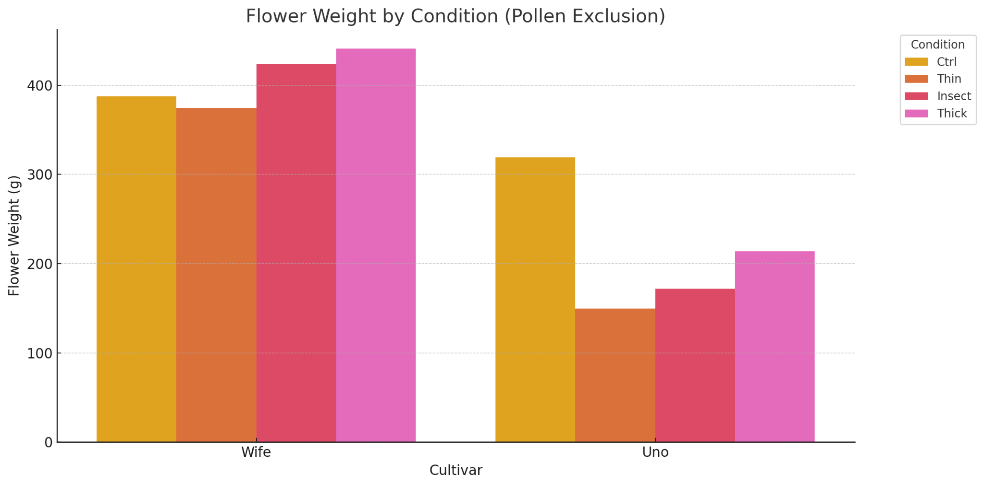

### **Hail Damage Field Dataset:**

* **Flower Weight**:
  + **Unicorn** cultivar shows a reduction in flower weight when injured compared to control conditions, indicating sensitivity to hail damage.
* **Seed Weight**:
  + **Unicorn** cultivar maintains a consistent seed weight across injury and control conditions, suggesting some resilience in seed production despite hail damage.

Fig 7. Seed Weight by Condition (Hail Damage)

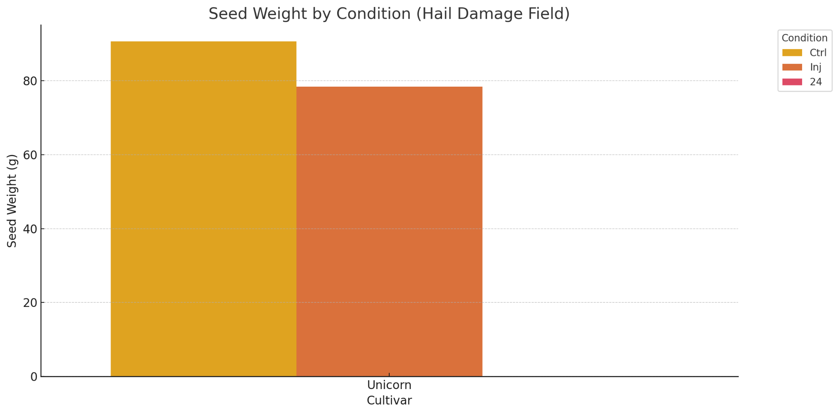

Fig 8. Flower Weight by Condition (Hail Damage)

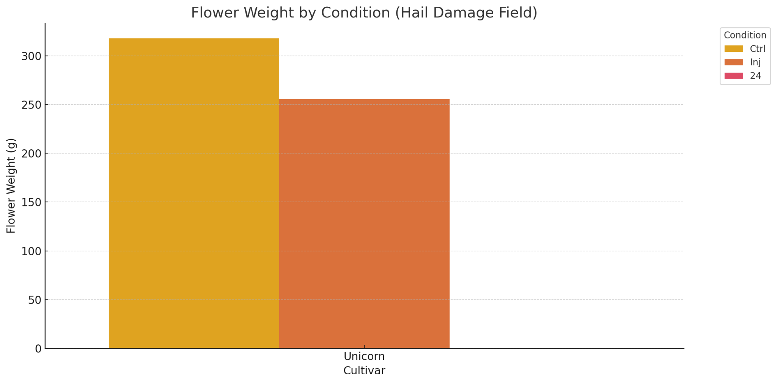

### 

### **Insights:**

* **Wife** cultivar thrives in terms of flower production under control conditions, suggesting it is better suited for conditions where pollination is not restricted.
* **Uno** cultivar benefits in seed production under controlled pollination, indicating potential for seed-focused cultivation strategies.
* **Unicorn** cultivar's resilience in seed production under hail damage might make it a reliable choice in less predictable environmental conditions.

**Findings & Conclusion**

### **Impact of Thick Insect Netting on Flower Weight**

* **Overview**: The data suggests that using thick insect netting positively impacts flower weight production across various cultivars, providing a controlled environment that mitigates the impact of external stressors, such as insects and potentially adverse weather conditions.
* **Cultivar Performance**:
  + **Wife Cultivar**:
    - Demonstrates a significant increase in flower weight under conditions with thick insect netting.
    - The controlled environment likely contributes to maximizing flower production by reducing stress and allowing optimal growth conditions.
  + **Uno Cultivar**:
    - Although generally lower in flower weight compared to **Wife**, the use of insect netting shows improvements in flower production.
    - This suggests that the netting helps stabilize the growing conditions, providing a more consistent yield.
  + **Unicorn Cultivar**:
    - While primarily noted for its resilience in seed production, the **Unicorn** cultivar also benefits from the netting, maintaining higher flower weights even under hail damage conditions.
* **Comparative Analysis**:
  + Flower weight is generally higher in netted conditions compared to open-field conditions without protection.
  + The reduction in insect interference and potentially harsh environmental conditions due to the netting results in healthier plant growth and increased flower yields.
  + The controlled environment facilitates a focus on resource allocation toward flower growth, resulting in improved yields.
* **Condition Impact**:
  + Netting provides a barrier against pests and insects, reducing the need for chemical pest control and minimizing plant stress.
  + Protects against unpredictable weather events, ensuring that the plants are less affected by external environmental changes.
  + Promotes a stable microenvironment conducive to optimal flowering.

### 

### **Conclusion**

The use of thick insect netting appears to be a highly effective method for increasing flower weight production in cannabis cultivars. By providing a protected and controlled environment, the netting allows plants to thrive and maximize their flower yields. This approach is particularly beneficial for cultivars like **Wife**, which exhibit substantial gains in flower weight when grown under netting. These findings support the adoption of insect netting as a practical cultivation strategy to enhance flower production while reducing the reliance on chemical interventions.