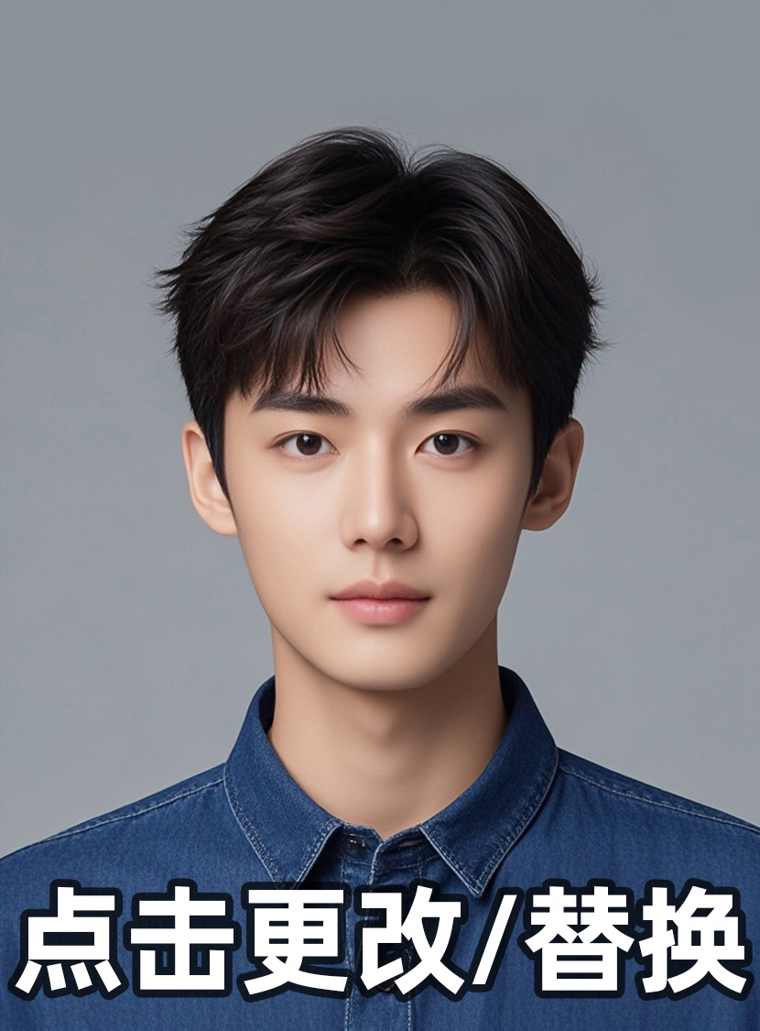
Joe Tang
No.67,Lane 123,Job Rd.Job District
Shanghai 20xx70
(+86) 138-xxxx-8000
xx@xxxx.com
Objective | Summer internship in Chemical Engineering

Education | University of Job,Shanghai

B.S. Chemical Engineering, Chemistry Minor, May 20xx, Junior Standing

Relevant | Chemical Process Analysis | Environmental Biotechnology

Course | Thermodynamics | Chemical Kinetics & Reaction Engineering

 | Process Fluid Mechanics | Heat and Mass Transfer

 | Process Control | Separation Processes

 | Technical Communication | Air Pollutant Emissions and Control

Skills | Lab equipment: | Atomic Absorption Spectroscopy, Gas Chromatography,

Supercritical Fluid Extraction, and Ion Chromatography

 | Computer: | MS-DOS/Windows and Macintosh applications including Microsoft

Ofﬁce,WordPerfect, Cricket Graph, Kaleidagraph, and Mathcad; FORTRAN programming

 | Others: | Strong analytical and problem-solving techniques, excellent

communication skills,and ability to work successfully both in groups and independently

Related | University of Job, Shanghai, Environment, Health and Safety (EH&S)

Experience | Strawberry Creek Management Intern | Jan. 20xx - present

 | • | Assess water pollution sources in Strawberry Creek Watershed using physical parameter andsurface water chemistry measurements

 | • | Develop a water quality monitoring plan, applying environmental regulatory compliance and urban creek restoration methodologies

 | • | Prepare a written report documenting assessment

 | • | Attend EH&S project management and implementation meetings

College of Chemistry

 | Instrument Technician for Environmental Chemistry | Aug. 20xx - present

 | • | Trained to use Perkin-Elmer 3100 atomic absorption spectrometer, Dionex, Basic Ion  Chromatography Module DX-300 series, Perkin-Elmer Autosystem Gas, Chromatograph,and Hewlett-Packard 7680T SFE Module

 | • | Demonstrate and explain instruments to students

 | • | Prepare laboratory demonstrations and chemical standards

College of Chemistry

 | Lab Assistant | Jan. 20xx-Aug. 20xx

 | • | Assisted in development of water quality and led remediation experiments

 | • | Obtained and analyzed water and soil ﬁ eld samples

 | • | Performed contamination-free analytical chemistry and prepared standards

 | • | Performed extensive library research

Additional | Fatapple’s Restaurant and Bakery, Shanghai

Experience | Waitress, Host/Busser, Cashier, Sept. 20xx - present

