Khut'bah Opening
إِنَّ الْحَمْدَ للهِ , نَحْمَدَهُ وَ نَسْتَعينُهُ وَ نَسْتَغْفِرُهُ , وَ نَعوذُ بِالله مِنْ شُرورِ أَنْفُسِنا , مَن يَهْدِهِ اللهُ فَلا مُضِلَّ لَه , وَ مَنْ يُضِلِلْ فَلا هادِيَ لَهْ , وَ أَشْهَدُ أَنْ لا إلهَ إِللهُ وَحْدَهُ لا شَريكَ لَه , و أَشْهَدُ أنَّ مُحَمَّدًا عَبْدُهُ و رَسولُه.
"All thanks and praises are due to Allah, whom we thank, seek for help and invoke for forgiveness. We seek refuge with Allah from the evils within ourselves. He whom Allah guides will never be misled and he whom He misguides will never find one to guide him. I bear witness that there is no deity worthy of worship except Allah and that Muhammad (SAW) is His slave and Messenger.
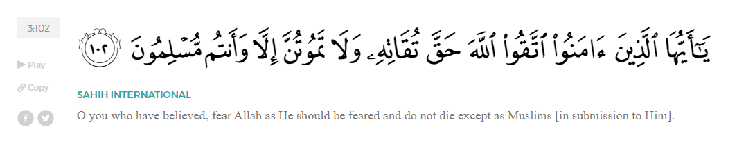
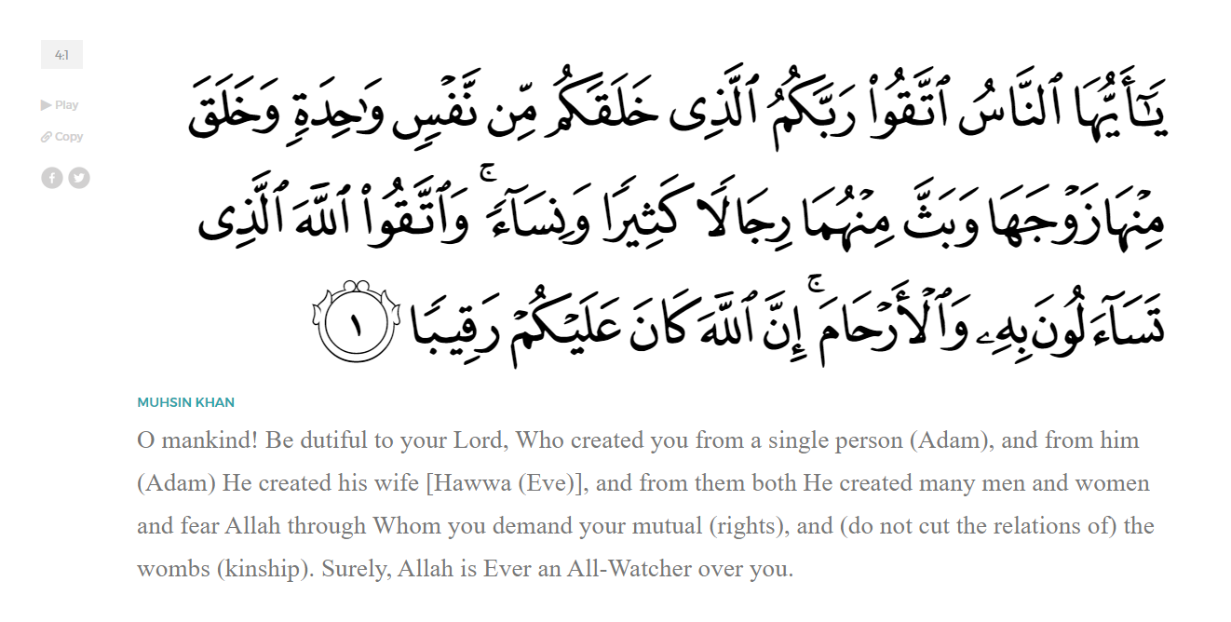
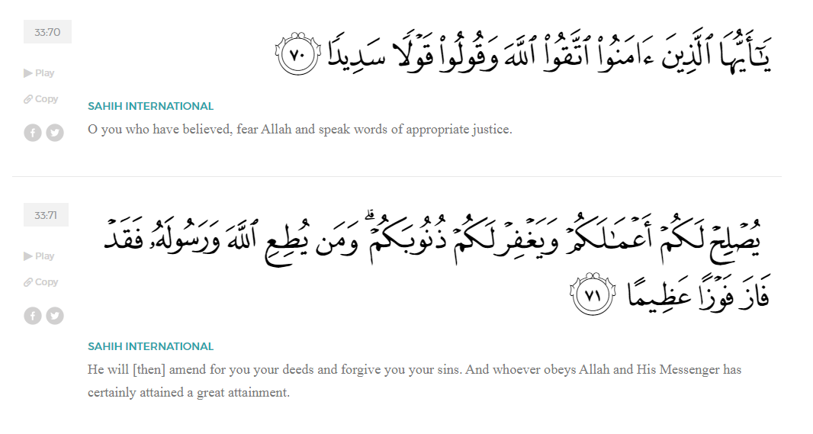
<Sirah of the Prophet (SAW) – Part 1 -Dr. Yassir Qadhi, Book and Series>
Do we really love the Messenger of Allah ﷺ as we should? Many of us say that we love him, but how can our love be sincere and strong if we do not truly know him ﷺ? How can we build a real connection with the Prophet ﷺ if our knowledge of his life, his struggles, and his character is only surface level? Real love requires familiarity and understanding, and without that, our claims of love remain incomplete. To cultivate this love of our messenger ﷺ, we will, inshaaAllah, begin a khutbah series on the seerah of the Prophet ﷺ, drawing from Dr. Yasir Qadhi’s book, The Sirah of the Prophet, so that we can deepen our understanding of his life and strengthen our love for him.
We begin with the chapter an introduction “About the Prophet” ﷺ:
To truly delve into the life of our noble Prophet ﷺ , it is appropriate to first outline and discuss his unique characteristics, knows as the shamaa’il. Learning about the characteristics of the Prophet ﷺ provides motivation and builds desire to learn more about him; his teachings and morals, the incidents that occurred in his life, and the lessons therein.
It is impossible to do justice in describing the Prophet ﷺ as Allah (SWT) Himself said:

“And We raised your remembrance” (94:4)
Allah indeed raised up his remembrance such that whenever Allah (SWT) is mentioned, the Prophet ﷺ is mentioned immediately after. This is evidenced in the shahadah, the adhaan, the prayer, and the Qur’aan itself. Allah (SWT) Himself describes the Prophet ﷺ in Surat Anbiyaa:
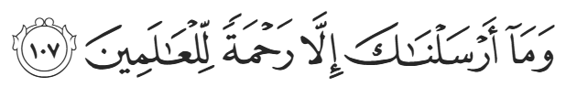
“We have sent you ˹O Prophet˺ only as a mercy for the whole world.” (21:107)
Allah (SWT) describes the Prophet ﷺ as a “mercy to all people”. The Prophet ﷺ is the embodiment of mercy, he is the channel of Allah’s mercy, his sending is mercy, his Message is mercy, his teachings are mercy, believing in him is mercy, and implementing what he teaches is mercy. He is unequivocally everything associated with the word mercy. We therefore inevitably falter in our attempts to describe the noble Messenger ﷺ when Allah (SWT) praised him so highly.
The Prophet ﷺ had many names, some given to him by Allah (SWT), and some by his Companions. The Prophet ﷺ said, “I have a number of names: I am Muhammad, I am Ahmad; I am al-Maahi – the one by whom Allah erases disbelief; I am Al-Haashir – the one after whom people will be resurrected; I am al-Aaqib – the one after whom there will be no Prophet; I am the Prophet of Mercy; I am the Prophet of Repentance; I am Al-Muqaffa – the one whom completes a long chain of Prophets; and I am the Prophet of Malaahim (Trials)”.
The name “Al-Maahi” is derived from the word mahaa which means “to wipe out”. Al-Maahi therefore means “The Eraser [of Disbelief]”, and it is evidenced by the Prophet’s impact on reducing disbelief in such a short frame of time. The name “Al-Haashir” refers to the Prophet’s existence signaling the Day of Judgement. Indeed, the Prophet’s coming is the first sign of the coming of the Day of Reckoning. The name “Al-Aaqib” is the Prophet’s confirmation as the Final Messenger. The title “Prophet of Repentance” describes the Prophet ﷺ as being the source of repentance and the one whose teachings will result in people’s repentance. The name “Al-Muqaffa” describes the Prophet ﷺ sufficing the world of any other prophet. The statement, “I am the Prophet of Malaahim (trials)” is a warning for both believers as well as disbelievers who oppose him.
The above list of names given to the Prophet ﷺ are descriptive in nature, functioning more as adjectives. The only two proper nouns by which Allah (SWT) names the prophet ﷺ are: Muhammad and Ahmad. The name “Muhammad” is mentioned in the Qur’aan four times, and the name “Ahmad” is mentioned once, which was via the tongue of Isa (Alayhiassalaam), as related by Allah from Surat (Saaf):
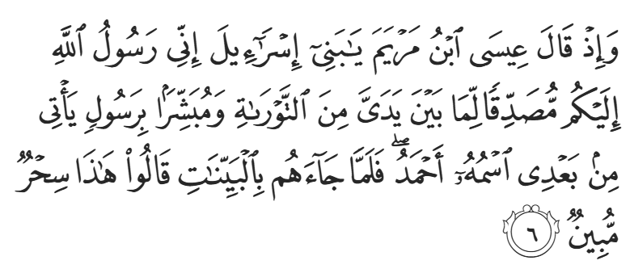
“And [mention] when Jesus, the son of Mary, said, "O Children of Israel, indeed I am the messenger of Allāh to you confirming what came before me of the Torah and bringing good tidings of a messenger to come after me, whose name is Aḥmad." But when he came to them with clear evidences, they said, "This is obvious magic."” (61:6)
Both “Ahmad” and “Muhammad” are derived from the root word hamd. The closest English equivalent to the word hamd is “praise”.
There is, however, a distinction to be made between hamd and “praise”. Hamd is more accurately defined as a combination of “thanks” (shukhr) and “praise” (madh). Being thankful to someone does not necessitate praise, and vice versa. For example, if somebody lends you money, you thank them, but may not necessarily praise them. Likewise, you may praise a talented athlete, but you are not thanking them per se. Hamd is given to an entity, irrespective of what has been done to you. When we say “Alhamdulillah”, it is because Allah is inherently worthy of being praised; even if we do not exist, He (SWT) would still be worthy of praise.
Both of his names ﷺ revolve around the word “praise” because Allah has praised him, the Angels have praised him, the Prophets have All praised him, and everyone on Earth has praised him. The Prophet ﷺ is praised in the Heavens and on the Earth; he was praised by previous nations and our current ummah; and he is praised in this life as well as the Hereafter. No human will exist who has been, is being, or will ever be praised more than our Prophet ﷺ. A single second does not pass without hundreds of millions of tongues and hearts praising him ﷺ. At any moment throughout the 24 hours of a day, people around the globe are praying to Allah (SWT) and are thus praising the Prophet ﷺ and sending peace and salutations upon him. This is in addition to the millions of believers voluntarily sending peace and blessings upon him and giving lectures and reminders about him ﷺ.
<Conclude 1st Khutbah with:
Aqoolu haathaa wa astaghfir-Allaah (I say this and I ask Allah for forgiveness)
أَقُولُ قَوْلِي هَذَا وَأَسْتَغْفِرُ اللَّهَ لِي وَلَكُمْ وَلِسَائِرِ المُسْلِمينَ وَالمُسْلِمَاتْ فَاسْتَغْفِرُوهْ إِنَّهُ هُوَ الْغَفُورُ الرَّحِيمُ
الحمد لله رب العالمين والصلاة والسلام على سيد المرسلين وعلى آله وأصحابه أجمعين
<2nd Khutbah>
The Prophet ﷺ’s ultimate praise is given by Allah. As for humanity’s praise, it will culminate on the Day of Judgement. When all of humanity are desperate for Allah (SWT) to begin the Reckoning, they will rush to Adam (AS) and say, “O Adam, you are our father, Allah created you with His Hand and blew the Ruh (soul) into you”. They will then beg him to ask Allah (SWT) on their behalf. Adam (AS) will excuse himself and say “Nafsee, Nafsee”-“Myself myself”, after explaining that he had committed a mistake, referring to eating from the forbidden tree in Paradise, and that he is not worthy for the task. He instead will instruct, “Go to someone else”. The whole of humanity will go to Nuh (AS) and beg him to ask Allah (SWT) to begin the Reckoning. Nuh (AS) will also excuse himself, saying, “I made a mistake which I should not have done. Allah instructed me not to ask anyone to be saved, but I asked Allah to save my son.” He will then say “Nafsee, nafsee”-“Myself, myself, go to someone else.” Humanity will go to Ibraheem (AS) with the same request and Ibraheem (AS) will respond “I told three lies, and so I need to worry about myself. Go to someone else”. Musa (AS) will similarly excuse himself and cite that he killed someone. Humanity Will flee to Isa (AS), who will in turn excuse himself, he will not mention a mistake but still state “I am not worthy”… Eventually, the entirety of mankind will go to Muhammad ﷺ and beg him to intercede on their behalf to Allah (SWT). As humanity’s representative to Allah (SWT), the Prophet ﷺ will respond, “This is my responsibility”. Mankind in its entirety—Muslims and non-Muslims alike—will praise him, and he will thus be raised to Al-Maqaam Al-Mahmood: The Station of Praise.
We will conclude this khutbah about the introduction of the Sirah of the Prophet ﷺ talking about the khasaais – the unique and distinctive traits of the Prophet ﷺ. They include, but are not limited to, the following:
- He is the final Prophet. Allah (SWT) Himself states in Surat Al-Ahzab:
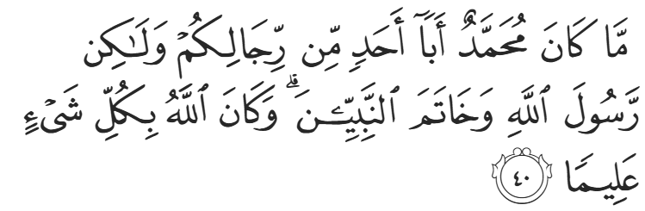
“Muḥammad is not the father of any of your men, but is the Messenger of Allah and the seal of the prophets. And Allah has ˹perfect˺ knowledge of all things.” (33:40)
- The Prophethood of Muhammad ﷺ was decreed before Allah even blew the Ruh into Adam (AS).
- He ﷺ is the only human being upon which Allah (SWT) swore an oath (qasam).
- He ﷺ is the only Prophet sent to the whole of humanity.
- He ﷺ is the only Prophet sent directly to the jinn.
- He ﷺ was granted the largest Ummah of all the Prophets.
- He ﷺ was given the most powerful miracle—the Qur’aan. It is the only scripture that is a miracle in and of itself.
- He ﷺ was the only one raised up to the presence of Allah (SWT) via the Night Journey and Ascension (Al-Israa wa Al-Mi’raaj).
- He ﷺ is the leader and master of all of humanity.
- His grave will be the first to be opened on the Day of Judgement.
- He ﷺ will be the first to be resurrected on the Day of Judgement.
- He ﷺ will be given the largest hawd (pool) in Paradise.
- He ﷺ will be the first to cross over the Siraat (a bridge that every human must pass on the Day of Judgment before entering Jannah, and those who fall will enter Hellfire).
- He ﷺ will be the first to knock on the doors of Jannah.
- His name ﷺ is the only name for whom the gates of Paradise will be opened.
- He ﷺ will be the first to enter Jannah.
- He ﷺ will receive the highest level of Paradise—an entire level in its own right.
<Duaa!>
- Oh Allah, please grant us a deep love for your Prophet Muhammad, SAW.
- Oh Allah, please make us energetic in doing good for your cause.
- Oh Allah, please enable us in will and means to walk Al-Sirrat-Al-Mustaqeem, even if it estranges us from others.
- Oh Allah, please support the suffering and oppressed Muslims around the world and grant them victory over that which oppresses them.
- Oh Allah, please protect us from ever being overburdened by debt and protect us from all evils and undesirable consequences associated to having debt.
- Oh Allah, please fill our hands with the work and deeds of righteousness and let them be of benefit to ourselves and the Ummah.
- Oh Allah please forgive us our shortcomings and deviances in following your Qur'an and the Sunnah of Rasul'Allah, SallAllahuAlayhiWaSallam.
- Oh Allah please grant us understanding and guidance of your Qur'aan
- Oh Allah, please grant us patience with the trials of this world.
- Oh Allah, please prevent our hearts from getting overly attached to the Dunya and grant us the best in this life and the best in the hereafter.
- Oh Allah, please forgive us our past sins and make us your devoted servants.
- Oh Allah please make us amongst those whose Duaa is accepted.
- Oh Allah, please grant us Jannat'ul Firdaus and protect us from ever coming close to the Fires of Jahannum.

