Khut'bah Opening
إِنَّ الْحَمْدَ للهِ , نَحْمَدَهُ وَ نَسْتَعينُهُ وَ نَسْتَغْفِرُهُ , وَ نَعوذُ بِالله مِنْ شُرورِ أَنْفُسِنا , مَن يَهْدِهِ اللهُ فَلا مُضِلَّ لَه , وَ مَنْ يُضِلِلْ فَلا هادِيَ لَهْ , وَ أَشْهَدُ أَنْ لا إلهَ إِللهُ وَحْدَهُ لا شَريكَ لَه , و أَشْهَدُ أنَّ مُحَمَّدًا عَبْدُهُ و رَسولُه.
"All thanks and praises are due to Allah, whom we thank, seek for help and invoke for forgiveness. We seek refuge with Allah from the evils within ourselves. He whom Allah guides will never be misled and he whom He misguides will never find one to guide him. I bear witness that there is no deity worthy of worship except Allah and that Muhammad (SAW) is His slave and Messenger.
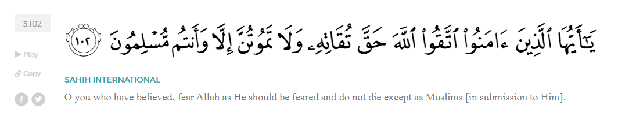
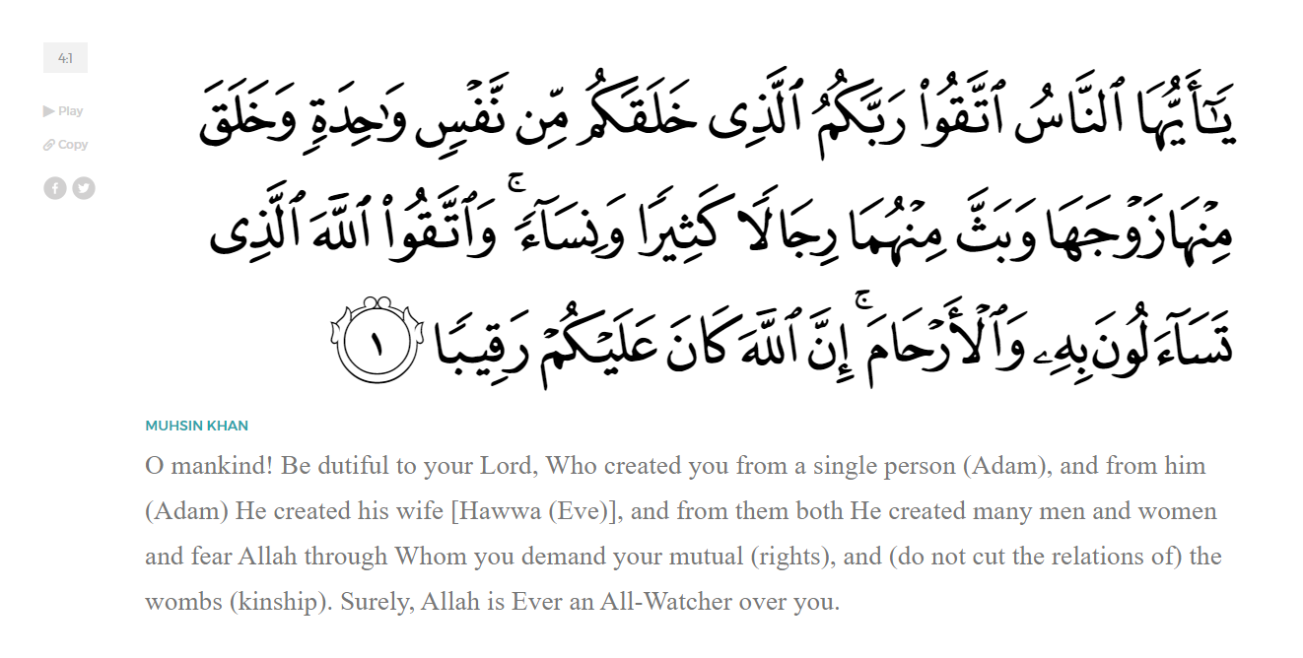
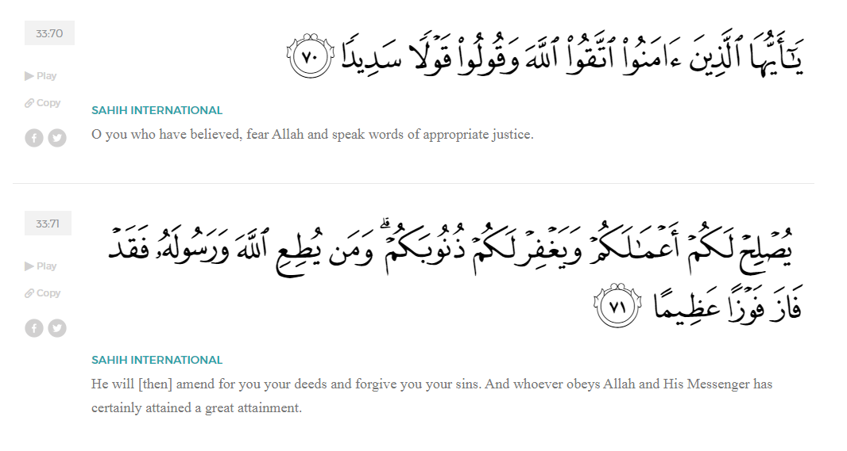
<Sirah of the Prophet (SAW) – Part 10 -Dr. Yassir Qadhi, Book and Series>
Dear brothers and sisters,
InshaaAllah we will continue our khutbah series on the seerah of the Prophet ﷺ, drawing from Dr. Yasir Qadhi’s book, The Sirah of the Prophet, so that we can deepen our understanding of his life and strengthen our love for him. Each step we take through the Prophet ﷺ’s life brings us closer to knowing him more deeply, appreciating his struggles, and embodying his character. Our goal in this series, inshaaAllah, is not just to learn history, but to let the seerah transform our hearts and strengthen our love for the Messenger of Allah ﷺ.
Today we will continue with the chapter on Early Islam where Tensions are Rising in Mecca.
As Islam slowly spread, the Quraysh tried to ban the recitation of the Qur’an. Not only did they try to physically stop any recitation, but they would also drown it out with abuse and profanity. Ibn ‘Abbas (RA) narrated that whenever the Prophet ﷺ would raise his voice to recite the Qur’an in front of the Ka’bah, the Quraysh would curse both Allah (SWT) and the Messenger ﷺ. The Prophet ﷺ would then raise his own voice to overcome their insults and profanity, but Allah (SWT) revealed, in Surat Isra’:
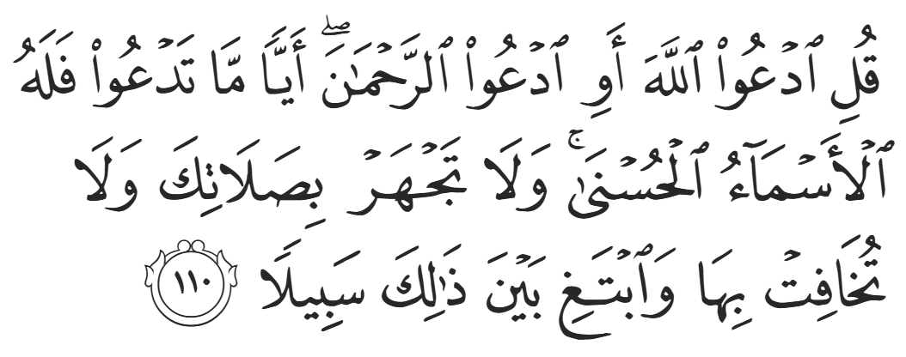
“Say, "Call upon Allāh or call upon the Most Merciful [ar-Raḥmān]. Whichever [name] you call - to Him belong the best names.” Do not recite your prayers too loudly nor silently, but seek a way between.” (17:110)
Allah (SWT) here is instilling the methodology of focusing on one’s own mission without being distracted by the actions of others.
The Companions gathered at Daar al-Arqam. No-one had publicly recited the Qur’an except the Prophet ﷺ, so they discussed who would be the first. ‘Abdullah ibn Mas’ud (RA) volunteered to take on the task. The Companions refused because Ibn Mas’ud had no Qurayshi family to protect him. Tribal custom dictated that tribe members protected each other, thus the bigger and more powerful the tribe, the more protection one had. Not only did Ibn Mas’ud not belong to a tribe, but he was not even from Mecca. He therefore had no-one to protect him in the event of an attack. Nevertheless, Ibn Mas’ud (RA) persisted and again volunteered himself, saying “I put my trust in Allah.”
Ibn Mas’ud went to the Ka’bah at the peak time of gathering. As the qaari’ (the reciter) of the Companions, he had a beautiful voice, and he began reciting in an exquisitely melodious tone. He recited Surah al-Rahmaan, and it was so captivating that people started to gather. Moreover, the style of Qur’anic recitation was a unique phenomenon to the Quraysh; it did not emulate poetry nor prose. It was equally fascinating as it was captivating. When they eventually realized what he was reciting, they pounced on him, physically beating him. He could not even finish two pages of the surah before being driven out, battered and bruised. The Companions bemoaned, “This is exactly what we were worried about!” Ibn Mas’ud boasted, “By Allah, nothing changed today except that my contempt for the Quraysh has only increased, and I am willing to do the same tomorrow.”
Three of the senior leaders of the Quraysh—Abu Jahl, Abu Sufyaan, and Al-Akhnas—were mesmerized by the parts of the Qur’an they had heard. Their reputation did not allow them to listen in public, so they waited until the dead of the night to listen. The Prophet ﷺ would pray tahajjud every night, which was the perfect opportunity. Each of them had set out to listen in secret, not knowing that the other two did the same. When they bumped into each other at Fajr time, they realized what had just happened. Each of them made their own excuse as to why they were there, but the reality was clear to all. The third night, it happened once more, and their embarrassment grew. They admitted what they were doing and made a pact not to come again lest they be exposed by anyone else. For a person to wake up at three-o-clock in the morning, leave their bed and home, and stand in an alleyway in the dead of the night just to listen to a recitation truly demonstrates the mesmerizing nature of the Qur’an. One can only imagine the tranquility, charisma, and exquisiteness of the Prophet’s own recitation ﷺ.
Al-Akhnas then approached Abu Sufyaan and asked, “What do you think about what we heard?” Embarrassed, Abu Sufyan said, “You tell me your opinion first.” After al-Akhnas insisted, Abu Sufyaan, not wanting to compromise his reputation, replied diplomatically, “Some parts were beyond my comprehension and other parts I understood.”
Al-Akhnas then approached Abu Jahl, asking the same question. Abu Jahl responded frankly, “We (i.e. the Banu Makhzuum) and the Banu ‘Abd Manaaf have always been in competition; when they began giving food to the pilgrims, we did too. When they began giving out water, we did too. We are like two horses about to reach the finish line, and they now come and say that they have a Prophet who Allah, inspired from the Heavens. How can we compete with that? By Allah, for as long as I live, I will never accept it.”
Another tactic used by the Quraysh was to ridicule the Prophet ﷺ and the believers, spreading rumors and hurling insults and mockery. For example, when a period of time passed without the Prophet ﷺ receiving Revelation, a Qurayshi woman mocked, “I see that your Shaytaan has abandoned you!”
This remark deeply hurt the Prophet ﷺ, and Allah (SWT) revealed the famous verses of Surah Al-Duha:
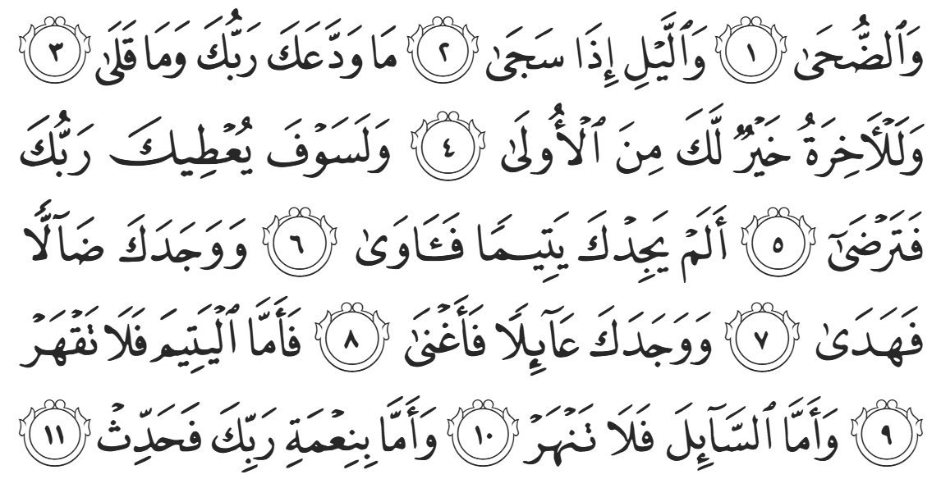
“By the morning sunlight, and the night when it falls still. Your Lord has not abandoned you, nor has He become hateful [of you]. And the next life is certainly far better for you than this one. And surely your Lord will give so much to you that you will be pleased. Did He not find you as an orphan, then shelter you? Did He not find you unguided, then guide you? And did He not find you needy, then suffice you? So do not suppress an orphan, nor repulse the beggar. And proclaim the blessings of your Lord.” (93:1-11)
<Conclude 1st Khutbah with:
Aqoolu haathaa wa astaghfir-Allaah (I say this and I ask Allah for forgiveness)
أَقُولُ قَوْلِي هَذَا وَأَسْتَغْفِرُ اللَّهَ لِي وَلَكُمْ وَلِسَائِرِ المُسْلِمينَ وَالمُسْلِمَاتْ فَاسْتَغْفِرُوهْ إِنَّهُ هُوَ الْغَفُورُ الرَّحِيمُ
الحمد لله رب العالمين والصلاة والسلام على سيد المرسلين وعلى آله وأصحابه أجمعين
<2nd Khutbah>
Dear brothers and sisters, these were indeed difficult times for the believers in Early Islam.
Abu Jahl would especially go out of his way to harm the believers. If they were a slave or mawla – a freed slave that still had allegiance to their old master, Abu Jahl would physically abuse them and instruct their owners to do the same. If they were noblemen of a prestigious clan, he could not physically attack them, but would instead verbally abuse them at any given opportunity. He would play on their notion of honor and tribal sensibilities, asking, “Are you better than your father and grandfather?” He would mention their names to evoke a response. If they were businessmen, he would boycott their business and pressure others to do so too. The Prophet ﷺ described Abu Jahl as “The Pharoah of my Ummah.”
Once, someone sold something to Abu Jahl but did not receive his payment. In a bid to prank the Prophet ﷺ, Abu Jahl remarked mockingly, “go to Muhammad, he will pay you!” The man, who was not from Mecca, assumed that the Prophet ﷺ perhaps owed Abu Jahl, and so went to the Prophet ﷺ and asked for the money. The Prophet ﷺ took him by the hand to Abu Jahl’s house and knocked on his door. He ﷺ said, “O Abu Jahl, give the man his money right now.”
Abu Jahl’s face turned pale and he began trembling. He scrambled to find payment and thrust a bag of money at the man. Later, a friend of Abu Jahl said, “How could you give the man his money after Muhammad demanded it?” Abu Jahl replied, “I saw something terrifying that you did not see.” In another narration, Abu Jahl said, “I saw a herd of angry camels behind him waiting to pounce!”
The Quraysh then stooped to an unprecedented level and began to slander and lie about the Prophet ﷺ and the believers. They would regurgitate the same lies: “He is crazy, he is a fortune teller; he is a magician; he is bewitched.” It is of course impossible for madness to be compartmentalized; one cannot be crazy in one aspect, yet be perfectly sane in every other aspect of their life. The Prophet ﷺ was not only sane in every regard, but he was exceptional in his role as a leader, a family man, and a warrior. The reality is that the Prophet’s sincerity could not be doubted, even by his staunchest enemies, which left madness and sorcery as the only conceivable explanations they could come up with.
Abu Jahl and Abu Lahab would stand on the outskirts of Mecca and warn travelers that the Prophet ﷺ was a magician. They would say, “Oh people, be careful! Do not be mesmerized into turning away from the gods of your forefathers!” These tactics ironically led to some people’s conversion.
Dimaad al-Azdi, the leader of a Yemeni tribe, literally put cotton in his ears until he eventually questioned his actions as an intelligent man. He said to himself, “I am a doctor, so I will cure him.” He approached the Prophet ﷺ, “I heard you are a madman, and I am here to cure you.” The Prophet ﷺ replied, “I am not a madman, but listen to my message.” He ﷺ then began with the Khutbah al-Haajjah, and before the Prophet ﷺ could even start reciting Qur’an, the man said, “Stop! Repeat what you just said.” The Prophet ﷺ repeated the Khutbah al-Haajjah and the man said, “By Allah, I have not heard anything more beautiful than this. What are you?” The Prophet ﷺ declared himself as a Prophet and Dimaad accepted Islam.
Quraysh also called him a poet, even though it was well-known that the Prophet ﷺ could not even read or write. Allah (SWT) revealed in Surat Al-Ankabuut:
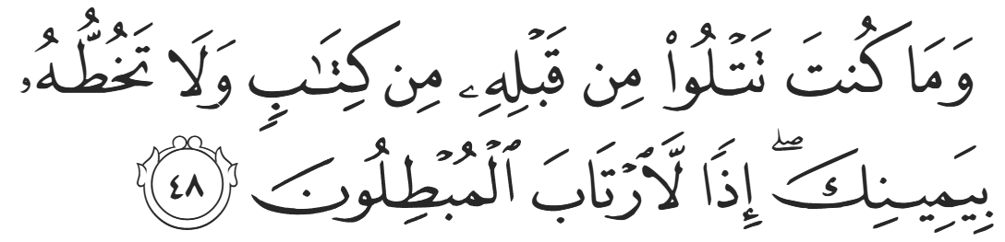
“And you could not recite before it any scripture, nor could you inscribe one with your right hand. Otherwise, the falsifiers would have had [cause for] doubt.” (29:48)
Just as Allah strengthened the Prophet ﷺ and the early believers through hardship, He strengthens our hearts, our homes, and our community through every trial. Their story reminds us that resilience is born from faith, and that every challenge carries within it a hidden mercy. When we walk the path of Islam with sincerity, we find that Allah’s support is closest in the moments we need it the most.

<Duaa!>
- Oh Allah, please grant us a deep love for your Prophet Muhammad, SAW.
- Oh Allah, please make us energetic in doing good for your cause.
- Oh Allah, please enable us in will and means to walk Al-Sirrat-Al-Mustaqeem, even if it estranges us from others.
- Oh Allah, please support the suffering and oppressed Muslims around the world and grant them victory over that which oppresses them.
- Oh Allah, please protect us from ever being overburdened by debt and protect us from all evils and undesirable consequences associated to having debt.
- Oh Allah, please fill our hands with the work and deeds of righteousness and let them be of benefit to ourselves and the Ummah.
- Oh Allah please forgive us our shortcomings and deviances in following your Qur'an and the Sunnah of Rasul'Allah, SallAllahuAlayhiWaSallam.
- Oh Allah please grant us understanding and guidance of your Qur'aan
- Oh Allah, please grant us patience with the trials of this world.
- Oh Allah, please prevent our hearts from getting overly attached to the Dunya and grant us the best in this life and the best in the hereafter.
- Oh Allah, please forgive us our past sins and make us your devoted servants.
- Oh Allah please make us amongst those whose Duaa is accepted.
- Oh Allah, please grant us Jannat'ul Firdaus and protect us from ever coming close to the Fires of Jahannum.

