Khut'bah Opening
إِنَّ الْحَمْدَ للهِ , نَحْمَدَهُ وَ نَسْتَعينُهُ وَ نَسْتَغْفِرُهُ , وَ نَعوذُ بِالله مِنْ شُرورِ أَنْفُسِنا , مَن يَهْدِهِ اللهُ فَلا مُضِلَّ لَه , وَ مَنْ يُضِلِلْ فَلا هادِيَ لَهْ , وَ أَشْهَدُ أَنْ لا إلهَ إِللهُ وَحْدَهُ لا شَريكَ لَه , و أَشْهَدُ أنَّ مُحَمَّدًا عَبْدُهُ و رَسولُه.
"All thanks and praises are due to Allah, whom we thank, seek for help and invoke for forgiveness. We seek refuge with Allah from the evils within ourselves. He whom Allah guides will never be misled and he whom He misguides will never find one to guide him. I bear witness that there is no deity worthy of worship except Allah and that Muhammad (SAW) is His slave and Messenger.
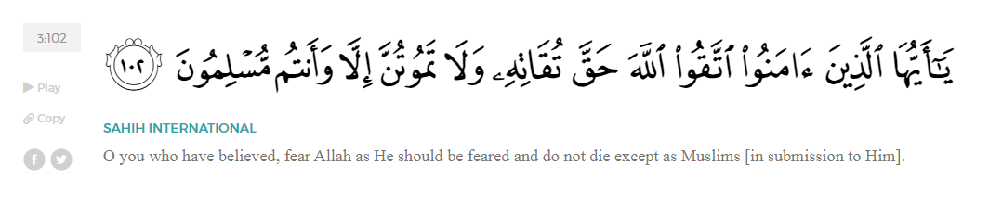
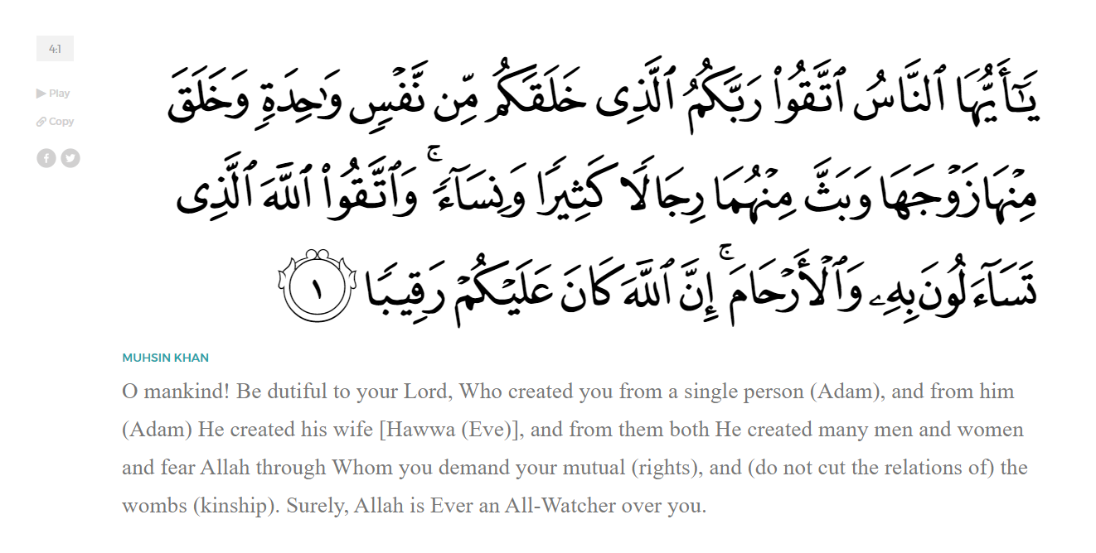
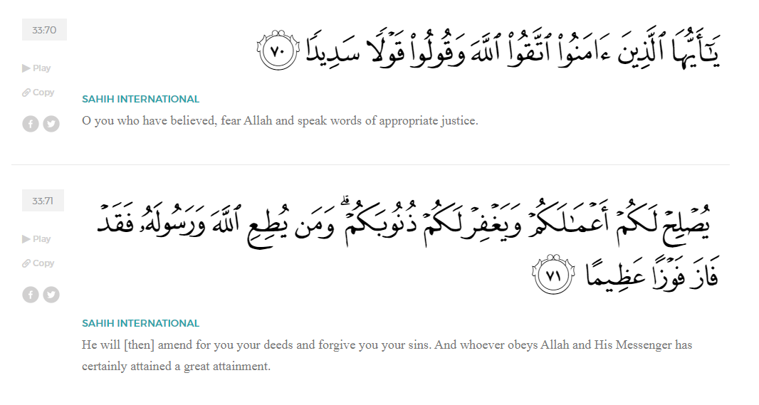
<Sirah of the Prophet (SAW) – Part 11 -Dr. Yassir Qadhi, Book and Series>
Dear brothers and sisters,
InshaaAllah we will continue our khutbah series on the seerah of the Prophet ﷺ, drawing from Dr. Yasir Qadhi’s book, The Sirah of the Prophet, so that we can deepen our understanding of his life and strengthen our love for him. Each step we take through the Prophet ﷺ’s life brings us closer to knowing him more deeply, appreciating his struggles, and embodying his character. Our goal in this series, inshaaAllah, is not just to learn history, but to let the seerah transform our hearts and strengthen our love for the Messenger of Allah ﷺ.
Today we will, inshaaAllah, continue with the Early Islam chapter starting with the section, “The Unlettered Prophet”.
Pre-Islamic Arabia was at the pinnacle of linguistic prowess. The poets of Makkah were masters of the Arabic language, and their reputations preceded them. Society revolved around the use of the language and poetry, from media and politics to entertainment and leisure. The most eloquent poets were the most influential and respected figures. The greatest poet of them all was al-Walid ibn al-Mugheerah, the Chieftain of the Banu Makhzuum and father of Khaalid ibn al-Waleed (RA).
On one occasion, the Prophet ﷺ was reciting the Qur’aan in front of the Ka’bah and al-Walid ibn al-Mughirah finally had a chance to listen properly. He was mesmerized and stopped in his tracks until the Prophet ﷺ finished. Al-Walid muttered a statement of prose which then spread like wildfire throughout Makkah, he said:
“By Allah, there is no-one amongst you more knowledgeable in poetry than me, neither the metre of rajaz, nor the form of qaseedah, or the poetry of the Jinn. By Allah, what he is saying does not resemble any of these, and by Allah, the speech he utters has a certain sweetness and charm. The upper part is fruitful, and the lower part is well-watered and abundant. It supersedes and nothing supersedes it, and it crushes whatever is beneath it.”
The people of Makkah began to panic. The greatest poet of Makkah – as a Pagan – admitted defat after hearing a single recitation of Qur’an. When the news reached Abu Jahl, he sought to rectify the situation. He said to al-Walid, “Your people have heard that you have praised the Qur’aan, and they will not be satisfied with you until you disassociate with Muhammad and speak out against the Qur’aan.”
Unlike Abu Taalib, who was the embodiment of integrity and leadership, standing his ground and sticking to his principles, al-Walid was a more typical politician, giving in to external pressure. He replied, “Tell me what to say.” Abu Jahl said, “Call him a madman.” Al-Walid responded, “But everyone knows he is not a madman, and he does not exhibit any symptoms of a crazy person.” Abu Jahl said, “Okay, so call him a fortune teller.” Al-Walid again responded, “But he is not a fortune teller; he doesn’t have their dialect nor their style.” Abu Jahl then said, “Call him a magician.” Once again, Al-Walid said, “But he is not a magician; he does not have their invocations or tricks.” Abu Jahl finally said, “Call him a poet.” Al-Walid responded, “By Allah, I am the best poet amongst you; none of you can compete with me, and I am saying that this is not poetry.” Abu Jahl persisted, demanding, “You must say something, and we will not be satisfied with you until you do.” Al-Walid then asked to be left alone for a few days to think of a solution.
Al-Walid grew increasingly exasperated thinking of a solution until he finally came up with an idea. However, before he even had the chance to vocalize it, Allah (SWT) sent down verses of the Qur’aan articulating—with striking accuracy—his ideas, thoughts, feelings, and even facial expressions. From Surat Al-Muddaththir:
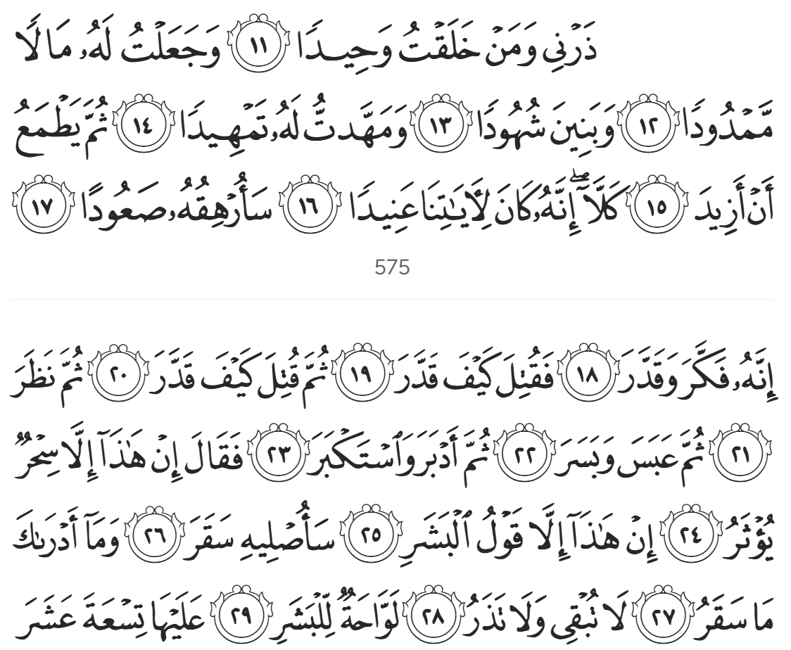
“And leave to me the one I created all by Myself, and granted him abundant wealth and children always by his side, and made life very easy for him. Yet he is hungry for more. But no, he has truly been stubborn with Our Revelations. I will make his fate unbearable, for he contemplated and determined [a degrading label for the Qur’aan]. May he be condemned! How evil was his determination! May he be condemned even more! How evil was his determination! Then he re-contemplated [in frustration], then he frowned and scowled, then turned his back [on the truth] and acted arrogantly, saying ‘This [Qur’aan] is nothing but magic from the ancients. This is no more than the word of man.’ Soon I will burn him in Hell! And what will make you realize what Hell is? It does not let anyone live or die, scorching the skin.” (74:11-29)
It is befitting for Allah (SWT) to send down some of the most powerful verses in the entire Qur’aan in response to al-Walid, who inevitably died a Pagan despite both his children eventually accepting Islaam.
Disbelief is very often fueled not by reason or a genuine refusal of the message of the Qur’aan and Islam, disbelief is often fueled by social pressures – sometimes from family members, social leaders, government leaders, or others all seeking to preserve status, influence, and the comfort of the familiar.
Very few people reject the truth because they believe it to be false; most reject it because accepting it would require humility, change, and the courage to stand apart from their surroundings. Al-Walid knew the Qur’an could not be poetry or sorcery, yet the pressure of his tribe, his reputation, and the fear of losing authority, outweighed the truth he himself recognized and admitted. His story is a timeless reminder that guidance is not merely about evidence—because the evidence was undeniable— guidance is about the willingness of the heart to surrender. And when a heart is chained by pride, no sign, no miracle, and no argument will penetrate it.
<Conclude 1st Khutbah with:
Aqoolu haathaa wa astaghfir-Allaah (I say this and I ask Allah for forgiveness)
أَقُولُ قَوْلِي هَذَا وَأَسْتَغْفِرُ اللَّهَ لِي وَلَكُمْ وَلِسَائِرِ المُسْلِمينَ وَالمُسْلِمَاتْ فَاسْتَغْفِرُوهْ إِنَّهُ هُوَ الْغَفُورُ الرَّحِيمُ
الحمد لله رب العالمين والصلاة والسلام على سيد المرسلين وعلى آله وأصحابه أجمعين
<2nd Khutbah>
Dear brothers and sisters,
The Quraysh would also challenge the Prophet ﷺ to produce a miracle. This occurs in many instances, one of which is narrated in Surah Al-Israa; I will read the translation only here:
“They challenge [the Prophet], ‘We will never believe you until you cause a spring to gush forth from the Earth for us, or until you [miraculously] produce a garden of palm trees and vineyards, and cause rivers to flow abundantly in it, or cause the sky to fall upon us in pieces, as you have claimed, or bring Allah and the Angels before us, face to face, or until you have a house of gold, or you ascend into the Heaven—and even then we will not believe in your ascension until you bring down to us a Book that we can read.’ Say, ‘Glory be to my Lord! Am I not only a human Messenger?’” (17:90-93)
The Quraysh were not asking for miracles because they wanted guidance. They were asking because they wanted entertainment, spectacle, and control over the Prophet ﷺ. Throughout history, sincere seekers asked the Prophets questions with humility, and Allah granted them clarity. But when people demanded miracles with arrogance, they were rarely satisfied even after witnessing them. This is because the issue was never the miracle—it was the ego. And Allah does not bend His signs to satisfy the ego of those who refuse to humble themselves. Allah (SWT) says in Surat Al-An’aam,
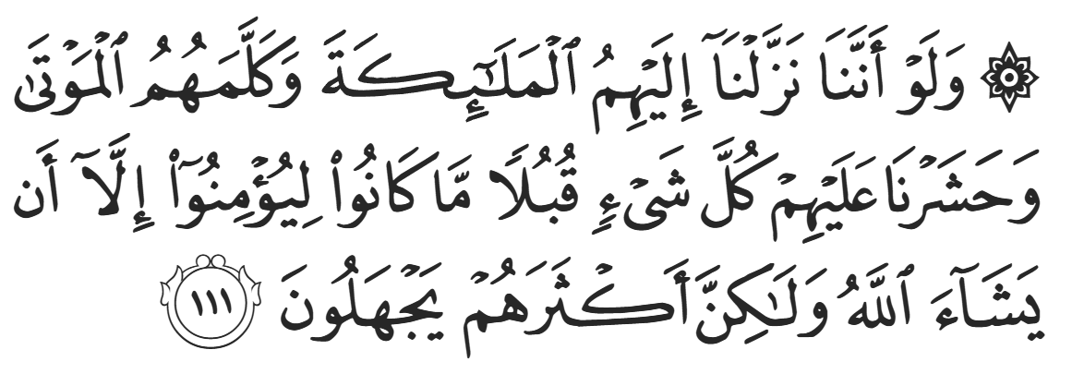
“Even if We had sent them Angels, made the dead speak to them, and assembled before their own eyes every sign [they demanded], they still would not have believed—unless Allah so willed. But most of them are ignorant” (6:111)
The previous nations—such as the likes of ‘Aad, Thamud and Musa—indeed refused to accept the truth even after being shown miracles.
Allah (SWT) tells us in Surat Israa:
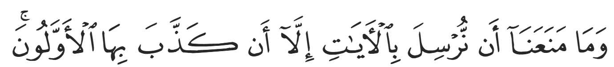
“Nothing keeps Us from sending the signs except that they had [already] been denied by earlier nations.” (17:59)
Today, many Muslims overlook the greatest miracle Allah (SWT) has given us: the Qur’an itself. We live in a world that chases after extraordinary spectacles, digital illusions, and manufactured wonders, yet the Qur’an remains the one miracle that transforms hearts, reshapes character, and brings tranquility to restless souls. Every generation that came before us saw their destruction after their miracles ended. But we have a miracle that we can hold, recite, memorize, and experience every day. Its linguistic precision, its preserved authenticity, its unmatched spiritual impact—all of it continues unchanged from the moment it was revealed. And this is a blessing for which we will be questioned.
Allah (SWT) tells us in Surat Al-Ankaboot:
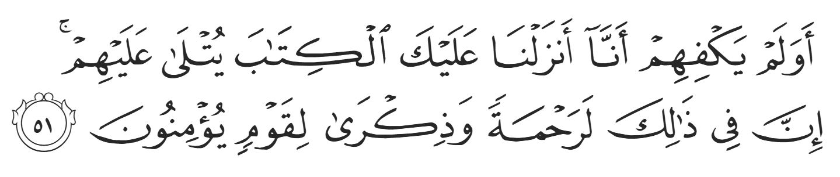
“And is it not sufficient for them that We revealed to you the Book [i.e., the Qur’ān] which is recited to them? Indeed in that is a mercy and reminder for a people who believe.”

<Duaa!>
- Oh Allah, please grant us a deep love for your Prophet Muhammad, SAW.
- Oh Allah, please make us energetic in doing good for your cause.
- Oh Allah, please enable us in will and means to walk Al-Sirrat-Al-Mustaqeem, even if it estranges us from others.
- Oh Allah, please support the suffering and oppressed Muslims around the world and grant them victory over that which oppresses them.
- Oh Allah, please protect us from ever being overburdened by debt and protect us from all evils and undesirable consequences associated to having debt.
- Oh Allah, please fill our hands with the work and deeds of righteousness and let them be of benefit to ourselves and the Ummah.
- Oh Allah please forgive us our shortcomings and deviances in following your Qur'an and the Sunnah of Rasul'Allah, SallAllahuAlayhiWaSallam.
- Oh Allah please grant us understanding and guidance of your Qur'aan
- Oh Allah, please grant us patience with the trials of this world.
- Oh Allah, please prevent our hearts from getting overly attached to the Dunya and grant us the best in this life and the best in the hereafter.
- Oh Allah, please forgive us our past sins and make us your devoted servants.
- Oh Allah please make us amongst those whose Duaa is accepted.
- Oh Allah, please grant us Jannat'ul Firdaus and protect us from ever coming close to the Fires of Jahannum.

